Sensor recorder 값

ᆞGravity Sensor 캡쳐

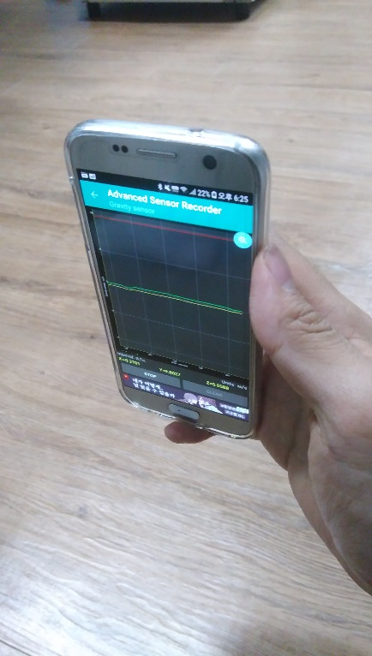 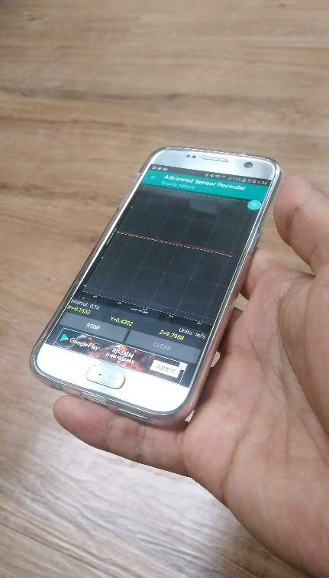 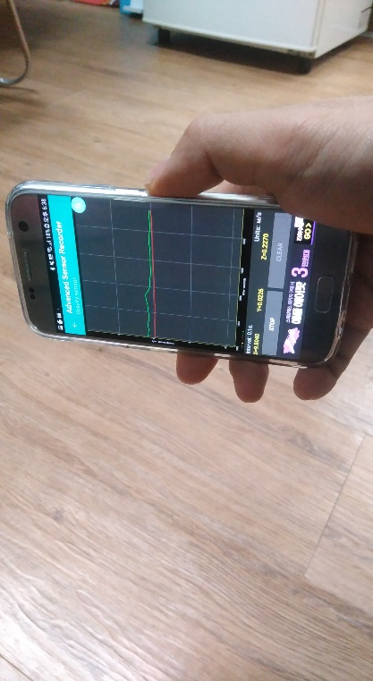

Z

X

G

Y

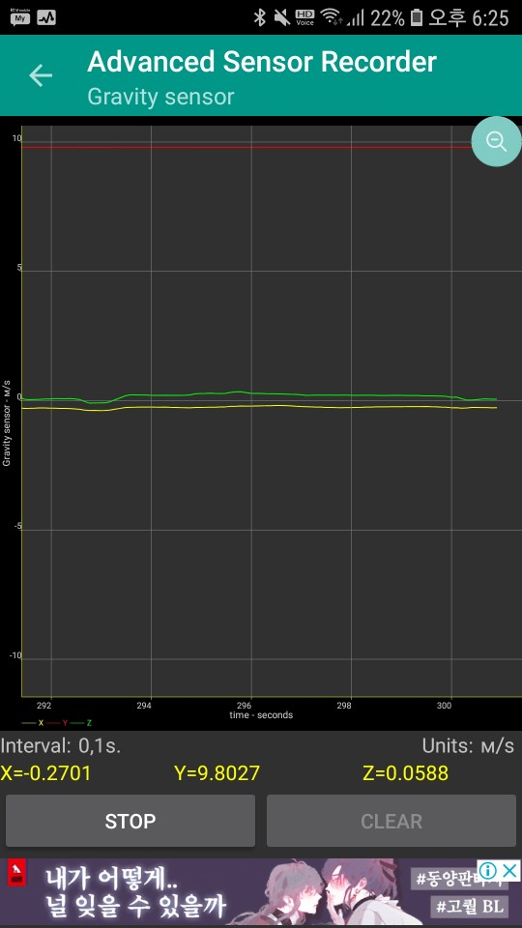 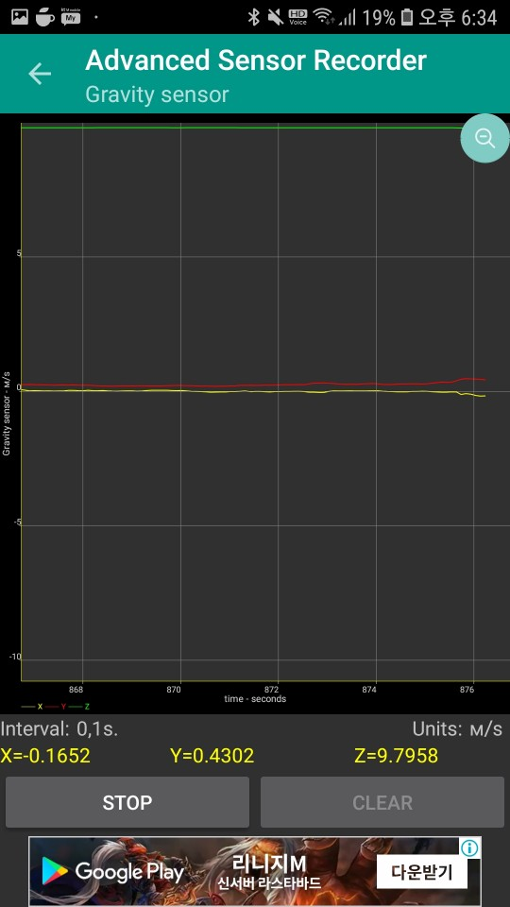 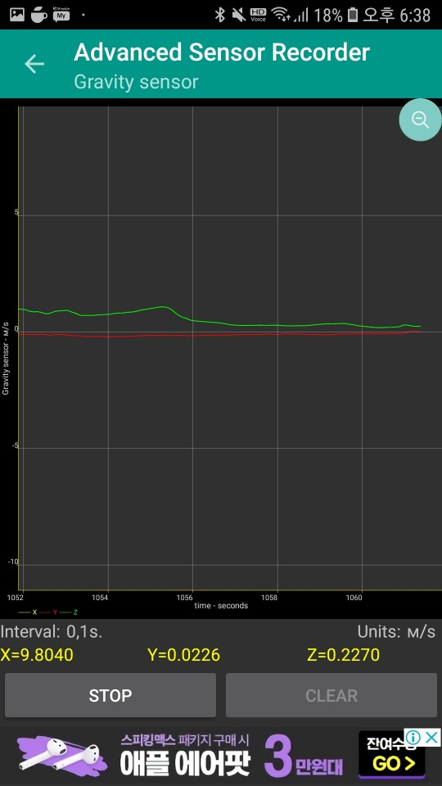

Y = 9.8027 (최대) Z = 9.7958 (최대) X = 9.8040 (최대)

Z = 0.0588 (최소) X = 0.1652 (최소) Y = 0.0226 (최소)