Example 1: (space truss)

A twenty five-bar truss is considered as shown in the following figure:

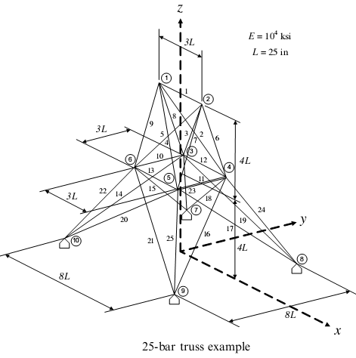

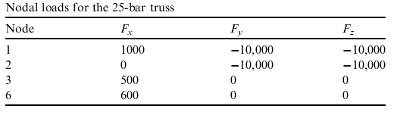
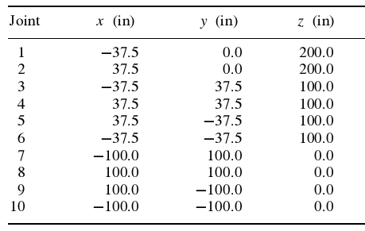

1. Definition of Data (Data.m)

function D=Data
% Definition of Data

% Nodal Coordinates
Coord=[-37.5 0 200;37.5 0 200;-37.5 37.5 100;37.5 37.5 100;37.5 -37.5… 100;-37.5 -37.5 100;-100 100 0;100 100 0;100 -100 0;-100 -100 0];

% Connectivity
Con=[1 2;1 4;2 3;1 5;2 6;2 4;2 5;1 3;1 6;3 6;4 5;3 4;5 6;3 10;6 7;4 9;5 8;… 4 7;3 8;5 10;6 9;6 10;3 7;4 8;5 9];

% Definition of Degree of freedom (free=0 & fixed=1)
% for 2-D trusses the last column is equal to 1
Re=zeros(size(Coord));
Re(7:10,:)=[1 1 1;1 1 1;1 1 1;1 1 1];
% or: Re=[0 0 0;0 0 0;0 0 0;0 0 0;0 0 0;0 0 0;1 1 1;1 1 1;1 1 1;1 1 1];

% Definition of Nodal loads
Load=zeros(size(Coord));
Load([1:3,6],:)=1e3*[1 -10 -10;0 -10 -10;0.5 0 0;0.6 0 0];
% or: Load=1e3*[1 -10 -10;0 -10 -10;0.5 0 0;0 0 0;0 0 0;0.6 0 0;…
% 0 0 0;0 0 0;0 0 0;0 0 0];

% Definition of Modulus of Elasticity
E=ones(1,size(Con,1))*1e7;
% or: E=[1 1 1 1 1 1 1 1 1 1 1 1 1 1 1 1 1 1 1 1 1 1 1 1 1]*1e7;

% Definition of Area
A=[.4 .1 .1 .1 .1 3.4 3.4 3.4 3.4 .4 .4 1.3 1.3 .9 .9 .9 .9 1 1 1 1 3.4 3.4…
3.4 3.4];

% Convert to structure array
D=struct('Coord',Coord ','Con',Con ','Re',Re ','Load',Load ','E',E ','A',A ');

2. Analysis of Truss (ST.m) ; Forces(F) , Deflections(U) , Reactions(R)

Write in Command Line:
>> D=Data ; [F,U,R]=ST(D)

F =

1.0e+004 *

Columns 1 through 10

-0.0336 -0.0240 0.0629 -0.0915 -0.0044 0.8385 -1.9544 0.9097 -1.8832 -0.0257

Columns 11 through 20

-0.0295 0.2846 -0.6882 0.2270 -0.3768 0.2003 -0.4035 0.1887 0.1736 -0.4047

Columns 21 through 25

-0.4288 -1.7643 0.9059 0.7367 -1.9404

U =

0.1131 0.1068 -0.0048 0.0117 -0.0156 0.0241 0 0 0 0
-0.3489 -0.3479 0.0177 0.0172 0.0227 0.0225 0 0 0 0
-0.0455 -0.0522 0.0615 0.0566 -0.1256 -0.1216 0 0 0 0

R =

1.0e+004 *

0 0 0 0 0 0 -0.4375 0.3375 -1.1651 1.0550
0 0 0 0 0 0 0.2034 0.0986 0.9046 0.7935
0 0 0 0 0 0 -0.5750 -0.4250 1.5800 1.4200

For example:
Force in the member 2-4 = Force(6) = 0.8385e4
Displacement of node 4 in y direction = 0.0172
Reaction of node 8 in z zirection = - 0.4250e4

Note: If the structure is unstable, this warning is appeared:
Warning: Matrix is singular to working precision.
Some of the Forces & Displacements are equal to NaN.

3. Plot Truss and Deformation shape (TP.m) (Optional)

Write in Command Line:
>> TP(D,U,20)
Note: The last argument is the scaling factor for deformation shape

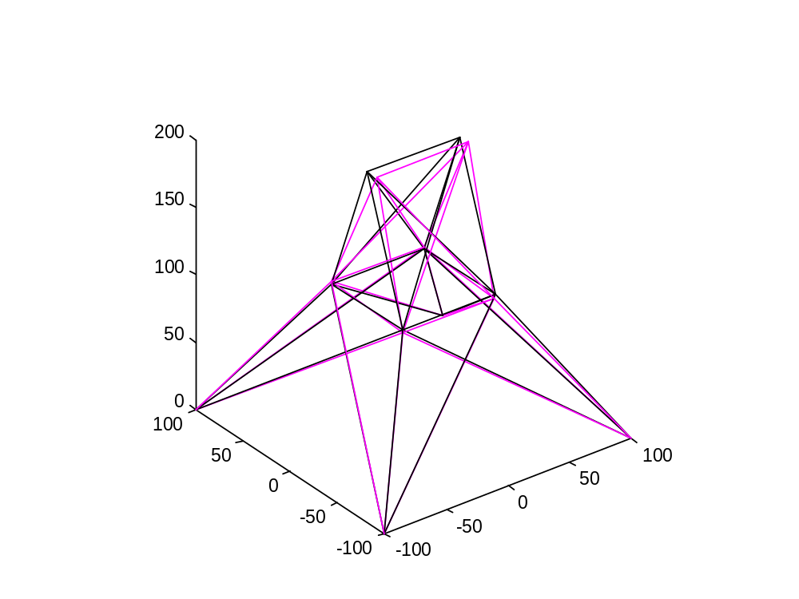

Example 2: (planar truss)

A ten-bar truss is considered as shown in the following figure:

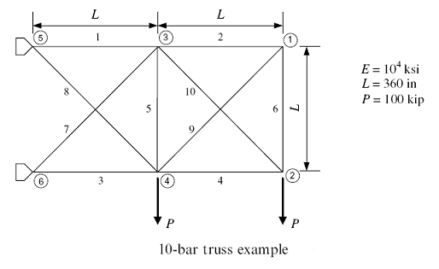

1. Definition of Data (Data.m)

function D=Data
Coord=360*[2 1 0;2 0 0;1 1 0;1 0 0;0 1 0;0 0 0];
Con=[5 3;1 3;6 4;4 2;4 3;2 1;6 3;5 4;4 1;3 2];
Re=[0 0 1;0 0 1;0 0 1;0 0 1;1 1 1;1 1 1];
Load=zeros(size(Coord));Load(2,:)=[0 -1e5 0];Load(4,:)=[0 -1e5 0];
% or: Load=[0 0 0;0 -1e5 0;0 0 0;0 -1e5 0;0 0 0;0 0 0];
E=ones(1,size(Con,1))*1e7;
% or: E=[1 1 1 1 1 1 1 1 1 1]*1e7;
A=[27.5 0.1 24.5 17.5 0.1 0.5 7.5 21.5 21.5 0.1];
D=struct('Coord',Coord ','Con',Con ','Re',Re ','Load',Load ','E',E ','A',A ');

2. Analysis of Truss (ST.m) ; Forces(F) , Deflections(U) , Reactions(R)

Write in Command Line:
>> D=Data ; [F,U,R]=ST(D)

F =

1.0e+005 *

1.3199 0.6963 -2.6801 -0.3037 0.0162 0.6963 -0.4524 2.3760 -0.9847 0.4296

U =

25.2381 -0.4563 0.1728 -0.3938 0 0
-27.1511 -32.1642 -0.6071 -1.1895 0 0
0 0 0 0 0 0

R =

1.0e+005 *

0 0 0 0 -3.0000 3.0000
0 0 0 0 1.6801 0.3199
0 0 0 0 0 0

3. Plot Truss and Deformation shape (TP.m) (Optional)

Write in Command Line:
>> TP(D,Def,1)
Note: The last argument is the scaling factor for deformation shape

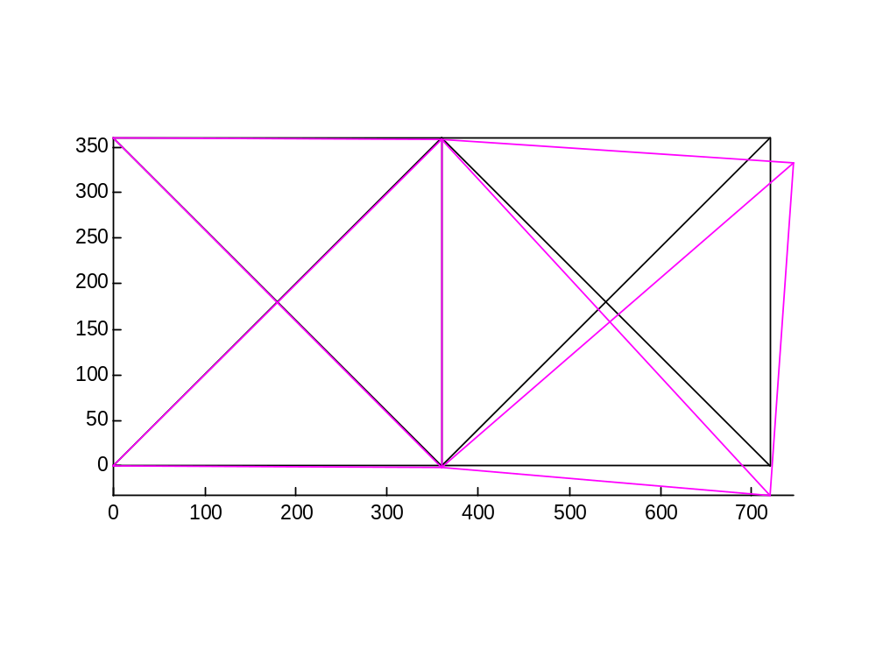

Function for Analysis of Truss (ST.m)

function [F,U,R]=ST(D)
w=size(D.Re);S=zeros(3*w(2));U=1-D.Re;f=find(U);
for i=1:size(D.Con,2)
H=D.Con(:,i);C=D.Coord(:,H(2))-D.Coord(:,H(1));Le=norm(C);
T=C/Le;s=T*T';G=D.E(i)*D.A(i)/Le;Tj(:,i)=G*T;
e=[3*H(1)-2:3*H(1),3*H(2)-2:3*H(2)];S(e,e)=S(e,e)+G*[s -s;-s s];
end
U(f)=S(f,f)\D.Load(f);F=sum(Tj.*(U(:,D.Con(2,:))-U(:,D.Con(1,:))));
R=reshape(S*U(:),w);R(f)=0;

Function for Plot of Truss (TP.m)

function TP(D,U,Sc)
C=[D.Coord;D.Coord+Sc*U];e=D.Con(1,:);f=D.Con(2,:);
for i=1:6
M=[C(i,e);C(i,f);repmat(NaN,size(e))];X(:,i)=M(:);
end
plot3(X(:,1),X(:,2),X(:,3),'k',X(:,4),X(:,5),X(:,6), 'm');axis('equal');
if D.Re(3,:)==1;view(2);end

Hossein Rahami
E-Mail: hrahami@iust.ac.ir
Company/University: Engineering Optimization Research Group (EORG)
Personal Profile
Engineering Optimization Research Group (EORG) - Faculty of Engineering - Tehran University - IRAN
Professional Interests
Structural Mechanics , Optimization , Evolutionary Algorithms , Graph Theory

