Client and Topic
For my final website project, I will be designing a professional site for my sister Adriana’s home-based flower business. As a stay-at-home mom, she began selling custom floral arrangements through social media about two years ago. Her business has grown rapidly, supported by a strong online presence and an impressive portfolio showcasing her creative work. A dedicated website will elevate her brand identity, provide a more polished experience for clients, and serve as a central hub for showcasing her designs, potentially managing orders, and expanding her reach.
Development Process and Engagement (50-word minimum):
Creating this website for Adriana offers a unique opportunity for close collaboration, as we live together and communicate daily. My familiarity with her creative process, having spent years observing her and our mom craft stunning floral arrangements, gives me valuable insight into her aesthetic and business goals. To ensure the site meets the needs of her target audience, I will conduct research on how similar small businesses have built their online presence. This includes analyzing design trends, functionality, and user experience strategies. I also plan to interview Adriana with a series of questions to better understand her clientele’s demographics, preferences, and purchasing behavior, which will guide the site’s structure and features.
Testing
Before launching the website, I will conduct proper testing to ensure everything functions correctly and is free of errors. This includes checking all links, loading time, buttons, and forms for proper functionality. I’ll also test the website on 3 major browser, Google Chrome, Safari, and Microsoft Edge to ensure compatibility and accessibility features. Adriana will help by reviewing the site from a user’s perspective, providing feedback on layout, usability, and content clarity. Additionally, I’ll ask a few friends or potential customers to navigate the site and report any issues. Final adjustments will be made based on their input to ensure smooth and professional user experience.
Once the site is complete, I will conduct a review using the following questions:
- Does the website reflect the brand identity and style of the flower business?
- Is the portfolio visually appealing and easy to browse?
- Can users easily find and use the contact form for inquiries?
- Does the site perform well on mobile and desktop devices?
- Are all links, images, and buttons functioning properly?
- Is the content free of typos and visually consistent?
- Does the site meet the needs of the target audience personas?
- Is the site optimized for basic SEO and discoverability?
- Does the site encourage engagement through social media or future updates?
Description (100-word minimum):
The business is a home-based flower shop that specializes in custom, grandiose floral arrangements for all types of occasions and events. The goal is to provide top-tier service to customers seeking professional-grade designs that reflect the significance of their special moments. Located in Hyattsville, the shop offers both pick-up and delivery options.
The website’s primary purpose is to showcase Adriana’s dynamic and extensive portfolio to engage potential clients. It will also provide information on current promotions, upcoming events, and allow users to reserve or request a quote for a bouquet. A “Client Love” section will feature comments and reviews from Instagram, TikTok, and direct messages, highlighting customer satisfaction and social proof.
The primary target audience includes middle-class Black and Latino men aged 20–35 living within a 30-mile radius.
Personas
Persona 1: Scott
Age: 32
- Occupation: Construction Worker
- Location: Upper Marlboro, MD
- Goals: Wants to surprise his partner with thoughtful floral gifts for birthdays and anniversaries
- Behavior: Shops online, values convenience and personalization
- Needs:
Easy-to-navigate mobile site
Custom bouquet options
Information on delivery options
Option to add personal messages
Persona 2: Jalen
- Age: 26
- Occupation: Financial Analyst
- Location: Washington, D.C.
- Goals: Buys flowers for girlfriend and his mother
- Behavior: Browses on weekends, prefers modern design and quick replies
- Needs:
Product photography
Pricing information
Social media integration
Loyalty or referral program
Persona 3: Carlos
- Age: 38
- Occupation: Middle School Teacher
- Location: Hyattsville, MD
- Goals: Orders flowers for family events—Mother’s Day, daughter’s birthday, graduations, and church events
- Behavior: Shops with purpose, values reliability and community connection
- Needs:
Seasonal collections and gift bundles
Testimonials from other customers
Contact information
Option for requesting an estimate
Adapting the website to this target audience will help build trust, inspire customers with bouquet ideas, and provide a professional channel for inquiries. All images will be original, showcasing Adriana’s personal floral designs to reflect her unique style and craftsmanship. Text content will also be provided by Adriana, including business details, promotions, updates, and social media links.
Content from other sources will include social media posts, customer reviews, and direct messages to highlight engagement and satisfaction. If video integration is used, YouTube will serve as the hosting platform to minimize bandwidth usage and ensure better compatibility across multiple browsers and devices.
The website’s content may need ideally monthly updates to reflect new designs, upcoming events, and seasonal promotions. Major holidays like Valentine’s Day and Mother’s Day often require reservations up to two months in advance to secure lower rates and guarantee availability. The website can feature timely reminders and banners to help customers plan ahead and avoid missing out.
Growth and Maintenance (50-word minimum):
As the clientele continues to grow, the portfolio will expand significantly and can be organized into categories such as “Valentine’s Day,” “Mother’s Day,” “Funeral,” and more, making it easier for visitors to browse by occasion. Additionally, integrating a blog section would allow Adriana to share floral care tips, behind-the-scenes stories, and other valuable content that may not require a full standalone page. Since the majority of clients are Black or Latino, offering a language toggle between English and Spanish would enhance accessibility and create a more inclusive experience for the target audience.
Organizing content into clearly defined sections will streamline both the development and future updates of the website. Preparing and optimizing images in advance, such as resizing, compressing, and categorizing, will make building the gallery more efficient and time effective. Additionally, having alt text ready for each portfolio piece will support accessibility and SEO. Creating basic wireframes for each page before coding will help visualize the layout and reduce time spent troubleshooting design structure during development.
For ongoing maintenance, the flower arrangement gallery should be updated at least once a month to reflect new work. Upcoming events and promotions should be posted as needed to keep the site current and engaging. Testimonials and reviews can be refreshed every three months, as they may be less frequent. Regular checks should be performed to ensure all links are functional, and security should be monitored weekly or monthly to protect and maintain site integrity.
Organization (100-word minimum):
All website content will be accessible through the homepage and the top navigation menu, as the site will contain only 10 pages. Related content will be grouped within dropdown menus to ensure better organization and create a more breathable, uncluttered layout.
Website Structure:
    - Home page
    - About
      - Our story (will include customer reviews as well)
      - Privacy policy
    - Collections
      - Best Sellers
      - Romance
      - Birthday
      - Mother’s Day
      - Miscellaneous Blooms
    - Help
      - Contact & Inquiries
      - Blog (delivery details, pickup information, updates, promotions, and more)
This structure will provide a minimalistic and well-organized navigation menu.
- The Collections menu will feature a dropdown with links to Best Sellers, Anniversary & Romance, Birthday, Mother’s Day, and Miscellaneous Blooms.
- The About menu will include Our Story and Customer Reviews.
- Additional information that does not require a dedicated page will be consolidated in the Blog section.
The layout will be minimalistic, highlighting the flower arrangements as the focal point. By using contrast and alignment, the design will guide customers naturally toward making purchases, without overwhelming them with unnecessary visual clutter.

Adriana’s Flower shop Site Map:
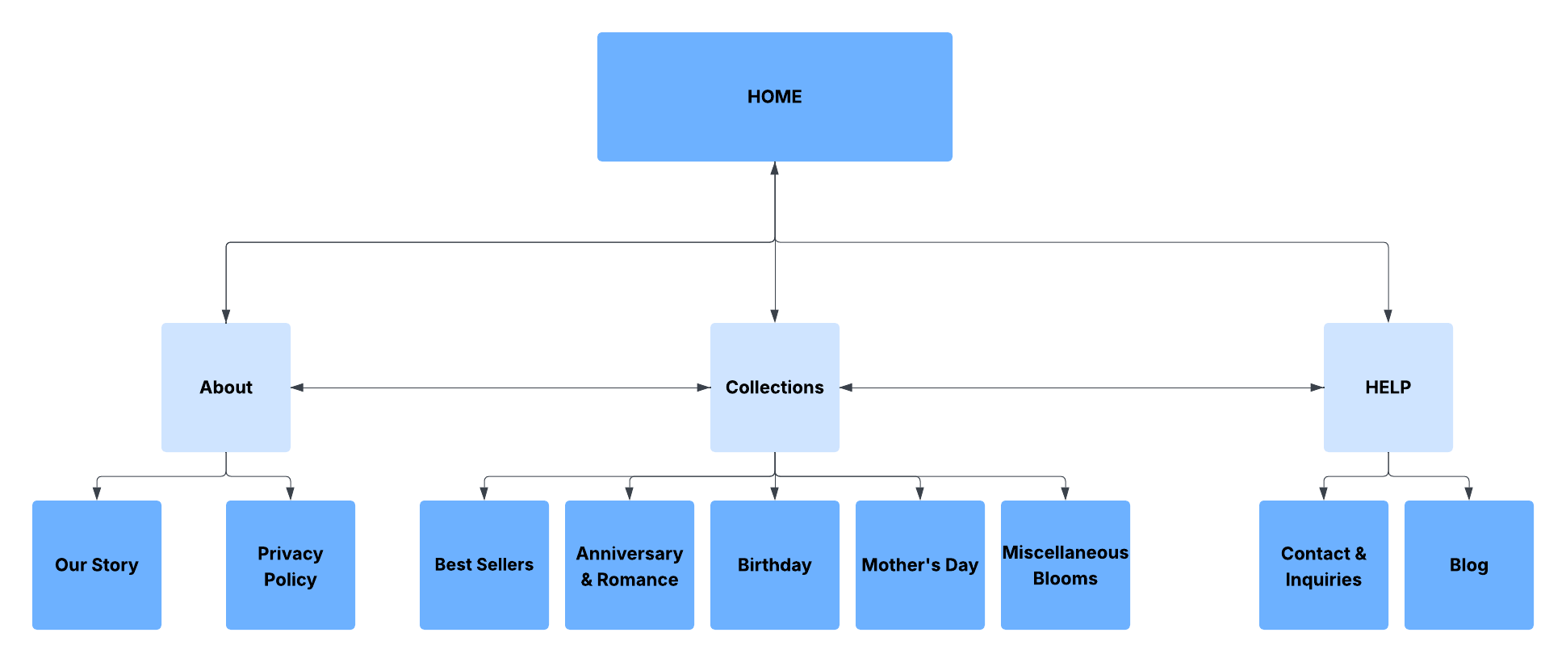
Wireframe HOMEPAGE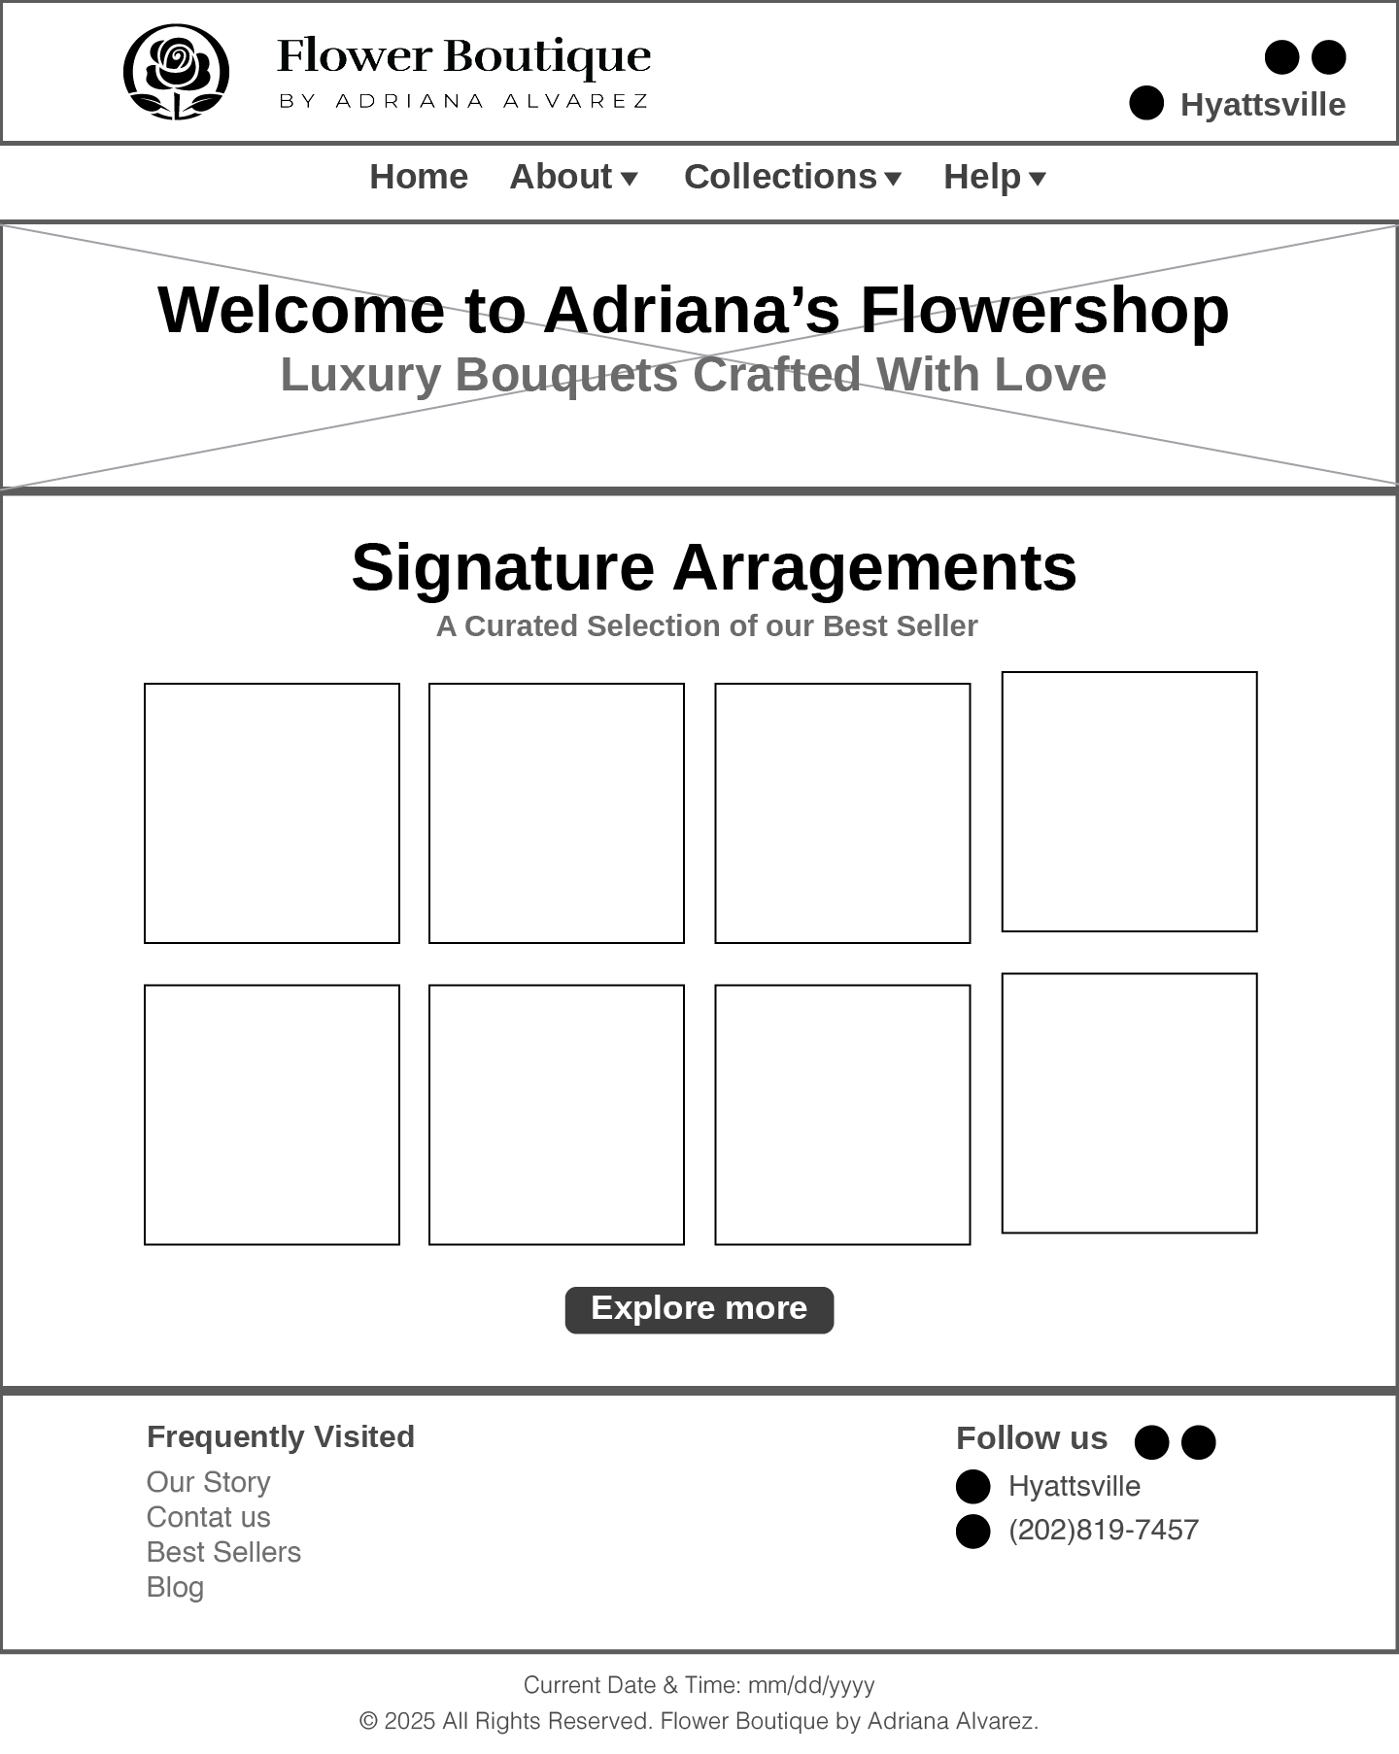
Wireframe COLLECTIONS – ROMANCE
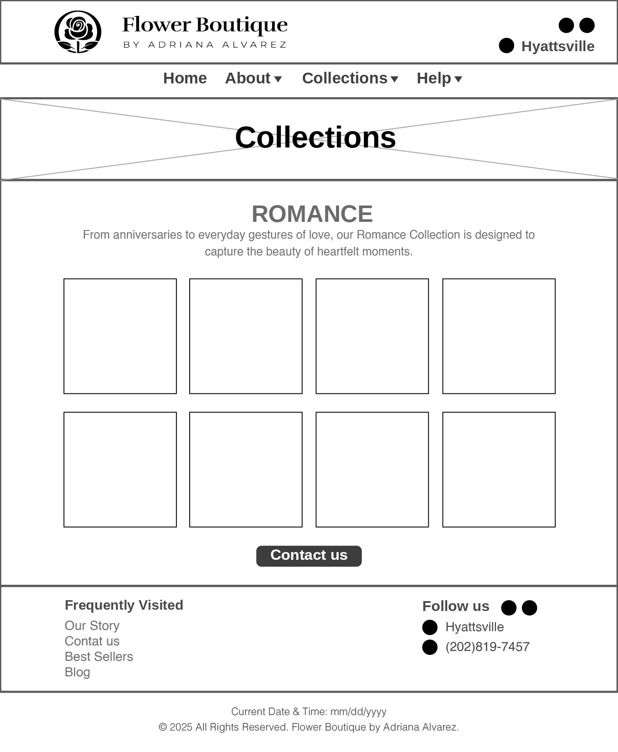

Security:
The website will not include an e-commerce component. This is not ideal, as flower prices fluctuate frequently and arrangements are highly dynamic. Clients often specify add-ons, choose different colors or flower types, and request customizations. As a result, costs vary depending on the combination of options selected.
The website will not require password protection, since it will function primarily as a portfolio showcasing various floral arrangements. A contact form will be available for visitors interested in purchasing or requesting an estimate.
The website will not support personal accounts. As this project is designed for a small home-based business, the customer volume is limited and does not justify the complexity of account management features.
Features to enhance the security of the website:
Add Google reCAPTCHA to forms to reduce spam submissions
Schedule frequent backups to safeguard data and ensure quick recovery in case of unforeseen failures or breaches.
Protect the contact form by encrypting email addresses and using secure POST methods to prevent exposure of sensitive information.
Web Hosting:
When selecting a web host, several variables must be considered to ensure the best fit for the client’s needs: pricing aligned with the client’s budget, reliability, security, performance, customer support, available add-ons, and bandwidth capacity. To make an informed decision, it is important to review unbiased feedback from real clients rather than relying solely on promotional material. Additionally, consulting with other web designers or developers can provide valuable insights and recommendations, helping to navigate the wide range of hosting options and identify the provider best suited for the project.
For Adriana’s Flower Boutique, an SSL certificate will be essential to establish trust and enable encrypted communication between the website and its visitors. A reCAPTCHA system will also be implemented to protect against spam and cyberattacks, ensuring that only genuine users can submit inquiries through the contact form.
The website will be developed using HTML, CSS, and JavaScript.
The domain adrianaflowerboutique.com has been identified as being available through Network Solutions. This domain was chosen because it directly reflects the business name featured in Adriana’s logo, reinforcing brand identity. The “.com” extension is ideal, as the site will serve a commercial purpose. Should the business be registered under a different name in the future, a new domain would be required to maintain consistency.
Marketing
The website will be promoted through a combination of digital and traditional marketing strategies. Paid advertising campaigns will be run on Instagram, TikTok, and Facebook to showcase Adriana’s floral arrangements and reach a broad audience. In addition, the website address will be included on printed materials such as flyers, business cards, car magnets, and other promotional items that Adriana already uses to market her business. Another effective option will be Google Ads, particularly during high-demand occasions such as Valentine’s Day, Mother’s Day, and weddings, when customers are actively searching for floral services.
To optimize search engine results (SEO), the website will incorporate:
- Relevant and keyword-rich content
- A user-friendly, responsive layout
- Fast-loading pages and optimized images
- Alt text for all images
- Meta tags including descriptions and keywords

