Re: Tip discrepancy 2021-02-11

Tips were slightly off because the exact tips were off by $0.49 and hours recorded off by 1 minute for Shayan when compared to the HnS Payroll 1.18-1.31.21.xlsx fil.

Figure 1 HnS Payroll 1.18-1.31.21.xlsx (original data)

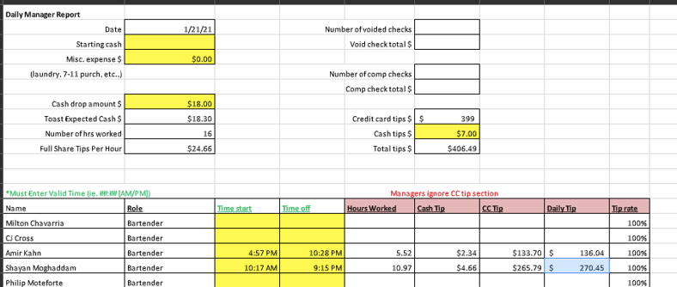

Figure 2 Corrected Shiftgarten Data

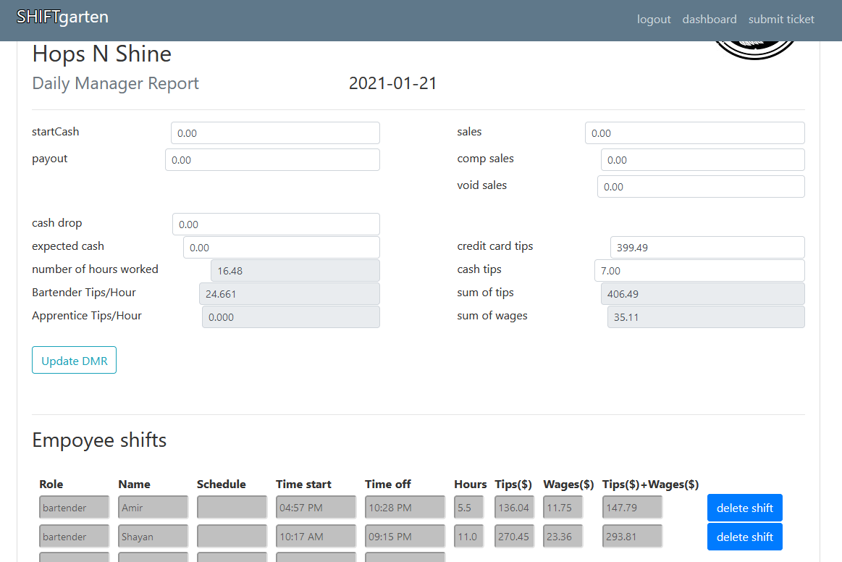

The last entry has credit card tips at $399 and cash at $7. The HnS spreadsheet DMR showed a total of $407.49 tips. I added $0.49 to the credit card tips.

The previous entry showed Shayan Time off 9:14pm instead of 9:15pm. The HnS spreadsheet DMR showed Shayan Time off 9:15pm.

When both adjustments were made the Tips of each employee matched.