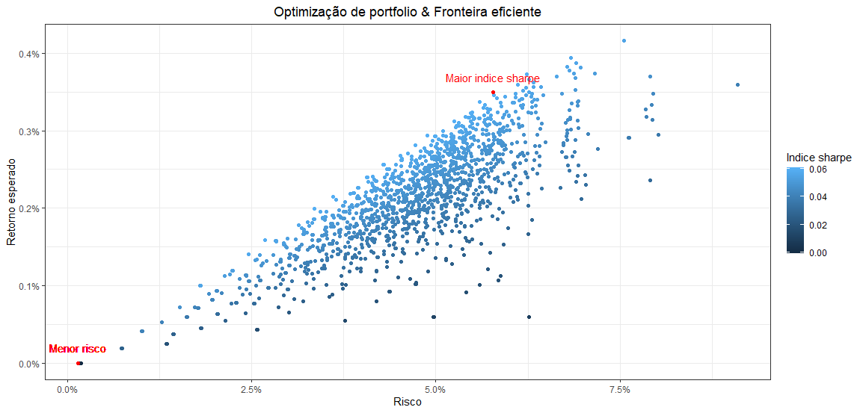

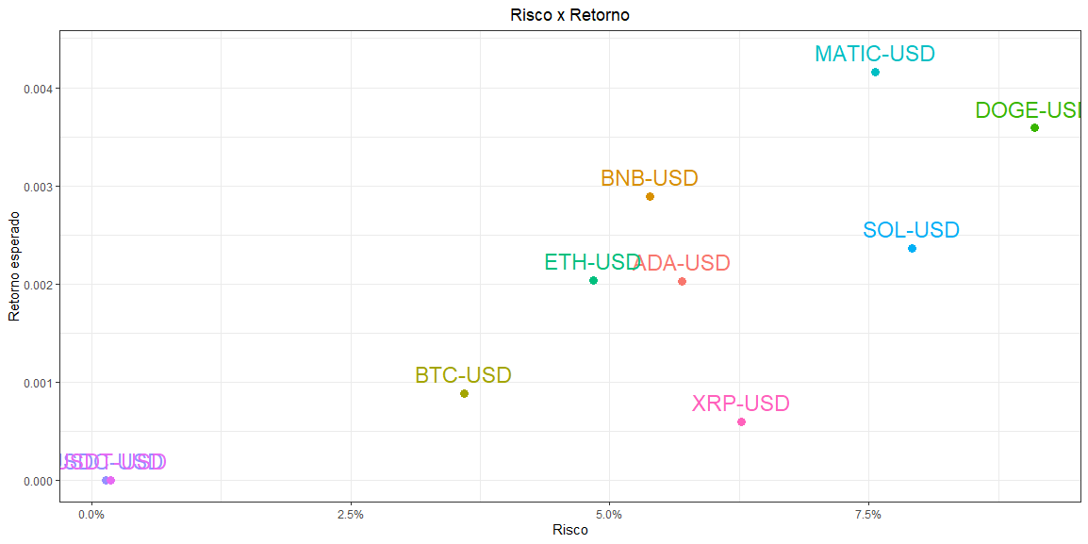

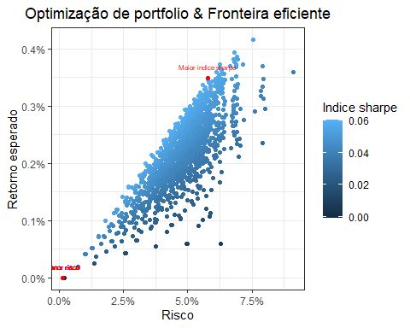

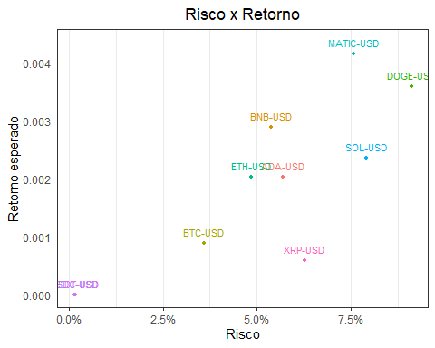

# Tabelas

Table : top 5 combinações com piores indices sharpe

| BTC-USD | ETH-USD | USDC-USD | USDT-USD | BNB-USD | XRP-USD | ADA-USD | DOGE-USD | SOL-USD | MATIC-USD | Indice Sharpe | Risco | Retorno esperado |
| --- | --- | --- | --- | --- | --- | --- | --- | --- | --- | --- | --- | --- |
| 0% | 0% | 0% | 100% | 0% | 0% | 0% | 0% | 0% | 0% | -0,061% | 0,183% | 0.0000 |
| 0% | 0% | 20% | 80% | 0% | 0% | 0% | 0% | 0% | 0% | -0,046% | 0,169% | 0.0000 |
| 0% | 0% | 40% | 60% | 0% | 0% | 0% | 0% | 0% | 0% | -0,026% | 0,157% | 0.0000 |
| 0% | 0% | 60% | 40% | 0% | 0% | 0% | 0% | 0% | 0% | 0,001% | 0,148% | 0.0000 |
| 0% | 0% | 80% | 20% | 0% | 0% | 0% | 0% | 0% | 0% | 0,035% | 0,144% | 0.0000 |
| 0% | 0% | 100% | 0% | 0% | 0% | 0% | 0% | 0% | 0% | 0,072% | 0,143% | 0.0000 |

Table : top 5 combinações com melhores indices sharpe

| BTC-USD | ETH-USD | USDC-USD | USDT-USD | BNB-USD | XRP-USD |  | ADA-USD | DOGE-USD | SOL-USD | MATIC-USD | Indice Sharpe | Risco | Retorno esperado |
| --- | --- | --- | --- | --- | --- | --- | --- | --- | --- | --- | --- | --- | --- |
| 0% | 0% | 0% | 0% | 60% | 0% |  | 0% | 0% | 0% | 40% | 6,047% | 5,776% | 0.0035 |
| 0% | 20% | 0% | 0% | 40% | 0% |  | 0% | 0% | 0% | 40% | 6,023% | 5,595% | 0.0034 |
| 0% | 0% | 20% | 0% | 40% | 0% |  | 0% | 0% | 0% | 40% | 6,008% | 4,886% | 0.0029 |
| 0% | 0% | 0% | 20% | 40% | 0% |  | 0% | 0% | 0% | 40% | 6,006% | 4,888% | 0.0029 |
| 0% | 20% | 20% | 0% | 40% | 0% |  | 0% | 0% | 0% | 20% | 5,974% | 4,288% | 0.0026 |
| 0% | 0% | 0% | 0% | 40% | 0% |  | 0% | 20% | 0% | 40% | 5,974% | 5,782% | 0.0035 |

‘