Pacata: ABA Collection and Analysis Tool

Andrew Bordin
Faculty of Applied Science & Technology
Sheridan College
Oakville, Canada
bordinan@sheridancollege.ca

Luiz Fernando Costa
Faculty of Applied Science & Technology
Sheridan College
Oakville, Canada
costalu@sheridancollege.ca
Ghassem Tofighi
Faculty of Applied Science & Technology
Sheridan College
Oakville, Canada
ghassem.tofighi@sheridancollege.ca

Abstract— ABA Therapy uses the principles of learning to change socially significant behaviour to a meaningful degree, i.e. increase good behaviour while decreasing bad ones. This is the most effective intervention for autism. Currently, there a few applications in the market to facilitate this process but there are two main needs that are yet to be fulfilled. The two main needs in the market were extensive functionality to support different types of programs and a well-designed user interface. Pacata solves these needs by working together with industry professionals to create a meaningful application.
Keywords—HCI, ABA, RBT, BCBA, Autism

Introduction
Applied Behaviour Analysis (ABA) therapy is very useful for children with autism who may not be able to pick up on social, motor and verbal behavior, as well as reasoning skills on their own. By using behavioural observation and positive reinforcement, undesirable behaviour can be decreased while wanted behaviour can be increased. The end goal is to remove the triggers and reinforcers of behaviour from the environment of the child, so they become natural responses [1].
There are learning centres that have yet to digitalize this process, recording data manually and keeping this same data and graphs for analysis of client sessions in physical locations, like cabinets.
Our goal is to create a web application which allows for two main things: RBT's (Registered Behaviour Technicians) to easily record and graph client data and BCBA's (Board Certified Behaviour Analysts) and Lead Therapists to easily view and analyze the graphs in order to make informed decisions on client programs and progress in a digitalized form.
The two most popular successful apps similar to our application are Thread Learning and Catalyst.
Some of the things user’s liked about Thread Learning [2]:
• Clean user interface
• Ability to take session notes
• Easy to Learn
• Can run more than one program or data type at the same time

Some of the things user’s disliked about Thread Learning [2]:
• Cost
• Exclusively to iPad

What users liked about Catalyst [3]:
• Ability to use on multiple devices
• Allows therapists to be able to add notes and save them as drafts

What users disliked about Catalyst [3]:
• Un-friendly user interface
• Cost

Pacata combines the best of both worlds. A well-designed, intuitive user interface like Thread Learning, with a cross-platform accessibility like Catalyst.

HCI Principles
It is important to consider concepts of HCI when designing the application. Below is listed the three main concepts that were considered for Pacata.

Familiarity [4] - In order to increase acceptance of our application, familiarity is key. At the moment (in the learning centre we have as inspiration for our project), pen and paper are currently being used to collect and graph data. This means RBT’s run around with a clipboard full of papers but organized in a specific way. For example, they have what they call the “daily data sheet,” where all of the client’s programs are on the same piece of paper in small separate boxes. Therefore, when digitalizing this, it is important to keep all those programs on the same page. In this manner, the user will not have to completely learn where all different programs are and lets them build on prior knowledge and experience.

Safety [4] - We must protect users from making errors, especially when creating an application that deals with client’s sensitive health data. This means ensuring that information should be deleted or not when selecting to delete something and double-checking granting access, amongst other things (two-way communication).

Personalization [4] - One important point that came up while interviewing an RBT is that the current solutions in the market do not allow for customization. Some of their clients’ programs (done in pen and paper) cannot be replicated in digital form. One example of this is with toileting programs. Therefore, our application should be flexible enough that users are not limited to specific types of programs but can create their own.

Prototype Design

Requirement Analysis
For the methodology used to gather requirements to implement the project, there were four steps. Below, we highlight the four steps for one of the tasks in our application.

- Identify a user group and a task: RBT + Data Collection

- Form a hypothesis about the activity: RBT’s are less valuable to their client by collecting data in pen and paper

- How to gather data about the activity: Desk studies
  - Observe RBT’s and clients in their sessions
Field studies
  - Interview RBT’s and ask specific question about collecting data in pen and paper; for example: how long does it take to collect data?

- Identify product opportunities: What was found from interviews is that RBT’s use 30 mins of their client’s session time to spend on graphing the data they collected. An opportunity is to digitalize the data collection and graphing process in order to automatically graph data points. In this manner, RBT’s will not have to spend over 30 mins of their client’s session doing independent work and instead can spend more time helping their client. Some of the questions asked were “How long do you need to spend for data collection?” “Would you benefit from a quicker process?” “Will your client benefit from a quicker process?”

Competitive Analysis

The table below is a matrix comparing the different competitors with our project. Different points were given for different features depending on their importance. The overall score was given by total points / number of features.

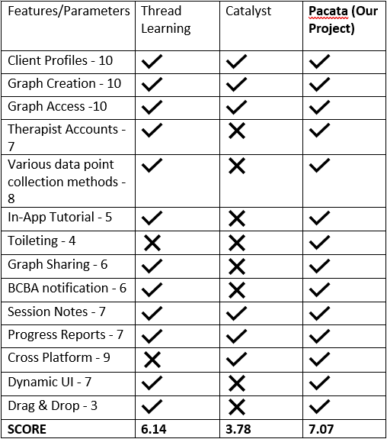
Figure 1: Competitive Analysis Matrix

First Initial Prototype Alternatives

This was Pacata’s first design iteration [5].
This was Pacata’s second design iteration [6].

After careful review, this was Pacata’s final prototype design [7] (screenshots below):

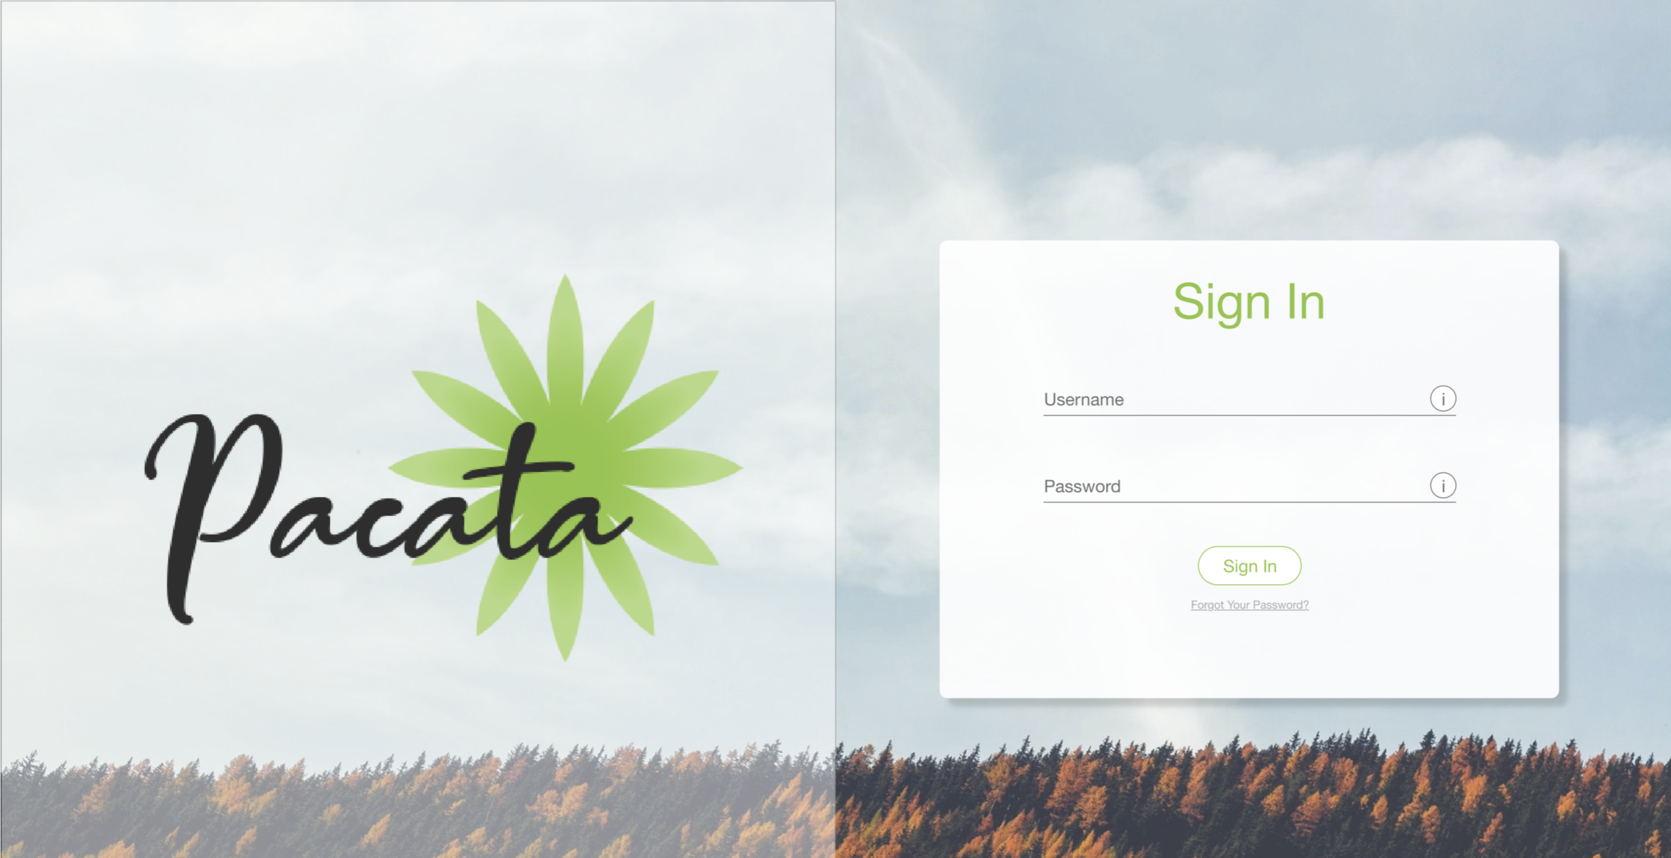
Figure 2: Pacata's Login Screen
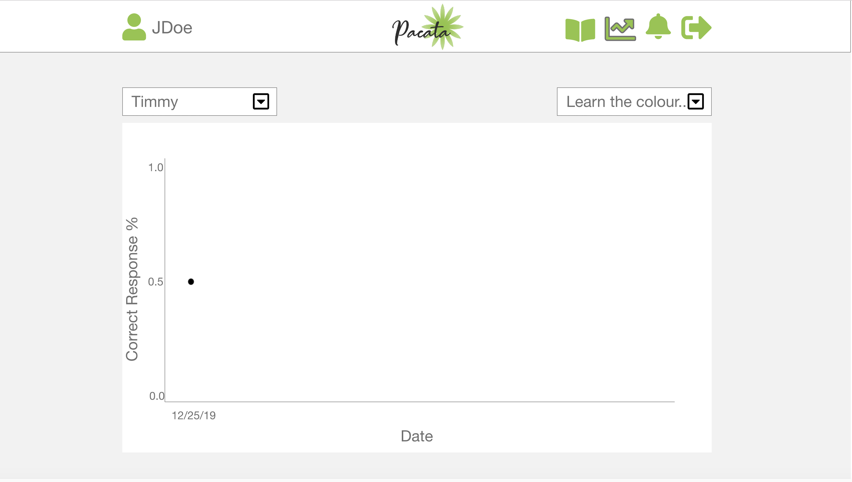
Figure 3: Pacata’s Data Analysis Page

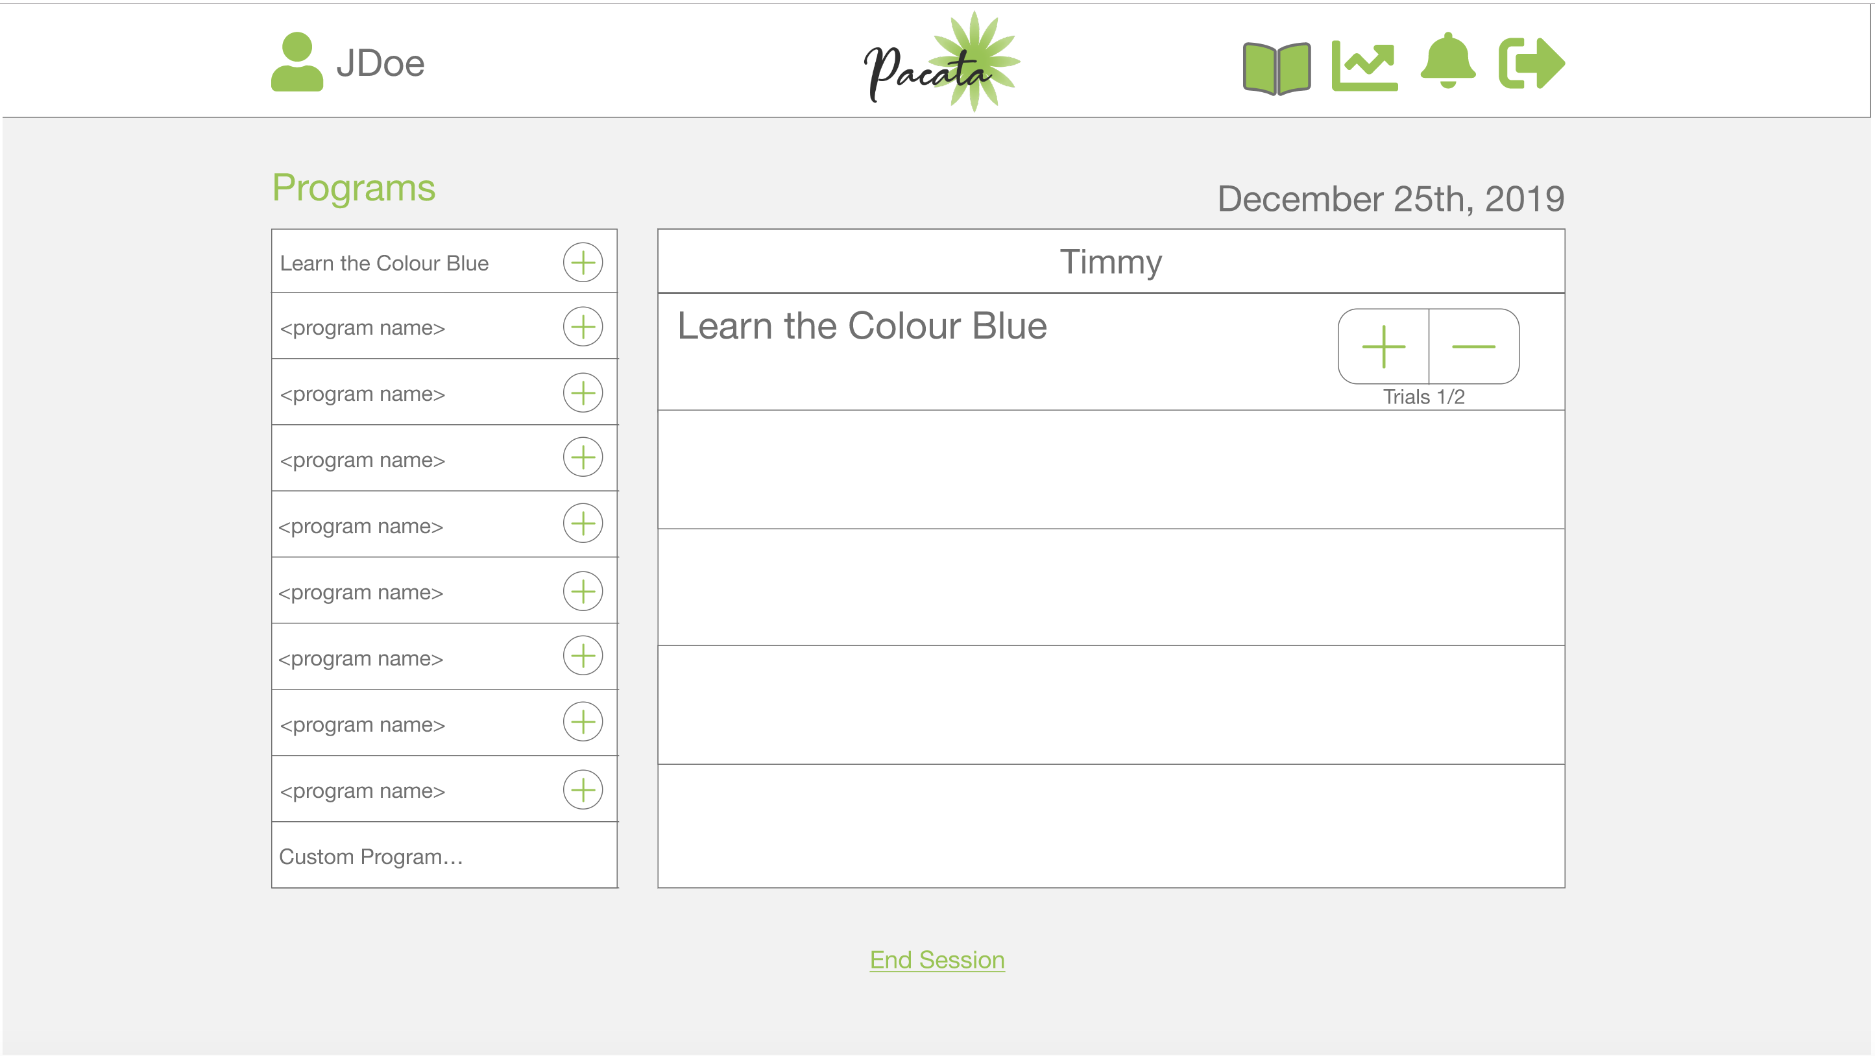
Figure 4: Pacata’s Data Collection Page

In terms of the previously mentioned HCI concepts, here are some screenshots demonstrating our consideration for them:
Personalization [3]:
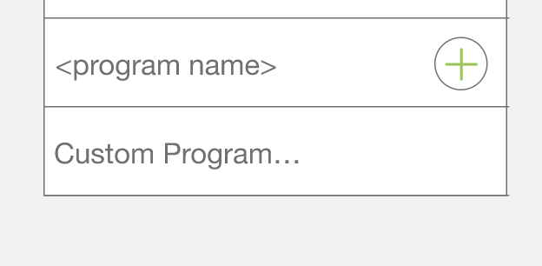
Figure 5: Custom program creation feature

Personalization [3]:
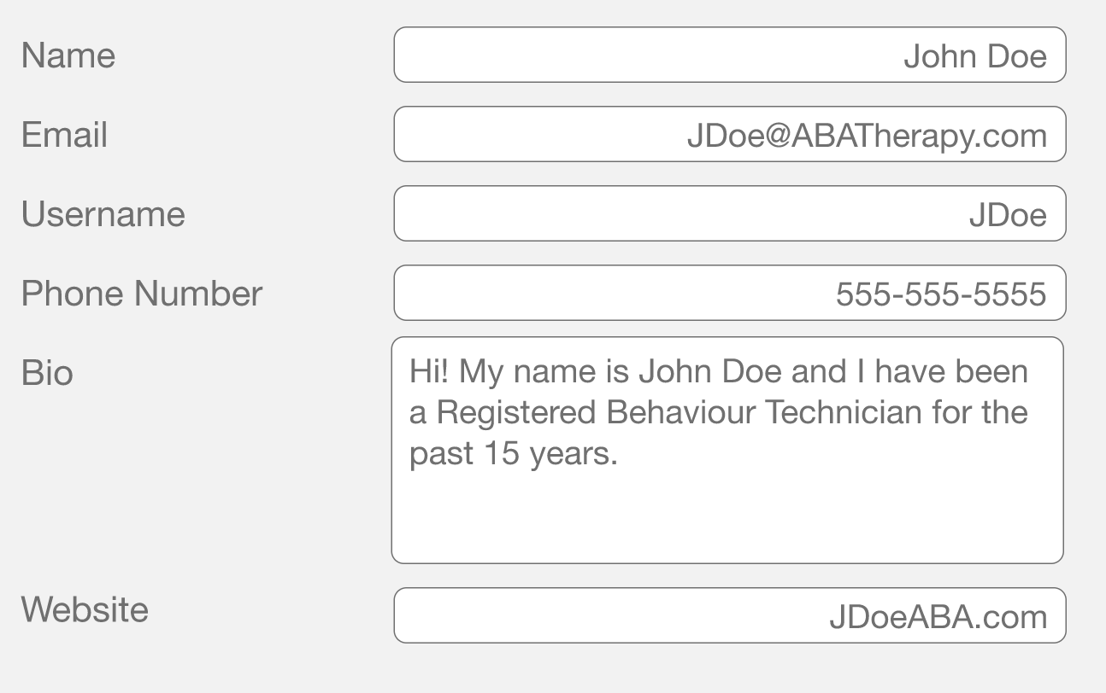
Figure 6: Profile Customization

Familiarity [3] (book icon – RBT’s keep client information in books/binders and this is the same place they can find that information in our application):

Figure 7: Menu icon familiar to real world application

Prototype evaluation

Below is the list of questions we created and used for testing the prototype on UserTesting.com:

- Login.
- Start tutorial.
- Add a program to a client. Click next when you're done.
- Record data for your client's program. Click next when you're done.
- Create your client's graph. Click next when you're done.
- Please check if you have any notifications. Click next when you think you're done.
- Where do you think you are able to edit your email and contact information?
Lastly, we also asked testers to comment on What they expected by clicking the different icons on the menus, as well as comment on the UI and how we could improve.

Our main goal with this test was to if the tutorial created was effective and to see how easy the main functionalities of the application were to use.

Usability Analysis
Success Rate
For this, we will analyze 7 asked tasks from both users and mark it as a success, fail or partial success.
The 7 tasks are:
1. Login
2. Start the tutorial
3. Add a program to a client
4. Record data for a client
5. Graph client data
6. Check for notifications
7. Edit profile information.

Here is the score breakdown for this analysis:
• A success is given a point.
• A fail is given zero points.
• A partial success is given a half a point.

The percentage is calculated out of 14 points (7 tasks for 2 users = 7*2 = 14).

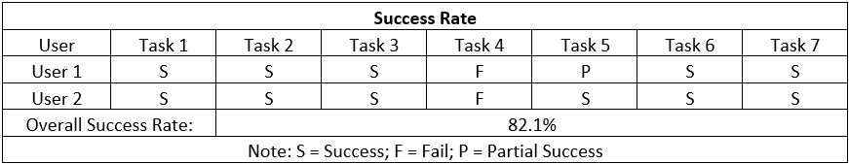
Figure 8: Success rate matrix

As it is seen, both users had problems in completing task 4. After analyzing the videos, there is no clear labels for the “plus” and “minus” sign as data recorders. Once the plus or minus is clicked, a label underneath them is updated as “Trials: ½” for example. This indicates that there were 2 trials in total and that one of them was positive. However, this should probably be separated and be labeled as: “positive responses: 1, negative responses: 1, total responses: 2, success rate: ½” with a “data recorded” title above it. This would make it super clear for users what the functionality of the “plus” and “minus” signs are.
This also shows that the “End Session” button should also clearly label its goal. Yes, it ends the session, but it also automatically graphs the data points. “End Session & Graph Data Recorded” would be better. This way, when users are asked to graph client’s data, they know where to click. User 1 had a bit of difficulty with this.

Subjective Satisfaction of UI
Both users seemed to have really liked the UI. In fact, they basically used the same words or synonyms to describe the UI. For example, we can see they used simple, easy to understand/intuitive and clean/no clutter. Therefore, it is safe to say that the UI, in this case, appeals to both users in the same way.

Figure 9: UI comments by testers

Overall, the application seemed to be at a good starting point, but some clarity was needed with the wording for some of the functionality and its results. By modifying the “trials” label and the “end session” button to use more explicit word, we believe the “success rate” would be higher, if not perfect.

Revised Prototype
It can be seen below the main revision made to the Pacata prototype. We have highlighted the pain points, found through testing, in the before picture and changed those in the after picture.

Before:
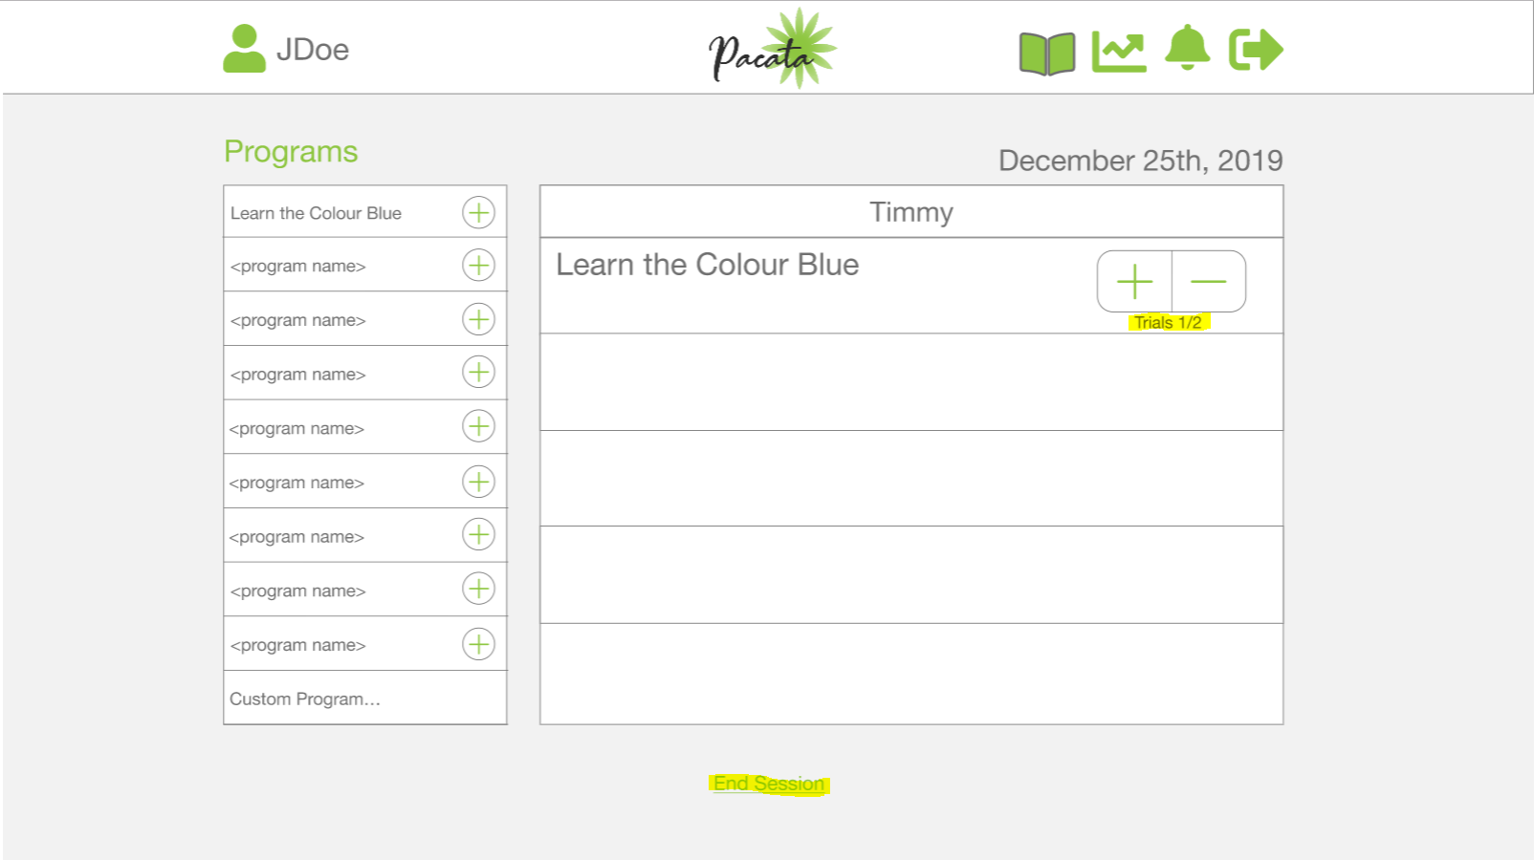
Figure 10: Pacata prototype before user testing

After:
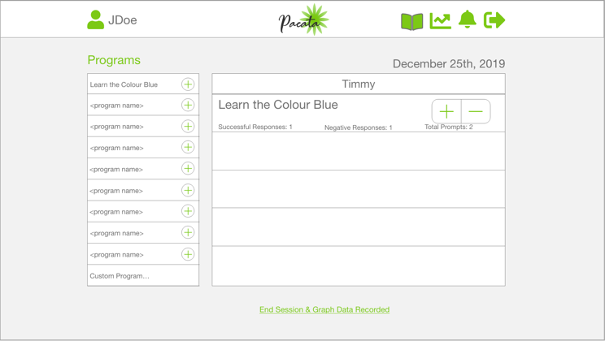
Figure 11: Pacata prototype after user testing

Future works & Conclusions

Pacata’s prototype can be improved in the future with the addition of these features:

- Dark Mode
- Custom Font Size
Both above were suggestions by a user on UserTesting.com. Both features would make it easier on the eyes of the user to use our application, giving them more power to make it as comfortable as possible.

- Adding more pre-defined programs – This will decrease manual work for the RBT, instead of creating custom programs most of the time, we should have a pool of commonly used programs that can be easily picked from a list.
- Client Profile Page – similar to the profile customization page for the therapist, it would be helpful to have a client profile page and be able to customize that in order to better know the clients.

References

[1] Autism Canada (2019). ABA. Retrieved from https://autismcanada.org/living-with-autism/treatments/non-medical/behavioural/aba/

[2] Thread Learning (2019). Applied Behavior Analysis (ABA) Software. Retrieved from https://www.threadlearning.com/

[3] Catalyst by DataFinch (2019). ABA Data Collection Software. Retrieved from https://datafinch.com/aba-data-collection/

[4] IBM Ease of Use: Design Concepts section. IBM, 2001

[5] Costa, F (2019, October, 9). Pacata. Retrieved from https://xd.adobe.com/view/9801d383-605e-4cf8-4030-d718dc9de9e1-ee30/?fbclid=IwAR2REicxLwJnPbAieNeT0vRwg4neaZL-X3ig3SjFTvtY6rZbZpqSu5iDbHA

[6] Bordin, A (2019, October, 9). Pacata Views. Retrieved from https://xd.adobe.com/view/bb4abcaa-4921-4ff3-7973-9b999b25f2e1-cd7b/screen/e3a3daec-f69e-4494-aab2-7a7798ea0738/Web-1920-2

[7] Bordin, A. Costa, F (2019, October, 9). Pacata WireFrames. Retrieved from https://xd.adobe.com/view/bda76bcf-ff26-4c6c-5ffa-d3a52d34345e-cb96/screen/e75eeef2-f2d8-4ff5-9c34-01be97e5087e/Web-1920-17?fullscreen

