# Standard Graphs

Blue whiting (Micromesistius poutassou) in subareas 1-9, 12, and 14 (Northeast Atlantic and adjacent waters)

**Species:** Micromesistius poutassou

**Stock code:** whb.27.1-91214

**Assessment Year:** 2022

**Key:** 17597

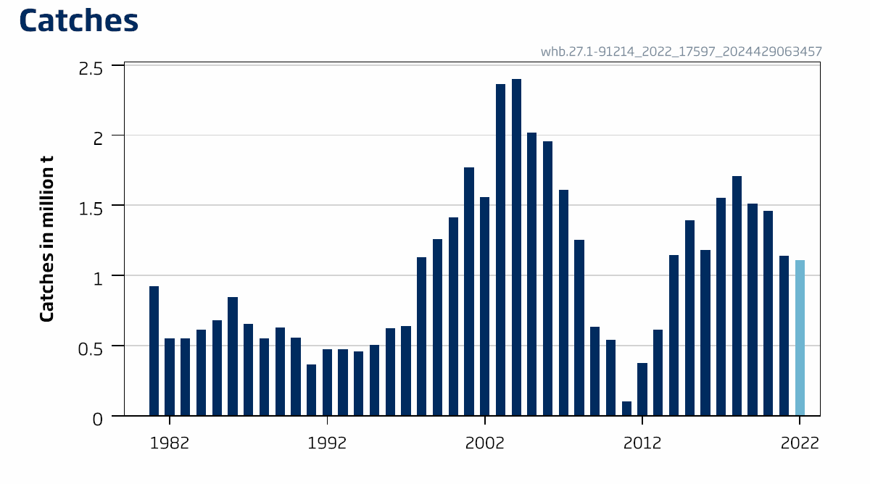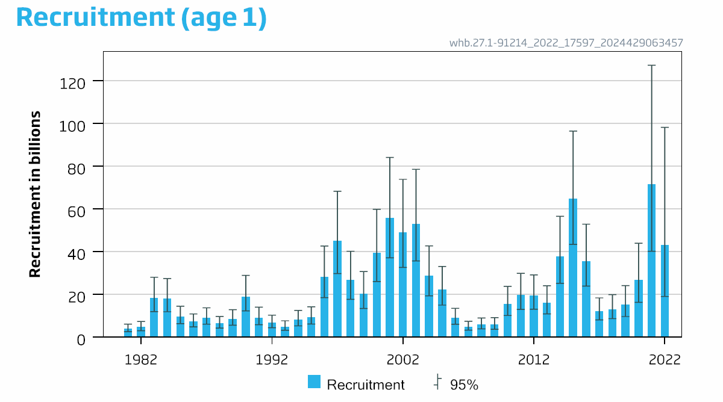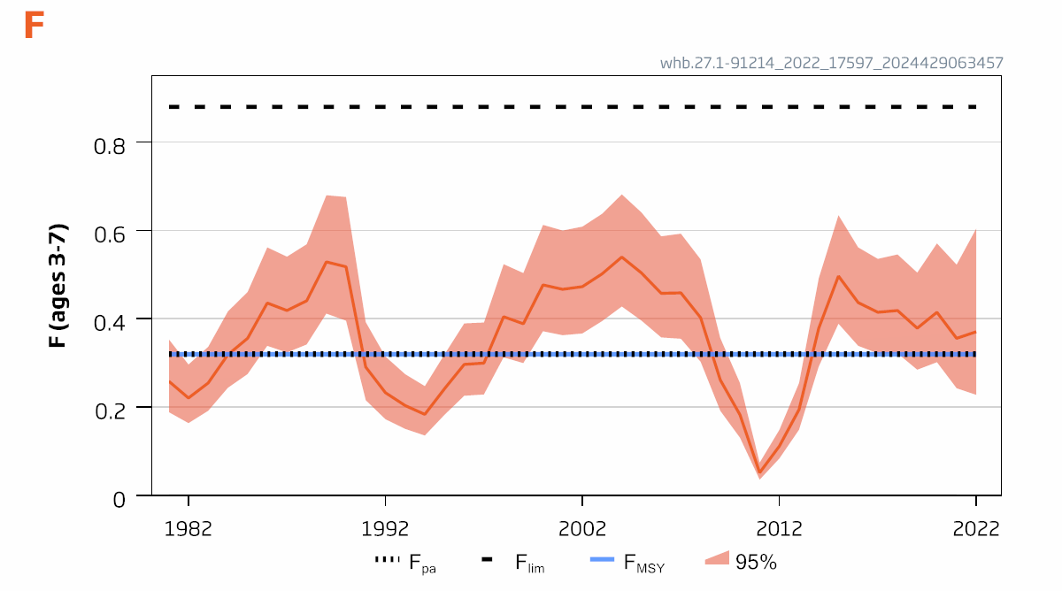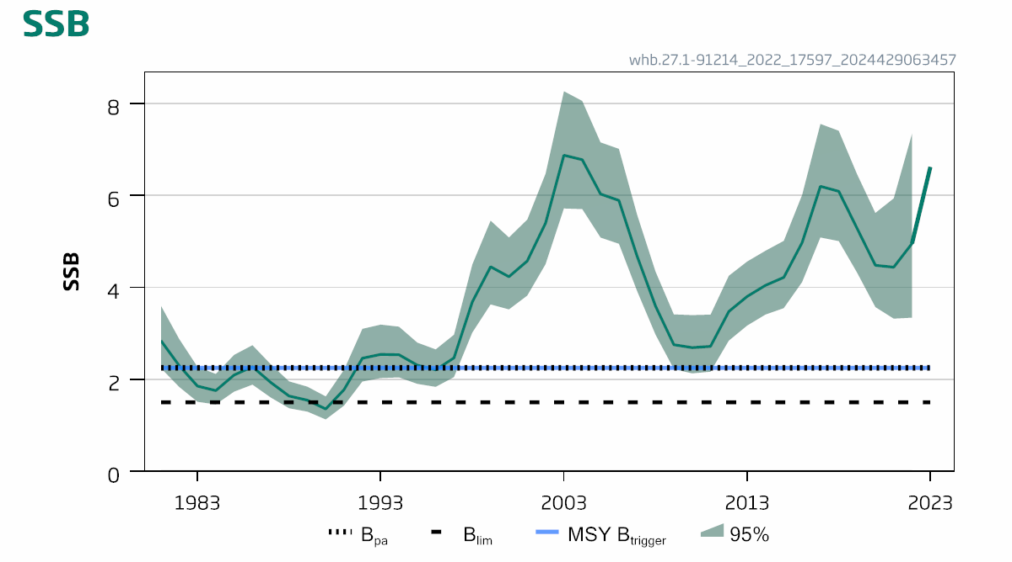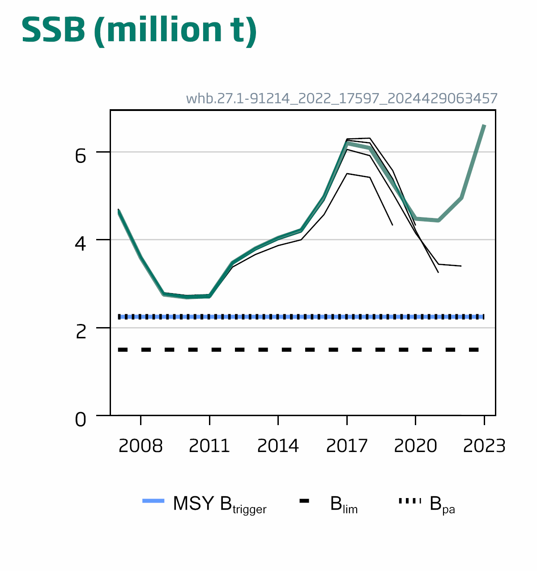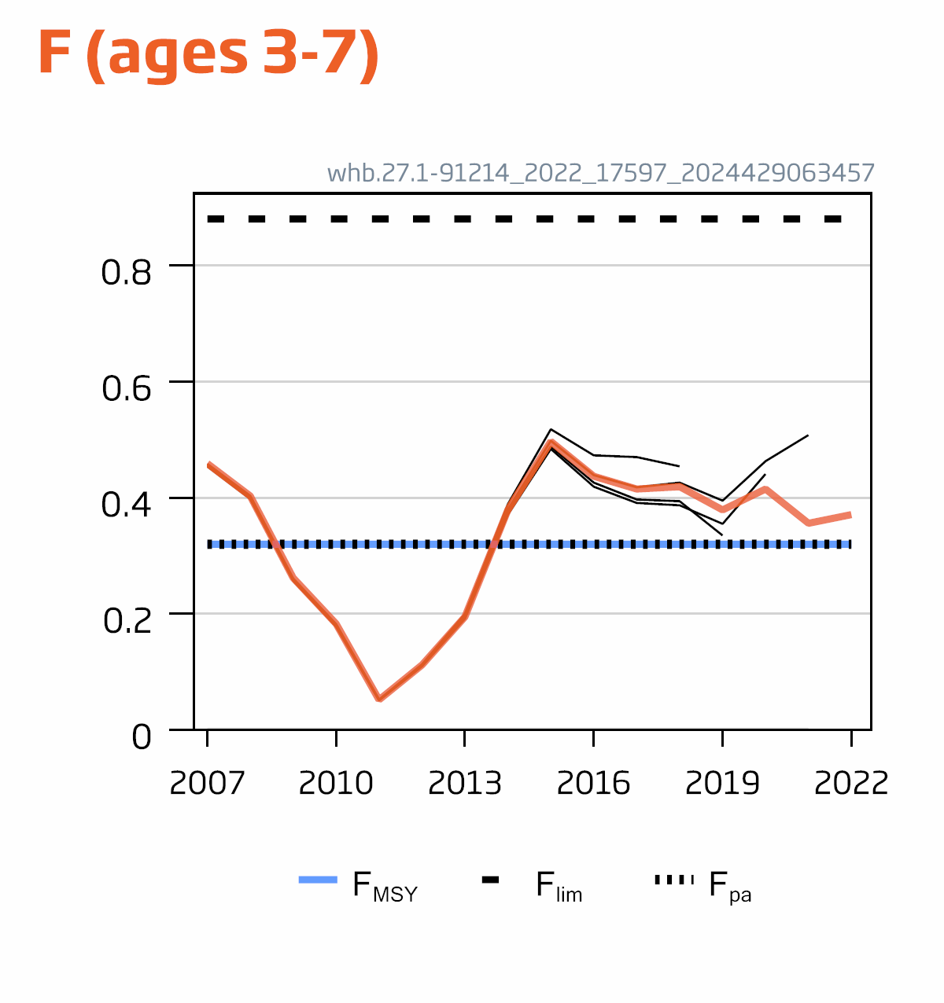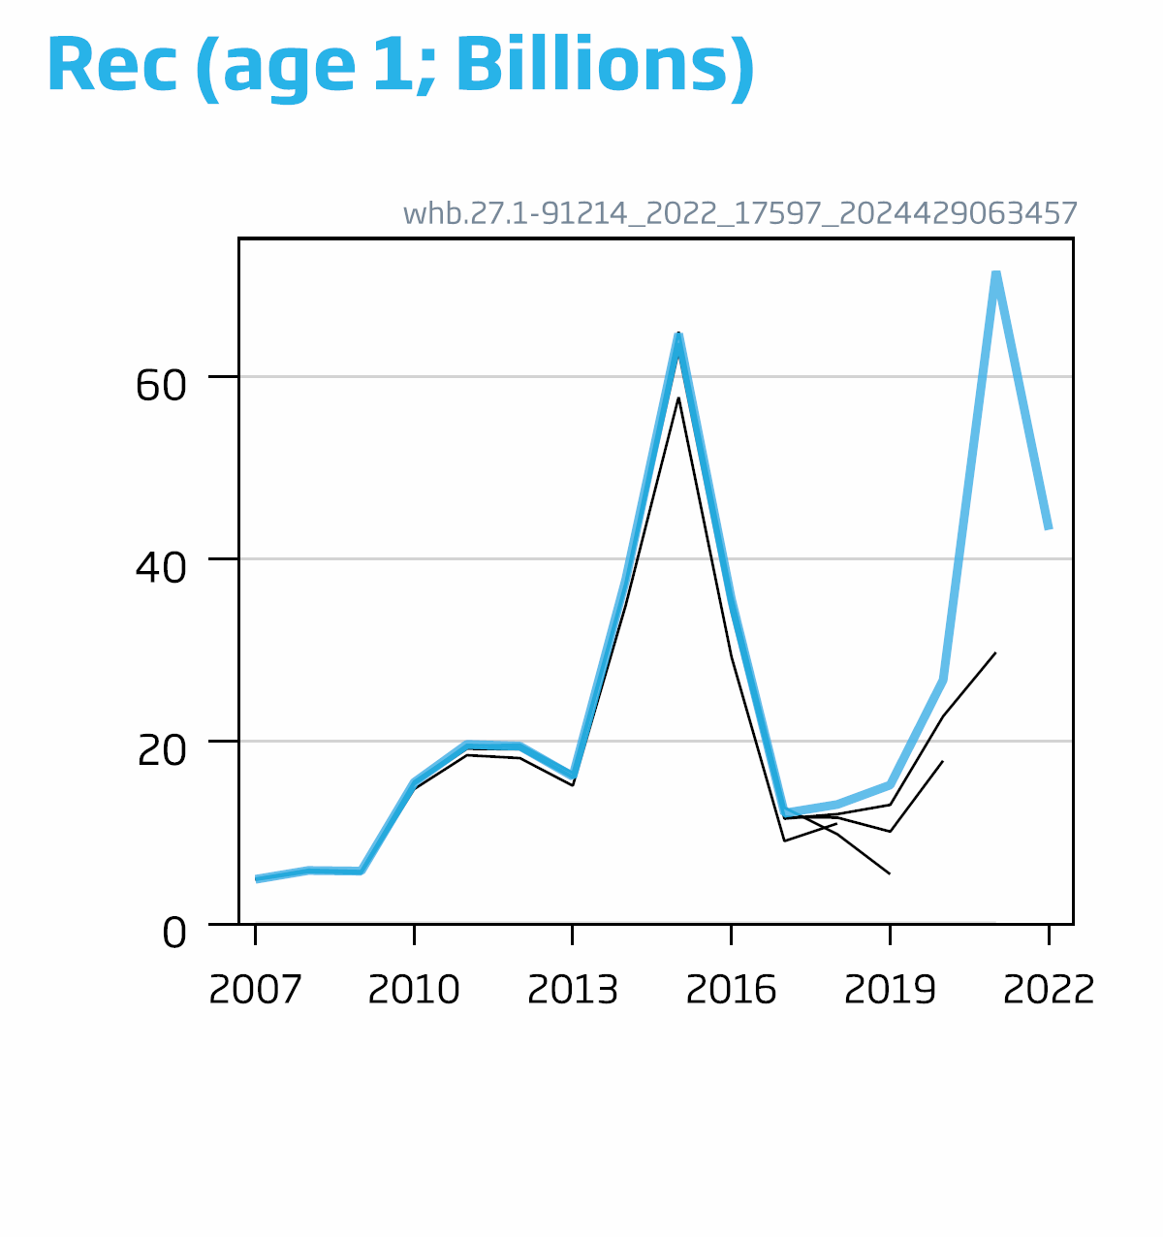

| **Year** | **Recruitment** | **Recruitment** |  | **SSB** | **SSB** |  | **Catches** | **F** | **F** |  |
| --- | --- | --- | --- | --- | --- | --- | --- | --- | --- | --- |
| **Low Recruitment** | **Midpoint Recruitment** | **High Recruitment** | **Low SSB** | **Midpoint** | **High SSB** |  | **Low** | **Midpoint** | **High** |
|  |  |  | **tonnes** | **tonnes** |  | **tonnes** |  |  |  |
| 1981 | 2549746 | 3948198 | 6113656 | 2245456 | 2846036 | 3607250 | 922980 | 0.189 | 0.26 | 0.35 |
| 1982 | 3001694 | 4696698 | 7348843 | 1835126 | 2299742 | 2881988 | 550643 | 0.164 | 0.22 | 0.30 |
| 1983 | 11937083 | 18293953 | 28036056 | 1512075 | 1854216 | 2273776 | 553344 | 0.192 | 0.26 | 0.34 |
| 1984 | 11900836 | 18077398 | 27459608 | 1454927 | 1756125 | 2119676 | 615569 | 0.24 | 0.32 | 0.42 |
| 1985 | 6312234 | 9550303 | 14449447 | 1732609 | 2095632 | 2534718 | 678214 | 0.28 | 0.36 | 0.46 |
| 1986 | 4792760 | 7206799 | 10836753 | 1884455 | 2274475 | 2745217 | 847145 | 0.34 | 0.44 | 0.56 |
| 1987 | 6047121 | 9113538 | 13734894 | 1603976 | 1933155 | 2329890 | 654718 | 0.32 | 0.42 | 0.54 |
| 1988 | 4251396 | 6409993 | 9664593 | 1370653 | 1638205 | 1957983 | 552264 | 0.34 | 0.44 | 0.57 |
| 1989 | 5609692 | 8492388 | 12856438 | 1297863 | 1546404 | 1842541 | 630316 | 0.41 | 0.53 | 0.68 |
| 1990 | 12270809 | 18840757 | 28928337 | 1128145 | 1356528 | 1631147 | 558128 | 0.40 | 0.52 | 0.68 |
| 1991 | 5826489 | 9049081 | 14054068 | 1429325 | 1777830 | 2211309 | 364008 | 0.22 | 0.29 | 0.39 |
| 1992 | 4365051 | 6698667 | 10279865 | 1951887 | 2460102 | 3100643 | 474592 | 0.173 | 0.23 | 0.32 |
| 1993 | 3184796 | 4942776 | 7671146 | 2027313 | 2543671 | 3191545 | 475198 | 0.151 | 0.20 | 0.28 |
| 1994 | 5277115 | 8113390 | 12474069 | 2042807 | 2535468 | 3146943 | 457696 | 0.136 | 0.184 | 0.25 |
| 1995 | 6125353 | 9322644 | 14188844 | 1901995 | 2308211 | 2801183 | 505176 | 0.183 | 0.24 | 0.32 |
| 1996 | 18496998 | 28090039 | 42658289 | 1836837 | 2207682 | 2653398 | 621104 | 0.23 | 0.30 | 0.39 |
| 1997 | 29748090 | 45080996 | 68316864 | 2048273 | 2467358 | 2972189 | 639681 | 0.23 | 0.30 | 0.39 |
| 1998 | 17717886 | 26696161 | 40224044 | 3017327 | 3685247 | 4501018 | 1131955 | 0.31 | 0.41 | 0.52 |
| 1999 | 13419599 | 20303064 | 30717343 | 3630259 | 4449851 | 5454480 | 1261033 | 0.30 | 0.39 | 0.50 |
| 2000 | 26002313 | 39448363 | 59847495 | 3521792 | 4233012 | 5087862 | 1412449 | 0.37 | 0.48 | 0.61 |
| 2001 | 37187292 | 55947436 | 84171646 | 3821738 | 4575712 | 5478433 | 1771805 | 0.36 | 0.47 | 0.60 |
| 2002 | 32631938 | 49106855 | 73899478 | 4504809 | 5401566 | 6476838 | 1556955 | 0.37 | 0.47 | 0.61 |
| 2003 | 35655989 | 52947963 | 78625974 | 5716742 | 6875173 | 8268346 | 2365319 | 0.40 | 0.50 | 0.64 |
| 2004 | 19302031 | 28714768 | 42717673 | 5701925 | 6778079 | 8057341 | 2400795 | 0.43 | 0.54 | 0.68 |
| 2005 | 14998683 | 22271163 | 33069881 | 5083744 | 6031586 | 7156150 | 2018344 | 0.40 | 0.50 | 0.64 |
| 2006 | 6005043 | 9009113 | 13515995 | 4948048 | 5891687 | 7015288 | 1956239 | 0.36 | 0.46 | 0.59 |
| 2007 | 3264414 | 4913368 | 7395256 | 3915203 | 4673775 | 5579322 | 1612269 | 0.36 | 0.46 | 0.59 |
| 2008 | 3862867 | 5883847 | 8962167 | 2971047 | 3593824 | 4347144 | 1251851 | 0.30 | 0.40 | 0.54 |
| 2009 | 3702391 | 5813482 | 9128311 | 2222003 | 2754203 | 3413874 | 634978 | 0.192 | 0.26 | 0.36 |
| 2010 | 10141289 | 15534228 | 23795027 | 2129607 | 2690487 | 3399087 | 539539 | 0.131 | 0.183 | 0.26 |
| 2011 | 12986631 | 19713440 | 29924598 | 2166277 | 2717639 | 3409333 | 103771 | 0.036 | 0.052 | 0.075 |
| 2012 | 13074672 | 19509226 | 29110475 | 2840438 | 3476370 | 4254677 | 375692 | 0.084 | 0.112 | 0.149 |
| 2013 | 10896851 | 16196200 | 24072726 | 3168694 | 3803134 | 4564602 | 613863 | 0.149 | 0.195 | 0.26 |
| 2014 | 25189811 | 37769539 | 56631551 | 3409524 | 4045006 | 4798933 | 1147650 | 0.29 | 0.38 | 0.49 |
| 2015 | 43428474 | 64728113 | 96474232 | 3548784 | 4218197 | 5013883 | 1390656 | 0.39 | 0.50 | 0.64 |
| 2016 | 23913789 | 35567778 | 52901145 | 4114630 | 4974200 | 6013339 | 1180786 | 0.34 | 0.44 | 0.56 |
| 2017 | 8062125 | 12172965 | 18379902 | 5085700 | 6199504 | 7557239 | 1555069 | 0.32 | 0.42 | 0.54 |
| 2018 | 8655930 | 13119298 | 19884169 | 5006887 | 6090429 | 7408460 | 1709856 | 0.32 | 0.42 | 0.55 |
| 2019 | 9638265 | 15254049 | 24141898 | 4319920 | 5284355 | 6464102 | 1512026 | 0.28 | 0.38 | 0.51 |
| 2020 | 16299607 | 26772174 | 43973408 | 3571612 | 4480563 | 5620836 | 1460507 | 0.30 | 0.42 | 0.57 |
| 2021 | 40213851 | 71562826 | 127350103 | 3320100 | 4440379 | 5938666 | 1139531 | 0.24 | 0.36 | 0.52 |
| 2022 | 19011128 | 43220294 | 98257917 | 3341999 | 4955777 | 7348815 | 1107529 | 0.23 | 0.37 | 0.61 |
| 2023 |  |  |  |  | 6621207 |  |  |  |  |  |
| Average | 14213336 | 22097698 | 34672481 | 2961489 | 3693995 | 4443559 | 1031220 | 0.27 | 0.36 | 0.47 |