112 TP Project Proposal

Patrick C (pcosta)

**Project Name:** FitBuilder

**Description:** FitBuilder is an interactive application that utilizes web scraping to allow users to build an outfit (top, bottoms/pants, and shoes) based on an input color selection for each category. After creating a unique outfit based on their personal tastes, FitBuilder then analyzes each clothing piece and determines if they are fashionable at a fundamental level. In the context of FitBuilder, this means looking at the colors of each piece and predicting if they would ‘work well together.’

**Competitive Analysis:** The main competitor(s) to this application could likely be image analyzers or social media platforms. While both applications/platforms give users the opportunity to hear feedback about outfits they have created or colors they input, I have yet to see a package that combines aspects of the two platforms into one experience.

**Structural Plan:** The finalized product will most likely be made of a main python file, as well as the requirement that Google Chrome be installed on the user’s computer. Within the python file, the program is split into two distinct parts: The main helper functions and the main app class.

**Algorithmic Plan:** Algorithmically speaking, the initial most difficult part of the project is getting the program to accurately find and display all clothing pieces from a user’s color input. To accomplish this, I will use BeautifulSoup to web scrape site(s) that provide good information about a wide range of clothing. After gathering the data, I will then create a series of dictionaries to accurately map clothing to color subcategories. Ultimately, the program will display clothing based on what is found within the specific dictionary. The next hardest part of the program is having it determine what an outfit with good fundamental color coordination looks like. To accomplish this, I will use PIL to find all unique colors within a given clothing piece image. Then, by comparing the colors between each of the clothing pieces, I can ultimately determine what counts as a ‘fashionable outfit’ (and conversely, what does not).

**Timeline:**

* Goal 1 (to be completed by TP0): Web scraping and dictionary creation, basic terminal-based UI
* Goal 2 (to be completed by TP1): Full, interactable program UI with a basic outfit coordination evaluation feature
* Goal 3 (to be completed by TP2): Program ability to determine if a user-created outfit is fashionable at a fundamental color-based level (MVP)

**Version Control:** Program backup is done through Google Drive, with each version of FitBuilder numbered accordingly.

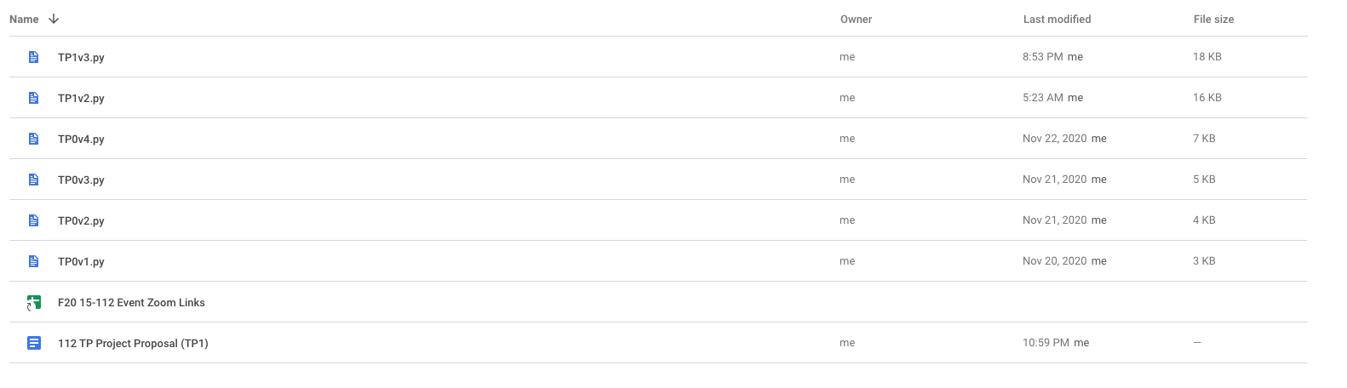

**Module List:**

* BeautifulSoup
* Selenium
* Requests

**TP2 Update:** Made a slight modification to the harshness of the component of the program which determines if something is ‘fashionable.’ Mainly focusing on complementary colors, the program uses a recommended complement percentage to determine if something has colors that work well enough together. The idea of ‘well enough’ is something largely up to interpretation, though.

**TP3 Update:** Included the ability to determine if an outfit has adjacent colors as well, broadening the range of outfits that are considered to have good compatibility.