HAS AND HAVE EN TERCERA PERSONA SINGULAR
El Have se utiliza para hablar de posesiones cuando algo te pertenece.
Para uso de la tercera persona del singular
Solo se utiliza la conversión del verbo Have a Has para oraciones afirmativas, debido que para hacer preguntas o negaciones el verbo vuelve a su estado base que es Have
Para los pronombres del auxiliar do I,YOU,THEY, WE
Oraciones afirmativas:
Sujeto + verbo + complemento
- He has a dog.
Oraciones negativas
La parte negativa es doesn’t o don’t dependiento de los pronombres
Sujeto + negative + verbo + complemento
- She doesn’t have a cat
Preguntas:
El auxiliar es does o do
Auxiliar + Sujeto + verbo + complemento + ?
- Does she have a cat ?
  - Yes, She does.
  - No, She doesn’t

CAN’T O CANNOT
Se utiliza para negar capacidad, permiso, posibilidad o habilidades. Se utiliza con todos los pronombres
SUJETO + CAN’T + VERBO + COMPLEMENTO.
I can sing She can dance
I can’t sing She cant’t dance
I cannot sing She cannot dance

CAN
Se utiliza para habilidades, para hablar de permisos y para algo que puede ser cierto a veces. Tambien lo usamos para esas habilidades y a esos verbos de percepción
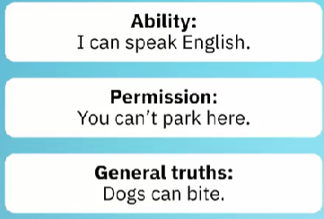
ORACIONES AFIRMATIVAS
Sujeto + Can + verbo + complemento.
I can dance.
He can dance.
PREGUNTAS
CAN + SUJETO + VERBO + COMPLEMENTO?
POSIBLES REPUESTAS CORTAS
YES, Sujeto + Can
No+ Subjeto + Can’t
Ejemplos
- Can we swin?
  - Yes, We can.
  - No, we can’t / Cannot

Cuándo usar in, on, at para tiempo

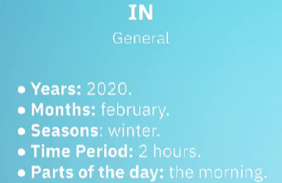
What does in express?
- General periods like years and months. Example: “The pandemic was in 2020.” “My birthday is in February.”
- Seasons as general time frames. Example: “Christmas is in winter.”
- Time periods that last a duration. Example: “My class starts in two hours.”
- Parts of the day in general use. Example: “I have breakfast in the morning.”

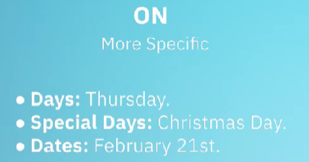
When do we use on?
- Days of the week. Example: “My class is on Thursday.”
- Special days that are unique. Example: “I see my family on Christmas Day.”
- Specific dates with the full date. Example: “My birthday is on February 21st.”

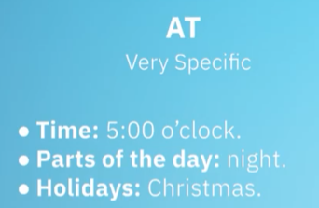
When is at correct?
- Exact clock times. Example: “My appointment is at 5:00 PM.”
- Specific parts of the day. Example: “At night,” “at midnight,” “at noon.”
- Holidays as a period vs a day. Example: “I visit my family at Christmas.” But “I visit my family on Christmas Day.”

Reglas para convertir verbos de sigulares a plural

Verbos terminados en F o FE se le agrega la VES
SINGULAR | PLURAL
Knife | Knives
Life | Lives
Wife | Wives
Leaf | Leaves
Wolf | Wolves
Verbos terminados en Y pero antes tienen una consonante se elimina la Y y se le agrega IES
Singular | Plural
City | Cities
Baby | Babies
Story | Stories
Country | Countries
Party | Parties
Verbos teminados en O pero tienen una consonante, se les agrega la ES
Singular | Plural
Potato | Potatoes
Tomato | Tomatoes
Hero | Heroes
Echo | Echoes
Torpedo | Torpedoes
Para aquellas palabras terminadas en S, CH, SH, X, Z se agrega la ES
Singular | Plural
Bus | Buses
Match | Matches
Box | Boxes
Quiz | Quizzes
Dish | Dishes
Para aquellos verbos culminados en US se remplaza por I
Singular | Plural
Fungus | Fungi
Nucleus | Nuclei
Cactus | Cacti
Alumnus | Alumni
Syllabus | Syllabi

Los verbos que no cumplen las reglas anteriores simplemente se les agrega una S al final

Irregulars nouns (Change completely)
Singular | Plural
Man | Men
Woman | Women
Child | Children
Tooth | Teeth
Foot | Feet
Mouse | Mice
Person | People
Irregulars nouns (No Change)
Singular | Plural
Sheep | Sheep
Deer | Deer
Fish | Fish
Series | Series
 | News

USO DEL AND
Lo utilizamos para conectar palabras y oraciones
Ejemplo conectando palabras
- I like apples and oranges
- She is tall and Smart
- The car is big and fast
Ejemplos conectando oraciones
- I like apples and you like oranges
- She is tall and you are smart
- The car is big and the bike is fast

