

Sistema de nfonmac 6n y Segu miento de Obras y Contratos de Supervision

4/20/2017

i i i

SISOCS

V.2. 0 MANUAL DE USUARIOCIUDADANO

SistemadeInformación y Seguimiento deObrasy Contratos de Supervisi ón

TABLA DE CONTENIDO

1. INTRODUCTION ............................ . ............................... . ............................... . ............. . 3

2. CITIZEN INFORMATION MODULE ......................... . ............................... . ..... 4

2.1 Search Methods ......................... . ............................... . ............................. . 4

2.2 Entry into technical prefix and data sheet ......................... . ............................... . 6 sections of the Technical Prefija: ......................... . ............................... . .................. . 6 access to the data sheet ......................... . ............................... . ............................... . . 8

3. ANNEX. Description of the information to be disclosed ............................ . ... 11

**1. INTRODUCCIÓN**

The System of Information and Monitoring of Works and Oversight Contracts "SISOCS" is the tool created by Executive Decree PCM 02-2015, through which relevant information on the planning, procurement, contracting and implementation of public infrastructure projects.

SiSOCS has been created as a procurement system subsystemcofthe "HonduCompras" State and is progressively applicable to all public institutions that contract execution of works and supervisory services.

This manual corresponds to version 2.0 of the SISOCS that has been adapted to disseminate information on all types of publiccinfrastructureprojects, following the Data Standard of the Transparency Initiative in the Construction Sector-CoST (See Annex 1).

In this way, through SISOCS, the entire life cycle of public infrastructure projects can be tracked from start to satisfaction, including construction maintenance projects.

The summary information is by project, regardless of the number of contracts that have the same. The detailed information for each of the contracts is then displayed for either the design, supervision or execution of works or contracts that include more than one function and so-called "turnkey".

The SISOCS presents the information of each contract ordered by bullets containing basic information sheets required by the CoST Infrastructure Data Standard, as well as all supporting documentation that can be viewed and downloaded from the system at the convenience of users.

At the same time, you have access to reports automatically generated by SISOCS and the database that can be downloaded in open data format so that citizens can perform their own analyses and the reports they want to generate during their audit processes Social.

In this way, SISOCS promotes innovation and technology, transparency, accountability and citizen participation, values on which the Alliance for The Open Government is based, while facilitating the implementation of CoST's three core processes: disclosure, assurance and citizen accountability demand (social audit).

**2.** **MODUL**O**DE**   **INFORMACIÓN**   **CIUDADANA**

The citizen information module is where the general public can consult and download information on public infrastructure projects managed by the various institutions that are in charge of them. To enter the system you must open a

Internet browser like Firefox or Chrome and type the following address: sisocs.org.

2.1SEARCH METHODS

Modulo dl ntormadon Citizen

To enter the citizen module you must click on the button

....

SI q,cs Ima,

. , . , , . , . , , . , , . , , . , , . , , . , , . , , . , , . , , . , , . , , . , , . , , . , , . , , . , , . , , . , , . , , . , , . , , . , , . , , . , , . , , . , , . , , . , , . , , . , . , , . , . , , . , , . , , . , , . , , . , , . , , . , , . , , . , , . , , . , , . , , . , , . , , . , , . , , . , , . , , . , , . , , . , , . , , . , , . , , . , , . , , . , , . , , . , , . , , . , , . , ,

Modulo de lnformaonCiudadana

CONTRATO DE CONSTRUCTIONN Y SUPERVISION DE LA CARRE TERA VILLA DE SANANTONIO - GOASCORAN, SECCIO N I, constructionnysuperv1siondelacarreterav1llad,lr

aprheard

SISOCS

Sistema de lnformaci6n and Seguimiento de Obras and Contracts de

Supervision

SISOCS es un aa herramienta medrarne la a ll le pubnca y d1funde mformaaon relevante dee the processs de construction6n. s sucervrsren y mantenmuentc de la dd d vial oliciat del pais. c;iesbonados par la [)lrecci6n General decarreterasyelFondoVial

Med1ante ll SISOCS. cans vrsuanzar avances nsrccs y anancercs de theworks . tamcren obbenes un resumencon mscrmacen basrca deIa plamticaa6ndelproyecto las prccesos de adqurstccn . lagesbonde contracts, Iotas, and umcaoon geografica de thes projects Tammen cansdescargarmformaa6n publlca

El SlSOCS es de faol ingreso  *y*  consulta pero sr necesnas ayuda cans downloadr el a Manual Operabvo curer que a pass o a paso a o en e er uso oetrmsmo

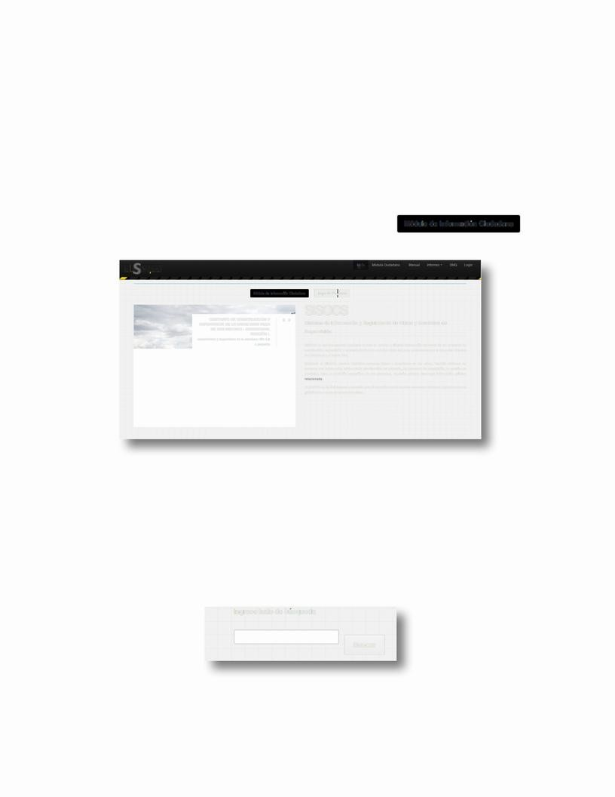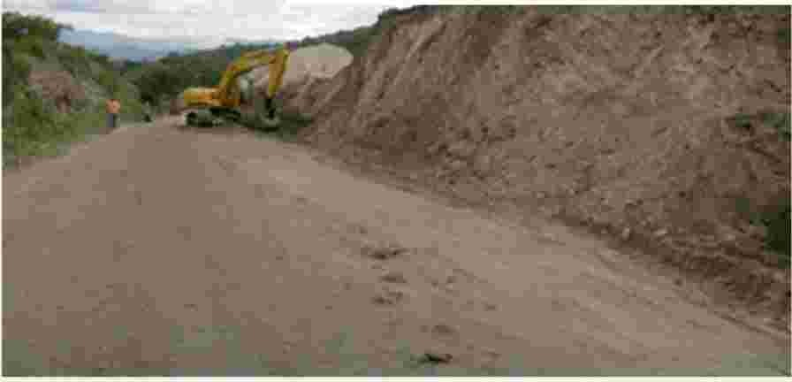

*SISOCS home screen.*

There are two ways to search for projects:

• **Text search:** Projects can be searched by entering the name of the

department, name of the responsible official, name of the project, etc. in

the following box:

lngrese texto de busqueda

Bu scar

*Text search section.*

4

Then click the **Search button.**

• **Map search:** Click on the point on the map of the department from which

you want to consult existing projects.

Yes,I o.. cs M<rl<oQ

�

ProyeclosReg1slrados

HagachcenlassecCmnesdela1Magen Forv1supahzarlosprOyectoslcx:aHzados InThedepanamenlYou

· �?

,

•

To

Ⅰ

*Search section by map.*

In both search methods the result will be an array like the one shown in

the following image:

S-I

-Q,CS--------------------------------· --�--------

Lista de Proyectos

Francisco Morazan

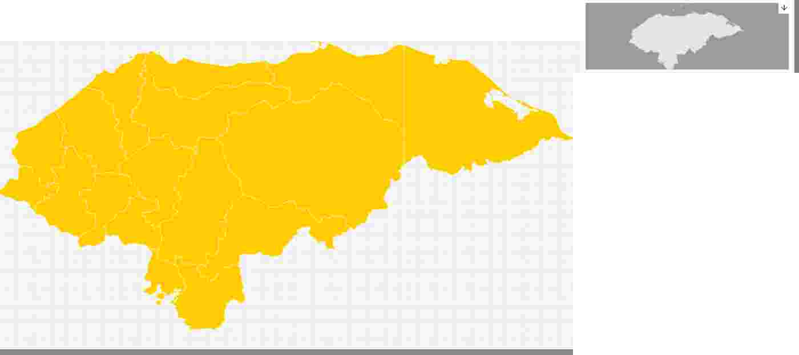

n•t1Co< o.m,,oa....,o• p_,_,,_ .. -oe<s... - ,..,. .,.,. •.., ,,,..,..,. . ... . , •..,,,. •.,.,Pu.. -.eJt.ocrio.co.<<>tl<"'""""""

<Rflllleplu,,olrefuono<lelpa,..,.,,. o or.. .o:<r>""'"Wh<eT'"""IY,....."""""",.....,.,">n,cncr..,hodf..,.« >

COMtru«onyfltol,•,er,:,,c..,,,ei LLtr.,,_oc.,a.,z.,,,,.. nor G"""'!>"- ! ll'n>;ffloconw.eenlo oca,oe19km<muna>Upffl><,e<len:doalrocmdtr...,,_o"4)erll<,oj.. a>.,_rr...,w""ncrn,ybosletrtun1d•<0e20cm,,onun

..:l>O<IO<""""""""S-Omv«>"07Smde-on....,.,._C_...,. . . . q,eoo'*'•P! IOPo<n.....,,.,.,cw,.,,..,.. q,e . . ,...-e1e:n.o,"""""""""'"""''''''Q,...,,..

-<lel!o:uolo .. . r,tOloP-....-<"""llNC<O>l'"'<t>=-=-•lo""'""dllldelo""""°"""""'"""°"""«•-l'lon•eo•-...,•"""'""-""b'"""""''"""' r,tOloP-....-<""llNC<O>l'"'<t>----•lo"""dllldelo""""""""""""""""""""""""""-"-•-l'lon•eo•-...,•""""""""""""""""""""""""""""""""""""""""""""""""-i-ln•eo•-...,""""""""""b'"""""""""""""""""""""""""""""""""""""""""""""""""""""""""""""""""-""""""-""""-"-"-"-"-"-i•-...,•"""""""""""""""""""""""""""""""""""""""""""""""""""""""""""

Est-<JeHDndJr&.e>erno.,.ct>odoe,.,,,,.,oentldeoetoN-l-oNo:IOS-2010y0182011! Lcor.-,ecr.-<10por•m<1m•rv-orb"' r<<><scu.ente<M<1<>nrlo

_.,..,,.aioro....,,_o_,.cr --pr-oeo,..,.. 0;ou-•lo"-".. , ,,.to."""""""""" •p,-><l<>-M•cone<prcpl,sm<>o<t,,,,....,.i.c....,,.. <>o occ-. . . .,.,.... ,. . oc,,eO<a! O'l"'"".,""""'o"" . . "'"""oncnoi.CA-6m..,.•e<use,o,:ro,_.,.... oc,,e10s ........ u'**'Oed<,..,. ,. . .,.,"'"1<r'""""""''oei. oconom,o.<n,dto<>oi.! bcocoonOelo "o"""'".. r"'mrl

D'.ll./ /2015 "llKft'OCONMUCLA.o.sl'AlJl:ArnLOSPFll'DIO!',Dl'lAfUBUAMREAICIN!:tJR. [Nfl flPIDYKTOCOl.f>ISHfNELMCHfOCONMUClASfAlJICA. A ! NlOSPR[OIOSOELARJHtlA-EANON!:tJRE. fNflMl.fjl:. IOOUOtsrRIIOCENTIW,rnHDl'PAATAMrnlO MUNIC•ODELOtsrRITOCENTRAEN[lDl'PAATAM! N"lODl'fRM<CISCOMOIIAZAN" Dl'flWfCISCOM� ,[NTFll'SUSP •Ales.OC11.. . ;. r.O[S[SW< l)! XCAVAC0 N Ol'eACHE(NWJY!:TRAl . COR',[)(Av.oclO+l.wr.t.000EWJ! Rlll

! D8RONTEIZ)51JMINtsrROlCOI.OCACIONDl'MUCLA"5fAlJICA.. llAUl'RfOM[l!:lAASfAlJICA..

010/ T l201S :...:'m:MUNl:l'IO -Ll: ooDNc:1 0 : FA 'OOA : ::--:i::: s;:,...-M-E: ::7-o-,:;:::: ::) SB.lAOODl'JUITTAS. Ⅰ.. WNOICIOtlAMl:>llODl'POi! DS91MOVI. IIACIOtlDl'fQU.lf'OlOILPIEZAflNALll OOl'llODl'LPFO'IKlO

"!! Kft'OCONMUCLA.o.sl'AlJl:HNB. TR. OMOfNTRIUIAAlAALDl'AOET.&. MAR.II. MSTAl70 UPFD'r'KlOCOUS6T! ENH. "!! Kft'OCONMUCLA.o.sl'AlJl:HNTHETRAMOENTRAOAAlAALDl'AOET.&. MAR.II. MSTAl70METFDSRllHDl'l'DACIJDO. OISP.. MElltOS.iNTESOEI.. OESV, 0ACIJDO. Or! SPllill.MlfjlC•IOOELOISTRIIOC(NTRAl,. ENEL MlfjlC•IOOELOtsrRIIOC[NTRAl,.! N[LOEPllRTAMENlOO[fltll'l;ISCOMORlllH"[IITRESUSACTJVO,. O[SfSl.lNliEXCAVACIOIOE&ACft'INQ. UY-MloR(A.00,TRAZAOO

Dl'FAATAMENTOOEfRANCISCCMOAAZA/r OOF!iA00,UCAYACo0N DO;i.. OOOEMAT6t-ll BRONTEZIMUClA.o.YALll:AJIACAl'RE00EMEZCLAAYALTICA "EMPrn'lA. OODl'CAlll5ENELCASCOU'l! The. IIOEN! LMUNICl'IOC(WIJU-VIOEOJO.llNA. , flPFOl'EC10CON>ISUENEl0EMPEO'lA. OODl'CAllfiENUCASCOU'l! The. IIOENELMUNICl'IODEWIJU-VIOEOJO.llNA.,rnElDEPAATAMEN"lODl'IAA ISCOMORAZAN"E!

In! lDl'PARTAMENTOOf,IW-ICISCCMOR.ll.t.N" SIJSPRtlCJPAl.lSACTMOAOl'SESflhllll,l,,Z.,U)()YW.. RCADOl! XUVJ. Co0NOEW.. L! Ri,OI.C Lfll!IOTADODl'W.. TUIIAL•CONfO<IW.. CIONOESIJ!11,t.,;f,NT! S SIJMfilSTflOYCOIDCACo0NOEMATEl'IIALSflECTOR .. ISt""'6fMPEORADOCONPl[01-AlALlA()O. (.. ISem17IIOR0l.U) OfCOffCR[lOOEIS•ISe,,,1l. W

Cllf «- IS "PWIMENT,O::iONC CONCFtflOIIORWLICODl'lASEWNO,. INTII0.0.0.fRENT! Alllo. Ftl! IOlA ELPFOYEClOOONSISTlENLAPAVIMENf,0::()NCONCONCRUO RAULICODI' lASEWNO,. ENTMOAfRENTEAlllo. RFtlllAMOFlfRA.,! NElML.fll:•()Dl'lAVENTA.,ENEL

MOFll'AaENELMuNl'.l'IODELavInTa.ENHoePARTAM[NtOOffRNIC5'.'. 0MOR.lllAN" OfF,,,RTAMENToOfF! WICISCOMOR.lllANfNTRESUSPl! INCl'Al5-'CTMDO.. Dl'Sf,ITRAUOOYWJlCAOOCONTHIUI02EJ/AVAf.o0NTFOl(W.. T! R-llCOMUNII AC-EOOEW.. TER-ll(O!. Sp!IIX(lf•SU! SASEOEWJERlllS6.KIOS,O::ARllfOOEW.. TERllt.OESU!e.osl6.CONfORMACo0NYCOMPO.CTAf.o0NOESIJ9Slst:TUV.. Or!. WithcReLO�RAUU:O•OOOPs.eoa, ..... (tlCL\MCDIITE,Ct.f'AOOYSEllAOOOEJl.l'fTA5jl.J.ClROOfFll'fUERZOGAAOONTEltN•ZIO�CM. Z.9SELlAOOOfJL.fllAS.10

. �::�?.; ;:_�;;;;;; •:; ,::�:�::; :

WFOIUOOECOr.lCFll'TOllMOVLllACo0NOEfQUl'OIZLIMPUADl'FtKICIDEV. HROrULOOH. PFtOl'ECTO

Ol CU l /2011 : The L:[-.::cTO?w AH-

*Citizen module search results matrix.*

5

2.2ENTRY TO TECHNICAL DATA SHEET AND DATA SHEET

After carrying out the search for the citizen module you can consult

the detail of the project of interest by clicking on the button

Ver 1nformac1on detallada , lo que conduce

to the Technical Prefija screen like the one shown in the following image:

SI. ocs

"""'""""""'"""'"""'"""'"""'"""'"""'"""'"""'"""'"""'""""""'"""'"""'"""'""""""'""""""'""""""'

Codogo: DGC-DC- Project: Construction and Pavingn del ucramiento Carretera Zamorano- Guonope

063-2015

Dncripcion

EIProye<:IOcor• la. PJ. nti.a6ndf.2ikmc:onUMsupe-.rficlederodJ.durac:ondob1en r10su- rflcw. su:b gr.n.lWde15ansyhi.se-trr.ur de

20ans.. conunar, chodecaluda.de5.50mycon0. 75mdehoni>tosaambosladosCabedaucatquer. o lll ipagoporW'ICie-l'IYUUiCIOne v.mque ambto e ado-.ieda.1e-.rre.nosquesonpropertydeb. la.J.4ric::cb. P .ncana. ftlC.estaJ1doconSC1Errla. } au'Ondaddelamsmadelaneoe-Sldaddee ca.ril«>. JanrandJ.ladoun.. peffl"ll1adebs1e-rr1-rmcon•IC. mdodeHonduras,S1E-ndo.prob.do.tmtSmO• e-ldeae10 sb.woNor ZOS-2010y02S-2012 Elambtose- origNpati.tneJl)l'a.rysoh,e.. nta. rloa. s msigwe-.n1's:"''parb.s.e:gurlciad. orde.fWT'll-.nJOsedONl,sotverwproble.ma.sdedre-na.ie. aoooe-so•la. Alc:1JicaM:I. er.ma.ndadeb.poblaa6nbe.nelic:wia.cone-Jprop6s110dedl51T1111Ull'la.tan:idadde .n.rsde1ri.ns.'l>q1>eoeaSJOnanene5r10decfse<X:IconOnla.c.A-8. mE-JOfM•Jusoya n10qwebsusumostwindedlcucme1e-raymept n»dela.e<:onomia. ,e .r.51ildela.ubtcl.oondela.economia form. I

EnteResponuble:

Prop6sito:

FK dea c.ion: Pru stoen4>s� 5,4')(),00J J

...........,,.,.,,...O.iStriBucion de Amounts

\

�������������

Contrator DGC-DC.001.063-2015

241-04.324. 9.S

3,494,87224

Artay{(Spe-.l'V'.. sionJ?>O(rnomo_aau-a!) =>24804324. 9S

(mor1e1_onguwj:>24CD432USicfmc,rX>] "'>Ofdpli-:oJ->}

Art.1y(S11pervtS10nj->l(mon::,_.1Clll.1l)->34Q4S7226 {

•fT'IOf'"_ongma.1] •>3494-Sn24(<f.roon"J-> ODl52tt.51&4(<fplm>]->)

lndic.adorudedesempeOO

11. 76

Contrator If DGC-DC.002.063-2015

ucnaa6nPubk.JN.10or Li>rH11E"nDCarreie. 1.1b.rnor.1.n0-Gwnopecon111t.. 1 ContestPrMdopar.1ta.SU'pefY™Ondeta.CorSlfUOCll)nyP.1wner11oCIOndel

Lor Aj)rolclrrwi.de2,gKiometros,bc.bdoand E-IOE- r»de l.h.1.Jl'IIE-r»<:me»r.1h.mor.1.!'. 0· Gwnopeconun.. lorg Aptoxurwf.tde2. Q

ancrsool.brcin l<i6me-:ros. crazy. JJz.adoeneJOE-paname.n»deFtanc:tSOOl.btcin

Pawnert.1000 of2.. 9kmsc:on11r,.a.superb-de-rocf.actur.1condoU".a.IDM-nD S1Ipe deli.p.. 1.V!l'l'ler de29kmscon11.n.a.wpelic:ledandrod.1dur.1con

supe,rfcal,,subba.sec.ra. n de15cmsyba.x- ilda.de20cms,c:onunanci"Odoble-;ra1a. JTUEr'supe.rflClalsubba.segr U:WdE15cmsyba. bedad eZD

it's over. Jde5 011'11Syc:on 75m1Sde shoulders.1a.nibosta.dos

.con .1.NnC>decabd..de5.50rmycon075rmdehombros.1ambos

Ofe nt. : ETERNA, SA

Montoen lpslps. 24.&04324� Avance Prog1.Jma:do: 96.48%

Montoenl0ps. 3,4''J4. S7224 IAont0oenUSO 153,321.53

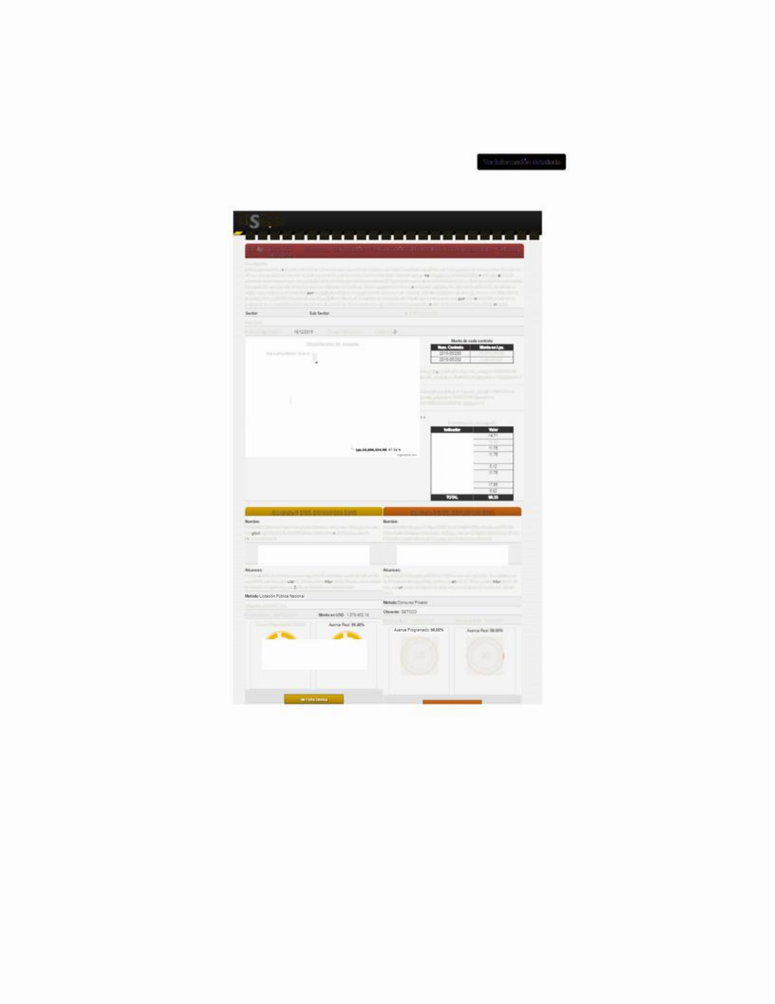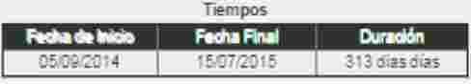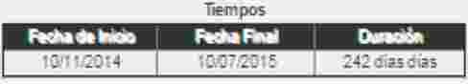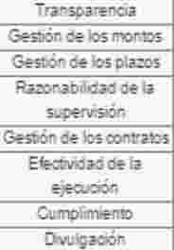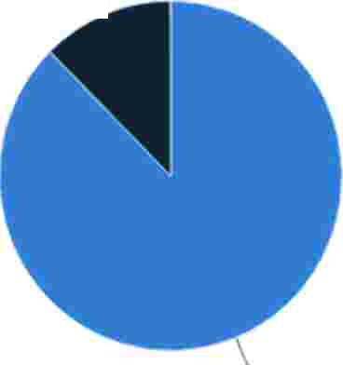

*Citizen module data pre-data sheet*

SECTIONS OF THE PRE-TECHNICAL DATA:

**:** Project section : This screen identifies the project code and name, the distribution chart of contract amounts identified by their number, and a performance table of the indicators.

-·... ,-'---------------------

**Sl<"iOCS**

**Code:**   **PMR-453**   **Project:**   **WORKS**  **DE**   **REPARACION**   **D**E**THE**    **FALLTO**   **CHANCAYA,**   **CARRETERA**   **SANTA**

**RITA**   **-**   **YORO;** **DEPARTAMENTOR**    **YORO**

Descripcion:

WORKS DE REPARACION DE LA FALLA CHANCAYA: FALLA N. -1 69+500, FALLTO N. -2 70+160, FALLA N. -3 70+550, FTOLLTO N. -4 70+810, ASENTAMIENTO CALZADA 72+195,COMPONENTE DE DRENAJE VIAL, COMP ONENTE VIAL, COMPONENTE SENALIZACION VIAL

Sector: Yourb Sector: Ente Responsable: Prop6sito:

Fecha de approving: 1 2/02/2013 Prespuesto en Lps. : 94,600,000. 00

Distributionof amounts Amount de cadto contract

( Lps. 8.416,875. 69: 8. 54 %

2014-01/0000000222

2014-02/0000000225

8,416,875. 69

90, 144,555. 45

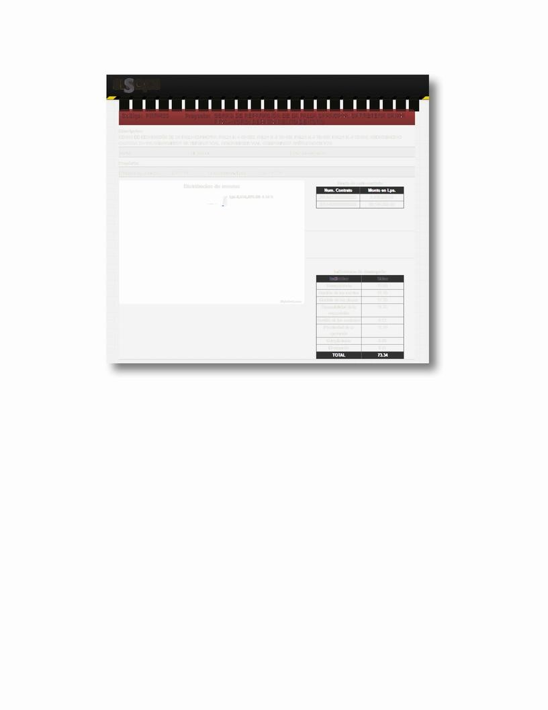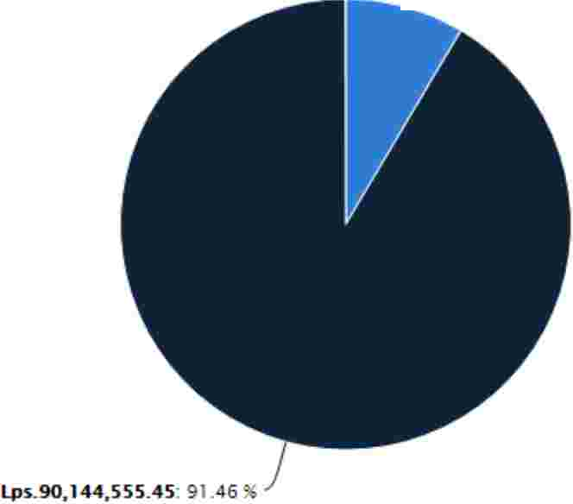

lndicadores de desempeiio

|  |  |  |
| --- | --- | --- |
|  | **lndlcadOI'**  Transparencia | **v.iOI'**  17. 65 |
| Gesti6n de los montos | 11. 76 |
| **H19hchutscam** | Gesti6n de los plazos | 11. 76 |
|  | Razonabilidad de la  **supervisi6n** | 11. 76 |
|  | Gesti6n de lo'scontracts | 0. 12 |
|  | Efectividad de la  **ejecuci6n** | 11. 76 |
|  | Cumplimiento | 0. 00 |
|  | Divulgac ion | 8. 51 |

*Pre-projects section – data sheet.*

**Performance Indicators:**

|  |  |  |  |
| --- | --- | --- | --- |
| **No** | **Indicator** | **Weight** | **Description** |
| **1** | **Management of the** | **17.65** | **Competitiveness level of the method used** |
| **Acquisition** | **for the procurement process** |
| **2** | **Management of** | **11.76** | **Percentage ofincremein the amount of**  **Project** |
| **Amounts** |
| **3** | **Managingdeadlines** | **11.76** | **The number of months increasing in the**  **contract signed** |
| **4** | **Reasonability of the**  **Supervision** | **5.90** | **Percentage ratio between contract amount**  **executor and supervisorr** |
|
| **5** | **Management of** | **11.76** | **Percentage ratio of the expansion of**  **executor and supervisor contracts** |
| **Contracts** |
| **6** | **Efficiency in** | **11.76** | **Difference between programmed physical advancement and**  **real progress** |
| **Execution** |

|  |  |  |  |
| --- | --- | --- | --- |
| **7** | **Priority note** | **17.65** | **Term of the Priority Note extended by**  **SEFIN** |
| **8** | **Disclosure** | **11.76** | **Percentage of disclosure of information**  **every phase of a project management cycle** |
|  | **Total** | **100** |  |

**Contract section:**  Followed by the project section are listed the different contracts of the same, identified by the number and name of the contract. In this section you have a look at the start dates, end date, duration of the contract,

scopes, amounts, and graphs that show the scheduled and actual progress.

**Contrato** s   **DGC-020-UEBM-2011**  **Contrator**  **LPI**  **-**  **DGC**  **-**  **001**  **-**  **UEBM**  **-**  **2012**

**Nombre:**  **Nombre:**

CONCURSO OE SERVICIOS OE CONSULTORIA PARA EL ESTUOIO Y OBRAS DE REP ARACION OE LA FALLA CHANCAYA, CARRETERA SANTA OISENO Y POSTERIOR SU PERVISION DE LAS OBRAS DE REPARACION OE RITA - YORO; OEPARTAMENTO DE YORO

THE FALLA OE CHANCAYA, OREPTO OE IR

**rwt11:**  **;** **.**

**Times**

**Fecha**  **Fmal**  **Cmicidn**

**rmMl:i**

**Tiempos**

**Fecha**  **Final**  **Cmicidn**

11106/2012 1

08/03/2014

I 635dias�

**Scopes:**

2210512013 1

22/02/2014

I 276dias�

**Alcances:**   **El**   **contrato**   **consiste**   **en**   **la**   **reparaci6n**   **d**e**e**   **las**   **fall** **as**   **ubieverys**   **en**   **los**   **KM**   **69+500,**  ESTUDIO O IISENO AND SUPERV ISION DE LAS OBRAS DE REPARACION DE LA 70+160, 70+550 and 70+810. Adere nas, los trabajos e reparaci6o tambi en incluyen FALLA DE CHANCAYA ENLA CARRETERA SANTA R ITA-YORO el mejoramiento si ignificativo del com ponente vial desde ll KM 69+310 untila ll

KM 72+195.

**Method:Concurso**  **Publico**  **Internacional**

Bidder: EUROESTUOIOS

Monto en Lps. 8,416,875. 69 Monto en USO 391,482. 59

**Avance**  **Programado:**  **82.** **16%**  **Avance**  **Real:**  **0.** **00%%**

**Method:Licitaci6n**  **PUblica**  **Internacional**

Bidder:: SERMACO

Monto en Lps. 90, 144,555. 45 Monto en USO 4, 192,770. 00

**Ver**  **F1cha**  **Tecmca**

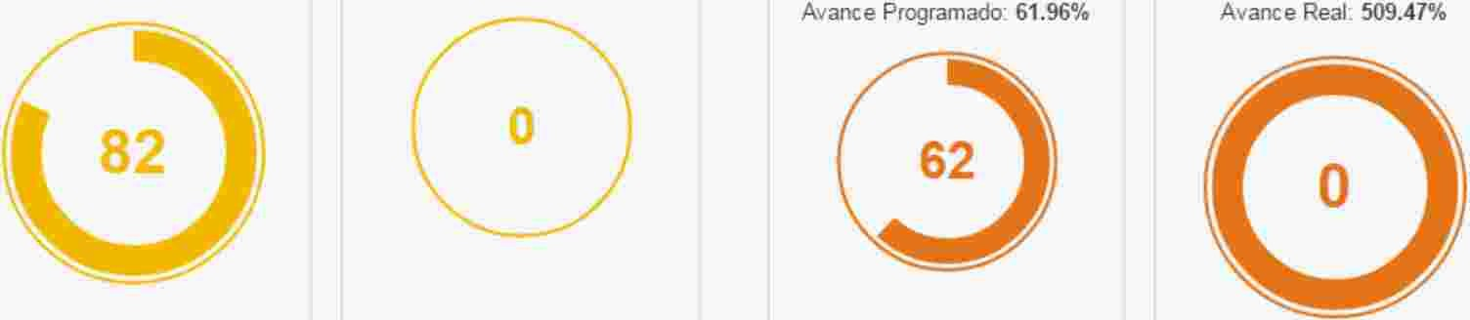

*Pre-contract section – data sheet.*

ACCESS TO THE TECHNICALTABCNICA

Access to the data sheet is done by pressing the button

of the contract to be consulted.

**Yes,I**   **o..** **cs**  Mooooo-

������������������������������������������

Lista de Proyectos

Francisco Morazan

n eocct""ur0Quot-,•P...,n1<COl! S,... S,.. hoo• CoiO.,.noP,r.,,. , P-,1 ,..,.,.va,1eoeA.,.. e,en,.,,,Olec-"Pu...._eR.oCl,c,1.Co,co'><.a:onoe

"*""""p...,,a( ,........,.,ooeto•.. --oeo:.,.en11econWMeToi,p,n••-"-""""oconc,:,1c,..,ho<t"...,.co

Ccn,n,c:cO,,sP•...--1eo6noetLOom,e,ooC••01er1Zomorano G.-.o<)and EcPro;eacconsaeenll_..,...... oco6nOe29!mcc,,one.....,_,eCler'*"-'<1<ondotiiett"-...,...... O--,flc"(M)t>ese•....,.,ClelScrns,i.setttur1<11Cle10trn <onun on:hoClecol,.daCleS mfec:,,075mdehorTb<.,.••Cobedoe,t.w'.•11Jenohol:>riip•oJ)Ol'ndemruzac.. menv$.! IQUeel«••boo!l!<tU110Dllfe<t1terrenosQ""""m proi-loddelllE,cc,e111 .... r><<>111P"""""'"'<"""IINCl-mdocon,i:-e111.. _.udadde111mtSmOdebne<-<lllddee,tecormlOhllnreo,«,do..apermutaCleb tenen0<conel E>1.X,Clel1ofWrm,-.doopu,,,doelm...,oenro<locre!:0 1<11..i.,r,,0No10S-1010fOZ!-1012E•c! WTDO><ecr.-"'1pmram<1or•y-or'<>a5p,.,™"'5CU••n»e,; Mei<>r•la

....,,... , ••• 1<d-oseaO'oa_,,..,,.OC>le! Ymded•''111"--<eso111A.t1eoJc••o.dem""""""""-"tJenel-cc. . ,1,one,pro""""ooed1SY1,,..,.<r<1<11<1<1e oc,_..,..,;e.,.,511oqueoc'"'''"""esi:ep'"o<1enersecco,,conllC•'6me,orae,uso111P"<>'ethlm,e,n>Q1Jell:>s.,.. oos""'oeoch<o.,.,.,,... u....,cr.,...,,10olo

0

"! Ij! CHEOCONMEZUAA.'l'. . lTIC . . ENllr." >PREOICJ; Ct:tAfUERZA REANWR" ENEL ElPilOYECTOCOl,f; ISHENELMCHEOCONMEZCtA-'uf. . lTICAENLOSPREOEtARJERU. . . BlUHONWRE. 11,ENELMLtlCPIOOELOIST!lllOUNTAAl,ENElet:PtJHi>. MENiO

MUNCPIOOELOISTRlfOCENTAAlENELCt:PA. Rta. MENf0Ct:fRl>NC6COMOf1.o.ZAN• Ct:A'tl>NCISCOMOfl.o.ZAN ,ENfltESlAPRJHClPA. LI'M. ICTIVDO. Ct:SESTA. N IIEXCAVA. CiCNCt:! The. CHE(NC! UlEMARCA.00,TAAZAOOCORTA.00 EJC. W.telON,BOf.. OODEMA. TERIO. L SO! IIIANTE)lJSUMt.lSTROYCOLOCA.C100et:MEZCtAA.!. I.LCA.. IA. CIJIREOMEZCtAA.SfkJICA..

.p0,:::E:::NICPIO ;: ::: ?::a ? Ct:P,; ::::: -ESSU :-r.,oo.m STA. N lic;-...:R::,l-: :; l E; ?: -TE4) Ac.t.RREODE MA. TBUO. L Ct:SPEROCIOSI LC6A DE COt«:RETOHICRAU. IC04000PSI E• 15CM.( NCUIYECOU� C A.00161 ACEFIO Ct: REfUBUO GAAOO fiTEllfY•lWKG,CMl  *1)*

Sfl.tAOOCt:A.1NTA.S.l1A.KNOWONA.MIENlOCt:POlOS9iMOV.. _llACJ0Net:EO:UPOlO)LIMPIElAf$L.llllOl-JLOOELPAOYfClO "! Ij! CH!:O CONMEZUA.lSFAI.TICAENaTFlAMOENTAAD.. 1.AtAALCUDET.&.M.>. RAl-! ASl'Al70 ELPAOl'EClOCONSISTEENa"! Ij! CH!:O CONMEZUA.lSFA.LTICAENELTAAMOENTAADAAtA.t.t.OEADETA.MARAl,lSTA.l70METAOSIINTESCt:LOESlll6A.CIJDlDESPA.f.t..

MET1'CJ; A.NTESDB. DESVl'JA. C1J! AUIES.ll,MLtlCPIODELDISTRnl)CENTAAlENEl MLtlCPIODELDISTRllOCENTAAlENELCt:fllRT'-MENlODEF!tfu'-1SCOMOIAZAN"ENfRESUS . . CTIVIDO. DESESTA. NIJEXCAVACl00Ct:MCH!:(NClUYEMN! CADO,TAALlllO

0

Ct:PA. RT'-MENIORDEfAAl'K&OMOAAlAN" CORTA.OOEXCAV. . CiCNII01.>.00DEMA.TERLALSOBRANTE)l)MEZUA.lSf TICA.l)A.CARREODEME1UAA.'l'Al.TICA..

0Sl/OGC/UoO. T! N/20lS "1:MPEOAAOOCt:CA. U.ESENELC"5COUR8>. NQENELMUNCPIOCt:s.t.NA.1A.NOEOJO.ONll,ELPROY-ClOOON51STEENEL"EMPEDAAOOCt:CA. UfSENELC"5COUllaA.NOENELMUNICf'IOCt:s.t.NA.1A.NDEOJ0.0Nll,ENELCt:fll. Rta. MENf0Ct:fR.vt::ISCOMOAAZA. WENfRE ENELCt:lllRTAMENTODEfAANCISCOMORAAlAN" SUSPRf<CJlilUSit.CTMD.lOESESlANlTRJ.ZAOOYMARCA.OOlEl((A.V.. Cl'JNet:MATERIALCOMltllllOTA.OOCt:MATERJA. L.•CONfORMACl'jNCt:SU! IUs.t.NTES

SUMNISTROYCOlOCACl'JNet:MATERW. SHECTO or.. . lStm,.. 6EMPEOR.lOOOONPlDAAT•l.Mllll... l 15cmJ7110A0Ul) Ct:CONCRElOCt:lS•lScmU.20

0

OllOGC JW201S "P. . VIMEITTKl'JNCOOOONCRElOHID. llCOCt:tASfflJNDlENTAADA. fRENTE . . lllARRIOtA ELPRml"CTOCORNSISTEENL . . PA. VIMENTKllNCONOONCRETOHID UllCODEtASEGJNDlENTAADAfREITTE . . IllARR! OtAMORER" EtlELMlt<ICf'IOCt:LAVENT.. ENB.

*Citizen module search result table.*

The data sheet details the information of the project consulted, going through the process of

procurement, ending with the progress of the project's implementation.

**SI**  **O,CS**

�

P1an1ficaondelProorama

stamncacen cerercvectc

1nv1tac10nyca11ficac10n AdJud1Cac10n j

|  |  |  |
| --- | --- | --- |
| inroe Ce acun  Codie:o: | DesembolsosyMontos | Map  NombRedel Qroe:ra�: SEGUNDOr PROYEctO DE RECONSTRUCCiON And I. JoramIINTOR DE ROADS |
|  |  | Locate 6ndeL Proe:ra�: FranciscOr Morazim, Andgold, Giveli, Comll'fae:ua, Copiin. |
| Descripci6n: | I. JORAR LTo CaLIGivesD DE LTo AdmINISTRACL6N AND The ReD EE RoadS DEL |  |
|  |  |  |
| Faith<:Youapproved6n: | 29/D4/20Cl! | Prop6sito: •CoNstrvcci6Ndeobras  • Manten· m'· ntorut" ar" |
| Fe<:hadeRe<:epci6n: | 29/12/2013 |  |

**j** GestiondelosContratos J

RECEPTOR, ME. JORAR LAGOBERNABILIDADYLACAPACIDADAOMINISTRAT. VADE

�",:-.m,,,-.,�.-.wo-, ,','Ct-"or"-, ,�,-Cm,-,,�-•,,Ra-},-.�...... a..._...._..................--'�=:=:-Ⅰ:-:-=�=, �, =7=--·.....,......_......;;;,.. _._.......,_._......,

. . .. . ..

and '" ,.. Direcci6nGeneraldeCarreteras(OGC) Correo:  [uebm20U@yahoocom](mailto:uebm20U@yahoocom)

*Data sheet of the citizen module.*

To view the documents belonging to each phase of the procurement process and

contratación debe hacer clic en el botón

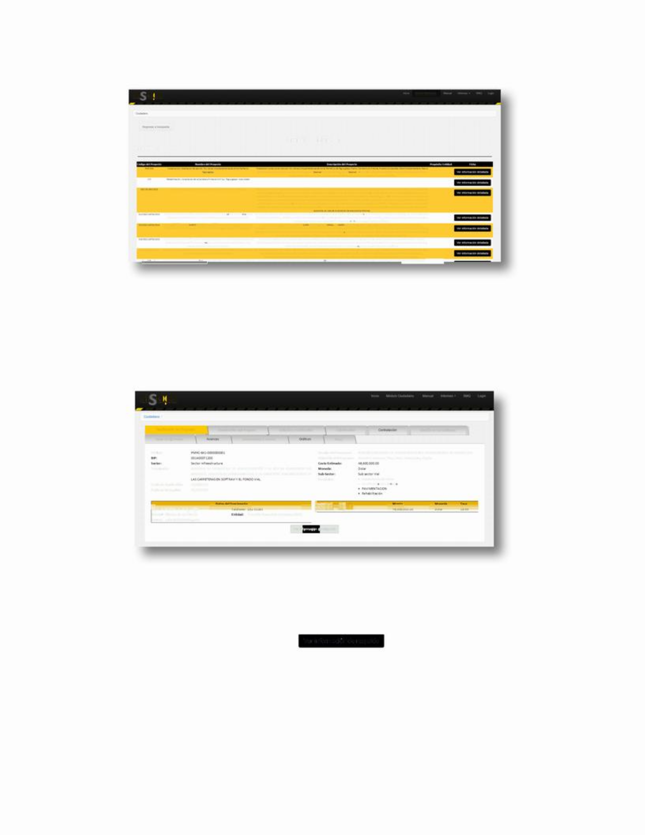

Ver information de respaldo .

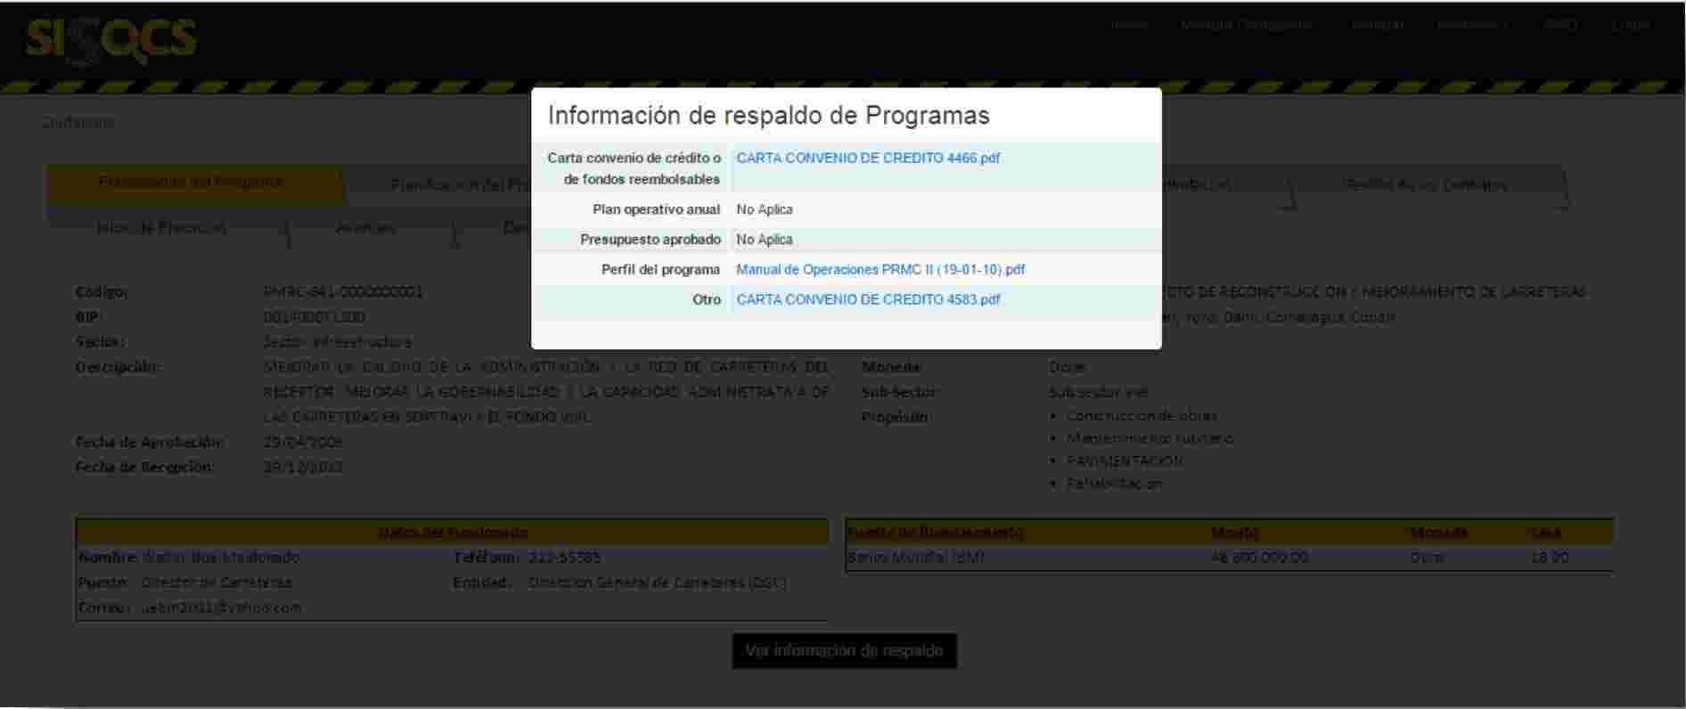

*Display of relevant documents for each phase of the road project.*

To view each document click on the corresponding link.

**3 ANEXO. DESCRIPCIÓN DE LA INFORMACIÓN QUE DEBE SER DIVULGADA**

The information for each phase of the project cycle must be recorded and published once the supporting documents that accompany each tab have been generated, in real time. In the event that some or some of the documents do not apply to the specific project, this option will be selected in the system, with the possibility of publishing a clarifying note because it does not apply.

Below is a description of the information that should be disclosed in each

Tab:

**Planning Sheet**

**Project**

**Contiene al menos los siguientes datos:**

• **Project name:**    It must be linked to the official name of the project, but it can be shortened if they are very extensive.

**The body responsible for the project:**     entity

public in charge of the project.

•  **Official responsible for the project:**     includes

name, position and dependency in which it works.

Contact **Details:**    refers to the phone and email of the official responsible for the project.

**• Project location:**    refers to the municipality or municipios where the project is located

**Purpose:**  Identifies whether it is a construction project rehabilitation or maintenance of works.

**Description ofthecarved and scopes of the project:**     It should be brief and as far as possible avoid technicalities indicating the main characteristics of the work to be carried out.

**The date of approval of the budget of the**

**project:**  day, month and year when the project was

aprobado.

**Estimated project cost:**     as published in the Annual Procurement and Procurement Plan-PACC, in national or foreign currency, as the case may be.

**BIP Code:**   assigned by the Enrollment Bank

SEFIN Projects.

**Beneficiaries:**  a description of who/who is

benefit from the project, and may be the number of

|  |  |
| --- | --- |
|  | estimated individuals, families or communities  Beneficiaries.  **• Source of funding:**    establishes whether these are international bodies, public-private partnerships, national funds, or mixed sources.    **Supporting Documentation:**  • **Specifications and plans ofe** the **work if**  **Corresponds.**  •  **Project's multi-year budget and program.**  • **Feasibility study if applicable.**  • **Environmental Impact Study if applicable.**  • **Environmental License and Agreement of Mitigation Measures if applicable as applicablea.**  .  •  **Land Impact and Resettlement Study if**  **Comes.**  •  **Resettlement and Compensation Plan if**  **Corresponds.**  • **Priority Note and Registrationc**In the Project Bank of**the Ministry of Finance.**  • **Financing agreement:**    letter or letters of credit, donation, PACC or other agreement as appropriate.  •  **Other**  (in the case of documents of no relevance  provided for in this Handbook or note of information  clarification). |
| **Invitation Sheet and** | **It contains at least the following data:** |
| **Qualifiedn** | **Number and name of the purchasingcprocess:** |
|  | according to the numbering established by the Office |
|  | Regulations on Purchasing and Contractions of the State-  ONCAE.  • Acquisition**cEntity:** **Refers** to the Executing Unit or Specific Department within the entity carrying out the procurement process.  Contact  **details of the body responsible for**  **purchasingcprocess.** It includes the publication of the names and positions of officials or employees and their roles, phone numbers and addresses.  •  **Method and procurement**process. Identifies whether |
|  | it's a national public tender or |
|  | international, private national or national tendering |
|  | international, national public competition or |

|  |  |
| --- | --- |
|  | international, national private competition or  international, or direct procurement.  **• Type of contractor**: specificwhether it is a design contract, execution of works, supervision, verification, concession or mixed including turnkey contracts.    **Backup Documents:**  **• Invitation to participate in the process of (pre) qualification**       for the execution of the project(s) or in the (pre) qualification for the contest for the supervision of works;  •  **Basis of (pre) qualification** of the process.  **Resolution declaring the (pre) qualification**     of the interested parties who established the requirements laid down in the basics.  **• Name and background of companies (pre)**  **qualified** to participate in the tender.  **• Call or invitation to tender**     published in HonduCompras or other means.  • **Condition**Sheet**iso Concurs**Bases**or** (Terms of Reference)  **Clarifications or Amendments**   to the Terms and Conditions  Contest Rules.  • **Act of receipt/submission of tenders,**indicating the list ofbidders or participating firms.  • **Other** (in the case of relevant documents not provided for in this Manual or note of clarification or rectification information). |
| **Evaluation Sheet** | **It contains at least the followingdata:** |
| **of the** | **Number, name and amount of the offera**  **of the** |
| **Offers/Adjudication** | **signatures thatn** were bidding or incured, specifying whether |
|  | are national and international. |
|  | **Number, name of consultationren/signatures** |
|  | **consultancies in**cort**a** and bid amount. This  registration applies to contest processes, where short lists are integrated as a result of a (pre) qualification process. The list is integrated with a minimum of three and a maximum of six consulting firms.  Estimated  **Costo estimado del contrato**   contract cost (Base price), as published in the PACC, in national or foreign currency, as the case may be. |

|  |  |  |
| --- | --- | --- |
|  |  | **Supporting Documentation:**  • **Act of Opening Offers**.  • **Report or minutes of recommendationn**.  **Resolution of the award of the tender or**  contest.  • **Other** (in the case of relevant documents not provided for in this Manual or note of clarification or rectification information). |
| **Tab**  **Hiringn** | **of** | **It contains at least the followingdata:**    •  **Contract number**.  Contract **Management Entity**  •  **Title of the Contractor**. It involves recording verbatim  the name of the contract.  **• Name of the consultationr**   **or the**     **firma/company**  **Hired**  **• Price of the contractor** in the agreed currency.  **Scopes of work**   as set out in the  Contract.  • **Start date and duration** of the contract in months.    **Supporting Documentation:**  • **Contrator**document. It refers to the integrated publication of the contract and its conditions, for which, the SISOCS allows to make a direct link with the system**"Honducompras"..**  • **Registration, background and information of the consultant or owner(s) of the contracted**firm. In this case the SISOCS, will also allow a direct link with the system**"Honducompra**s". **s**  Specifications and plans of the project to be implemented  where appropriate.  • Other (in the case of relevant documents not provided for in this Manual or note of clarification or rectification information). |
| **Management Sheet** | | **It contains at least the followingdata:**    •  **Number of modifications to the contractor**. In order  from the first addendum to the last.  **The date of each change**    as  stipulated in the corresponding addendum.  **Type of modification**  to the contract indicating whether  about changes that affect price, changes that |
| **Contracts.** | |
|  | |

|  |  |
| --- | --- |
|  | affect the work programme, changes that affect  the duration of the contract, changes that affect  scope of the contract, after signing an addendum.  **• Justification of**    **themodification**  of the contract, as indicated in the corresponding addendum.  **• Updated**price**or** contract agreed under addendum  if applicablee.  •  **Updated**  date of termination of the contract  agreed in amended up, if applicable.  **• Updated scope**  of the project agreed in  addendum if applicable.    **Supporting Documentation:**  **• Initial work oro** signature program  contract.  **Adendas**  or modifications to contracts  duly subscribed.  **• Updatedor** work-up program if it has been  agreed in addendum.  • **Other** (in the case of relevant documents not provided for in this Manual or note of clarification or rectification information). |
| **Home Tab** | **It contains at least the followingdata:** |
| **Execution.** |  |
|  | **• Name and contact details of the consultationr**  **in charge** |
|  | **project** design. |
|  | **Name and contact details of the name of** |
|  | **contractor representative**    (executor of the contractor) |
|  | project). |
|  | **Name and contact details of the representative of the** |
|  | supervisor (consultant). |
|  | •  **Type of warranty(s)**       granted as the case may be: |
|  | Advance Guarantee: This warranty is recorded  provided that an advance is granted to the contractor. Contract Compliance Guarantee: Applies your registration when it comes to public works contracts and consulting contracts. Project quality assurance: This record applies when it is set as mandatory, taking into account the nature of the project. In contracts for the supervision of works, a guarantee of fees excluding costs is recorded.  • **Amount of warranty(s).**). |

|  |  |
| --- | --- |
|  | •  **Expiration date of warranties**.  • **Project geor-referenationciación** data with start point and end point identification (Latitude, Longitude).  **• Date of the order to start**      supervision and  project execution.    **Supporting Documentation:**  • **Warranty document(s))** that may be (i) Bank bond or guarantee, issued by an authorized financial institution; (ii) Government bonds and; iii) Certified Checks.  • **Other**  (in the case of relevant documents not provided for in this Manual or note of clarification or rectification information). |
| **Progress sheet in** | **It contains at least the followingdata:** |
| **the Execution of** |  |
| **Projects.** | Physical  **progress of the project**    accumulated in percentage |
|  | distributed in scheduled and real. |
|  | •  **Financial**  progress of work in distributed percentage |
|  | programmed and real. |
|  | **• Registration of disbursements** or payments (number and number |
|  | amount). |
|  | **The main activitiesofs** the project in the  including the performance of the contract  environmental mitigation measures  **Comments on the problemspresented** in the  execution and to-dos.  **Photographs of progress** of the works. |
|  | **Back Documentation:** |
|  | •  **Project design report,**   when |
|  | Corresponds. |
|  | •  **Implementation progress**   reports  contractors present.  •  **Construction monitoring reports.**  • **Project evaluationn** reports (continuous as in the case of verifiers and at the end), where applicable.  •  **Technicalría técnica**auditreports, where applicable. |
|  | •  **Financialría financiera**auditreports, when |
|  | Corresponds. |
|  | • **Final receipt act,** where applicable. |

• **Nonconformance report,**where applicable.

• **Other** (in the case of relevant documents not provided for in this Manual or note of clarification or clarification information).