**[Insert Full Name]**

**[Insert Contact No.]**

**[Insert Email Address]**

**[Insert New Stud No.]**

**[Insert Email Address]**

**[Insert Contact No.]**

**[Insert New Stud No.]**

**[Insert Full Name]**

**[Insert Email Address]**

**[Insert Contact No.]**

**[Insert Full Name]**

**[Insert New Stud No.]**

**[Insert New Stud No.]**

**[Insert Email Address]**

**[Insert Contact No.]**

**[Insert Full Name]**

**[Insert Email Address]**

**[Insert Contact No.]**

**[Insert Full Name]**

**[Insert New Stud No.]**

**[Insert Email Address]**

**[Insert Contact No.]**

**[Insert Full Name]**

**[Insert New Stud No.]**

**[Insert Contact No.]**

**[Insert Email Address]**

**[Insert Email Address]**

**[Insert Contact No.]**

**[Insert Full Name]**

**[Insert New Stud No.]**

**[Insert Full Name]**

**[Insert New Stud No.]**



**SAMPLE BUSINESS CARD**

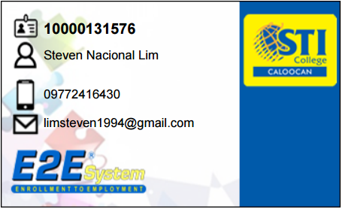

* NOTES:
  + **Print your business cards using clean white substance 20 paper.**
  + **Transactions with participating companies will be processed only through your business cards.**