Bug 001
1. Title:
User able to login with any username/password
2. Environment:
- Application / Module: ParaBank
- Browser / OS / Device: Chromium
- App Version / Build: 1.0
- Additional Environment Details:
3. Steps to Reproduce:
- Go to https://parabank.parasoft.com/parabank/index.htm
- Login as any user (make up a random one) and password (random as well)
- You will be able to login even though that user is not there and/or someone else
4. Expected Result:
Should not be able to login with invalid credentials
5. Actual Result:
Was able to login with invalid credentials
6. Evidence:
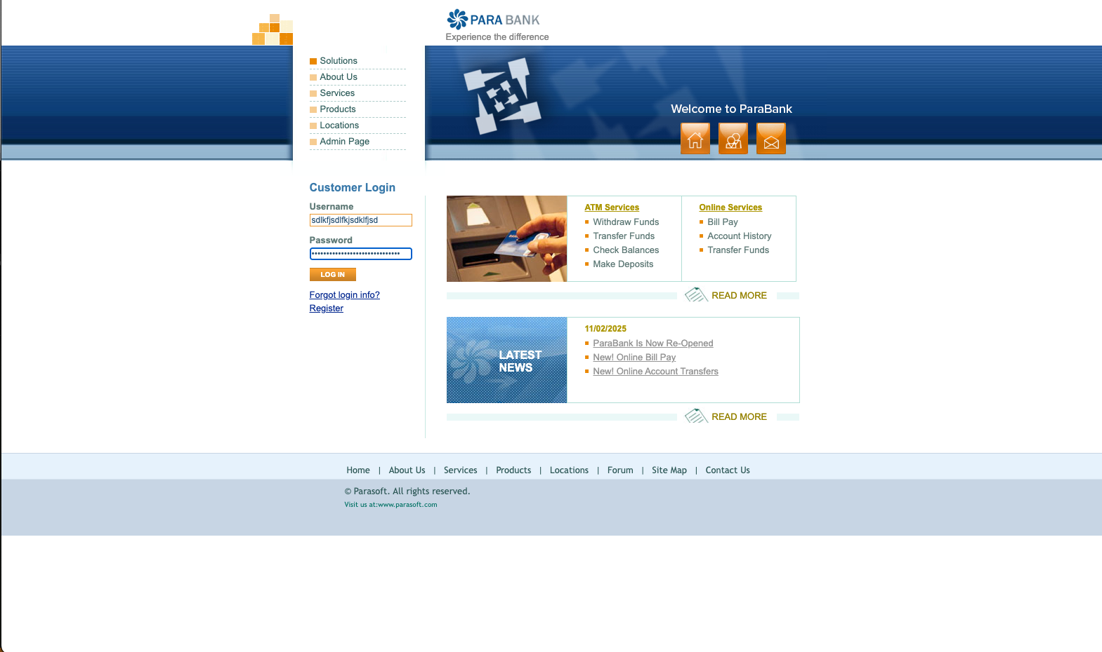
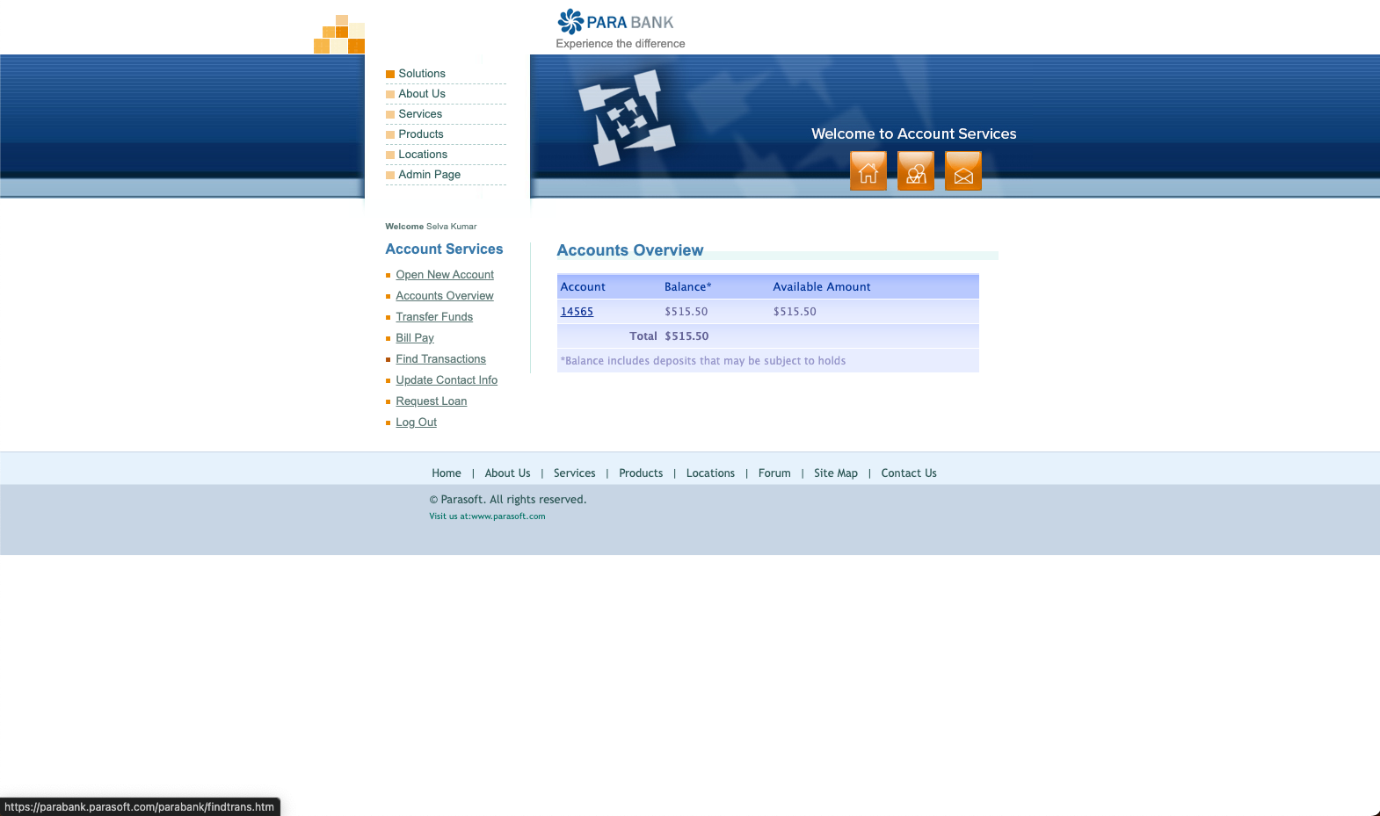
7. Severity:
Major – Security risk and/or function now behaving as per spec
8. Suspected Cause:
Unknown
9. Fix Hypothesis / Suggested Fix:
Review and correct user account permissions and security settings.
10. Retest Plan:
- Try to login again with invalid credentials
- Should not be able to login with invalid credentials
Bug 002
1. Title:
Console error when performing any “ATM Services” or “Online Services” actions
2. Environment:
- Application / Module: ParaBank
- Browser / OS / Device: Chrome
- App Version / Build: 1.0
- Additional Environment Details:
3. Steps to Reproduce:
- Go to https://parabank.parasoft.com/parabank/index.htm
- Click on any links for “ATM Services” or “Online Services”
- You will see raw xml.
- Inspect the page with devtools, you will see console errors (see attachment)
4. Expected Result:
Should be able to load the pages without any issues
5. Actual Result:
Was not able to perform any “ATM Services” or “Online Services” from the main screen
6. Evidence:
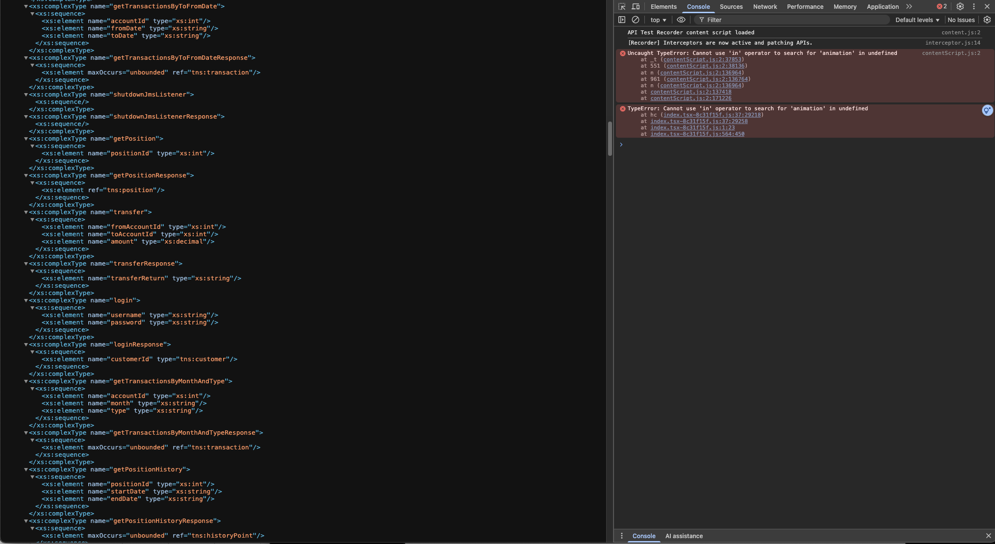

7. Severity:
Major – Users unable to perform actions in “ATM Services” and “Online Services”
8. Suspected Cause:
javascript issue
9. Fix Hypothesis / Suggested Fix:
Review the javascript code and resolve the issue.
10. Retest Plan:
- Try to click any links in “ATM Services” and “Online Services” and perform actions
Bug 003
1. Title:
Accessibility failures on https://parabank.parasoft.com/parabank/index.htm
2. Environment:
- Application / Module: ParaBank
- Browser / OS / Device: Chromium
- App Version / Build: 1.0
- Additional Environment Details:
3. Steps to Reproduce:
- Run playwright axe-core
- See the failure from automation.
4. Expected Result:
Accessibility tests should pass
5. Actual Result:
Failures reported by accessibility tool
6. Evidence:
+ Array [
+ Object {
+ "description": "Ensure the contrast between foreground and background colors meets WCAG 2 AA minimum contrast ratio thresholds",
+ "help": "Elements must meet minimum color contrast ratio thresholds",
+ "helpUrl": "https://dequeuniversity.com/rules/axe/4.11/color-contrast?application=playwright",
+ "id": "color-contrast",
+ "impact": "serious",
+ "nodes": Array [
+ Object {
+ "all": Array [],
+ "any": Array [
+ Object {
+ "data": Object {
+ "bgColor": "#ffffff",
+ "contrastRatio": 3.84,
+ "expectedContrastRatio": "4.5:1",
+ "fgColor": "#828282",
+ "fontSize": "9.8pt (13px)",
+ "fontWeight": "normal",
+ "messageKey": null,
+ },
+ "id": "color-contrast",
+ "impact": "serious",
+ "message": "Element has insufficient color contrast of 3.84 (foreground color: #828282, background color: #ffffff, font size: 9.8pt (13px), font weight: normal). Expected contrast ratio of 4.5:1",
+ "relatedNodes": Array [
+ Object {
+ "html": "<p class=\"caption\">Experience the difference</p>",
+ "target": Array [
+ ".caption",
+ ],
+ },
+ ],
+ },
+ ],
+ "failureSummary": "Fix any of the following:
+ Element has insufficient color contrast of 3.84 (foreground color: #828282, background color: #ffffff, font size: 9.8pt (13px), font weight: normal). Expected contrast ratio of 4.5:1",
+ "html": "<p class=\"caption\">Experience the difference</p>",
+ "impact": "serious",
+ "none": Array [],
+ "target": Array [
+ ".caption",
+ ],
+ },
+ Object {
+ "all": Array [],
+ "any": Array [
+ Object {
+ "data": Object {
+ "bgColor": "#c7d5e4",
+ "contrastRatio": 3.97,
+ "expectedContrastRatio": "4.5:1",
+ "fgColor": "#007163",
+ "fontSize": "7.5pt (10px)",
+ "fontWeight": "normal",
+ "messageKey": null,
+ },
+ "id": "color-contrast",
+ "impact": "serious",
+ "message": "Element has insufficient color contrast of 3.97 (foreground color: #007163, background color: #c7d5e4, font size: 7.5pt (10px), font weight: normal). Expected contrast ratio of 4.5:1",
+ "relatedNodes": Array [
+ Object {
+ "html": "<ul class=\"visit\">
+ <li>Visit us at:</li>
+ <li><a href=\"http://www.parasoft.com/\" target=\"_blank\">www.parasoft.com</a></li>
+ </ul>",
+ "target": Array [
+ ".visit",
+ ],
+ },
+ ],
+ },
+ ],
+ "failureSummary": "Fix any of the following:
+ Element has insufficient color contrast of 3.97 (foreground color: #007163, background color: #c7d5e4, font size: 7.5pt (10px), font weight: normal). Expected contrast ratio of 4.5:1",
+ "html": "<li>Visit us at:</li>",
+ "impact": "serious",
+ "none": Array [],
+ "target": Array [
+ ".visit > li:nth-child(1)",
+ ],
+ },
+ Object {
+ "all": Array [],
+ "any": Array [
+ Object {
+ "data": Object {
+ "bgColor": "#c7d5e4",
+ "contrastRatio": 3.97,
+ "expectedContrastRatio": "4.5:1",
+ "fgColor": "#007163",
+ "fontSize": "7.5pt (10px)",
+ "fontWeight": "normal",
+ "messageKey": null,
+ },
+ "id": "color-contrast",
+ "impact": "serious",
+ "message": "Element has insufficient color contrast of 3.97 (foreground color: #007163, background color: #c7d5e4, font size: 7.5pt (10px), font weight: normal). Expected contrast ratio of 4.5:1",
+ "relatedNodes": Array [
+ Object {
+ "html": "<a href=\"http://www.parasoft.com/\" target=\"_blank\">www.parasoft.com</a>",
+ "target": Array [
+ "li:nth-child(2) > a[href$=\"parasoft.com/\"]",
+ ],
+ },
+ ],
+ },
+ ],
+ "failureSummary": "Fix any of the following:
+ Element has insufficient color contrast of 3.97 (foreground color: #007163, background color: #c7d5e4, font size: 7.5pt (10px), font weight: normal). Expected contrast ratio of 4.5:1",
+ "html": "<a href=\"http://www.parasoft.com/\" target=\"_blank\">www.parasoft.com</a>",
+ "impact": "serious",
+ "none": Array [],
+ "target": Array [
+ "li:nth-child(2) > a[href$=\"parasoft.com/\"]",
+ ],
+ },
+ ],
+ "tags": Array [
+ "cat.color",
+ "wcag2aa",
+ "wcag143",
+ "TTv5",
+ "TT13.c",
+ "EN-301-549",
+ "EN-9.1.4.3",
+ "ACT",
+ "RGAAv4",
+ "RGAA-3.2.1",
+ ],
+ },
+ Object {
+ "description": "Ensure every HTML document has a lang attribute",
+ "help": "<html> element must have a lang attribute",
+ "helpUrl": "https://dequeuniversity.com/rules/axe/4.11/html-has-lang?application=playwright",
+ "id": "html-has-lang",
+ "impact": "serious",
+ "nodes": Array [
+ Object {
+ "all": Array [],
+ "any": Array [
+ Object {
+ "data": Object {
+ "messageKey": "noLang",
+ },
+ "id": "has-lang",
+ "impact": "serious",
+ "message": "The <html> element does not have a lang attribute",
+ "relatedNodes": Array [],
+ },
+ ],
+ "failureSummary": "Fix any of the following:
+ The <html> element does not have a lang attribute",
+ "html": "<html>",
+ "impact": "serious",
+ "none": Array [],
+ "target": Array [
+ "html",
+ ],
+ },
+ ],
+ "tags": Array [
+ "cat.language",
+ "wcag2a",
+ "wcag311",
+ "TTv5",
+ "TT11.a",
+ "EN-301-549",
+ "EN-9.3.1.1",
+ "ACT",
+ "RGAAv4",
+ "RGAA-8.3.1",
+ ],
+ },
+ Object {
+ "description": "Ensure <img> elements have alternative text or a role of none or presentation",
+ "help": "Images must have alternative text",
+ "helpUrl": "https://dequeuniversity.com/rules/axe/4.11/image-alt?application=playwright",
+ "id": "image-alt",
+ "impact": "critical",
+ "nodes": Array [
+ Object {
+ "all": Array [],
+ "any": Array [
+ Object {
+ "data": null,
+ "id": "has-alt",
+ "impact": "critical",
+ "message": "Element does not have an alt attribute",
+ "relatedNodes": Array [],
+ },
+ Object {
+ "data": null,
+ "id": "aria-label",
+ "impact": "critical",
+ "message": "aria-label attribute does not exist or is empty",
+ "relatedNodes": Array [],
+ },
+ Object {
+ "data": null,
+ "id": "aria-labelledby",
+ "impact": "critical",
+ "message": "aria-labelledby attribute does not exist, references elements that do not exist or references elements that are empty",
+ "relatedNodes": Array [],
+ },
+ Object {
+ "data": Object {
+ "messageKey": "noAttr",
+ },
+ "id": "non-empty-title",
+ "impact": "critical",
+ "message": "Element has no title attribute",
+ "relatedNodes": Array [],
+ },
+ Object {
+ "data": null,
+ "id": "presentational-role",
+ "impact": "critical",
+ "message": "Element's default semantics were not overridden with role=\"none\" or role=\"presentation\"",
+ "relatedNodes": Array [],
+ },
+ ],
+ "failureSummary": "Fix any of the following:
+ Element does not have an alt attribute
+ aria-label attribute does not exist or is empty
+ aria-labelledby attribute does not exist, references elements that do not exist or references elements that are empty
+ Element has no title attribute
+ Element's default semantics were not overridden with role=\"none\" or role=\"presentation\"",
+ "html": "<img src=\"images/clear.gif\" width=\"56\" height=\"42\" border=\"0\" class=\"admin\">",
+ "impact": "critical",
+ "none": Array [],
+ "target": Array [
+ ".admin",
+ ],
+ },
+ ],
+ "tags": Array [
+ "cat.text-alternatives",
+ "wcag2a",
+ "wcag111",
+ "section508",
+ "section508.22.a",
+ "TTv5",
+ "TT7.a",
+ "TT7.b",
+ "EN-301-549",
+ "EN-9.1.1.1",
+ "ACT",
+ "RGAAv4",
+ "RGAA-1.1.1",
+ ],
+ },
+ Object {
+ "description": "Ensure every form element has a label",
+ "help": "Form elements must have labels",
+ "helpUrl": "https://dequeuniversity.com/rules/axe/4.11/label?application=playwright",
+ "id": "label",
+ "impact": "critical",
+ "nodes": Array [
+ Object {
+ "all": Array [],
+ "any": Array [
+ Object {
+ "data": null,
+ "id": "implicit-label",
+ "impact": "critical",
+ "message": "Element does not have an implicit (wrapped) <label>",
+ "relatedNodes": Array [],
+ },
+ Object {
+ "data": null,
+ "id": "explicit-label",
+ "impact": "critical",
+ "message": "Element does not have an explicit <label>",
+ "relatedNodes": Array [],
+ },
+ Object {
+ "data": null,
+ "id": "aria-label",
+ "impact": "critical",
+ "message": "aria-label attribute does not exist or is empty",
+ "relatedNodes": Array [],
+ },
+ Object {
+ "data": null,
+ "id": "aria-labelledby",
+ "impact": "critical",
+ "message": "aria-labelledby attribute does not exist, references elements that do not exist or references elements that are empty",
+ "relatedNodes": Array [],
+ },
+ Object {
+ "data": Object {
+ "messageKey": "noAttr",
+ },
+ "id": "non-empty-title",
+ "impact": "critical",
+ "message": "Element has no title attribute",
+ "relatedNodes": Array [],
+ },
+ Object {
+ "data": Object {
+ "messageKey": "noAttr",
+ },
+ "id": "non-empty-placeholder",
+ "impact": "critical",
+ "message": "Element has no placeholder attribute",
+ "relatedNodes": Array [],
+ },
+ Object {
+ "data": null,
+ "id": "presentational-role",
+ "impact": "critical",
+ "message": "Element's default semantics were not overridden with role=\"none\" or role=\"presentation\"",
+ "relatedNodes": Array [],
+ },
+ ],
+ "failureSummary": "Fix any of the following:
+ Element does not have an implicit (wrapped) <label>
+ Element does not have an explicit <label>
+ aria-label attribute does not exist or is empty
+ aria-labelledby attribute does not exist, references elements that do not exist or references elements that are empty
+ Element has no title attribute
+ Element has no placeholder attribute
+ Element's default semantics were not overridden with role=\"none\" or role=\"presentation\"",
+ "html": "<input type=\"text\" class=\"input\" name=\"username\">",
+ "impact": "critical",
+ "none": Array [],
+ "target": Array [
+ "input[type=\"text\"]",
+ ],
+ },
+ Object {
+ "all": Array [],
+ "any": Array [
+ Object {
+ "data": null,
+ "id": "implicit-label",
+ "impact": "critical",
+ "message": "Element does not have an implicit (wrapped) <label>",
+ "relatedNodes": Array [],
+ },
+ Object {
+ "data": null,
+ "id": "explicit-label",
+ "impact": "critical",
+ "message": "Element does not have an explicit <label>",
+ "relatedNodes": Array [],
+ },
+ Object {
+ "data": null,
+ "id": "aria-label",
+ "impact": "critical",
+ "message": "aria-label attribute does not exist or is empty",
+ "relatedNodes": Array [],
+ },
+ Object {
+ "data": null,
+ "id": "aria-labelledby",
+ "impact": "critical",
+ "message": "aria-labelledby attribute does not exist, references elements that do not exist or references elements that are empty",
+ "relatedNodes": Array [],
+ },
+ Object {
+ "data": Object {
+ "messageKey": "noAttr",
+ },
+ "id": "non-empty-title",
+ "impact": "critical",
+ "message": "Element has no title attribute",
+ "relatedNodes": Array [],
+ },
+ Object {
+ "data": Object {
+ "messageKey": "noAttr",
+ },
+ "id": "non-empty-placeholder",
+ "impact": "critical",
+ "message": "Element has no placeholder attribute",
+ "relatedNodes": Array [],
+ },
+ Object {
+ "data": null,
+ "id": "presentational-role",
+ "impact": "critical",
+ "message": "Element's default semantics were not overridden with role=\"none\" or role=\"presentation\"",
+ "relatedNodes": Array [],
+ },
+ ],
+ "failureSummary": "Fix any of the following:
+ Element does not have an implicit (wrapped) <label>
+ Element does not have an explicit <label>
+ aria-label attribute does not exist or is empty
+ aria-labelledby attribute does not exist, references elements that do not exist or references elements that are empty
+ Element has no title attribute
+ Element has no placeholder attribute
+ Element's default semantics were not overridden with role=\"none\" or role=\"presentation\"",
+ "html": "<input type=\"password\" class=\"input\" name=\"password\">",
+ "impact": "critical",
+ "none": Array [],
+ "target": Array [
+ "input[type=\"password\"]",
+ ],
+ },
+ ],
+ "tags": Array [
+ "cat.forms",
+ "wcag2a",
+ "wcag412",
+ "section508",
+ "section508.22.n",
+ "TTv5",
+ "TT5.c",
+ "EN-301-549",
+ "EN-9.4.1.2",
+ "ACT",
+ "RGAAv4",
+ "RGAA-11.1.1",
+ ],
+ },
+ Object {
+ "description": "Ensure the document has a main landmark",
+ "help": "Document should have one main landmark",
+ "helpUrl": "https://dequeuniversity.com/rules/axe/4.11/landmark-one-main?application=playwright",
+ "id": "landmark-one-main",
+ "impact": "moderate",
+ "nodes": Array [
+ Object {
+ "all": Array [
+ Object {
+ "data": null,
+ "id": "page-has-main",
+ "impact": "moderate",
+ "message": "Document does not have a main landmark",
+ "relatedNodes": Array [],
+ },
+ ],
+ "any": Array [],
+ "failureSummary": "Fix all of the following:
+ Document does not have a main landmark",
+ "html": "<html>",
+ "impact": "moderate",
+ "none": Array [],
+ "target": Array [
+ "html",
+ ],
+ },
+ ],
+ "tags": Array [
+ "cat.semantics",
+ "best-practice",
+ ],
+ },
+ Object {
+ "description": "Ensure links have discernible text",
+ "help": "Links must have discernible text",
+ "helpUrl": "https://dequeuniversity.com/rules/axe/4.11/link-name?application=playwright",
+ "id": "link-name",
+ "impact": "serious",
+ "nodes": Array [
+ Object {
+ "all": Array [],
+ "any": Array [
+ Object {
+ "data": null,
+ "id": "has-visible-text",
+ "impact": "serious",
+ "message": "Element does not have text that is visible to screen readers",
+ "relatedNodes": Array [],
+ },
+ Object {
+ "data": null,
+ "id": "aria-label",
+ "impact": "serious",
+ "message": "aria-label attribute does not exist or is empty",
+ "relatedNodes": Array [],
+ },
+ Object {
+ "data": null,
+ "id": "aria-labelledby",
+ "impact": "serious",
+ "message": "aria-labelledby attribute does not exist, references elements that do not exist or references elements that are empty",
+ "relatedNodes": Array [],
+ },
+ Object {
+ "data": Object {
+ "messageKey": "noAttr",
+ },
+ "id": "non-empty-title",
+ "impact": "serious",
+ "message": "Element has no title attribute",
+ "relatedNodes": Array [],
+ },
+ ],
+ "failureSummary": "Fix all of the following:
+ Element is in tab order and does not have accessible text
+
+ Fix any of the following:
+ Element does not have text that is visible to screen readers
+ aria-label attribute does not exist or is empty
+ aria-labelledby attribute does not exist, references elements that do not exist or references elements that are empty
+ Element has no title attribute",
+ "html": "<a href=\"admin.htm\"><img src=\"images/clear.gif\" width=\"56\" height=\"42\" border=\"0\" class=\"admin\"></a>",
+ "impact": "serious",
+ "none": Array [
+ Object {
+ "data": null,
+ "id": "focusable-no-name",
+ "impact": "serious",
+ "message": "Element is in tab order and does not have accessible text",
+ "relatedNodes": Array [],
+ },
+ ],
+ "target": Array [
+ "#topPanel > a[href$=\"admin.htm\"]",
+ ],
+ },
+ ],
+ "tags": Array [
+ "cat.name-role-value",
+ "wcag2a",
+ "wcag244",
+ "wcag412",
+ "section508",
+ "section508.22.a",
+ "TTv5",
+ "TT6.a",
+ "EN-301-549",
+ "EN-9.2.4.4",
+ "EN-9.4.1.2",
+ "ACT",
+ "RGAAv4",
+ "RGAA-6.2.1",
+ ],
+ },
+ Object {
+ "description": "Ensure all page content is contained by landmarks",
+ "help": "All page content should be contained by landmarks",
+ "helpUrl": "https://dequeuniversity.com/rules/axe/4.11/region?application=playwright",
+ "id": "region",
+ "impact": "moderate",
+ "nodes": Array [
+ Object {
+ "all": Array [],
+ "any": Array [
+ Object {
+ "data": Object {
+ "isIframe": false,
+ },
+ "id": "region",
+ "impact": "moderate",
+ "message": "Some page content is not contained by landmarks",
+ "relatedNodes": Array [],
+ },
+ ],
+ "failureSummary": "Fix any of the following:
+ Some page content is not contained by landmarks",
+ "html": "<div id=\"topPanel\">",
+ "impact": "moderate",
+ "none": Array [],
+ "target": Array [
+ "#topPanel",
+ ],
+ },
+ Object {
+ "all": Array [],
+ "any": Array [
+ Object {
+ "data": Object {
+ "isIframe": false,
+ },
+ "id": "region",
+ "impact": "moderate",
+ "message": "Some page content is not contained by landmarks",
+ "relatedNodes": Array [],
+ },
+ ],
+ "failureSummary": "Fix any of the following:
+ Some page content is not contained by landmarks",
+ "html": "<div id=\"headerPanel\" style=\"background: url(images/header-main.jpg) 0 0 no-repeat;\">",
+ "impact": "moderate",
+ "none": Array [],
+ "target": Array [
+ "#headerPanel",
+ ],
+ },
+ Object {
+ "all": Array [],
+ "any": Array [
+ Object {
+ "data": Object {
+ "isIframe": false,
+ },
+ "id": "region",
+ "impact": "moderate",
+ "message": "Some page content is not contained by landmarks",
+ "relatedNodes": Array [],
+ },
+ ],
+ "failureSummary": "Fix any of the following:
+ Some page content is not contained by landmarks",
+ "html": "<h2>Customer Login</h2>",
+ "impact": "moderate",
+ "none": Array [],
+ "target": Array [
+ "h2",
+ ],
+ },
+ Object {
+ "all": Array [],
+ "any": Array [
+ Object {
+ "data": Object {
+ "isIframe": false,
+ },
+ "id": "region",
+ "impact": "moderate",
+ "message": "Some page content is not contained by landmarks",
+ "relatedNodes": Array [],
+ },
+ ],
+ "failureSummary": "Fix any of the following:
+ Some page content is not contained by landmarks",
+ "html": "<p><b>Username</b></p>",
+ "impact": "moderate",
+ "none": Array [],
+ "target": Array [
+ "p:nth-child(1)",
+ ],
+ },
+ Object {
+ "all": Array [],
+ "any": Array [
+ Object {
+ "data": Object {
+ "isIframe": false,
+ },
+ "id": "region",
+ "impact": "moderate",
+ "message": "Some page content is not contained by landmarks",
+ "relatedNodes": Array [],
+ },
+ ],
+ "failureSummary": "Fix any of the following:
+ Some page content is not contained by landmarks",
+ "html": "<div class=\"login\"><input type=\"text\" class=\"input\" name=\"username\"></div>",
+ "impact": "moderate",
+ "none": Array [],
+ "target": Array [
+ ".login:nth-child(2)",
+ ],
+ },
+ Object {
+ "all": Array [],
+ "any": Array [
+ Object {
+ "data": Object {
+ "isIframe": false,
+ },
+ "id": "region",
+ "impact": "moderate",
+ "message": "Some page content is not contained by landmarks",
+ "relatedNodes": Array [],
+ },
+ ],
+ "failureSummary": "Fix any of the following:
+ Some page content is not contained by landmarks",
+ "html": "<p><b>Password</b></p>",
+ "impact": "moderate",
+ "none": Array [],
+ "target": Array [
+ "form > p:nth-child(3)",
+ ],
+ },
+ Object {
+ "all": Array [],
+ "any": Array [
+ Object {
+ "data": Object {
+ "isIframe": false,
+ },
+ "id": "region",
+ "impact": "moderate",
+ "message": "Some page content is not contained by landmarks",
+ "relatedNodes": Array [],
+ },
+ ],
+ "failureSummary": "Fix any of the following:
+ Some page content is not contained by landmarks",
+ "html": "<div class=\"login\"><input type=\"password\" class=\"input\" name=\"password\"></div>",
+ "impact": "moderate",
+ "none": Array [],
+ "target": Array [
+ ".login:nth-child(4)",
+ ],
+ },
+ Object {
+ "all": Array [],
+ "any": Array [
+ Object {
+ "data": Object {
+ "isIframe": false,
+ },
+ "id": "region",
+ "impact": "moderate",
+ "message": "Some page content is not contained by landmarks",
+ "relatedNodes": Array [],
+ },
+ ],
+ "failureSummary": "Fix any of the following:
+ Some page content is not contained by landmarks",
+ "html": "<p><a href=\"lookup.htm\">Forgot login info?</a></p>",
+ "impact": "moderate",
+ "none": Array [],
+ "target": Array [
+ "#loginPanel > p:nth-child(2)",
+ ],
+ },
+ Object {
+ "all": Array [],
+ "any": Array [
+ Object {
+ "data": Object {
+ "isIframe": false,
+ },
+ "id": "region",
+ "impact": "moderate",
+ "message": "Some page content is not contained by landmarks",
+ "relatedNodes": Array [],
+ },
+ ],
+ "failureSummary": "Fix any of the following:
+ Some page content is not contained by landmarks",
+ "html": "<p><a href=\"register.htm\">Register</a></p>",
+ "impact": "moderate",
+ "none": Array [],
+ "target": Array [
+ "#loginPanel > p:nth-child(3)",
+ ],
+ },
+ Object {
+ "all": Array [],
+ "any": Array [
+ Object {
+ "data": Object {
+ "isIframe": false,
+ },
+ "id": "region",
+ "impact": "moderate",
+ "message": "Some page content is not contained by landmarks",
+ "relatedNodes": Array [],
+ },
+ ],
+ "failureSummary": "Fix any of the following:
+ Some page content is not contained by landmarks",
+ "html": "<div id=\"rightPanel\">
+
+
+
+ <h1 class=\"title\">Error!</h1>
+
+
+
+ <p class=\"error\">An internal error has occurred and has been logged.</p>
+ </div>",
+ "impact": "moderate",
+ "none": Array [],
+ "target": Array [
+ "#rightPanel",
+ ],
+ },
+ Object {
+ "all": Array [],
+ "any": Array [
+ Object {
+ "data": Object {
+ "isIframe": false,
+ },
+ "id": "region",
+ "impact": "moderate",
+ "message": "Some page content is not contained by landmarks",
+ "relatedNodes": Array [],
+ },
+ ],
+ "failureSummary": "Fix any of the following:
+ Some page content is not contained by landmarks",
+ "html": "<div id=\"footermainPanel\">",
+ "impact": "moderate",
+ "none": Array [],
+ "target": Array [
+ "#footermainPanel",
+ ],
+ },
+ ],
+ "tags": Array [
+ "cat.keyboard",
+ "best-practice",
+ "RGAAv4",
+ "RGAA-9.2.1",
+ ],
+ },
+ ]
7. Severity:
Minor
8. Suspected Cause:
web page not formatted with accessibility in mind
9. Fix Hypothesis / Suggested Fix:
Add landmarks where they are issues
10. Retest Plan:
- Re-run playwright accessibility test

