Informe de proyecto
Oceanographic Vessel Selection
Información general del proyecto
Tabla 1. Información general del proyecto
Campo | Valor
Nombre | Oceanographic Vessel Selection
Descripción | caso oceanográfico pyDecisionMaking
Eslora máxima | —
Desplazamiento | —
Velocidad máxima | —
Velocidad crucero | —
Tripulación | —
Autonomía | —
Propulsión | —
Posicionamiento dinámico | —
Laboratorios | —
Otras características | —

Etapa 1. Definición y estructuración del proyecto
1.1. Gráficas de los árboles dimensionales
Los árboles se representan visualmente como en el mapa conceptual del software: niveles, nodos y conexiones jerárquicas.
Effectiveness (OMOE)
Árbol estándar / completo (con pesos)
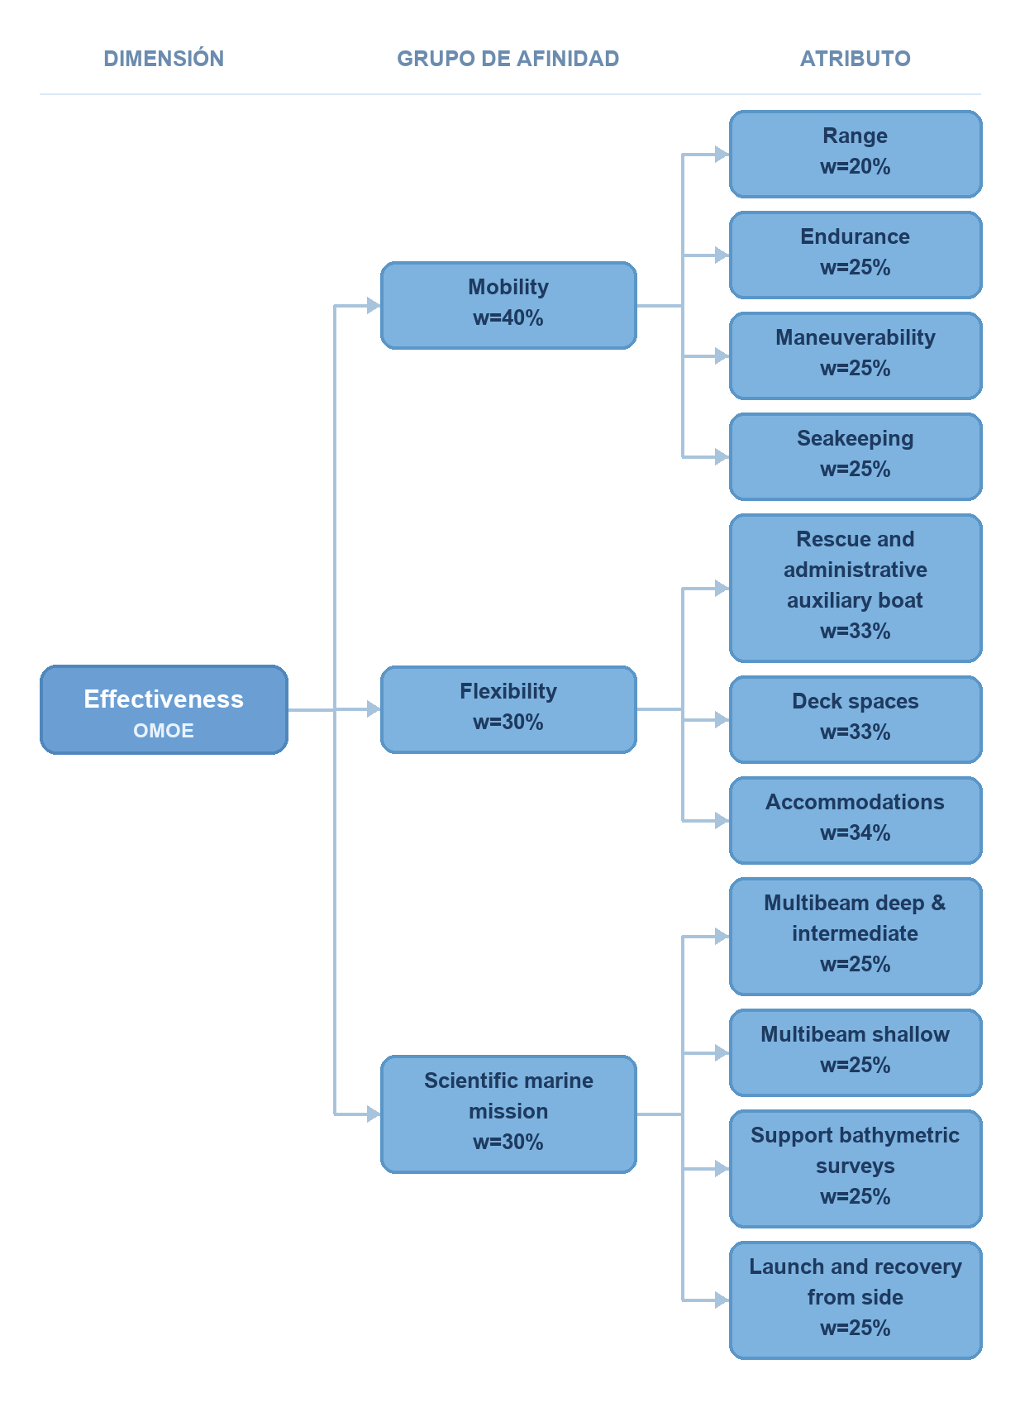

Escenario: M1 — Oceanography, hydrography and geophysics (con pesos)
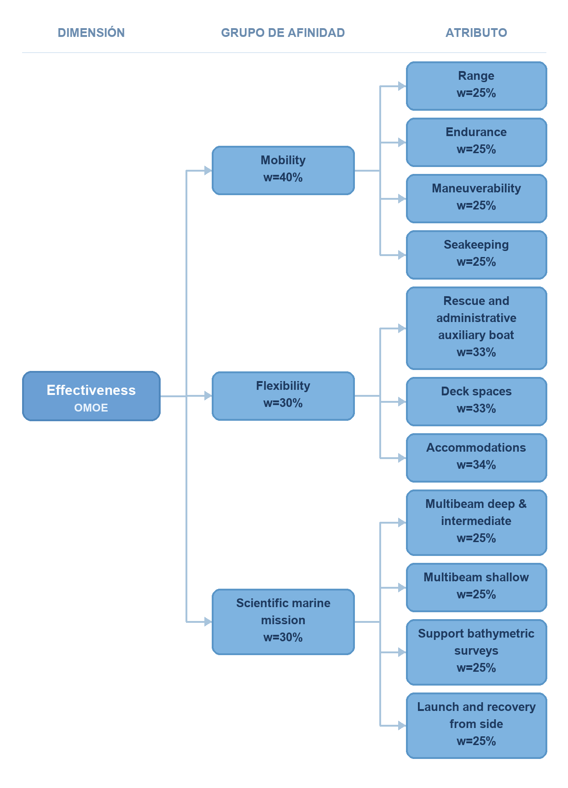

Escenario: M2 — Protection of human life at sea (con pesos)


Escenario: M3 — Humanitarian assistance and logistic support (con pesos)


Escenario: M4 — Support to aids to navigation (con pesos)


Escenario: M5 — Marine environment protection (con pesos)


Cost (OMOC)
Árbol estándar / completo (con pesos)
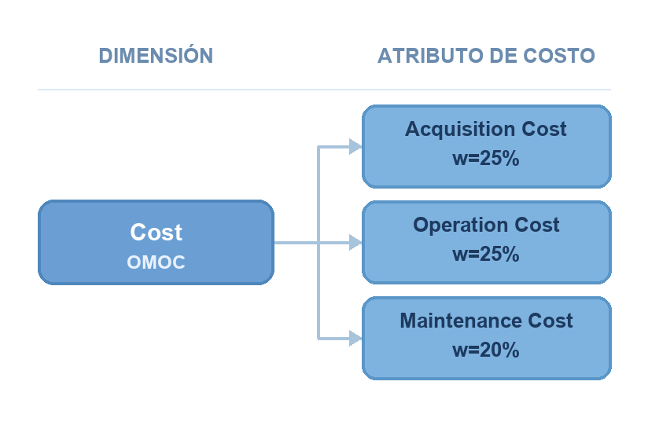
Escenario: Escenario base (con pesos)
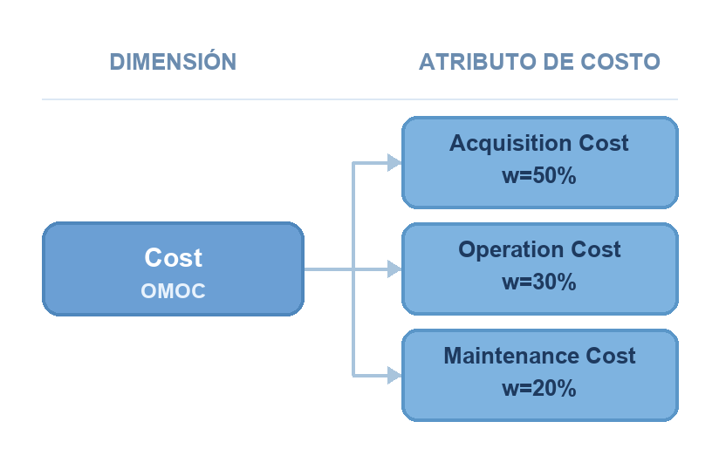

Risk (OMOR)
Árbol estándar / completo (con pesos)
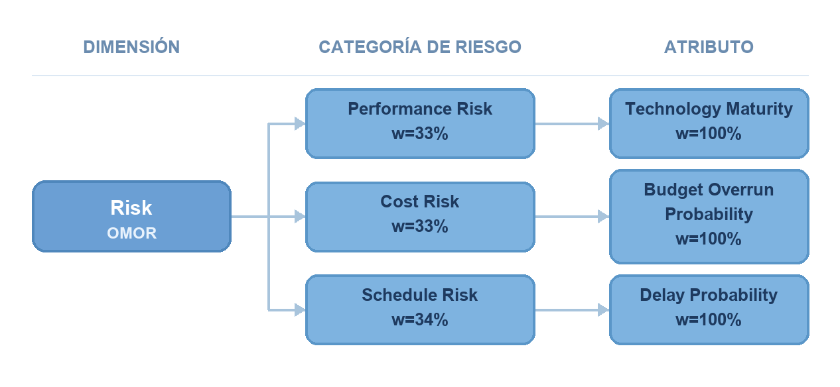
Escenario: Escenario base (con pesos)


1.2. Definición de las alternativas
Tabla 2. Definición de las alternativas
Alternativa | Descripción | Referencia | Costo declarado | Capacidades | Características
Ship_A | Importado desde oceanographic_alternatives.json | oceanographic-demo | 140.68 MUSD | — | —
Ship_B | Importado desde oceanographic_alternatives.json | oceanographic-demo | 155.82 MUSD | — | —
Ship_C | Importado desde oceanographic_alternatives.json | oceanographic-demo | 117.62 MUSD | — | —
Ship_D | Importado desde oceanographic_alternatives.json | oceanographic-demo | 50.43 MUSD | — | —
Ship_E | Importado desde oceanographic_alternatives.json | oceanographic-demo | 107.00 MUSD | — | —
Ship_F | Importado desde oceanographic_alternatives.json | oceanographic-demo | 222.92 MUSD | — | —

1.3. Tabla de definición de la estructura jerárquica
Effectiveness · Escenario: M1 — Oceanography, hydrography and geophysics
Tabla 3. Estructura jerárquica — Effectiveness — M1 — Oceanography, hydrography and geophysics
Escenario | Dimensión | Grupo de afinidad | Nodo intermedio — MOB | Nodo terminal — DT | Descripción o función
M1 — Oceanography, hydrography and geophysics | Effectiveness | Mobility | — | Range | Función: min_max · L=1000, U=6000
 |  |  |  | Endurance | Función: min_max · L=15, U=60
 |  |  |  | Maneuverability | Función: escalas_discretas
 |  |  |  | Seakeeping | Función: escalas_discretas
 |  | Flexibility |  | Rescue and administrative auxiliary boat | Función: escalas_discretas
 |  |  |  | Deck spaces | Función: min_max · L=50, U=300
 |  |  |  | Accommodations | Función: min_max · L=20, U=150
 |  | Scientific marine mission |  | Multibeam deep & intermediate | Función: escalas_discretas
 |  |  |  | Multibeam shallow | Función: escalas_discretas
 |  |  |  | Support bathymetric surveys | Función: escalas_discretas
 |  |  |  | Launch and recovery from side | Función: escalas_discretas

Effectiveness · Escenario: M2 — Protection of human life at sea
Tabla 4. Estructura jerárquica — Effectiveness — M2 — Protection of human life at sea
Escenario | Dimensión | Grupo de afinidad | Nodo intermedio — MOB | Nodo terminal — DT | Descripción o función
M2 — Protection of human life at sea | Effectiveness | Mobility | — | Range | Función: min_max · L=1000, U=6000
 |  |  |  | Endurance | Función: min_max · L=15, U=60
 |  |  |  | Maneuverability | Función: escalas_discretas
 |  |  |  | Seakeeping | Función: escalas_discretas
 |  | Flexibility |  | Rescue and administrative auxiliary boat | Función: escalas_discretas
 |  |  |  | Deck spaces | Función: min_max · L=50, U=300
 |  |  |  | Accommodations | Función: min_max · L=20, U=150
 |  | Scientific marine mission |  | Multibeam deep & intermediate | Función: escalas_discretas
 |  |  |  | Multibeam shallow | Función: escalas_discretas
 |  |  |  | Support bathymetric surveys | Función: escalas_discretas
 |  |  |  | Launch and recovery from side | Función: escalas_discretas

Effectiveness · Escenario: M3 — Humanitarian assistance and logistic support
Tabla 5. Estructura jerárquica — Effectiveness — M3 — Humanitarian assistance and logistic support
Escenario | Dimensión | Grupo de afinidad | Nodo intermedio — MOB | Nodo terminal — DT | Descripción o función
M3 — Humanitarian assistance and logistic support | Effectiveness | Mobility | — | Range | Función: min_max · L=1000, U=6000
 |  |  |  | Endurance | Función: min_max · L=15, U=60
 |  |  |  | Maneuverability | Función: escalas_discretas
 |  |  |  | Seakeeping | Función: escalas_discretas
 |  | Flexibility |  | Rescue and administrative auxiliary boat | Función: escalas_discretas
 |  |  |  | Deck spaces | Función: min_max · L=50, U=300
 |  |  |  | Accommodations | Función: min_max · L=20, U=150
 |  | Scientific marine mission |  | Multibeam deep & intermediate | Función: escalas_discretas
 |  |  |  | Multibeam shallow | Función: escalas_discretas
 |  |  |  | Support bathymetric surveys | Función: escalas_discretas
 |  |  |  | Launch and recovery from side | Función: escalas_discretas

Effectiveness · Escenario: M4 — Support to aids to navigation
Tabla 6. Estructura jerárquica — Effectiveness — M4 — Support to aids to navigation
Escenario | Dimensión | Grupo de afinidad | Nodo intermedio — MOB | Nodo terminal — DT | Descripción o función
M4 — Support to aids to navigation | Effectiveness | Mobility | — | Range | Función: min_max · L=1000, U=6000
 |  |  |  | Endurance | Función: min_max · L=15, U=60
 |  |  |  | Maneuverability | Función: escalas_discretas
 |  |  |  | Seakeeping | Función: escalas_discretas
 |  | Flexibility |  | Rescue and administrative auxiliary boat | Función: escalas_discretas
 |  |  |  | Deck spaces | Función: min_max · L=50, U=300
 |  |  |  | Accommodations | Función: min_max · L=20, U=150
 |  | Scientific marine mission |  | Multibeam deep & intermediate | Función: escalas_discretas
 |  |  |  | Multibeam shallow | Función: escalas_discretas
 |  |  |  | Support bathymetric surveys | Función: escalas_discretas
 |  |  |  | Launch and recovery from side | Función: escalas_discretas

Effectiveness · Escenario: M5 — Marine environment protection
Tabla 7. Estructura jerárquica — Effectiveness — M5 — Marine environment protection
Escenario | Dimensión | Grupo de afinidad | Nodo intermedio — MOB | Nodo terminal — DT | Descripción o función
M5 — Marine environment protection | Effectiveness | Mobility | — | Range | Función: min_max · L=1000, U=6000
 |  |  |  | Endurance | Función: min_max · L=15, U=60
 |  |  |  | Maneuverability | Función: escalas_discretas
 |  |  |  | Seakeeping | Función: escalas_discretas
 |  | Flexibility |  | Rescue and administrative auxiliary boat | Función: escalas_discretas
 |  |  |  | Deck spaces | Función: min_max · L=50, U=300
 |  |  |  | Accommodations | Función: min_max · L=20, U=150
 |  | Scientific marine mission |  | Multibeam deep & intermediate | Función: escalas_discretas
 |  |  |  | Multibeam shallow | Función: escalas_discretas
 |  |  |  | Support bathymetric surveys | Función: escalas_discretas
 |  |  |  | Launch and recovery from side | Función: escalas_discretas

Cost · Escenario: Escenario base
Tabla 8. Estructura jerárquica — Cost — Escenario base
Escenario | Dimensión | Grupo de afinidad | Nodo intermedio — MOB | Nodo terminal — DT | Descripción o función
Escenario base | Cost | — | — | Acquisition Cost | Función: razon_inversa · L=250, U=50
 |  |  |  | Operation Cost | Función: razon_inversa · L=20, U=2
 |  |  |  | Maintenance Cost | Función: min_max · L=10, U=1

Risk · Escenario: Escenario base
Tabla 9. Estructura jerárquica — Risk — Escenario base
Escenario | Dimensión | Grupo de afinidad | Nodo intermedio — MOB | Nodo terminal — DT | Descripción o función
Escenario base | Risk | Performance Risk | — | Technology Maturity | Función: escalas_discretas
 |  | Cost Risk |  | Budget Overrun Probability | Función: escalas_discretas
 |  | Schedule Risk |  | Delay Probability | Función: min_max · L=100, U=0

1.4. Tabla de pesos por nodo
Effectiveness · Escenario: M1 — Oceanography, hydrography and geophysics
Tabla 10. Pesos por nodo — Effectiveness — M1 — Oceanography, hydrography and geophysics
Escenario | Dimensión | Grupo de afinidad | Nodo intermedio | Nodo terminal | Peso | Función de utilidad
M1 — Oceanography, hydrography and geophysics | Effectiveness | Mobility | — | Range | 20 % | min_max · L=1000, U=6000
 |  |  |  | Endurance | 25 % | min_max · L=15, U=60
 |  |  |  | Maneuverability | 25 % | escalas_discretas
 |  |  |  | Seakeeping | 25 % | escalas_discretas
 |  | Flexibility |  | Rescue and administrative auxiliary boat | 33 % | escalas_discretas
 |  |  |  | Deck spaces | 33 % | min_max · L=50, U=300
 |  |  |  | Accommodations | 34 % | min_max · L=20, U=150
 |  | Scientific marine mission |  | Multibeam deep & intermediate | 25 % | escalas_discretas
 |  |  |  | Multibeam shallow | 25 % | escalas_discretas
 |  |  |  | Support bathymetric surveys | 25 % | escalas_discretas
 |  |  |  | Launch and recovery from side | 25 % | escalas_discretas

Effectiveness · Escenario: M2 — Protection of human life at sea
Tabla 11. Pesos por nodo — Effectiveness — M2 — Protection of human life at sea
Escenario | Dimensión | Grupo de afinidad | Nodo intermedio | Nodo terminal | Peso | Función de utilidad
M2 — Protection of human life at sea | Effectiveness | Mobility | — | Range | 20 % | min_max · L=1000, U=6000
 |  |  |  | Endurance | 25 % | min_max · L=15, U=60
 |  |  |  | Maneuverability | 25 % | escalas_discretas
 |  |  |  | Seakeeping | 25 % | escalas_discretas
 |  | Flexibility |  | Rescue and administrative auxiliary boat | 33 % | escalas_discretas
 |  |  |  | Deck spaces | 33 % | min_max · L=50, U=300
 |  |  |  | Accommodations | 34 % | min_max · L=20, U=150
 |  | Scientific marine mission |  | Multibeam deep & intermediate | 25 % | escalas_discretas
 |  |  |  | Multibeam shallow | 25 % | escalas_discretas
 |  |  |  | Support bathymetric surveys | 25 % | escalas_discretas
 |  |  |  | Launch and recovery from side | 25 % | escalas_discretas

Effectiveness · Escenario: M3 — Humanitarian assistance and logistic support
Tabla 12. Pesos por nodo — Effectiveness — M3 — Humanitarian assistance and logistic support
Escenario | Dimensión | Grupo de afinidad | Nodo intermedio | Nodo terminal | Peso | Función de utilidad
M3 — Humanitarian assistance and logistic support | Effectiveness | Mobility | — | Range | 20 % | min_max · L=1000, U=6000
 |  |  |  | Endurance | 25 % | min_max · L=15, U=60
 |  |  |  | Maneuverability | 25 % | escalas_discretas
 |  |  |  | Seakeeping | 25 % | escalas_discretas
 |  | Flexibility |  | Rescue and administrative auxiliary boat | 33 % | escalas_discretas
 |  |  |  | Deck spaces | 33 % | min_max · L=50, U=300
 |  |  |  | Accommodations | 34 % | min_max · L=20, U=150
 |  | Scientific marine mission |  | Multibeam deep & intermediate | 25 % | escalas_discretas
 |  |  |  | Multibeam shallow | 25 % | escalas_discretas
 |  |  |  | Support bathymetric surveys | 25 % | escalas_discretas
 |  |  |  | Launch and recovery from side | 25 % | escalas_discretas

Effectiveness · Escenario: M4 — Support to aids to navigation
Tabla 13. Pesos por nodo — Effectiveness — M4 — Support to aids to navigation
Escenario | Dimensión | Grupo de afinidad | Nodo intermedio | Nodo terminal | Peso | Función de utilidad
M4 — Support to aids to navigation | Effectiveness | Mobility | — | Range | 20 % | min_max · L=1000, U=6000
 |  |  |  | Endurance | 25 % | min_max · L=15, U=60
 |  |  |  | Maneuverability | 25 % | escalas_discretas
 |  |  |  | Seakeeping | 25 % | escalas_discretas
 |  | Flexibility |  | Rescue and administrative auxiliary boat | 33 % | escalas_discretas
 |  |  |  | Deck spaces | 33 % | min_max · L=50, U=300
 |  |  |  | Accommodations | 34 % | min_max · L=20, U=150
 |  | Scientific marine mission |  | Multibeam deep & intermediate | 25 % | escalas_discretas
 |  |  |  | Multibeam shallow | 25 % | escalas_discretas
 |  |  |  | Support bathymetric surveys | 25 % | escalas_discretas
 |  |  |  | Launch and recovery from side | 25 % | escalas_discretas

Effectiveness · Escenario: M5 — Marine environment protection
Tabla 14. Pesos por nodo — Effectiveness — M5 — Marine environment protection
Escenario | Dimensión | Grupo de afinidad | Nodo intermedio | Nodo terminal | Peso | Función de utilidad
M5 — Marine environment protection | Effectiveness | Mobility | — | Range | 20 % | min_max · L=1000, U=6000
 |  |  |  | Endurance | 25 % | min_max · L=15, U=60
 |  |  |  | Maneuverability | 25 % | escalas_discretas
 |  |  |  | Seakeeping | 25 % | escalas_discretas
 |  | Flexibility |  | Rescue and administrative auxiliary boat | 33 % | escalas_discretas
 |  |  |  | Deck spaces | 33 % | min_max · L=50, U=300
 |  |  |  | Accommodations | 34 % | min_max · L=20, U=150
 |  | Scientific marine mission |  | Multibeam deep & intermediate | 25 % | escalas_discretas
 |  |  |  | Multibeam shallow | 25 % | escalas_discretas
 |  |  |  | Support bathymetric surveys | 25 % | escalas_discretas
 |  |  |  | Launch and recovery from side | 25 % | escalas_discretas

Cost · Escenario: Escenario base
Tabla 15. Pesos por nodo — Cost — Escenario base
Escenario | Dimensión | Grupo de afinidad | Nodo intermedio | Nodo terminal | Peso | Función de utilidad
Escenario base | Cost | — | — | Acquisition Cost | 25 % | razon_inversa · L=250, U=50
 |  |  |  | Operation Cost | 25 % | razon_inversa · L=20, U=2
 |  |  |  | Maintenance Cost | 20 % | min_max · L=10, U=1

Risk · Escenario: Escenario base
Tabla 16. Pesos por nodo — Risk — Escenario base
Escenario | Dimensión | Grupo de afinidad | Nodo intermedio | Nodo terminal | Peso | Función de utilidad
Escenario base | Risk | Performance Risk | — | Technology Maturity | 100 % | escalas_discretas
 |  | Cost Risk |  | Budget Overrun Probability | 100 % | escalas_discretas
 |  | Schedule Risk |  | Delay Probability | 100 % | min_max · L=100, U=0

Etapa 2. Matrices de evaluación
2.1. Organización de la matriz
Las tablas de evaluación se presentan transpuestas respecto al módulo de carga: filas = alternativas, columnas = nodos terminales. Los valores son las entradas x registradas por el usuario. La matriz bruta (2.3) es el resultado agregado del cálculo por dimensión, antes de Pareto, normalización o método multicriterio.
2.2. Evaluaciones por dimensión y escenario
Effectiveness
Escenario: M1 — Oceanography, hydrography and geophysics
Tabla 17. Evaluación — Effectiveness — M1 — Oceanography, hydrography and geophysics
Alternativa | Multibeam deep & intermediate | Range | Rescue and administrative auxiliary boat | Deck spaces | Endurance | Multibeam shallow | Accommodations | Maneuverability | Support bathymetric surveys | Launch and recovery from side | Seakeeping
Ship_A | No | 4197.1339922894185 | None | 84.88448213128598 | 16.12548398502001 | Yes | 33.32437290229598 | Medium | No | Basic | Poor
Ship_B | No | 4509.101567292757 | 2+ Boats | 92.78466204952424 | 45.75964494915003 | Yes | 114.7864837335454 | Low | Yes | Advanced | Excellent
Ship_C | Yes | 4408.5518451328735 | 1 Boat | 77.8880433989691 | 39.163664868395784 | No | 76.51948258698366 | Medium | Yes | Basic | Excellent
Ship_D | Yes | 4155.514786350494 | None | 178.53902995214727 | 25.302380271501946 | No | 56.202044315391106 | Low | No | Advanced | Good
Ship_E | No | 5786.588204298366 | 2+ Boats | 171.66785291358235 | 59.79402102717212 | No | 44.68672274479283 | High | No | Advanced | Excellent
Ship_F | No | 5035.499716325712 | 1 Boat | 282.9390098590194 | 38.80233116710215 | Yes | 33.466245249367496 | High | No | Basic | Excellent

Escenario: M2 — Protection of human life at sea
Tabla 18. Evaluación — Effectiveness — M2 — Protection of human life at sea
Alternativa | Multibeam deep & intermediate | Range | Rescue and administrative auxiliary boat | Deck spaces | Endurance | Multibeam shallow | Accommodations | Maneuverability | Support bathymetric surveys | Launch and recovery from side | Seakeeping
Ship_A | Yes | 1468.4761993079624 | 2+ Boats | 99.70941267166212 | 25.46974020258328 | No | 104.48497691133802 | High | Yes | Advanced | Poor
Ship_B | No | 5947.616753182976 | 2+ Boats | 131.07068360383045 | 43.79998919343418 | No | 119.88076508700838 | High | No | Advanced | Poor
Ship_C | Yes | 3538.408373021626 | 2+ Boats | 176.91572049440856 | 19.788487025896725 | No | 45.85844322941529 | High | No | Advanced | Good
Ship_D | Yes | 2214.9862119786226 | None | 74.23270355720584 | 36.28378243250671 | Yes | 76.03665371282908 | Medium | Yes | Basic | Poor
Ship_E | No | 1285.8263645374154 | None | 64.21989493217113 | 41.2879917506537 | No | 86.0177046091444 | High | No | Basic | Excellent
Ship_F | Yes | 4712.083419904993 | None | 229.40304678469948 | 21.99515593987457 | Yes | 46.46765060256888 | Medium | Yes | Basic | Excellent

Escenario: M3 — Humanitarian assistance and logistic support
Tabla 19. Evaluación — Effectiveness — M3 — Humanitarian assistance and logistic support
Alternativa | Multibeam deep & intermediate | Range | Rescue and administrative auxiliary boat | Deck spaces | Endurance | Multibeam shallow | Accommodations | Maneuverability | Support bathymetric surveys | Launch and recovery from side | Seakeeping
Ship_A | Yes | 5047.152283389133 | 1 Boat | 135.06262912949796 | 15.292444185512746 | No | 40.212334975531604 | Low | No | Advanced | Excellent
Ship_B | Yes | 3005.8239351116445 | 1 Boat | 103.15663601353515 | 17.978487234519626 | No | 84.90006373399605 | High | Yes | Basic | Excellent
Ship_C | No | 3443.0285401447395 | None | 64.4812916235469 | 20.034047639440278 | No | 134.14124789652527 | Medium | Yes | Basic | Good
Ship_D | No | 4366.822736466507 | 1 Boat | 232.05339711029566 | 59.287434511468476 | No | 124.07702641202084 | Low | No | Basic | Poor
Ship_E | Yes | 3018.8777565913874 | 2+ Boats | 198.6297883833603 | 57.37182572530902 | Yes | 100.5195963431734 | High | Yes | Basic | Poor
Ship_F | Yes | 1461.492338563667 | None | 133.38913465127206 | 34.06090976536768 | No | 37.006555891221296 | Medium | Yes | Advanced | Poor

Escenario: M4 — Support to aids to navigation
Tabla 20. Evaluación — Effectiveness — M4 — Support to aids to navigation
Alternativa | Multibeam deep & intermediate | Range | Rescue and administrative auxiliary boat | Deck spaces | Endurance | Multibeam shallow | Accommodations | Maneuverability | Support bathymetric surveys | Launch and recovery from side | Seakeeping
Ship_A | Yes | 1483.5818841673201 | None | 232.43294667345447 | 53.13724648563569 | No | 89.7096518891111 | High | Yes | Advanced | Good
Ship_B | Yes | 2233.137538469917 | 2+ Boats | 157.10845682364493 | 40.26156603734179 | No | 95.85928024293531 | Medium | No | Advanced | Excellent
Ship_C | Yes | 5889.922468386671 | 2+ Boats | 168.82059452468283 | 38.97177762882821 | Yes | 91.4744671543427 | Low | No | Basic | Poor
Ship_D | Yes | 3681.428769551722 | 1 Boat | 112.45161197052512 | 21.308203369264852 | No | 140.02452790588165 | Low | No | Basic | Good
Ship_E | Yes | 4348.629873849146 | None | 217.92255573999282 | 29.138273825800923 | No | 58.999620373839086 | Medium | No | Advanced | Good
Ship_F | No | 3804.534323873732 | 2+ Boats | 59.00703451520765 | 20.034324626520075 | Yes | 67.99807798658492 | High | No | Basic | Poor

Escenario: M5 — Marine environment protection
Tabla 21. Evaluación — Effectiveness — M5 — Marine environment protection
Alternativa | Multibeam deep & intermediate | Range | Rescue and administrative auxiliary boat | Deck spaces | Endurance | Multibeam shallow | Accommodations | Maneuverability | Support bathymetric surveys | Launch and recovery from side | Seakeeping
Ship_A | No | 3886.76072628381 | None | 243.26708519717297 | 46.70573262967156 | No | 148.0787976858985 | Low | Yes | Advanced | Excellent
Ship_B | No | 1454.5470608689695 | 2+ Boats | 89.99550043061257 | 17.120236894113056 | Yes | 108.46255775452252 | Low | Yes | Advanced | Poor
Ship_C | No | 4564.744864095609 | 1 Boat | 159.525020978626 | 32.954653499884316 | No | 87.28485933462679 | High | No | Basic | Excellent
Ship_D | Yes | 5844.9812864237565 | 1 Boat | 171.4102813626796 | 56.68651423536574 | No | 47.78714889589362 | Low | No | Advanced | Poor
Ship_E | Yes | 4105.796277465464 | 2+ Boats | 103.2885780667601 | 40.33471405375258 | No | 54.47605391755218 | Low | No | Advanced | Poor
Ship_F | Yes | 2541.2917496506684 | None | 220.51667207764413 | 55.45416699341655 | Yes | 106.70134338262059 | Low | No | Basic | Good

Cost
Escenario: Escenario base
Tabla 22. Evaluación — Cost — Escenario base
Alternativa | Acquisition Cost | Operation Cost | Maintenance Cost
Ship_A | 140.6820604736871 | 17.013987679533507 | 2.4638868744047633
Ship_B | 155.8228690198274 | 19.479410797045126 | 8.747017320110483
Ship_C | 117.61711242949107 | 12.589556932230199 | 3.071032593369193
Ship_D | 50.43107567028529 | 9.027591636580638 | 9.338662662034
Ship_E | 106.99747824333134 | 9.887322314138778 | 5.888961660354282
Ship_F | 222.9211392439928 | 19.571708592757332 | 8.296945479463572

Risk
Escenario: Escenario base
Tabla 23. Evaluación — Risk — Escenario base
Alternativa | Budget Overrun Probability | Delay Probability | Technology Maturity
Ship_A | High | 67.01751743776934 | Proven
Ship_B | Low | 72.07218193601946 | Experimental
Ship_C | High | 7.099308600903253 | Experimental
Ship_D | Medium | 42.30074859901629 | Proven
Ship_E | Low | 98.38533102514823 | Proven
Ship_F | High | 17.9360663418207 | Proven

2.3. Matriz bruta o matriz inicial
Matriz que arroja el cálculo al inicio: alternativas × dimensiones con el valor agregado de cada dimensión, antes de filtro de Pareto, normalización o MADM (equivalente a la «matriz de utilidades» / matriz original del cálculo).
Tabla 24. Matriz bruta del cálculo (alternativas × dimensiones)
Alternativa | Effectiveness | Cost | Risk
Sentido | Maximizar | Minimizar | Minimizar
Ship_A | 0.4741 | 0.5095 | 0.5579
Ship_B | 0.5449 | 0.7280 | 0.5750
Ship_C | 0.4816 | 0.3916 | 0.0241
Ship_D | 0.4029 | 0.3035 | 0.6388
Ship_E | 0.5060 | 0.3826 | 0.9945
Ship_F | 0.4718 | 0.8873 | 0.3910

