Kloudio: A Solitaire Game Using Two Standard 52-Card Decks

1. Objective of the Game

The primary objective of the solitaire named Kloudio is to build eight complete suit sequences. Each of the eight sequences corresponds to one of the four standard suits, duplicated across the two decks, as they appear in a couple of standard 52 cards Decks. 2 decks of standard 52 cards provide eight piles; These can be built in either the central Foundation Piles or the outer King Piles.

Build Foundation Piles in the central area, starting with an Ace and building up in the same suit to a King (e.g., Ace♣, 2♣, ..., King♣).
Build King Piles in the four designated surrounding positions, starting with a King and being built down in the same suit to an Ace (e.g., King♠, Queen♠, ..., Ace♠).

According to the game player strategy, it is possible to choose where to build each suit. If you have available Ace♥, and both Kings♥ It is perfectly accepted to play the Ace♥ in the foundation center and the Kings♥ in two available foundations king, completing the two possibles suits in any of the three in progress foundations freeing the third one—either a central Foundation or a King Pile—for a new sequence.

When both an Ace sequence and a King sequence of the same suit are in progress, the player may choose whether to build upward or downward for that suit.
Example: If the top card of the Ace Foundation is 6♥ and the top card of a King Pile is 8♥, the player may choose to place the available 7♥ on either pile.

The game is won when all 104 cards (from two decks) are successfully played onto these eight piles and the piles are set aside off the game.

2. Materials Needed

Two standard 52-card decks (104 cards total) shuffled together.

3. Game Setup

The playing area is organized as follows:

A. Central Foundation Area:

This area is initially empty. Aces will be placed here to start Foundation Piles. As two decks are used, up to eight Foundation Piles can be built (two for each suit). Only one Ace Foundation can be active in the central spot at a time.

B. King Pile Positions:
Four designated empty spaces on the corners of the Central Foundation Area. Kings will be placed here as they become available to start King Piles. Only four stacks of kings can be active at a time, and the suits can be duplicated.

C. Reserve Piles (Ten Face-Down Stacked Cards):
The Deal is done starting from the North position, and clockwise, forming four piles of 10 cards each, placed face down. They are arranged in a square or cross formation around the Central Foundation Area (North, East, South and West as sides of the square). North and South in horizontal position. East and West in vertical position.
Dealing method: Deal one card to the North pile, then one to East, one to South, one to West. Repeat this clockwise dealing pattern until each of the four Reserve Piles completes the 10 face-down cards (40 cards total).

D. Tableau Piles:
Next to each of the four Reserve Piles, deal three cards face-up to form four Tableau Piles. These cards should be Staggered Column or cascaded so that all three cards in each pile are 2 of them partially visible and the top one completely visible. North and South in Staggered Horizontal Column and East and West in Staggered Vertical Column

Dealing method: After dealing with the Reserve Piles, deal one card face-up to the North Tableau (horizontally), one to East (vertically), one to South (horizontally), one to West (vertically). Then deal a second card face-up onto each of these, slightly offset out of the square. Finally, deal a third card face-up onto each, again slightly offset (12 cards total).

E. Stockpile:
The remaining cards (104 - 40 for Reserves - 12 for Tableau = 52 cards) form the face-down Stockpile

Diagram Summary:

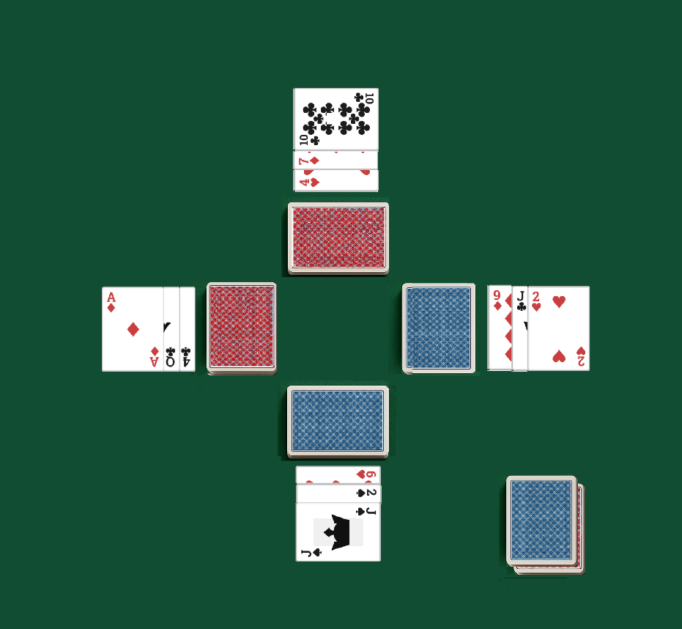
- Center: Empty (for Ace Foundations)
- Surrounding Center: 4 Empty corner spots (for King Foundations)
- Tableau Pile: 4 Reserve Pile (10 face-down cards)
- Outer Ring: 4 Piles adjacent to each reserve 10 cards pile (each with 3, staggered visible face-up cards)
- Aside: 1 Stockpile (face-down)

Figure 2.- Initial Setup
4. Rules of Play

4.1. Initial Moves (Before Drawing from Stockpile)

Examine the top face-up card of each of the four Tableau Piles.
If any of these cards can be played according to the rules below, do so:
Play an Ace to an empty Central Foundation slot.
Play a King to an empty King Pile slot.
Play a card onto an existing Pile.
4.1.1 Play onto an existing Foundation Pile (same suit, ascending rank).
4.1.2 Play onto an existing King Pile (same suit, descending rank).
Move a card from the top of one Tableau Pile to the top of another Tableau Pile if it is one rank lower and of the opposite color (e.g., Red 7 on Black 8).

4.2. Playing Cards - General Rules

Building on Central Foundation Piles (Aces):

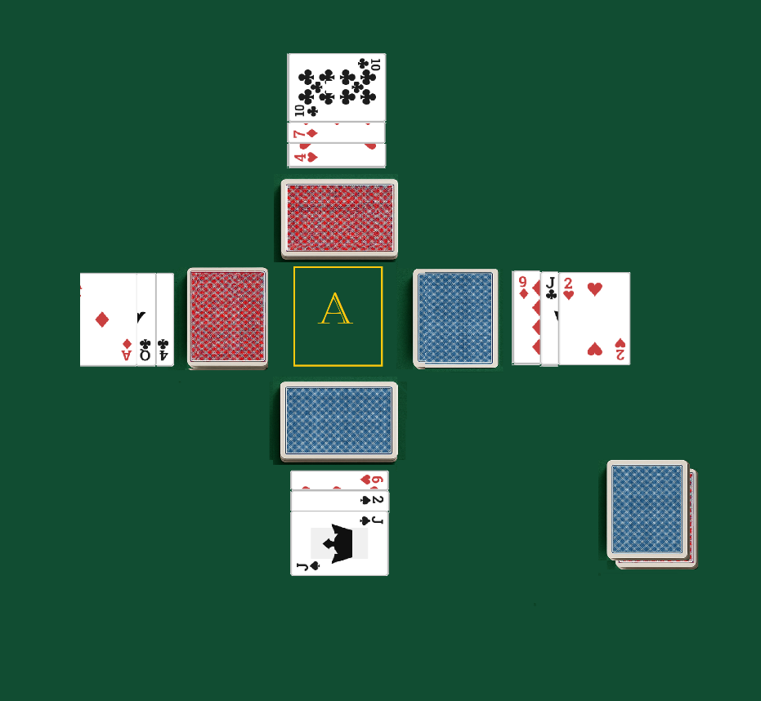
When an Ace becomes available (from Tableau, Reserve, or Stockpile draws), it can be moved to the Central Foundation Area to start a new pile. If the central area is occupied by a completed Ace-to-King sequence that has not yet been set aside, or an incomplete sequence, until the pile is either completed and removed or a space becomes available or the current sequence is completed.

Build upwards in the same suit (e.g., Ace♣, 2♣, ..., King♣).
Only the top card of a Foundation Pile is visible, but the sequence is known.
When the Central Foundation Area is finished, it is possible to clear the spot, setting aside the complete foundation.
Figure 3.- Building on Central Foundation Piles (Aces)

Building on King Piles (Kings):
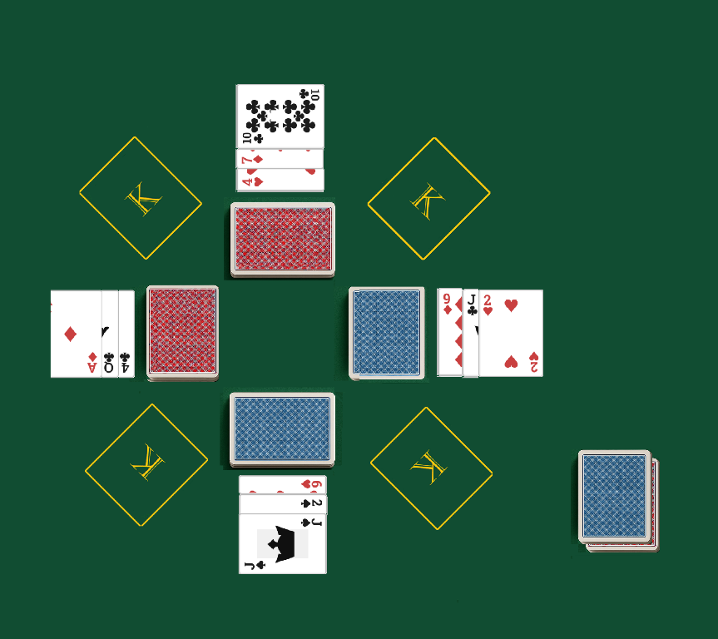
When a King becomes available, it can be moved to one of the four empty King Pile positions.
Build downwards in the same suit (e.g., King♦, Queen♦, Jack♦, ..., Ace♦).
Only the top card of a King Pile is visible, but the sequence is known.

When one of the kings Piles is finished, it is possible to clear the spot, setting aside the complete foundation, freeing the spot for a new becoming available King.

Figure 4.- Building on King Piles (Kings)

Building on Tableau Piles:

The top face-up card of any Tableau Pile is available for play onto Foundations, King Piles, or another Tableau Pile.
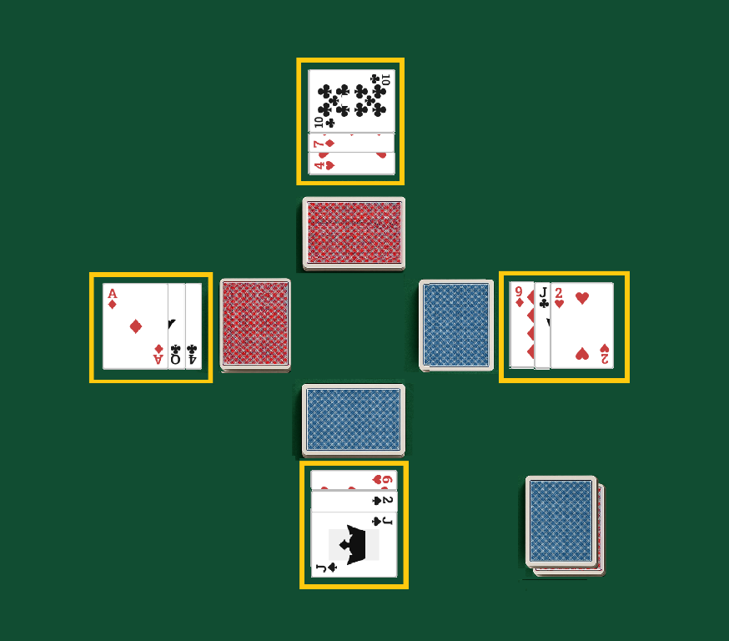
Move a card from the top of one Tableau Pile to the top of another Tableau Pile, if the card being moved is one rank lower and of the opposite color to the card it is being placed upon (e.g., a black Jack onto a red Queen).
When a card is moved from a Tableau Pile, if it exposes a card beneath it (from the initial staggered 3 cards), that newly exposed card becomes playable.

If all three initial face-up cards from a Tableau Pile are played, the top card of its corresponding Reserve Pile is turned face-up and becomes the new top card of that Tableau Pile, available for play.
Figure 5.- Building on Tableau Piles

Managing Reserve Piles:
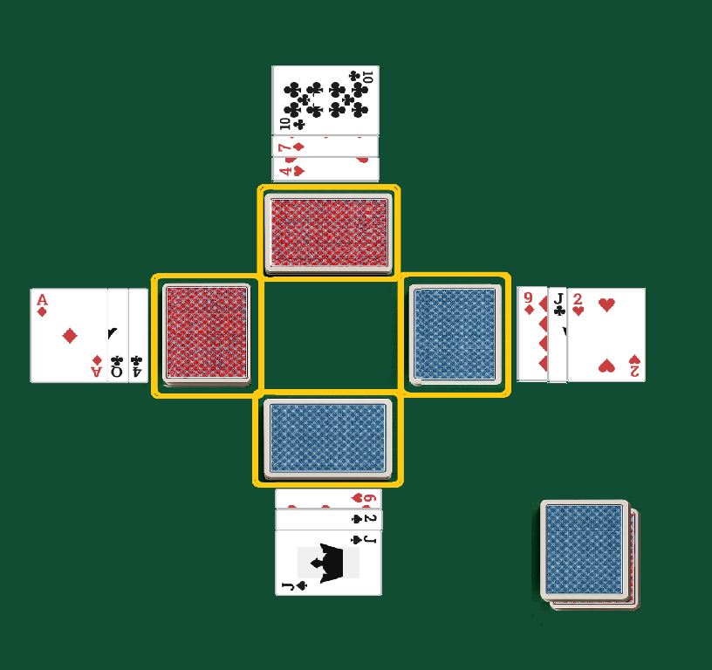
When a Tableau Pile becomes empty of its initial three face-up cards (or subsequent cards turned up from its reserve), the top card of its associated 10-card face-down Reserve Pile is turned face-up and placed onto that Tableau Pile. This card is now available for play. This continues until the Reserve Pile is exhausted.

At all times the top cards visible in the foundation or Kings piles, are available for play onto Foundations, King Piles, or Tableau Pile, once a Reserve Pile is exhausted, its corresponding Tableau Pile cannot be refilled.
Figure 6.- Managing Reserve Piles:

4.3. Stockpile Drawing Phases
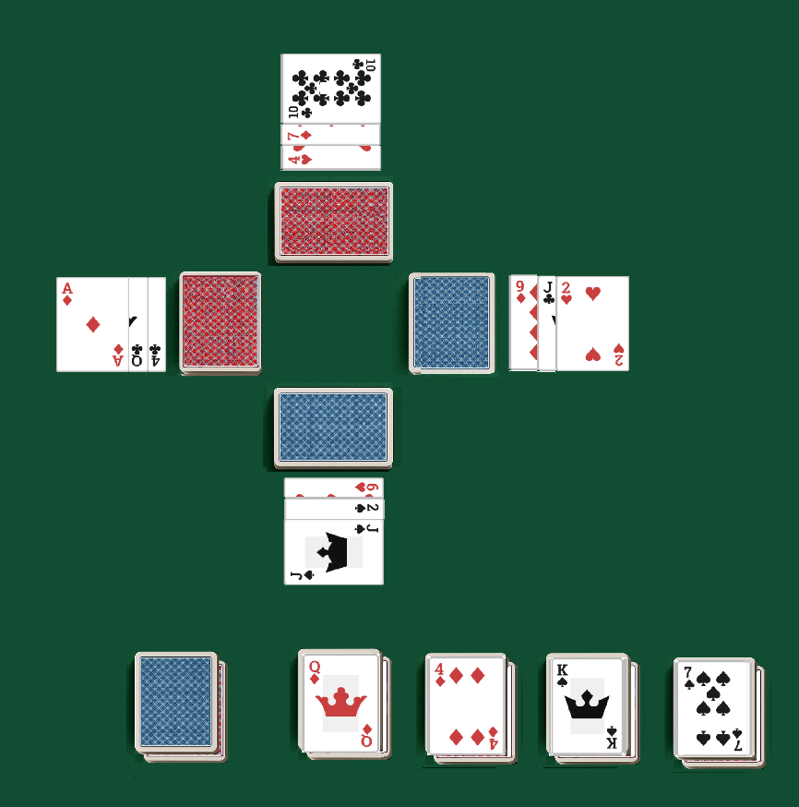
The Stockpile is drawn through multiple times, each time forming temporary stacks, and decreasing the number of stacks formed in subsequent passes.

First Drawing Phase (Building Four Temporary Stacks):

Draw four cards from the face-down Stockpile. Place them face-up, side-by-side, from left to right, to start four temporary stacks (Stack 1, Stack 2, Stack 3, Stack 4).
Play any available top cards from these four temporary stacks according to the general playing rules (to Foundations, King Piles, or Tableau Piles).

Repeat: Draw the next four cards from the Stockpile and place one face-up on top of each of the four temporary stacks.
Figure 7.- First Drawing Phase (Building Four Temporary Stacks)
Again, play any available top cards. If played the top card of a temporary stack, the new top card is now playable, and so on.
Continue this process (drawing four cards, distributing one to each stack, playing available cards) until the entire Stockpile is exhausted.
Consolidation 1: Once the Stockpile is empty, pick-up Stack 4 and place it face-up on top of Stack 3. Place this combined stack on top of Stack 2. Finally, place this larger combined stack on top of Stack 1. You now have one large face-up pile (the new Stockpile). Turn this entire pile face-down.

Second Drawing Phase (Building Three Temporary Stacks):
Draw three cards from the face-down Stockpile. Place them face-up, from left to right, side-by-side, to start three temporary stacks (Stack A, Stack B, Stack C).

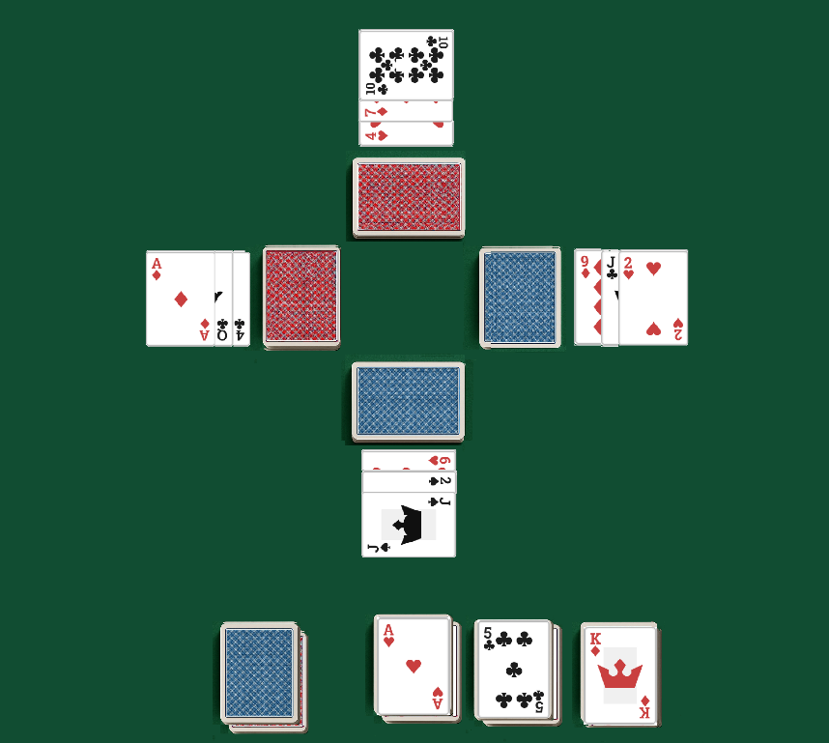
Play any available top cards.
Repeat: Draw the next three cards and place one on top of each temporary stack. Play available cards, the new top card is now playable.
Continue until the Stockpile is exhausted.
Consolidation 2: Pick up Stack C and place it on Stack B. Place this combined stack on Stack A. You now have one large face-up pile, turn this entire pile face-down (the new Stockpile).

Figure 8.- Second Drawing Phase (Building Three Temporary Stacks):
Third Drawing Phase (Building Two Temporary Stacks):
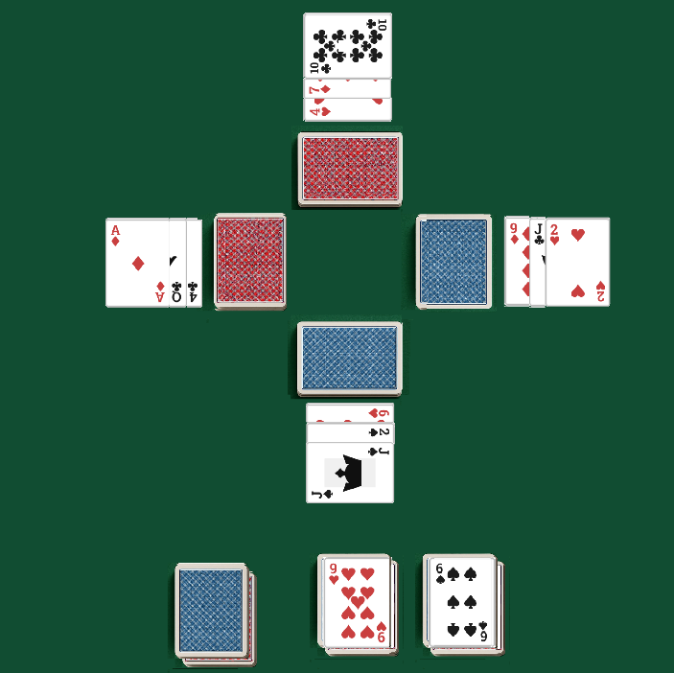
Draw two cards from the face-down Stockpile.
Place them face-up, from left to right, side-by-side, to start two temporary stacks (Stack Alpha, Stack Beta).

Play any available top cards.
Repeat: Draw the next two cards, one to each stack. Play available cards, the new top card is now playable.
Continue until the Stockpile is exhausted.
Consolidation 3: Pick up Stack Beta and place it on Stack Alpha. Turn this entire pile face-down (the new Stockpile).

Figure 9.- Third Drawing Phase (Building Two Temporary Stacks)

Fourth and last Drawing Phase (Building One Temporary Stack):
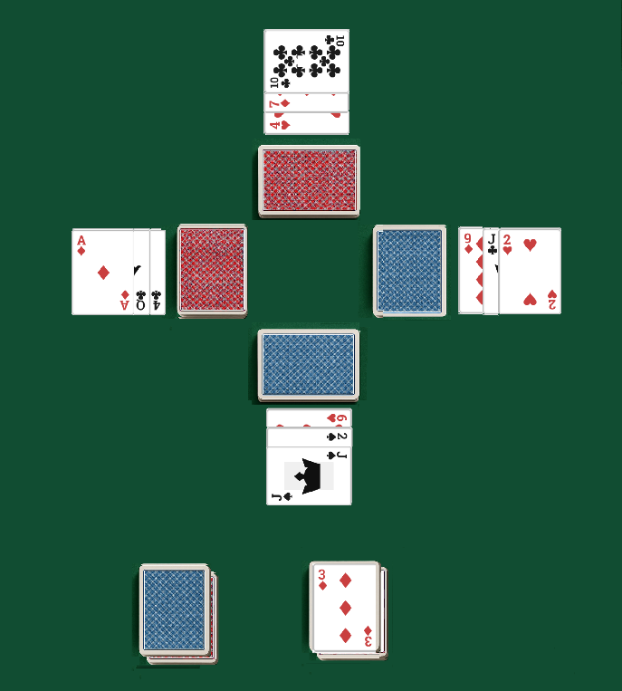
Draw one card from the face-down Stockpile and place it face-up to start one temporary stack.
Play the card if possible.

Repeat: Draw one card at a time, placing it on the single stack. Play the top card, if possible, the new top card is now playable.
Continue until the Stockpile is exhausted.

No further passes: If no more plays can be made after the Stockpile is exhausted in this fourth phase, and the game is not won, the game is lost.

The Stockpile is drawn through in four distinct phases, each reducing the number of temporary stacks (4 → 3 → 2 → 1).
Figure 10.- Fourth and last Drawing Phase)

After the fourth and final pass —where cards are drawn one at a time to form a single stack— the Stockpile is exhausted. From that point on, the game continues only as long as legal moves remain.

The game ends when no further legal moves can be made from the Tableau, Reserve, or remaining temporary stack cards, even if unplayed cards remain. (Note, the user might not intend for the single pile to be turned over and drawn through repeatedly until no moves are possible.) Based on the last instruction "4th drawing: Stack 1 Card at the time forming 1 stack", it implies this is the final pass.
Important Note for all Drawing Phases: Only the top card of each temporary stack formed during a drawing phase is available for play. Cards underneath is not playable until exposed.

4.4. Managing Completed Piles

Completed Foundation Piles (Ace to King): When a Foundation Pile in the central area is completed (Ace through King of the same suit), the entire pile is set aside of the game, freeing the central spot for a new Ace of a different or not suit/deck to start a new Foundation.
Completed King Piles (King to Ace): When a King Pile in one of the four surrounding positions is completed (King through Ace of the same suit), the entire pile is set aside, freeing that King Pile position for a new King of a different or not suit/deck.

Important Note for King Piles. For all King Foundations, the suits can be duplicated in King Piles; there is no requirement for suit uniqueness to complete the 4 foundations with the 4 suites.
Completed Suit Sequences and Reset:

A suit may be completed in either direction—Ace to King (Foundation) or King to Ace (King Pile). Since two full decks are used, a maximum of two complete sequences per suit is allowed.

It is possible to have one ascending sequence and two descending sequences of the same suit in progress. For example, if you are building an Ace-to-King Foundation and two King-to-Ace Piles of ♥, you may complete one or both sequences independently. When a sequence is completed, it is removed from play and the corresponding Foundation or King Pile spot is freed for a new sequence of any suit.

Remaining sequences of the same suit may continue to be played until they are also completed and set aside.

5. Winning the Game

The game is won when all 104 cards have been successfully played into eight complete suit sequences—whether built upward from Ace to King, downward from King to Ace, or a combination of both—and all completed piles have been set aside from play.

6. Losing the Game

The game is lost if no more legal moves can be made and not all cards have been played to their respective complete piles. This typically occurs when the Stockpile has been exhausted in its final drawing phase, and no further plays are possible from the Tableau, Reserve Piles, or Stockpile.

7. Game Flow – Quick Reference Table

Game Flow – Quick Reference Table
Area | Start Condition | Build Direction | Suit Restriction | Max Active Piles | Reset Condition
Foundation | Ace | Ascending (A → K) | Same suit | 1 active at a time | Sequence completed and removed
King Piles | King | Descending (K → A) | Same suit (duplicates allowed) | 4 | Sequence completed and removed
Tableau | 3 face-up cards | Alternating color, descending | Any | 4 | Refilled from corresponding reserve
Reserve | 10 face-down cards | N/A | Linked to Tableau | 4 | Exhausted when empty
Stockpile | 52 cards | 4→3→2→1 draw phases | Any | 1 | Game ends after 4th pass + no moves

8. Enjoy the Kloudio solitaire game. Probabilities to win are 4.4%

