DBS311NII Assignment 1

ERD for a college registration system

The following ERD illustrates the above rules:

1. A student is currently in a study program or has enrolled for study but not yet started. 1 Student is enrolled with only 1 program (and indirectly courses and sections).
2. 1 program may be associated with many students and many courses, but only 1 department.
3. 1 course belongs to only 1 program and there may be many sections for 1 course.
4. 1 section of a course is delivered by only 1 professor at a time.
5. In 1 department, there may be multiple professors and multiple programs.
6. Any 1 student or any 1 professor has only 1 financial account for tuition or pay.

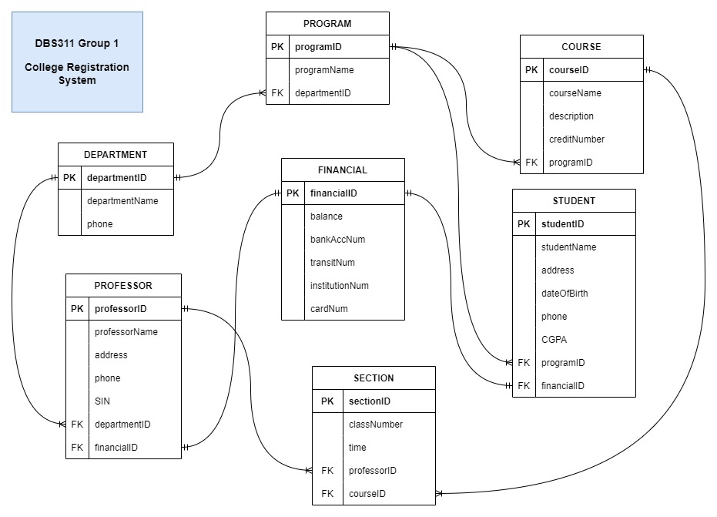

Individual input

Chungon: “course” table

