**The 1987 Constitution of The Republic of The Philippines – Article III Bill of Rights**

Section 1. No person shall be deprived of life, liberty, or property without due process of law, nor shall any person be denied the equal protection of the laws.

Section 2. The right of the people to be secure in their persons, houses, papers, and effects against unreasonable searches

Section 3. (1) The privacy of communication and correspondence shall be inviolable except upon lawful order of the court.

(2)Any evidence obtained in violation of this or the preceding section shall be inadmissible for any purpose in any proceeding.

Section 4. No law shall be passed abridging the freedom of speech, of expression, or of the press

Section 5. No law shall be made respecting an establishment of religion, or prohibiting the free exercise thereof.

Section 6. The liberty of abode and of changing the same within the limits prescribed by law shall not be impaired except upon lawful order of the court.

Section 7. The right of the people to information on matters of public concern shall be recognized.

Section 8. The right of the people, including those employed in the public and private sectors.

Section 9. Private property shall not be taken for public use without just compensation.

**Types of Speech That Maybe Forbidden by The Government (Reynolds, n.d.):**

1. Perjury 2. Fraud 3. Defamation 4. Obscene speech
2. Incitement of panic 6. Incitement to crime 7. Fighting Words
3. Sedition (incitement of discontent or rebellion against a government)

**Two of These Types of Speech That Are Particularly Relevant to Information Technology (Reynolds, 2015)**

1. Obscene Speech
2. Defamation

1. **Obscene Speech** - Obscenity refers to a narrow category of pornography that violates contemporary community standards and has no serious literary, artistic, political or scientific value.

**2.Defamation** - The right to freedom of expression is restricted when the expressions, whether spoken or written, are untrue and cause harm to another person.

**Slander and Libel** - An oral defamatory statement is slander, and a written defamatory statement is libel.

**Controlling Access to Information on the Internet** - Although there are clear and convincing arguments to support freedom of speech online, the issue is complicated by the ease with which children can access the internet.

**Communications Decency Act (CDA)** - The Telecommunications Act in the US became law in 1996. Its primary purpose was to allow freer competition among phone, cable, and TV companies.

**Section 230** of the CDA provides immunity to an Internet service provider (ISP) that publishes user-generated content.

**Child Online Protection Act (COPA)** - In October 1998, the Child Online Protection Act (COPA) was signed into law.

**Republic Act No. 10175 Cybercrime Prevention Act of 2012** - An act in the Philippines defining cybercrime, providing for the prevention, investigation, suppression and the imposition of penalties.

**According to its Chapter I, Section 2. Declaration of Policy** The State recognizes the vital role of information and communications industries such as content production, telecommunications, broadcasting electronic commerce, and data processing.

**Internet Filtering** - An internet filter is software that can be used to block access to certain Web sites that contain material deemed inappropriate or offensive.

**Children’s Internet Protection Act (CIPA) -** In another attempt to protect children from accessing pornography and other explicit material online, Congress passed the Children’s Internet Protection Act (CIPA) in 2000.

**Internet Censorship** - Internet censorship is the control or suppression of the publishing or accessing of information on the Internet.

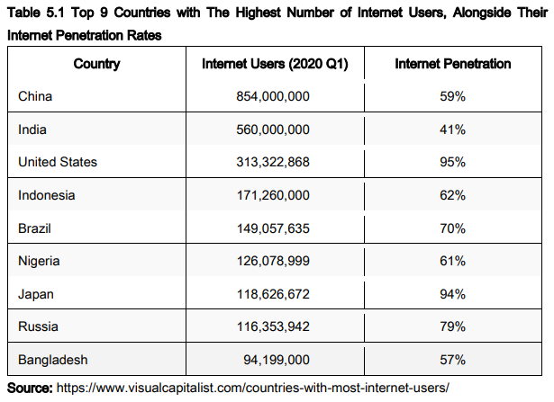

**Anonymity on the Internet**

**Anonymous expression** is the expression of opinions by people who do not reveal their identity.

**Doxing** involves the examination of Internet records in an attempt to reveal the identity of an anonymous poster.

**Hate Speech** - Persistent or malicious harassment aimed at a specific person is hate speech, which can be prosecuted under the law, but general, broad statements expressing hatred of an ethnic, racial, or religious group cannot.

**Pornography** - Many people, including some free-speech advocates, believe that there is nothing illegal or wrong about purchasing adult pornographic material made by and for consenting adults.

**Sexting** - Sending sexual messages, nude or seminude photos, or sexually explicit videos over a cellphone.

**Intellectual property** is a term used to describe works of the mind such as art, books, films, formulas, inventions, music.

**The Purpose of Intellectual Property Law** - To make sure that people with good ideas can profit from those ideas.

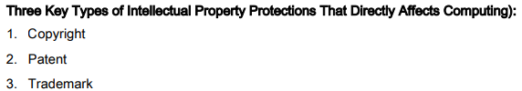

**Copyright infringement** is a violation of the rights secured by the owner of a copyright.

**Copyright Term**

Copyright law guarantees developers the rights to their works for a certain amount of time. Since 1960, the term of copyright has been extended 11 times from its original limit of 28 years.

**Eligible Works** - The types of work that can be copyrighted include architecture, art, audiovisual works, choreography, drama, graphics, literature, motion pictures, music, pantomimes, pictures, sculptures, sound recordings, and other intellectual works, as described in Title 17 of the U.S. Code.

**Fair Use Doctrine** - Copyright law tries to strike a balance between protecting an author’s rights and enabling public access to copyrighted works.

**Software Copyright Protection** - The use of copyrights to protect computer software raises many complicated issues of interpretation.

**The World Intellectual Property Organization (WIPO) Copyright Treaty (1996)** headquartered in Geneva, Switzerland, is an agency of the United Nations established in 1967.

**The Digital Millennium Copyright Act (1998)** was signed into law in 1998 and implements two 1996 WIPO treaties.

A **patent** is a grant of a property right issued by the United States Patent and Trademark Office (USPTO) to an inventor.

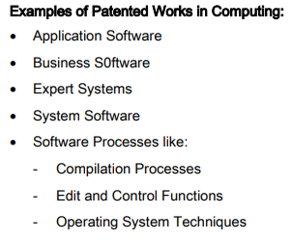

**Patent infringement**, or the violation of the rights secured by the owner of a patent.

A **software patent** claims as its invention some feature or process embodied in instructions executed by a computer.

**Plagiarism** is the act of stealing someone’s ideas or words and passing them off as one’s own.

**software defect** is any error that, if not removed, could cause a software system to fail to meet its users’ needs.

**Facebook’s Apps Outage** - In the summer of 2019 Facebook users stopped being able to view or load images from the newsfeed.

**CPUs Flaw** - Google had shocked everyone in 2018 revealing CPUs vulnerabilities which is meltdown and spectre.

**Crashed Lunar Lander** - On April 11th 2019 the history wasn’t made, but it came pretty close to it.

**British Airways Glitch** - When the busiest month for airways came along, computer system completely went down.

**Self-Driving Killer Car -** On March 18th 2018 a self-driving Uber car that was being tested on the roads.

**Software quality** is the degree to which a software product meets the needs of its users.

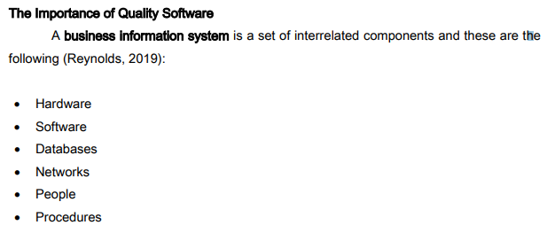

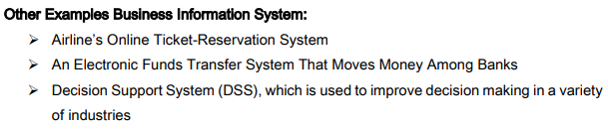

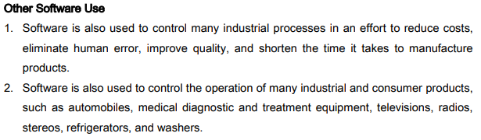

**Software Product Liability** The liability of manufacturers, sellers, lessors, and others for injuries caused by defective products is commonly referred to as **product liability**.

**Strict liability** means that the defendant is held responsible for injuring another person, regardless of negligence or intent.

**Quality assurance (QA)** refers to methods within the development cycle designed to guarantee reliable operation of a product.

**Dynamic Software Testing Software** is developed in units called subroutines or programs.

**Two Forms of Dynamic Testing**

• **Black-box testing** involves viewing the software unit as a device that has expected input and output behaviors but whose internal workings are unknown (a black box).

• **White-box testing** treats the software unit as a device that has expected input and output behaviors but whose internal workings.

**Other Types of Software Testing**

• **Static Testing -** Special software programs called static analyzers are run against new code.

• **Integration Testing -** After successful unit testing, the software units are combined into an integrated subsystem that undergoes rigorous testing.

• **System Testing** - After successful integration testing, the various subsystems are combined to test the entire system as a complete entity.

• **User Acceptance Testing** - Independent testing is performed by trained end users to ensure that the system operates as they expect.

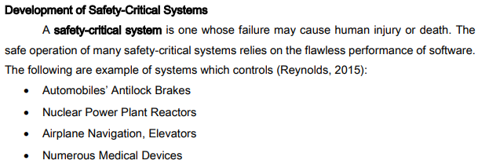

**Two Different System Characteristic**

1. **Reliability** has to do with the capability of the system to continue to perform.
2. **Safety** has to do with the ability of the system to perform in a safe manner.

**Quality Management Standards** - The International Organization for Standardization (ISO), founded in 1947.

**Failure Mode and Effects Analysis (FMEA)**

