CSE299 Project Progress Update — Section 14
Dhaka Air Quality Prediction System
Current milestone: Raw data inspection, Dhaka extraction, cleaning and standardization
Course / Section | CSE299 / Section 14
Member 1 | Nizam Uddin Nihon — 2031139342
Member 2 | Ikramun Masud Lubaba — 2232451042
Member 3 | Md Huzayfa — 2222948642
Project | Dhaka Air Quality Prediction System

Item | Current status
Data source | CAMS-BD hourly air-quality and meteorological dataset (Mendeley Data)
Raw source files | 4 workbooks: 2012-2021, 2022, 2023, 2024
Dhaka stations used | BARC, Darussalam, DoE
Cleaned rows | 206,271
Time range | 2012-11-01 to 2024-12-31
Current stage | Clean dataset prepared; model development is the next stage

1. Work completed
- Collected and opened the original CAMS-BD Mendeley dataset.
- Inspected the four yearly raw workbooks and their changing column structures.
- Identified the usable Dhaka monitoring stations: BARC, Darussalam, and DoE.
- Selected the pollution and meteorological fields required by the project.
- Standardized column names and changing column order across yearly files.
- Parsed and standardized timestamp information.
- Converted measurement fields to numeric values and treated clearly invalid sensor values as missing.
- Removed duplicate station-timestamp records and sorted the final data chronologically.
- Produced audit tables, a cleaned-data preview, and charts for evidence of progress.

2. Current cleaned dataset
Main variables: PM2.5, PM10, Temperature, Humidity, Wind Speed, Wind Direction, CO, NO, NO2, NOX, SO2, O3, Pressure, Solar Radiation, Rain, Date/Time, and Location.
Measure | Value
Cleaned rows | 206,271
PM2.5 available | 162,685 (78.9%)
PM10 available | 147,432 (71.5%)
Temperature available | 132,013 (64.0%)
Humidity available | 146,928 (71.2%)
Wind speed available | 125,821 (61.0%)

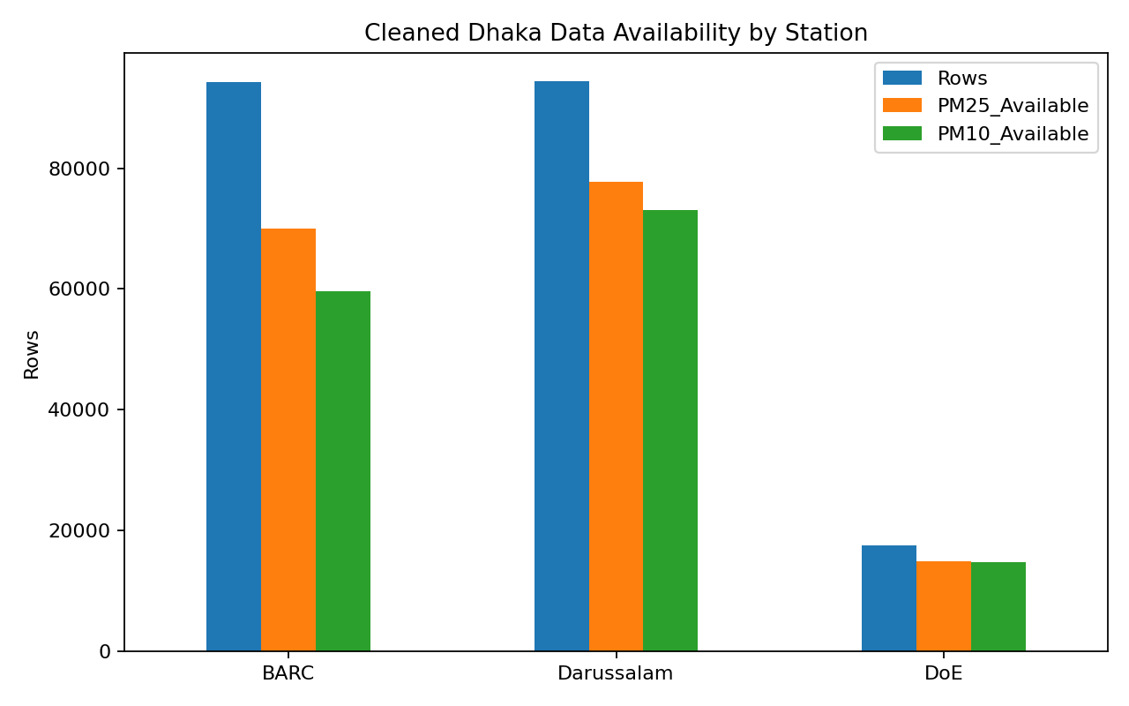
Figure 1. Availability of cleaned records by Dhaka monitoring station.

3. Data-quality observations
The raw dataset is not uniform across all years. Column names and column positions change between files, so the cleaning pipeline maps fields by their header names instead of assuming a fixed Excel column position.
The source contains missing measurements and some invalid or out-of-range sensor values. These values are kept as missing rather than replaced with invented measurements.
The Sangsad station is not included in the current cleaned dataset because the older source block does not provide usable timestamps for the time-based project workflow.
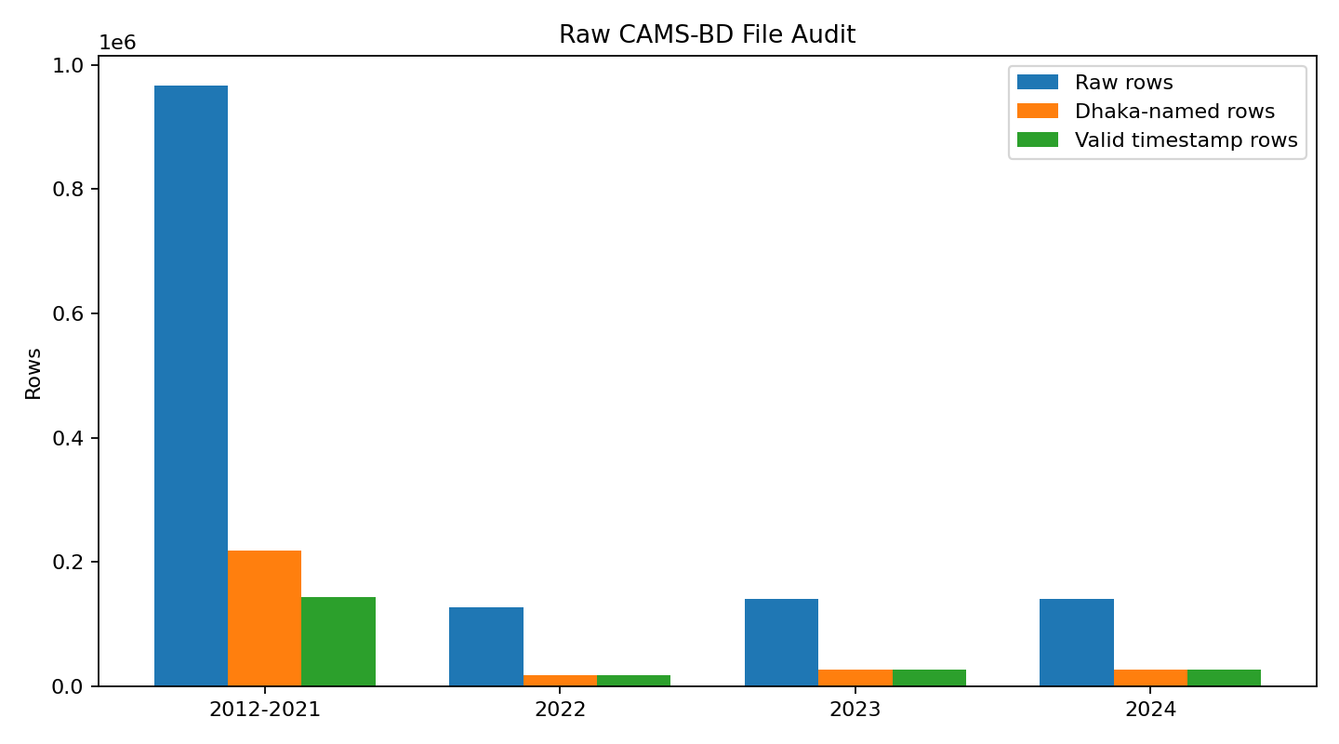
Figure 2. Raw-file audit showing the size of each source workbook and the Dhaka rows identified during inspection.

4. Repository evidence
- data/processed/Dhaka_CAMS_Cleaned_2012_2024.csv - current cleaned Dhaka dataset.
- data/audit/ - raw-file inventory, station audit, and cleaned-dataset summary.
- results/cleaned_dataset_preview.csv - small preview for quick checking.
- results/raw_file_audit.png - raw-source audit chart.
- results/station_data_availability.png - station-level data-availability chart.
- src/clean_dhaka_data.py - reproducible raw-to-clean data pipeline.
- src/summarize_cleaned_data.py - quick dataset-status script.

5. Current status and next step
The raw-to-clean preparation stage is complete enough to begin model development. This update intentionally does not claim final model performance. The next development step is to prepare ML input features and a prediction target, build the first baseline/model experiments, and then begin connecting the selected prediction workflow to the web application.

Short update to present
“We started from the original CAMS-BD raw dataset, inspected all yearly files, selected the usable Dhaka stations, and standardized the pollution and weather columns. We handled missing and invalid values, fixed timestamp formats, removed duplicate station-time records, and created one chronological Dhaka dataset with 206,271 cleaned records covering 2012 to 2024. The cleaned dataset is now ready for the next stage, where we will prepare the ML features and begin our first model experiments.”

