TechCorp Quarterly Report: Q3 2025 Results

Financial Performance
In the third quarter, our company demonstrated robust revenue growth despite seasonal market fluctuations. The primary driver was the surge in cloud service subscriptions. We exceeded our targets by 15%, allowing us to increase investment in R&D.
The chart below illustrates the revenue trend by month. Please note thee sharp spike in August.
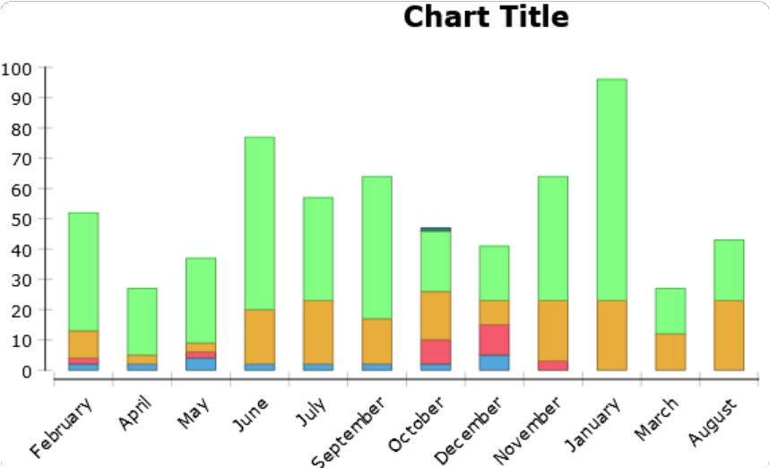
As seen in the chart above, the marketing campaign launched at the end of the summer yielded a significant influx of new users, which directly impacted our financial results.

Server Architecture Update
To support the growing number of users, we executed a full migration of our database system. The old monolithic architecture could no longer handle the load, so the decision was made to transition to microservices.
The diagram below shows the new structure of interaction between the frontend, load balancer, and database cluster.

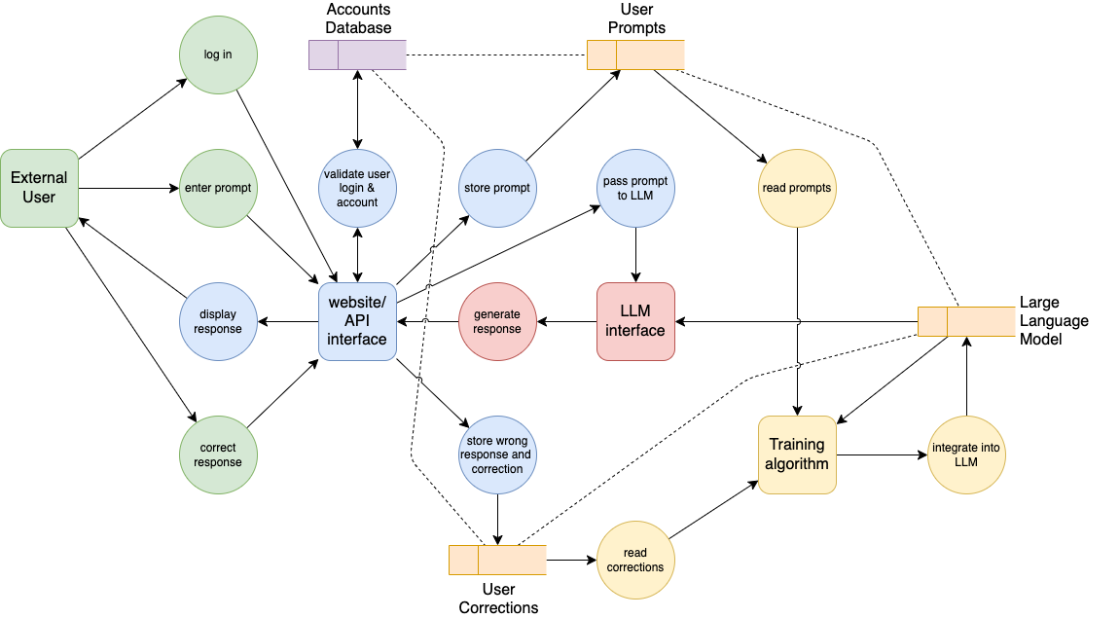
This architecture ensures fault tolerance: if one database node fails, the system automatically switches to a backup node, ensuring the user experiences no downtime.

Corporate Life & Sustainability
Our company cares about more than just technology; we are committed to the environment. Last month, a team of volunteers visited a national park to plant trees. We believe that a balance between work and nature helps maintain employee mental health.
Here is a photo of our team taking a break in nature.

We plan to hold such events every six months, attracting more employees from our remote offices.

New Mobile App Interface
We have completed beta testing for version 2.0 of our application. The major change is the completely redesigned login screen, which now supports biometric authentication. The design has become more minimalist and user-friendly ("Clean Look").
Take a look at the screenshot of the new login screen:

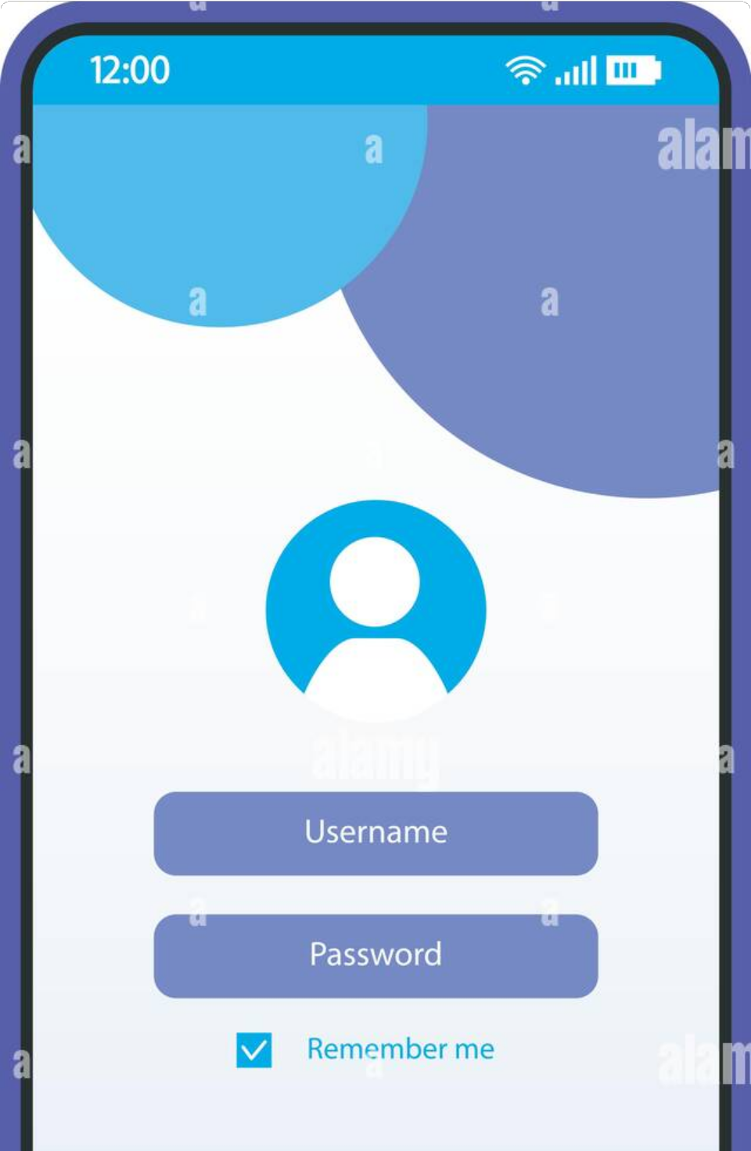

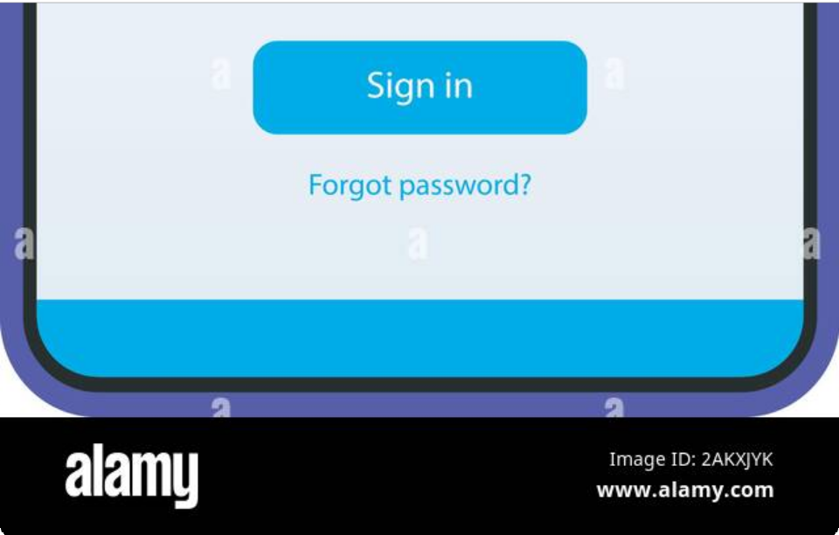
We removed unnecessary elements, leaving only the essentials to ensure the user can access the system in just a few seconds.

