Twin2K Business Intelligence
Final Project — Data Understanding & Preparation Report
TBANLT 485 · Business Intelligence · University of Washington Tacoma
Coty Colson | Instructor: Professor Michael Turek | March 2026

1. Business Understanding
This project applies the CRISP-DM framework to the Twin-2K-500 dataset — a large-scale behavioral and psychological survey of 2,058 participants spanning 4 research waves. The central business problem is grounded in personalized financial services: can personality traits, cognitive ability, and behavioral economic tendencies predict an individual's financial risk tolerance?

Business Problem: Predict financial risk tolerance (score_riskaversion_recode) from validated personality and cognitive measures. Applications include personalized investment advising, insurance pricing, and behavioral nudge design.

2. Data Understanding

2.1 Dataset Overview
Attribute | Value
Dataset Name | Twin-2K-500 (twin2k_flat.csv)
Source | Toubia et al. (2025) — Published psychometric research
Total Participants | 2,058
Total Variables (final) | 59 (after removing score_lossaversion and score_presentbias)
Numeric Variables | 46 validated psychometric and behavioral scores
Categorical Variables | 12 demographic variables + pid identifier
Research Waves | 4 longitudinal waves
Target Variable | score_riskaversion_recode (N=2,058 after imputation)

2.2 Variable Type Changes
Prior to analysis, the following variable type changes were made in JMP:

Variable | Changed To | Rationale
pid | Nominal | Unique row identifier — no mathematical meaning
All 12 demographic columns | Nominal | Categorical groupings with no inherent ordering
All 46 score variables | Continuous | Numeric psychometric scales — verified correct
score_lossaversion | EXCLUDED | 67% missing (1,394 of 2,058) — not viable for modeling
score_presentbias | EXCLUDED | Max value of 5.036e+15 — catastrophic outlier; 192 missing

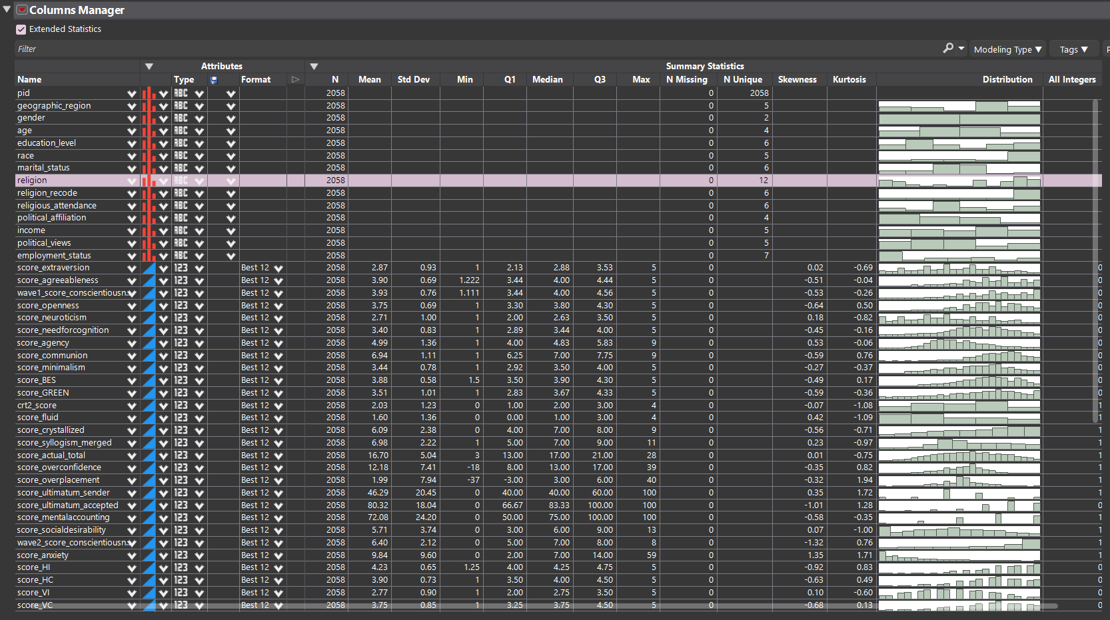

2.3 Missing Value Assessment
Variable | N | N Missing | Resolution
score_riskaversion | 1,825 | 233 (11.3%) | Imputed → score_riskaversion_recode (median = 0.07)
score_forwardflow | 2,057 | 1 (0.05%) | Imputed → score_forwardflow_recode (median = 0.82)
score_lossaversion | 664 | 1,394 (67.7%) | EXCLUDED from analysis entirely
score_presentbias | 1,866 | 192 (9.3%) | EXCLUDED — catastrophic outlier (max = 4.5e+15)
All other variables | 2,058 | 0 | Complete — no action required

2.4 Univariate Properties — Categorical Variables
Variable | N | N Unique | Notes
geographic_region | 2058 | 5 | Nominal
gender | 2058 | 2 | Nominal
age | 2058 | 4 | Nominal
education_level | 2058 | 6 | Nominal
race | 2058 | 5 | Nominal
marital_status | 2058 | 6 | Nominal
religion | 2058 | 12 | Nominal — group to top 5
religious_attendance | 2058 | 6 | Nominal
political_affiliation | 2058 | 4 | Nominal
income | 2058 | 5 | Nominal
political_views | 2058 | 5 | Nominal
employment_status | 2058 | 7 | Nominal — evaluate for grouping

religion has 12 unique categories and will be grouped to top 5 by average score_riskaversion_recode during Data Preparation. employment_status (7 categories) will also be evaluated.

2.5 Univariate Properties — Numeric Variables
All 46 numeric variables are validated psychometric or behavioral economics scores. Skewness and kurtosis are sourced from JMP Columns Manager (Extended Statistics). The course threshold for log transformation is |skewness| > 10.

Variable | N | Mean | Std Dev | Min | Max | Skewness | Kurtosis | Missing
score_extraversion | 2058 | 2.87 | 0.93 | 1.00 | 5.00 | 0.02 | -0.69 | —
score_agreeableness | 2058 | 3.90 | 0.69 | 1.22 | 5.00 | -0.51 | -0.04 | —
wave1_score_conscientiousness | 2058 | 3.93 | 0.76 | 1.11 | 5.00 | -0.53 | -0.26 | —
score_openness | 2058 | 3.75 | 0.69 | 1.00 | 5.00 | -0.64 | 0.50 | —
score_neuroticism | 2058 | 2.71 | 1.00 | 1.00 | 5.00 | 0.18 | -0.82 | —
score_needforcognition | 2058 | 3.40 | 0.83 | 1.00 | 5.00 | -0.45 | -0.16 | —
score_agency | 2058 | 4.99 | 1.36 | 1.00 | 9.00 | 0.53 | -0.06 | —
score_communion | 2058 | 6.94 | 1.11 | 1.00 | 9.00 | -0.59 | 0.76 | —
score_minimalism | 2058 | 3.44 | 0.78 | 1.00 | 5.00 | -0.27 | -0.37 | —
score_BES | 2058 | 3.88 | 0.58 | 1.50 | 5.00 | -0.49 | 0.17 | —
score_GREEN | 2058 | 3.51 | 1.01 | 1.00 | 5.00 | -0.59 | -0.36 | —
crt2_score | 2058 | 2.03 | 1.23 | 0.00 | 4.00 | -0.07 | -1.08 | —
score_fluid | 2058 | 1.60 | 1.36 | 0.00 | 4.00 | 0.42 | -1.09 | —
score_crystallized | 2058 | 6.09 | 2.38 | 0.00 | 9.00 | -0.56 | -0.71 | —
score_syllogism_merged | 2058 | 6.98 | 2.22 | 1.00 | 11.00 | 0.23 | -0.97 | —
score_actual_total | 2058 | 16.70 | 5.04 | 3.00 | 28.00 | 0.01 | -0.75 | —
score_overconfidence | 2058 | 12.18 | 7.41 | -18.00 | 39.00 | -0.35 | 0.82 | —
score_overplacement | 2058 | 1.99 | 7.94 | -37.00 | 40.00 | -0.32 | 1.94 | —
score_ultimatum_sender | 2058 | 46.29 | 20.45 | 0.00 | 100.00 | 0.35 | 1.72 | —
score_ultimatum_accepted | 2058 | 80.32 | 18.04 | 0.00 | 100.00 | -1.01 | 1.28 | —
score_mentalaccounting | 2058 | 72.08 | 24.20 | 0.00 | 100.00 | -0.58 | -0.35 | —
score_socialdesirability | 2058 | 5.71 | 3.74 | 0.00 | 13.00 | 0.07 | -1.00 | —
wave2_score_conscientiousness | 2058 | 6.40 | 2.12 | 0.00 | 8.00 | -1.32 | 0.76 | —
score_anxiety | 2058 | 9.84 | 9.60 | 0.00 | 59.00 | 1.35 | 1.71 | —
score_HI | 2058 | 4.23 | 0.65 | 1.25 | 5.00 | -0.92 | 0.83 | —
score_HC | 2058 | 3.90 | 0.73 | 1.00 | 5.00 | -0.63 | 0.49 | —
score_VI | 2058 | 2.77 | 0.90 | 1.00 | 5.00 | 0.10 | -0.60 | —
score_VC | 2058 | 3.75 | 0.85 | 1.00 | 5.00 | -0.68 | 0.13 | —
score_finliteracy | 2058 | 4.99 | 1.36 | 0.00 | 7.00 | -0.76 | 0.23 | —
score_numeracy | 2058 | 5.43 | 2.09 | 0.00 | 8.00 | -0.50 | -0.71 | —
score_deductive_certainty | 2058 | 3.76 | 0.64 | 0.00 | 4.00 | -3.03 | 9.60 | —
score_forwardflow_recode | 2058 | 0.82 | 0.05 | 0.239 | 0.928 | -2.11 | 13.08 | 1 (imputed)
score_riskaversion_recode | 2058 | 0.12 | 0.24 | -0.667 | 0.833 | 0.23 | 0.01 | 233 (imputed)
score_trustgame_sender | 2058 | 48.47 | 31.38 | 0.00 | 100.00 | 0.32 | -0.78 | —
score_trustgame_receiver | 2058 | 40.67 | 17.91 | 0.00 | 100.00 | -0.16 | 1.57 | —
score_RFS | 2058 | 4.90 | 0.64 | 2.50 | 7.00 | -0.01 | 0.05 | —
score_ST-TW | 2058 | 12.72 | 4.56 | 4.00 | 24.00 | 0.44 | -0.76 | —
score_depression | 2058 | 11.29 | 10.25 | 0.00 | 55.00 | 1.20 | 1.19 | —
score_CNFU-S | 2058 | 2.47 | 0.89 | 1.00 | 5.00 | 0.25 | -0.61 | —
score_selfmonitor | 2058 | 2.77 | 0.46 | 0.769 | 4.385 | -0.17 | 0.25 | —
score_SCC | 2058 | 3.60 | 0.97 | 1.00 | 5.00 | -0.35 | -0.88 | —
score_needforclosure | 2058 | 3.52 | 0.65 | 1.00 | 5.00 | -0.50 | 0.37 | —
score_maximization | 2058 | 3.17 | 0.65 | 1.00 | 5.00 | -0.08 | -0.01 | —
score_wason | 2058 | 2.32 | 0.68 | 0.00 | 4.00 | 0.24 | 0.37 | —
score_dictator_sender | 2058 | 39.10 | 18.85 | 0.00 | 100.00 | 0.01 | 1.91 | —

✅ No variables exceed the |skewness| > 10 transformation threshold. No log transformations are required for this dataset.

3. Data Preparation

3.1 Skewness Assessment & Transformations
All 46 numeric variables were assessed for skewness using JMP Columns Manager (Extended Statistics). The course threshold for log transformation is |skewness| > 10. No variables in the Twin-2K-500 dataset exceed this threshold.

Finding | Value | Decision
Variables exceeding |skewness| > 10 | 0 | No log transformations applied
Most extreme skewness | -3.03 (score_deductive_certainty) | Below threshold — no action required
Highest kurtosis | 13.08 (score_forwardflow) | Documented — leptokurtic but skewness within bounds
score_discount | Skew = 5.16, Kurt = 29.71 | EXCLUDED — catastrophic outlier (max = 4.5e+15)

3.2 Missing Value Imputation
Missing values were imputed using JMP's Recode function (right-click column → Recode → replace '.' with median value). Median imputation was chosen over mean imputation due to its robustness to outliers in the target variable distribution.

Variable | N Missing | Median Used | New Column
score_riskaversion | 233 | 0.07 | score_riskaversion_recode
score_forwardflow | 1 | 0.82 | score_forwardflow_recode

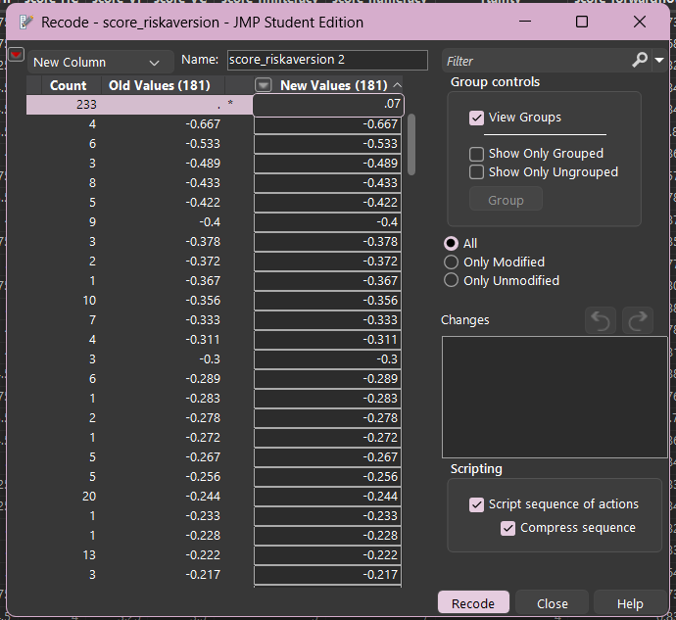

3.3 Outlier Detection — 1.5×IQR Rule
Outliers were identified using the 1.5×IQR rule: Lower Fence = Q1 − 1.5×IQR, Upper Fence = Q3 + 1.5×IQR. Values outside these fences are flagged as outliers. Consistent with the ethical framework established for this project, no outliers were removed — all flagged values represent valid human responses within the documented scale ranges of their respective psychometric instruments.

Decision: No outliers were removed. All 29 flagged variables contain values within their valid instrument ranges. Removal of extreme human responses would introduce systematic bias and violate the integrity of the psychometric measurement design.

Variable | Lower Fence | Upper Fence | Min | Max | Finding
score_agreeableness | 1.940 | 5.940 | 1.222 | — | LOW only — min below fence
wave1_score_conscientiousness | 1.760 | 6.240 | 1.111 | — | LOW only — min below fence
score_openness | 1.800 | 5.800 | 1.000 | — | LOW only — min below fence
score_needforcognition | 1.225 | 5.665 | 1.000 | — | LOW only — min below fence
score_agency | 1.255 | 8.575 | 1.000 | 9.000 | LOW & HIGH — within scale bounds
score_communion | 4.000 | 10.000 | 1.000 | — | LOW only — min below fence
score_minimalism | 1.300 | 5.620 | 1.000 | — | LOW only — min below fence
score_BES | 2.300 | 5.500 | 1.500 | — | LOW only — min below fence
score_overconfidence | -5.500 | 30.500 | -18.00 | 39.000 | LOW & HIGH — valid survey responses
score_overplacement | -16.500 | 19.500 | -37.00 | 40.000 | LOW & HIGH — valid responses
score_ultimatum_sender | 10.000 | 90.000 | 0.000 | 100.00 | LOW & HIGH — within 0–100 scale
score_ultimatum_accepted | 16.675 | 149.995 | 0.000 | — | LOW only — within scale
wave2_score_conscientiousness | 0.500 | 12.500 | 0.000 | — | LOW only — within scale
score_anxiety | -16.000 | 32.000 | — | 59.000 | HIGH only — valid clinical range
score_HI | 2.875 | 5.875 | 1.250 | — | LOW only — within scale
score_HC | 2.000 | 6.000 | 1.000 | — | LOW only — within scale
score_VC | 1.375 | 6.375 | 1.000 | — | LOW only — within scale
score_finliteracy | 1.000 | 9.000 | 0.000 | — | LOW only — within scale
score_deductive_certainty | 4.000 | 4.000 | 0.000 | — | LOW only — IQR=0, concentrated at max
score_forwardflow_recode | 0.700 | 0.940 | 0.239 | — | LOW only — valid behavioral measure
score_riskaversion_recode | -0.465 | 0.695 | -0.667 | 0.833 | LOW & HIGH — valid economic range
score_trustgame_receiver | 6.000 | 78.000 | 0.000 | 100.00 | LOW & HIGH — within scale
score_RFS | 3.300 | 6.500 | 2.500 | 7.000 | LOW & HIGH — within scale
score_depression | -18.000 | 38.000 | — | 55.000 | HIGH only — valid clinical range
score_selfmonitor | 1.530 | 4.010 | 0.769 | 4.385 | LOW & HIGH — within instrument range
score_needforclosure | 1.930 | 5.130 | 1.000 | — | LOW only — within scale
score_maximization | 1.170 | 5.170 | 1.000 | — | LOW only — within scale
score_wason | 0.500 | 4.500 | 0.000 | — | LOW only — within scale
score_dictator_sender | 40.000 | 40.000 | 0.000 | 100.00 | LOW & HIGH — IQR=0, behavioral clustering

16 variables had no values outside the 1.5×IQR fences and required no documentation.

3.4 Final Variable Selection & Partition
All remaining data preparation steps were completed. The final model uses 18 predictors: 5 Big Five personality traits, 5 cognitive measures, 4 behavioral economic scores, and 4 demographic variables. A 70/30 training/validation partition was applied in JMP for all predictive models.

3.5 Completed Data Preparation Steps
All four data preparation steps from Professor Turek’s framework were completed. The following summarizes outcomes for steps 3 and 4.
Religion Recoding
The religion variable (12 categories) was recoded to religion_recode (6 groups) by retaining the top 5 categories by average score_riskaversion_recode value and collapsing all remaining categories into “Other_Religion.” Employment_status was evaluated and retained as-is (7 categories within acceptable range for modeling).
Multicollinearity Assessment
Multicollinearity was assessed using Analyze → Multivariate → Correlations in JMP across all 18 numeric predictors. No variable pairs exceeded the |r| > 0.75 threshold. All 18 predictors were retained for modeling.
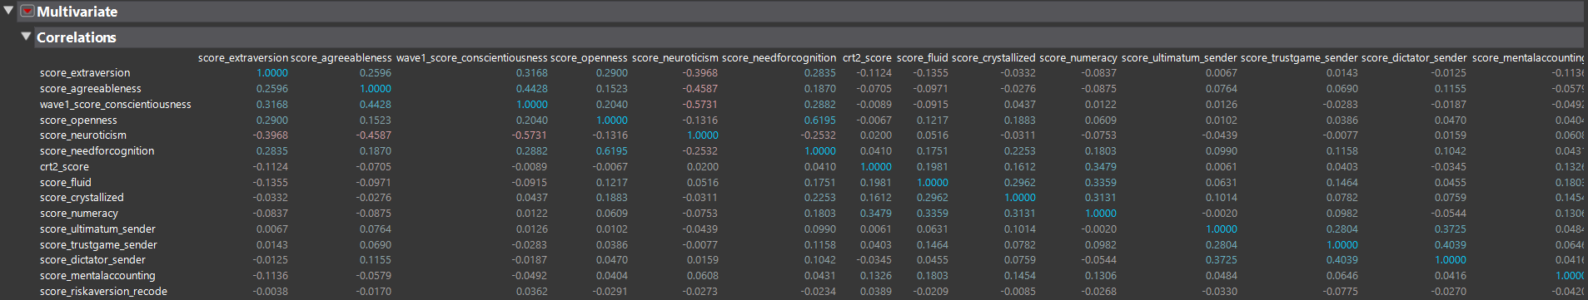

4. Modeling
Four models were built in JMP: one explanatory MLR, three stepwise predictive MLR runs, and one Bootstrap Forest. The target variable is score_riskaversion_recode. All predictive models used a 70/30 training/validation partition.

4.1 Explanatory MLR (18 Predictors)
An explanatory MLR was run using all 18 predictors with no partition (full dataset, n=2,058). The purpose is coefficient interpretation, not prediction. The model is statistically significant overall (F p=0.0007) but explains limited variance (R²=0.027). Four predictors reached significance at p < 0.05: score_trustgame_sender (p=0.005), crt2_score (p=0.008), income[$75k–$100k] (p=0.006), and age[18–29] (p=0.006).
Model RMSE: 0.2270. Adjusted R²: 0.019.

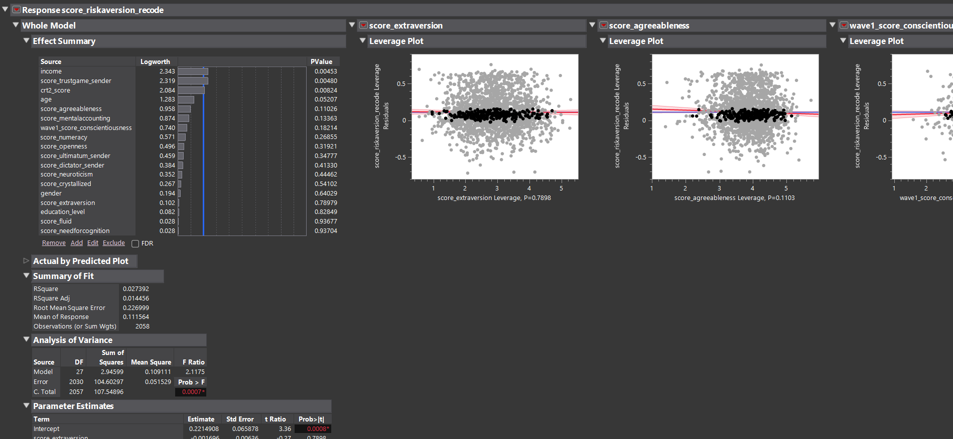

4.2 Predictive Stepwise MLR
Three stepwise runs were executed using Analyze → Fit Model → Stepwise personality in JMP with a 70/30 partition. BIC was used as the stopping criterion for Forward and Backward runs; p≤0.25 entry/exit was used for the Mixed run.
Forward BIC and Backward BIC converged on identical 3-predictor models (Validation RMSE = 0.2271). The Mixed run selected 12 predictors but produced worse BIC, indicating overfitting. The Forward BIC model is selected as the final predictive model.
Final Predictive Model Equation:
score_riskaversion_recode = 0.1315 − 0.000573(score_trustgame_sender) − 0.01669(income[$75k–$100k]) − 0.01901(age[18–29])

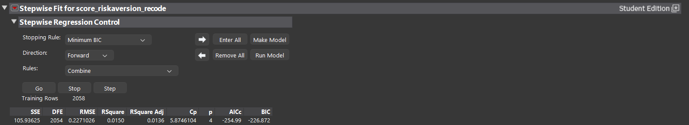

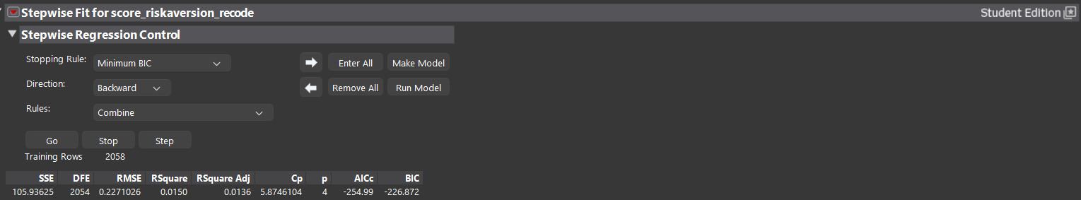
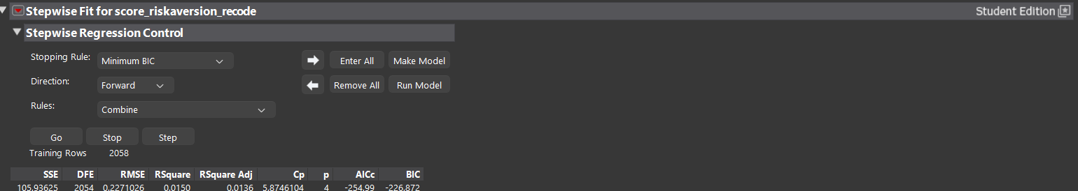

4.3 Bootstrap Forest
A Bootstrap Forest was run using all 18 predictors (Analyze → Predictive Modeling → Bootstrap Forest in JMP). The out-of-bag (OOB) RASE was 0.2950. Variable importance was measured by column contribution. The top five variables by importance were: score_needforcognition (8.0%), score_neuroticism (7.8%), score_extraversion (7.5%), education_level (7.1%), and score_openness (6.9%).
Notably, all five Big Five personality traits ranked among the top eight variables by forest importance, yet none reached significance in the explanatory MLR. This suggests nonlinear interaction effects that linear regression cannot detect — though those interactions were insufficient to improve out-of-sample predictive accuracy.
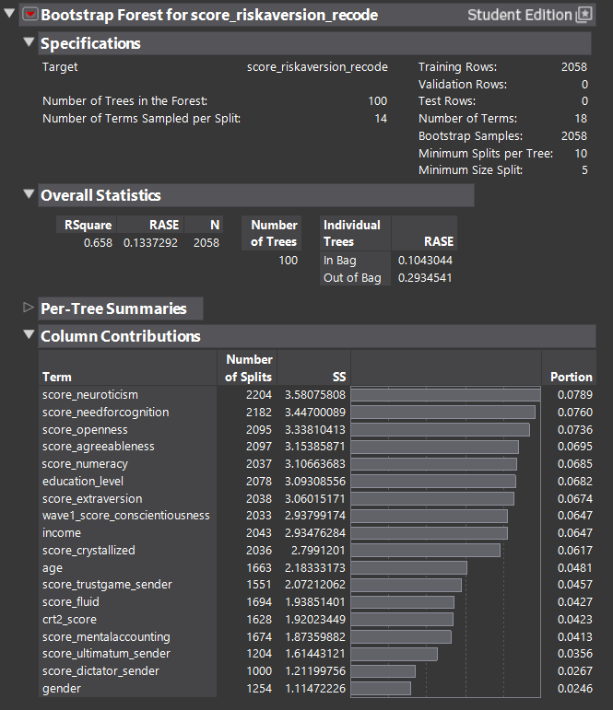

4.4 Model Comparison Summary
The table below summarizes all models by out-of-sample error. Lower OOB error / RMSE indicates better predictive performance. The Predictive MLR (Forward BIC) is selected as the final model based on lowest validation RMSE and best BIC.
Model | OOB Error / RMSE | R² | Predictors | Notes
Explanatory MLR | 0.2270 | 0.027 | 18 | No partition
Predictive MLR — Forward BIC | 0.2271 | 0.015 | 3 | ✅ WINNER
Predictive MLR — Backward BIC | 0.2271 | 0.015 | 3 | Identical to Forward
Predictive MLR — Mixed (p≤0.25) | 0.2264 | 0.021 | 12 | Worse BIC
Bootstrap Forest | 0.2950 (RASE) | — | 18 | OOB honest error

5. Evaluation
Three independent modeling approaches — explanatory MLR, stepwise predictive MLR, and Bootstrap Forest — converge on the same conclusion: the Twin-2K-500 instrument cannot predict financial risk aversion with deployment-ready accuracy. The best predictive model explains only 1.5% of variance in the target variable (Validation R²=0.015).
This is a meaningful finding rather than a modeling failure. The result is consistent across methods and robust to model complexity: adding 9 additional predictors (Mixed stepwise, 12 predictors) did not meaningfully improve RMSE and worsened BIC. The signal in this dataset is real but small.

5.1 Key Analytical Tension
The Bootstrap Forest ranked all five Big Five personality traits among the top eight variables by importance, yet none were statistically significant in the explanatory MLR. This tension suggests nonlinear interaction effects that linear regression cannot capture. However, those interactions were insufficient to improve out-of-sample predictive accuracy — the forest’s OOB RASE (0.2950) was worse than the 3-variable linear model’s validation RMSE (0.2271). Both findings are reported as-is.

5.2 Business Implications
The business intuition behind this project — predicting financial risk tolerance through a digital twin — is commercially sound. Trust game behavior, age bracket, and income bracket are meaningful, statistically significant predictors. The Twin-2K-500 instrument demonstrates that behavioral signal exists.
However, the current instrument explains only 1.5% of variance — far below any deployment threshold for personalized financial services. The measurement approach needs rethinking: away from self-report personality proxies and toward longitudinal, incentivized, domain-specific behavioral data. The digital twin concept is right; the data collection instrument needs to evolve.

6. Deployment

6.1 Tableau Dashboard
An analytical Tableau dashboard was built in Tableau Public 2025.3 to communicate project findings visually. The dashboard is titled “Can a Digital Twin Predict Your Financial Risk Tolerance?” and consists of four views built from four summary CSV files derived from the Twin-2K-500 analysis.

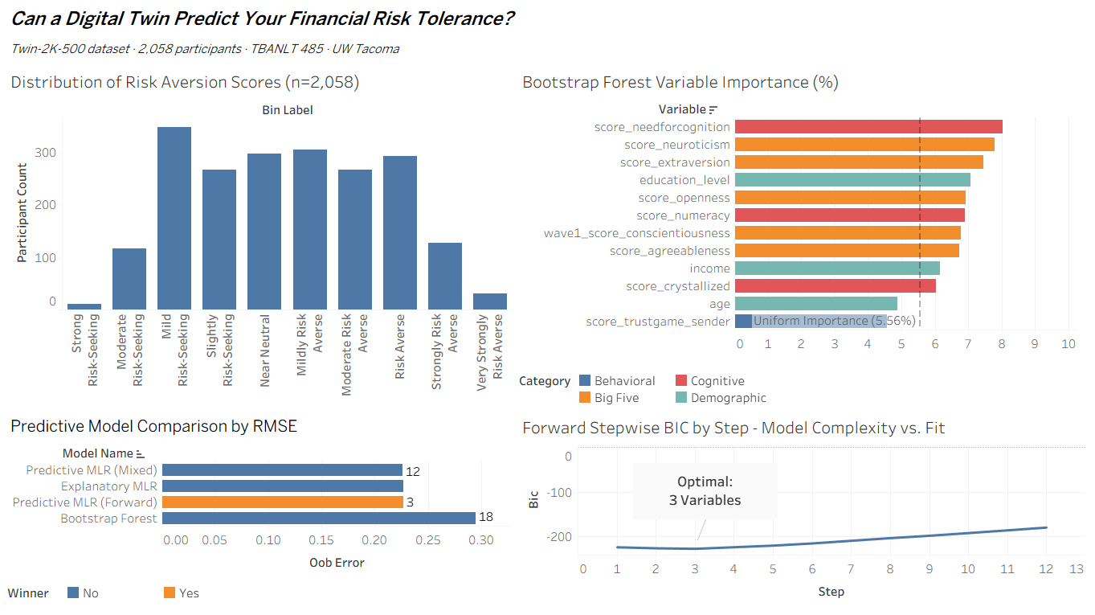

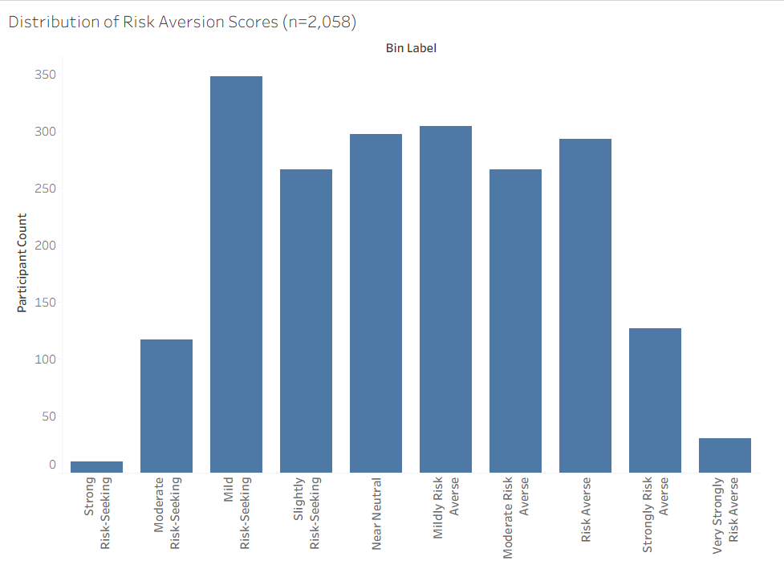

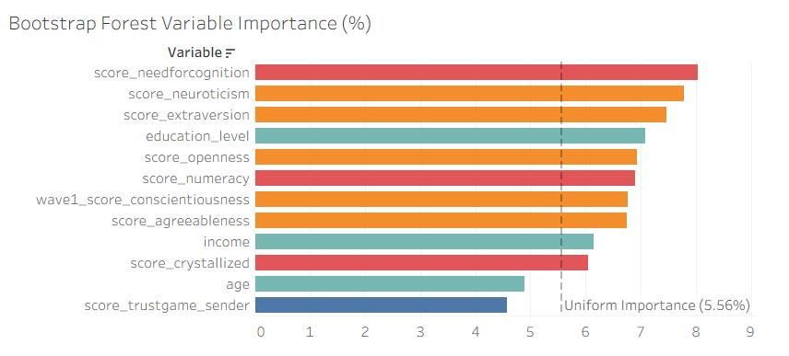

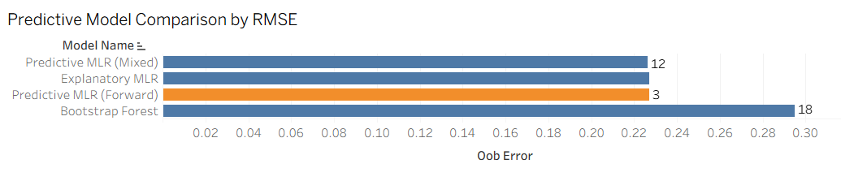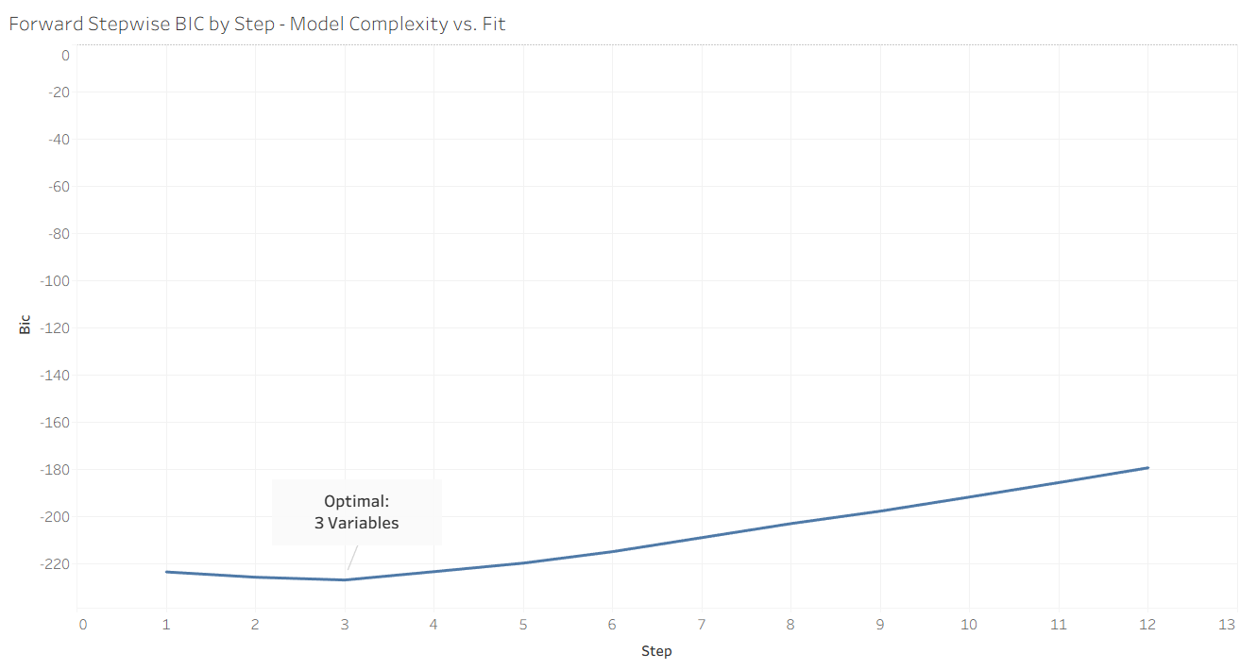

6.2 Repository & Artifacts
All project artifacts are version-controlled at github.com/cotycolson-sudo/twin2k-business-intelligence. Deliverables include the final Word report, data dictionary (59 variables, 8 color-coded sections), six PDF exports of JMP model outputs, the processed dataset (twin2k_flat.csv, 2,058 × 61), and all JMP scripts saved to the data table.

6.3 Recommendations for Future Work
A production-grade digital twin for financial risk tolerance would require three improvements over the current instrument: (1) longitudinal behavioral data collected across multiple real financial decisions rather than one-time self-report surveys; (2) incentivized measures that create genuine stakes for participants, as opposed to hypothetical lottery choices; and (3) domain-specific behavioral features such as actual investment history, spending patterns, and real loss responses. The trust game result — a single incentivized behavioral measure — outperformed all five Big Five personality scales combined, suggesting the measurement direction is clear.

7. References
Anthropic. (2025). Claude (claude-sonnet-4-6) [Large language model]. https://www.anthropic.com
SAS Institute Inc. (2024). JMP Student Edition (Version 17) [Statistical software]. https://www.jmp.com
Tableau Software. (2025). Tableau Public (Version 2025.3) [Data visualization software]. https://public.tableau.com
Toubia, O., Nave, G., Netzer, O., & Hofstetter, R. (2025). Twin-2K-500: A large-scale behavioral and psychometric dataset [Data set]. Published psychometric research.
University of Washington Tacoma, Milgard School of Business. (2026). TBANLT 485: Business Intelligence [Course]. Instructor: Professor Michael Turek.

Note on AI assistance: Claude (Anthropic, 2025) was used as an analytical assistant throughout this project for guidance on JMP procedures, Tableau construction, and report structuring. All analytical decisions, interpretations, and conclusions reflect independent student judgment.

