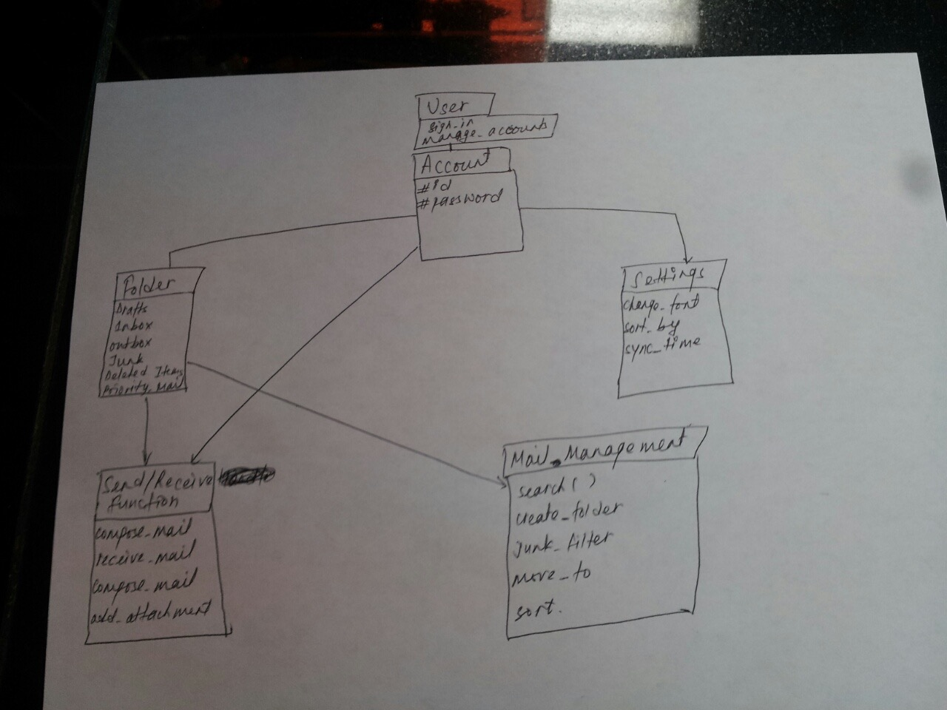

Here we created our first iteration of the class diagram. We included functions inside the classes so we corrected this in our next iteration.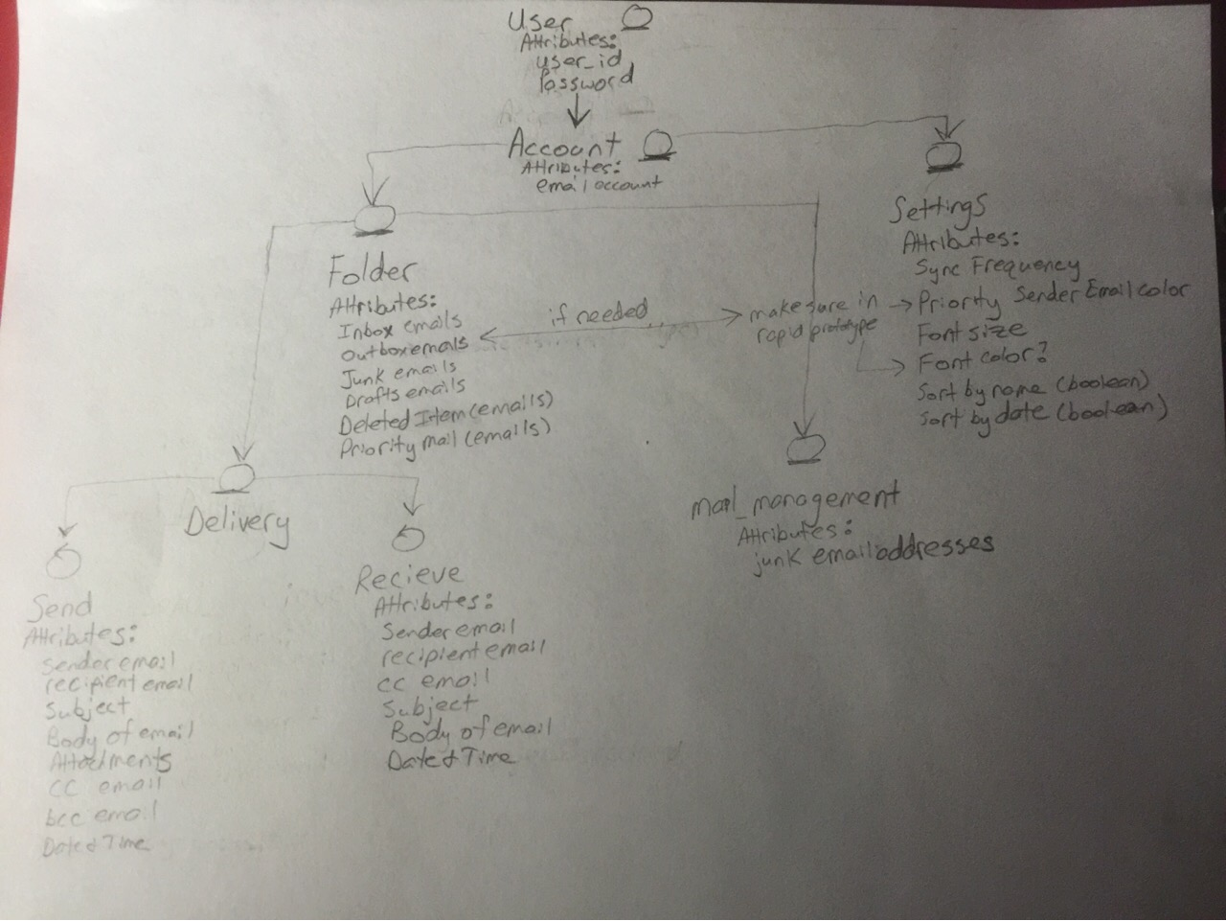

Here is our second iteration of our class diagram. We added attributes inside of each class and also separated out the send/receive class above into two differenct classes that both inherit from the Delivery class.

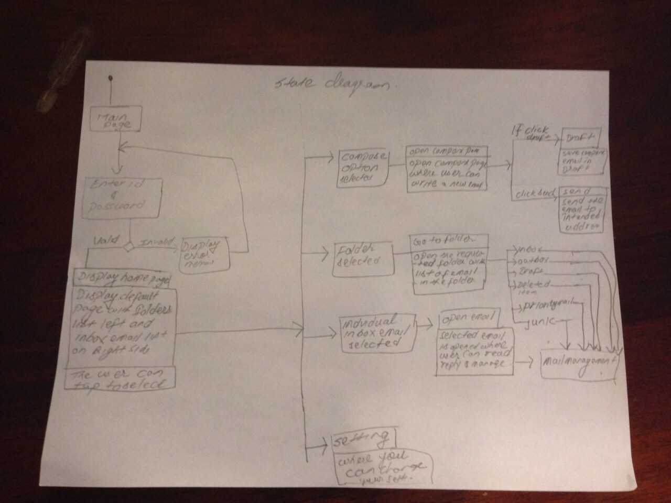

Here is our first iteration of our state chart diagram. Some of the states were separated when they actually needed to be in sequential order so we fixed this in the next iteration. Also a sign out option was not included here.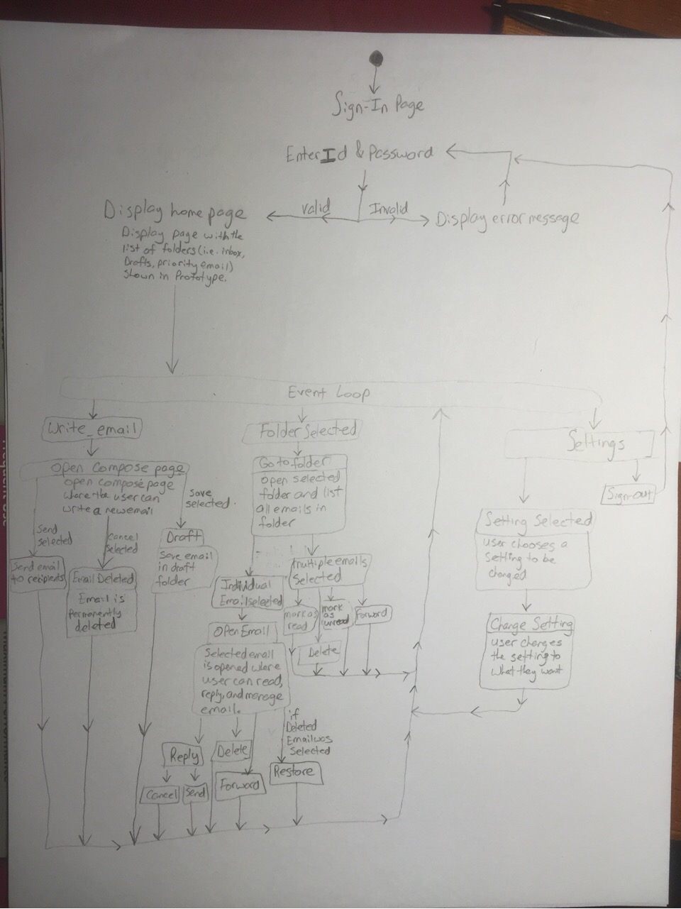

Here is the next iteration of our state chart diagram. We placed the folder selected and individual email box selected in sequential order since to be able to open an email you have to select the folder first. Additionally, we added states where if multiple emails are selected either mark as read or mark as unread or forward the emails is another state.

Also we added two states for the settings state: a sign out state and a setting selected state which goes to the change setting state.

**Non-Execution based testing for the Rapid Prototype:**

To get to RapidPrototype_v1.7 we added an outbox folder on slide 5.

On slide 6 we removed the “Font Size” option since this is covered in the display settings portion making this redundant.

On slide 27 we removed the search bar and added a new one that had example text on it.

On slides 5, 13, 18, 21, and 24 we added the new search bar with the example text since the search bar wasn’t on any of these slides.

Non execution based testing for the use cases:

Originally we had the following use cases: Send email, read email, delete email, categorize email, save email, sign-in/sign-out.

We made the following changes to our use cases:

We made the send_email use case dependent on the write_email use case, added a draft_email(save email) use case, added a View_Listed_Emails_Of_Folder use case and made Read_Email use case dependent on this.

We added a Deleted_Email_Management use case, and added a Change_Email_Status use case.

We added a Forward_Email use case, Account_Management use case, and we separated out the sign-in/sign-out use case into two use cases: Sign_In use case and Sign_Out use case. And we also added a Change_Settings use case.