ARVAR is a general purpose 3 d static finite element program using the global variational energy minimization technique.

**General Theory**:

The quantity P, is defined as follows:

$$P=\sum_{m=1}^{M}{\iiint{\left\{\sum_{i=1}^{3}{\sum_{j=1}^{3}{\int_{0}^{\vec{U}}{σ_{ij}*\left(\frac{∂e_{ij}}{∂\vec{u}}\right)∂\vec{u}}}}\right\}∂V}}-\sum_{n=1}^{N}{\vec{F_{n}}∙\vec{U_{n}}} Eq. 1$$

Where the σij (stresses) are functions of the eij (strains) as shown below. G represents a material model that need not be linear, but must be one to one.

$$\begin{matrix}σ_{11} & σ_{12} & σ_{13} \\ σ_{21} & σ_{22} & σ_{23} \\ σ_{31} & σ_{32} & σ_{33}\end{matrix}=G\left(\begin{matrix}e_{11} & e_{12} & e_{13} \\ e_{21} & e_{22} & e_{23} \\ e_{31} & e_{32} & e_{33}\end{matrix}\right)$$

Strains are functions of the nodal displacement vector U as shown below. The H operator need not be linear. Geometric nonlinearities can exist.

$$\begin{matrix}e_{11} & e_{12} & e_{13} \\ e_{21} & e_{22} & e_{23} \\ e_{31} & e_{32} & e_{33}\end{matrix} =H\left(\vec{u}\right)$$

The first term to the right of the equal sign in Eq. 1 represents total internal strain energy. It represents the work done in imposing a deformation U on the structure where U is a vector whose dimension is equal to the total number of degrees of freedom. The summation m is over all members (elements). The triple volume integral is over the volume V of each member.

The second term to the right of the equal sign is the dot product of applied nodal forces F with nodal displacements.

P can be thought of as an N dimensional surface where again N corresponds to number of degrees of freedom.

The Theorem of Minimum Stationary Potential Energy states that at the correct deformed state, the value P will be a minimum. Therefore, the magnitude of the gradient of P with respect to U at the correct deformed shape will be zero.

Differentiating P wrt a specific degree of freedom, uk yields:

$$\frac{∂P}{∂u_{k}}=\sum_{1}^{M}{\iiint{\left\{\sum_{i=1}^{3}{\sum_{j=1}^{3}{{\left.\left(σ_{ij}*\left(\frac{∂e_{ij}}{∂u_{k}}\right)\right)\right|}_{\vec{u}}}}\right\}∂V}}-f_{k} Eq. 2$$

In standard matrix method FEA, equation 2 is set to zero for all k, yielding k simultaneous equations. However, when equation 2 is not equal to zero, it represents the argument of the gradient vector in the direction of the kth degree of freedom. This gradient vector points along the path of steepest assent on the n dimensional P surface (Eq. 1) Therefore, varying the U vector in the direction of the negative gradient, which points to the minimum of the P surface, produces a reduction in P. By iterative process, the U vector is moved in the direction of the negative gradient vector, which is updated with every new value of U, until the magnitude of the gradient vector is sufficiently close to zero.

The graphic below shows this concept for a simple 2 degree of freedom system.





The Nature of the P Surface.

For linear elastic situations, the n dimensional P surface is second order function of the displacement vector in $\vec{U}$. For an unloaded structure, the bottom of the potential surface is located at $\vec{U}$ =0. The effect of applied forces is to tilt the surface in the direction of the applied force. Since the surface is second order, its curvature is everywhere positive. Thus no amount of tilting will result in a P surface that has no minimum.

If on the other hand, the materials are elasto-plastic, or gap_friction; or if there are geometric non-linearities, the P surface will no longer be 2nd order. It will approach zero curvature in certain areas. This means that if sufficient force is applied, the P surface can be tilted such that there is no global minimum. Consider the P surface depicted below:



The P surface can be thought of as a bowl of infinite extent. If the model is linear elastic, the bowl is an n dimensional paraboloid. If a marble was placed in the bowl, no amount of tilting (applied force) could cause the marble to roll out. However if the model in non-linear, the sides become more conical, and it is possible to tilt the surface (apply enough force) to cause the marble to roll out.

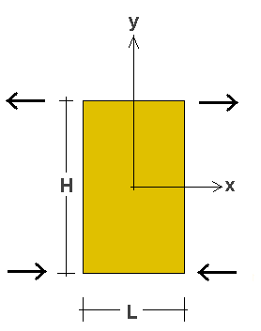

**Available Elements and Associated Properties**

The 8 Node Brick

ARVAR has the standard isoparametric 8 node brick. There are no high order shape functions and the brick is fully integrated with 8 Gauss points. As such, it is subject to parasitic shear stress when bent. In the pure bending case as is depicted adjacent, the error in internal strain energy due to parasitic shear is proportional to $\frac{1}{2}{\left(\frac{L}{H}\right)}^{2}$. Thus, if H is significantly larger than L, parasitic shear will be minimized.

The brick is linear elastic and small deflection formulated.

The brick can be degenerated all the way down to a 4 node tetrahedron.

The nodes must be numbered in such a way that a right hand threaded screw being twisted into face 5 (ijkl) will advance toward face 6 (mnop).

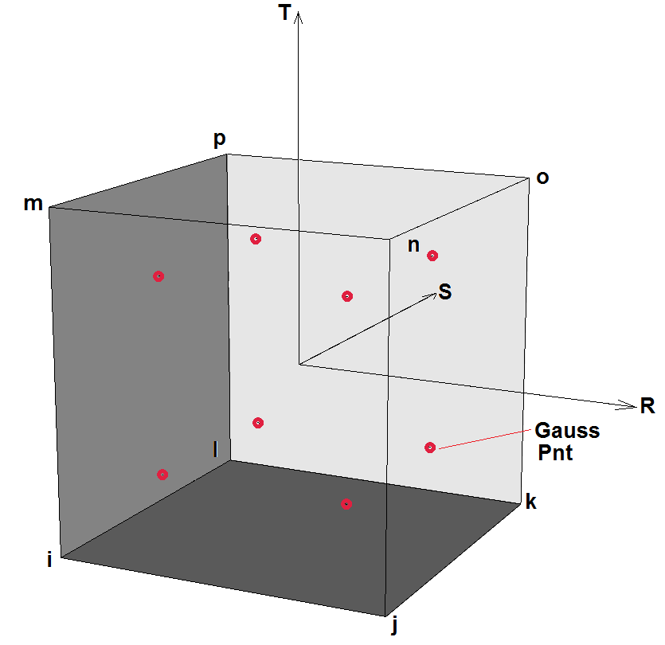In isoparametric space, the local element R, S, and T axes are as depicted adjacent.

Stress output is at the 6 element faces. The table below details the face numbers

|  |  |  |  |
| --- | --- | --- | --- |
| Face No. | R | S | T |
| 1 | -1 | 0 | 0 |
| 2 | 1 | 0 | 0 |
| 3 | 0 | -1 | 0 |
| 4 | 0 | 1 | 0 |
| 5 | 0 | 0 | -1 |
| 6 | 0 | 0 | 1 |

The Triangular Failure Element (TFE)

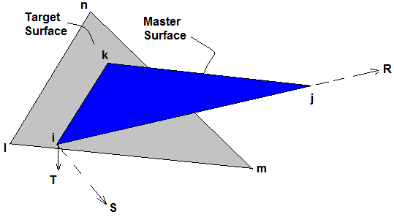The triangular failure element is a 6 node triangular element which functions as a gap_friction contact surface. The first 3 nodes specified, i,j, and k, define the geometry of the element in space. The next 3, l,m, and n define a target surface. The orientation of the local coordinate system is as shown. T is normal to the master surface and points in the direction of the target. S is TXR.

The nodes of the target surface need not correspond to those of the master. The target surface is a plane infinite extent. It is defined by l, m, and n but it is not bounded by them. For this reason, it is possible to have 10,000 TFE’s that all share the same unbounded target surface. Also, because of the infinite extent of the target, it is not possible for the master surface to slide off of the target. The size of the gap between the master and the target is irrelevant, however it can not be zero. The direction of the gap however defines opening and closing directions.

Normal stress on the master surface is E times the deflection in the positive T direction (gap closing), where E is the Young’s modulus of the material of the TFE. Deflection in the negative T direction (gap opening) produces no stress. The strain energy associated with normal stress distribution is integrated over the master surface yielding nodal normal forces.

Local axis shear stresses τrt, and τst are calculated in a similar manor to the normal stress. Shear stress at any point is E times the relative deflection between the master 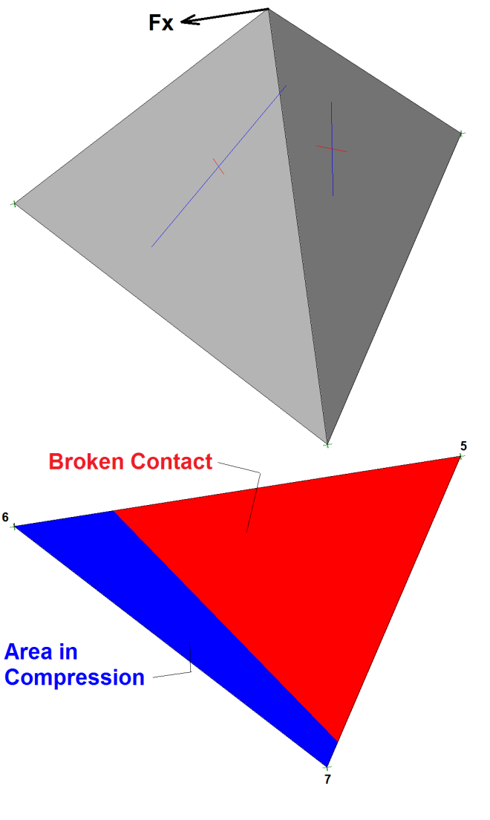and the target. Shear stress is integrated only over the portion of the target that is in compression. Nodal shear forces are further limited by the requirement that the shear force cannot exceed the nodal normal force times tan(φ).

TFE’s have no in plane stiffness. As such, they have to be attached to something; either bricks or axibars, or to fixed nodes.

Adjacent is depicted a concrete tetrahedron with 10’ long edges. It’s weight is 16.23 kips and is subject to a 6 kip Force in the X direction. Note that the TFE partially cracks.

The table below shows the nodal forces that result.

|  |  |  |  |
| --- | --- | --- | --- |
| Node | Fx | Fy | Fz |
| 5 | -0.53 | 0.035 | 0.91 |
| 6 | -3.49 | 0.065 | 9.91 |
| 7 | -1.98 | -0.10 | 5.41 |

The TFE can be locked so that is does not shear or crack by assigning a tensile strength to the gap. When this is done, the TFE can be used to attach dis-similar meshes together.

The TFE also has a dilatational capability. This option produces additional nodal normal force proportional to nodal shear force when frictional shearing occurs. .

The TFE also has a crude cracked base uplift option. Cracked bas uplift is assumed to exert itself in the gap. The local R axis must be such that the upstream side of the TFE is at R=0 (Node 1), and the local R axis points downstream. The crack length is assumed to be the location of where the normal stress goes to zero at the local R axis. Upstream and downstream pressures are taken from nodal pressures for tfe node 1 and 2 respectivly.

Below the TFE with cracked base uplift is compared to an analysis done with simple rigid body limit state assumptions.

|  |  |  |
| --- | --- | --- |
|  | Crack Length | Total Uplift Force/ft |
| Limit State Rigid Body | 11.0’ | 242.31 Kip/ft |
| ARVAR w/ TFE’s + Uplift | 10.88’ | 241.83 Kip/ft |

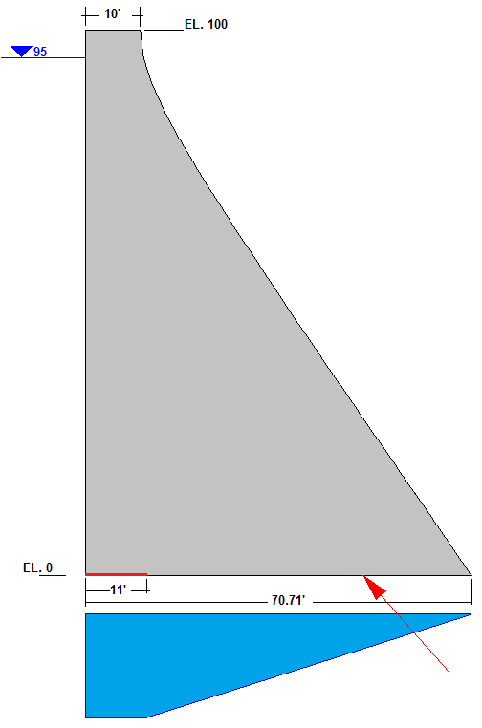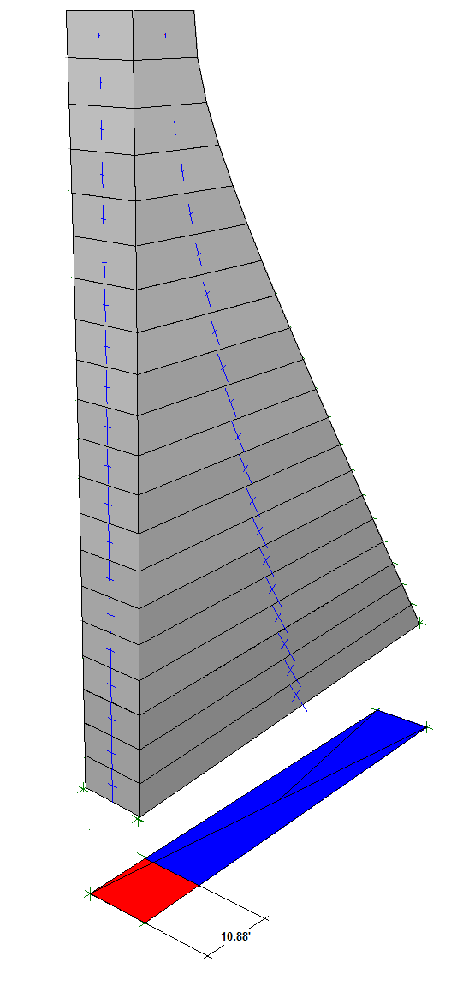

There is an asymmetry in stiffness when TFEs are used to model a quadrilateral surface.

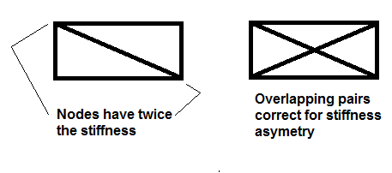

Consider the above figure. Each TFE has a compressional stiffness equal to its elastic modulus times its area. A uniformly compressed TFE will produce nodal forces equal to the total element stiffness divided by 3. This means that if a pair are used to model a quadrilateral surface, the nodes which share 2 TFEs will be twice as stiff as the nodes with only 1. This effect can be avoided by using a pair of pairs laid out so that each node has 2 TFEs associated with it. If cracked base uplift is used, only 1 pair should be activated, otherwise uplift will be doubled.

The Axibar

The Axibar is an axial force only element. It has no bending or shear stiffness. It is large deflection formulated. It also has the capability to yield in compression or tension. Axibars can be pre-stressed.

Input File

First Line:

Nodes Bricks TFE’s Axibars Materials (Maximum of 20 materials)

Next N lines where N is the number of nodes:

X Y Z Cx Cy Cz Fx Fy Fz Pressure

Where

X Y and Z are the location of the node

Cx Cy and Cz are constraint codes (1=free, 0=fixed)

Fx Fy and Fz are nodal forces

Pressure is a fluid pressure at a node. This pressure will be used to calculate brick face pressures if the node is attached to a brick, or cracked base uplift if it is attached to a TFE.

Next M lines where M is the number of materials:

E μ γ φ <Tension Yield Stress> <Compression Yield Stress> <Prestress or Dilatation Angle> <Color or Uplift toggle>

Where

**E** is Young’s modulus

**μ** is Poisson’s ratio

**γ** is weight density which is used for bricks only. It is automatically applied in the negative Z direction.

**Φ** is the friction angle used for TFE’s

**Tension Yield Stress** is used by Axibars and by TFEs. With TFEs, any value greater than zero will cause the TFE to behave elastically. Thus TFEs can have zro tensile strength, or infinite tensile strength.

**Compressive Yield Stress** is used for Axibars. It has a negative value since compressive stress is negative.

**Prestress or Dilatation angle** If the member referencing this is an Axibar, this value is a prestress. If the member is a TFE, then it is a Dilatation angle. Shear stress will cause additional normal stress.

**Color or Uplift toggle** If the member referencing the material is a brick, then this is color. If it is a TFE, then a value of 1 turns on the cracked base uplift routine, a value of 0 turns it off. Brick color codes are shown below.



Brick Face Pressure Codes (One line for each material, even if there are no bricks)

6 values, either 1 or 0, that turn on (1) or off (0) the brick face pressure calculation. If a value is 1, then the nodal pressures are used to calculate a pressure distribution on that face and associated nodal loads. If the value is 0, then no face pressure is calculated. Also, the program is looking for the brick face pressure code line even if there are no Bricks.

Pressurization is only done to visible element faces. Faces in contact with other brick element faces are not pressurized.

For example 1 0 0 0 1 0 means that brick faces 1 and 5 will be pressurized, but all other faces will not be.

When using brick face pressures, it is important to define the element geometry such that the faces are not random.

Care must be taken to not pressurize a brick face that is attached to a TFE that has uplift enabled, for this will double count uplift.

Bricks (One line for each Brick)

i j k l m n o p mat

Where i → p are the 8 brick nodes and mat is the material number.

If a degenerate brick (such as a triangular prism or a tetrahedron) is desired, nodes are duplicated. For example i j k k m m m m would define a tetrahedron.

TFE’s (One line for each TFE)

i j k l m n mat

where i → k define the master surface and l → m define the target, and mat is the material number. There must be a finite gap between master and target surfaces. It can be very small, but it must be finite. This defines the direction of crack closing.

Axibars (One line for each Axibar)

i j mat area

Where i and j define the ends of the bar, mat is the material number, and area is the cross sectional area of the bar.

Below is a sample input file. In the example, a triangular section made of Bricks is loaded by a hydrostatic load applied to its vertical face and a triangular uplift pressure applied to its base. The base is attached to ground using TFE’s with 45° friction. In addition, non prestressed Axibars are attached.

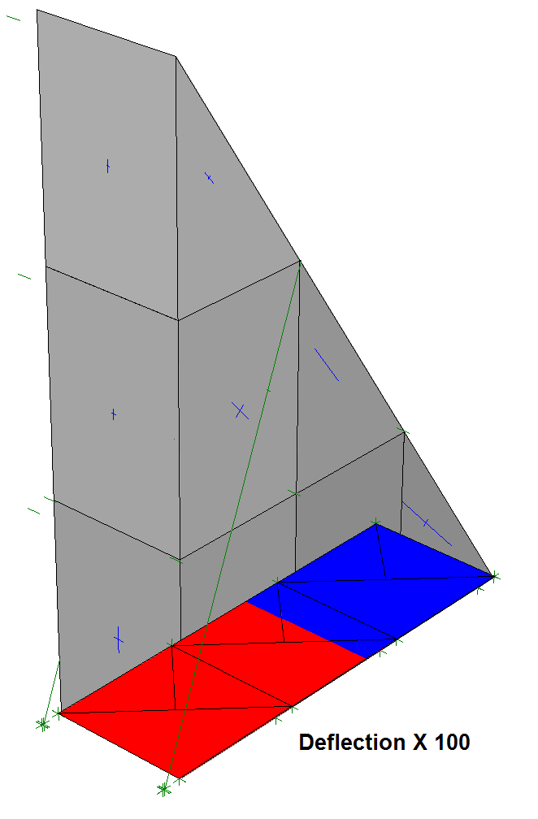

28 6 12 2 3

0 -5 0 1 0 1 0 0 0 2.808

10 -5 0 1 0 1 0 0 0 1.872

20 -5 0 1 0 1 0 0 0 0.936

30 -5 0 1 0 1 0 0 0 0

0 -5 15 1 0 1 0 0 0 1.872

10 -5 15 1 0 1 0 0 0 0

20 -5 15 1 0 1 0 0 0 0

0 -5 30 1 0 1 0 0 0 0.936

10 -5 30 1 0 1 0 0 0 0

0 -5 45 1 0 1 0 0 0 0

0 5 0 1 0 1 0 0 0 2.808

10 5 0 1 0 1 0 0 0 1.872

20 5 0 1 0 1 0 0 0 0.936

30 5 0 1 0 1 0 0 0 0

0 5 15 1 0 1 0 0 0 1.872

10 5 15 1 0 1 0 0 0 0

20 5 15 1 0 1 0 0 0 0

0 5 30 1 0 1 0 0 0 0.936

10 5 30 1 0 1 0 0 0 0

0 5 45 1 0 1 0 0 0 0

0 -5 -0.01 0 0 0 0 0 0 0

10 -5 -0.01 0 0 0 0 0 0 0

20 -5 -0.01 0 0 0 0 0 0 0

30 -5 -0.01 0 0 0 0 0 0 0

0 5 -0.01 0 0 0 0 0 0 0

10 5 -0.01 0 0 0 0 0 0 0

20 5 -0.01 0 0 0 0 0 0 0

30 5 -0.01 0 0 0 0 0 0 0

512000 0.17 0.15 0 0 0 0 0

256000 0 0 45 0 0 0 0

4176000 0 0 0 38880 0 0 0

1 1 1 1 1 1

1 1 1 1 1 1

1 1 1 1 1 1

1 2 12 11 5 6 16 15 1

2 3 13 12 6 7 17 16 1

3 4 14 13 7 7 17 17 1

5 6 16 15 8 9 19 18 1

6 7 17 16 9 9 19 19 1

8 9 19 18 10 10 20 20 1

1 2 11 21 22 25 2

11 12 2 25 26 22 2

1 2 12 21 22 26 2

11 12 1 25 26 21 2

2 3 12 22 23 26 2

12 13 3 26 27 23 2

2 3 13 22 23 27 2

12 13 2 26 27 22 2

3 4 13 23 24 27 2

13 14 4 27 28 24 2

3 4 14 23 24 28 2

13 14 3 27 28 23 2

21 9 3 0.01

25 19 3 0.01

Running the Program

Upon execution, the program will request an input file name. This file name must contain the full path name if the file is located in a directory other than the program. All output files will be put into the directory of the input file.

The program will then read the input file echo printing model geometry. It will then ask for a view point. This viewpoint X <enter> Y <enter> Z <enter> is where the model will be viewed from. The model can be viewed prior to running to check if the geometry is as desired. At any time, if “s” is entered for the X coordinate, the view cycle will be stopped and the analysis will proceed. The program writes a .bmp file for viewing.

The program then asks if there is a jumpstart file. If the model has been run before, it is sometimes desirable to read the deformed state from the previous run. These deformations will be applied to the new model as initial conditions.

The program then computes a step size used in finite difference differentiation. Too small a step will result in computer floating point error. Too large a step will cause conversion problems. It is recommended that the default step size be accepted.

An iteration limit is then asked for. It is usually prudent to give a high value (10s of thousands). If the model closes sooner than the iteration limit, the program will stop on its own. If the solution does not converge before reaching the iteration limit, the user can perform additional iterations my upping the initial iteration limit. For example, if the initial iteration limit was 10,000 and closure did not happen, than the user could raise the iteration to 20,000 and another 10,000 iterations would be done.

Upon completion the program asks if a force imbalance file is desired. This is a record of how the solution closed. It is usually not necessary, but if one can not figure out why a solution is not closing, this file may be of some value.

The program then returns to its graphic viewpoint mode. The model can be viewed from all different angles. Deflections can be multiplied. Principal stress vectors are displayed on the faces of every Brick. Blue is compressive, red is tensile.

4 output files are made. <Arvar_out.txt> is the text printout of all results. <Arvar_out.bmp> is a bitmap of Brick output. <TFE_out.bmp> is a graphic of the TFE’s. Blue indicates compression, red indicates cracking. If TFE’s are glued (assigned tensile strength) the tensile area is yellow. <Axibar_out.bmp> shows the Axibars. If they yield in compression, they are blue, if they yield in tension they are red, otherwise they are green.

In addition, there is a file called <Avar_lod.txt> produced which is a record of all nodal forces. This includes nodal forces from Brick self weight and Brick face pressure.

Have Fun.