User Story 7 – As a police officer, I want to update the status of a report so that I can track which incidents have been reviewed or actioned.
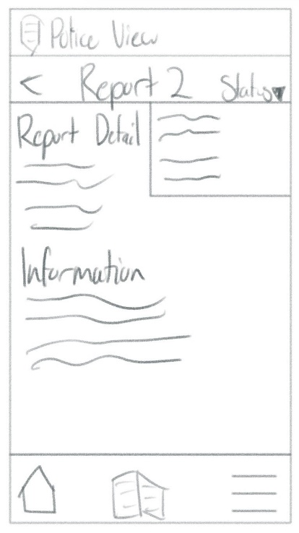
Author: Finn
Persistent icons for home, records and more to allow quick switching
Layout prioritises report detail and information so the officer can review facts before making changes
Interaction point for the officer to toggle between status options
Badge/shield to verify user is logged in with officer permissions
User Story 8 – As a public user, I want to write a crime report so that I can tell the police what happened.  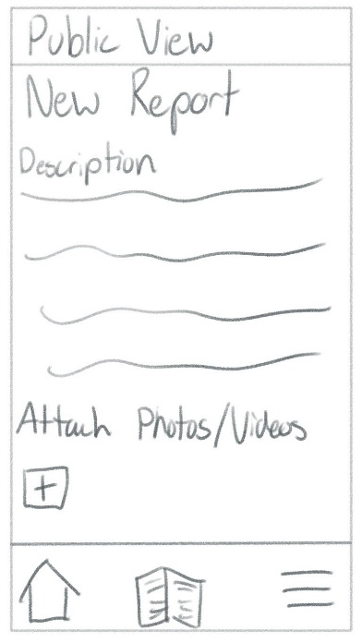  Author: Finn  Simple flow to reduce friction for a user who might be under stress when reporting  Clear attach photos/videos prompt with a plus icon to facilitate evidence collection  Dedicated description area for users to provide a detailed narrative of the incident | User Story 9 – As an administrator, I want to view system-wide usage statistics so that I can monitor how the app is being used.  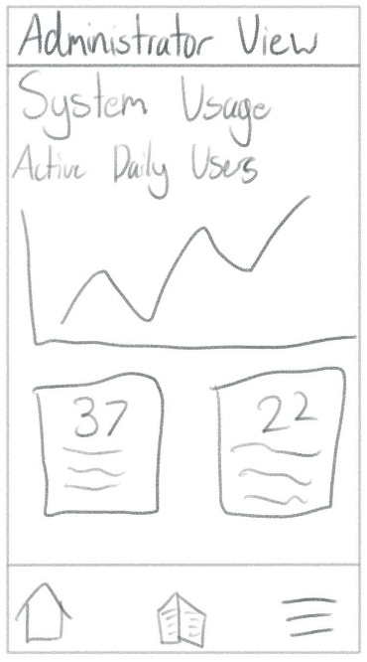  Author: Finn  Data cards to highlight key performance indicators  Use of a line graph to show active daily user’s trends over time  Access to the full system menu to allow the admin to manage users or export data

User Story 10 – As a user, I want my session to stay active after logging in so that I don’t have to repeatedly log in while using the app.  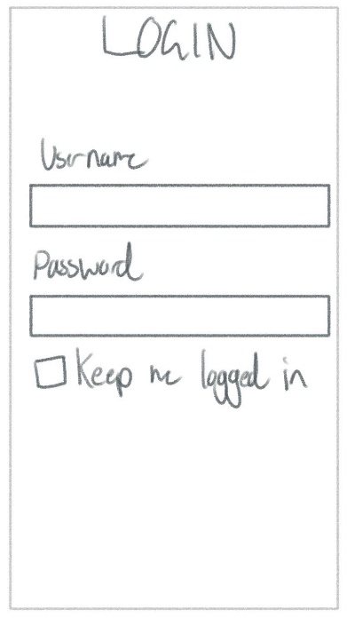  Author: Finn  Clean username and password inputs  No distractions on this page to ensure the login process is fast  A clearly labelled keep me logged in checkbox indicating secure token will be stored to user isn’t logged out | User Story 11 – As a public user, I want the app to automatically suggest the crime type and severity when I type my report description so that I don’t have to manually categorise the incident myself.  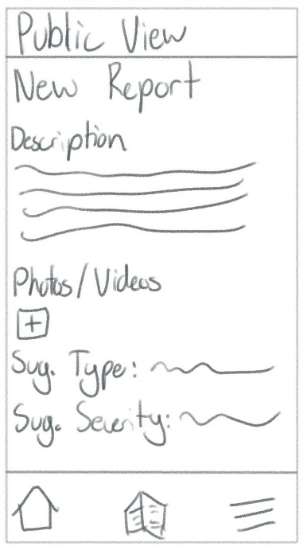  Author: Finn  Real time analysis of description field as system processes input  Suggested fields allow user to see the classification without hunting through long list  AI driven suggestions for both the type of crime and its severity
User Story 12 – As a user, I want to log in with my email and password so that I can submit and track my reports.

Author: Maan

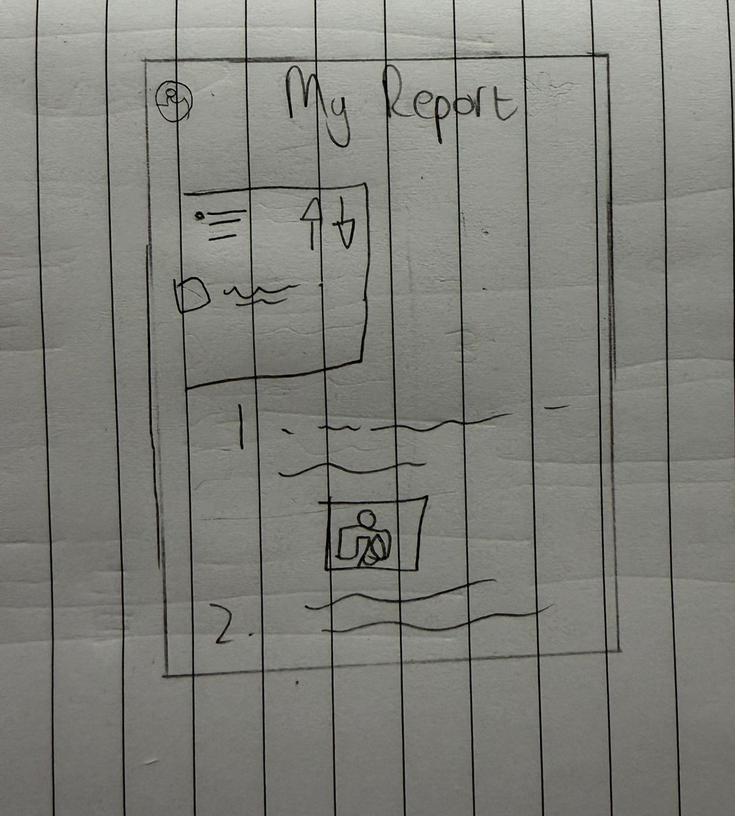

Shows all the user’s reports they have submitted, with photo.

User Story 13 – As a public user, I want to submit a report anonymously so that I can report a crime without fear of identification.  Click the submit button to finalize the report  Choose a category  Add extra description/information  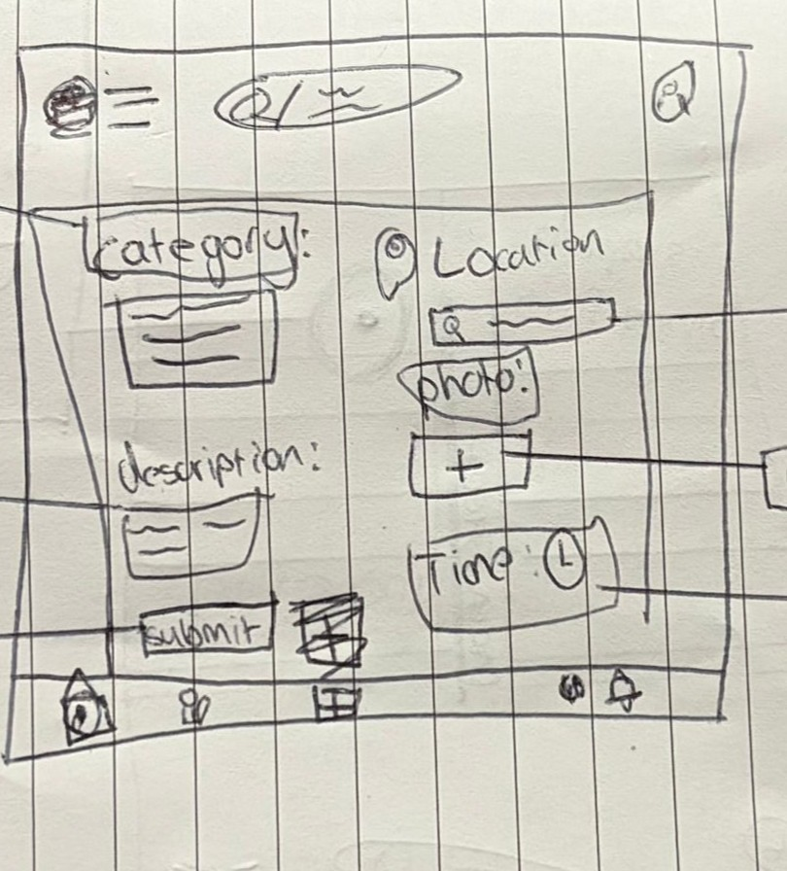  Author: Maan | Add the location for precision  Add a photo if desired  Add a time to show when report happened
User Story 14 – As a police officer, I want to log in through a secure portal so that only authorised personnel can access sensitive report data.
Shows all reports.
Allows officer to change how the priority score is calculated
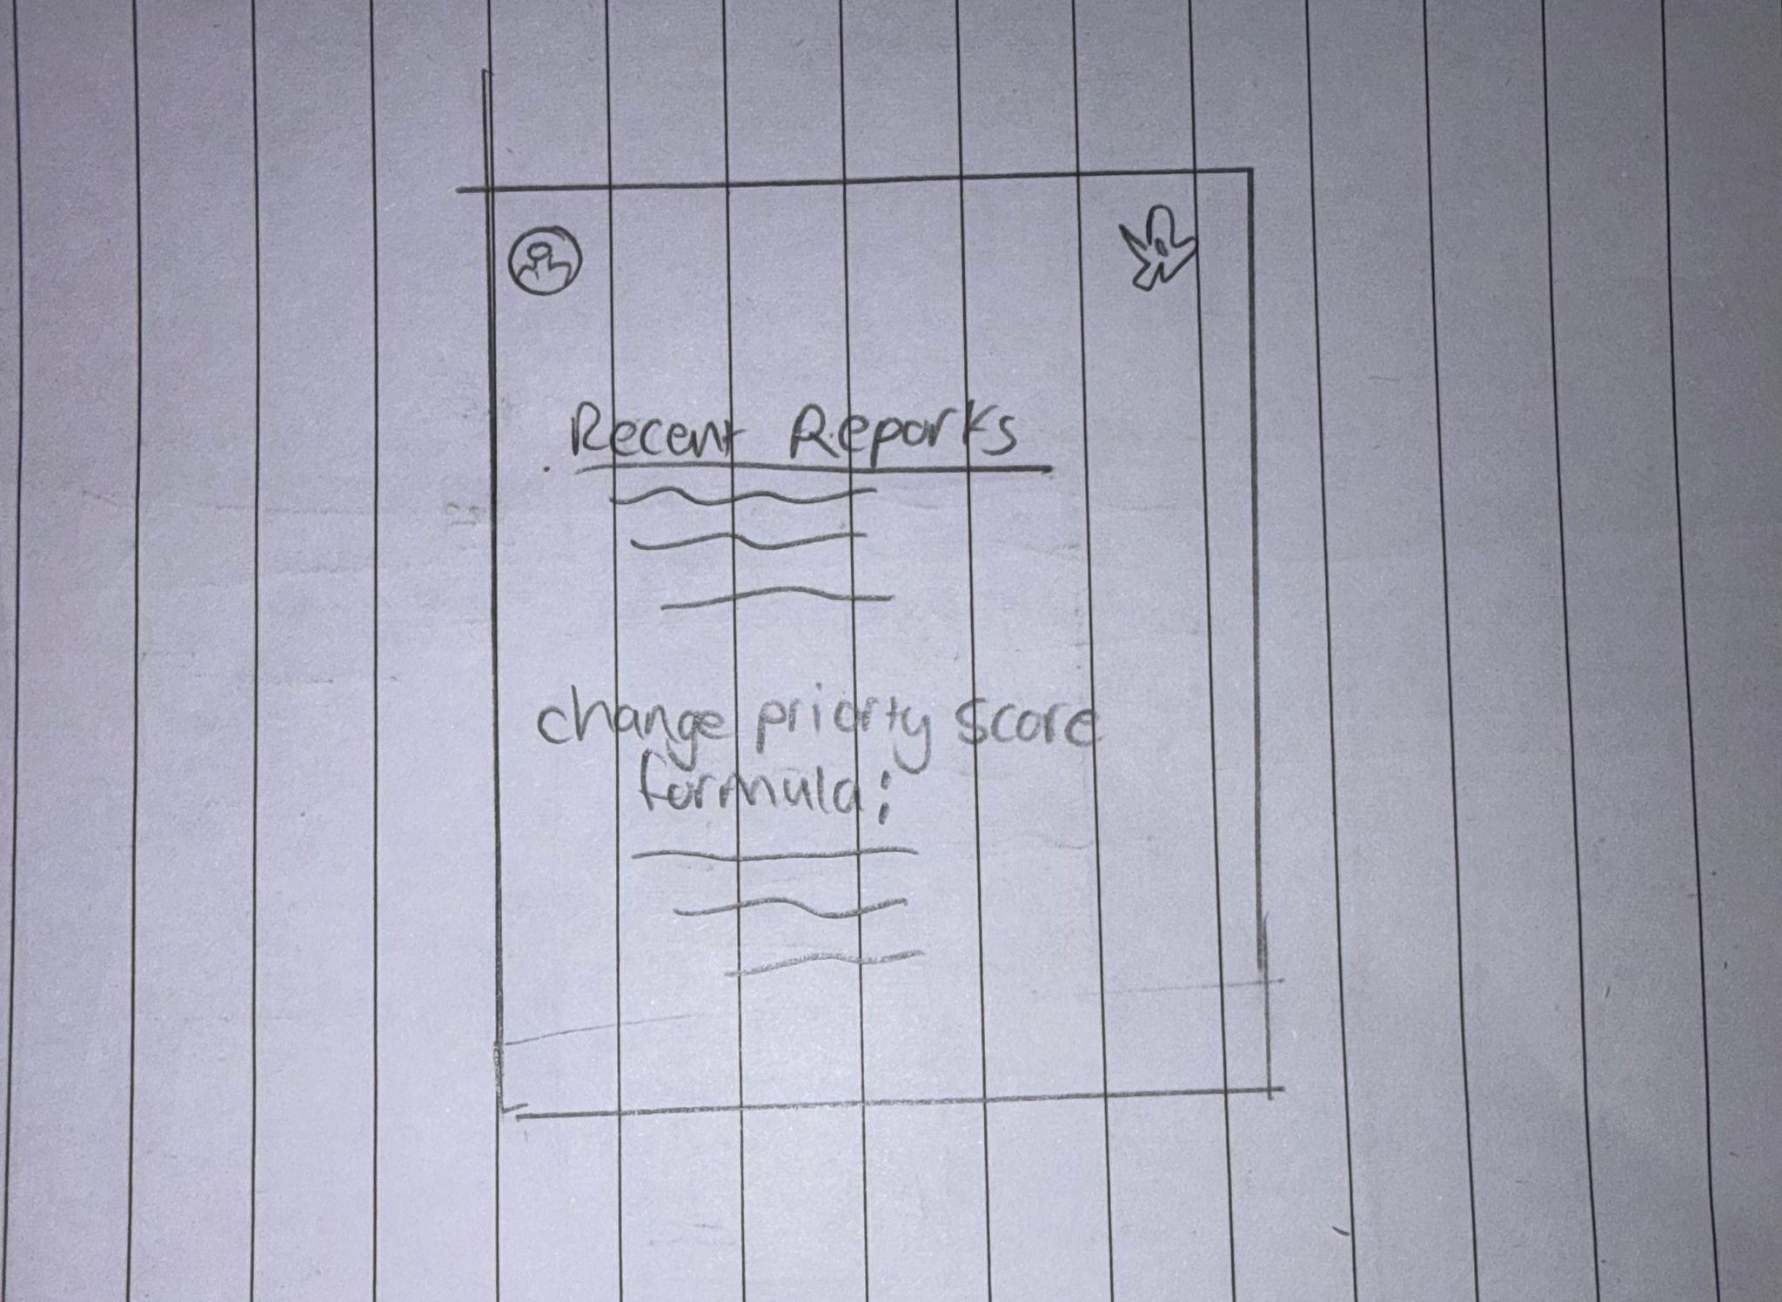

Author: Maan
User Story 15 –As a public user, I want to customise the colour theme of the app so that the interface matches my personal aesthetic preferences.
Users can change the way they want their ap to look like.
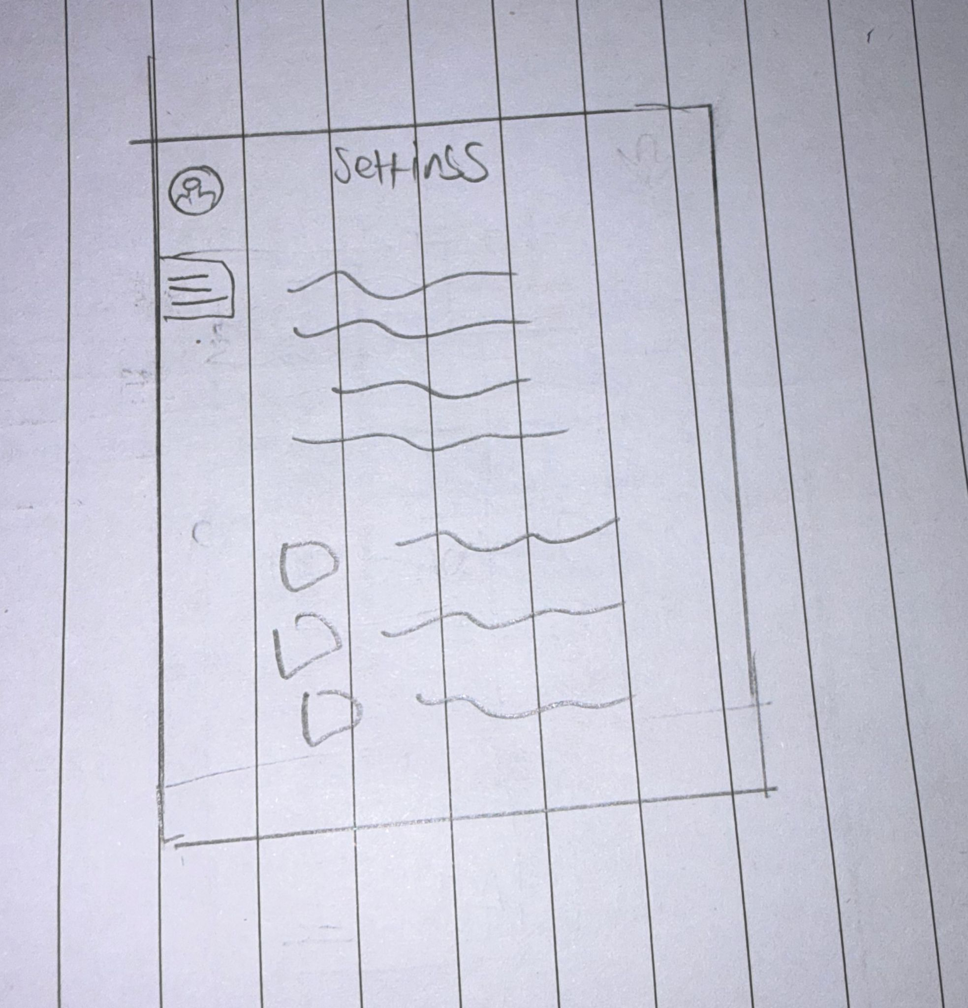

Author: Maan

User Story 16 –As a public user, I want to view reported crimes in my local area so that I am aware of incidents nearby.
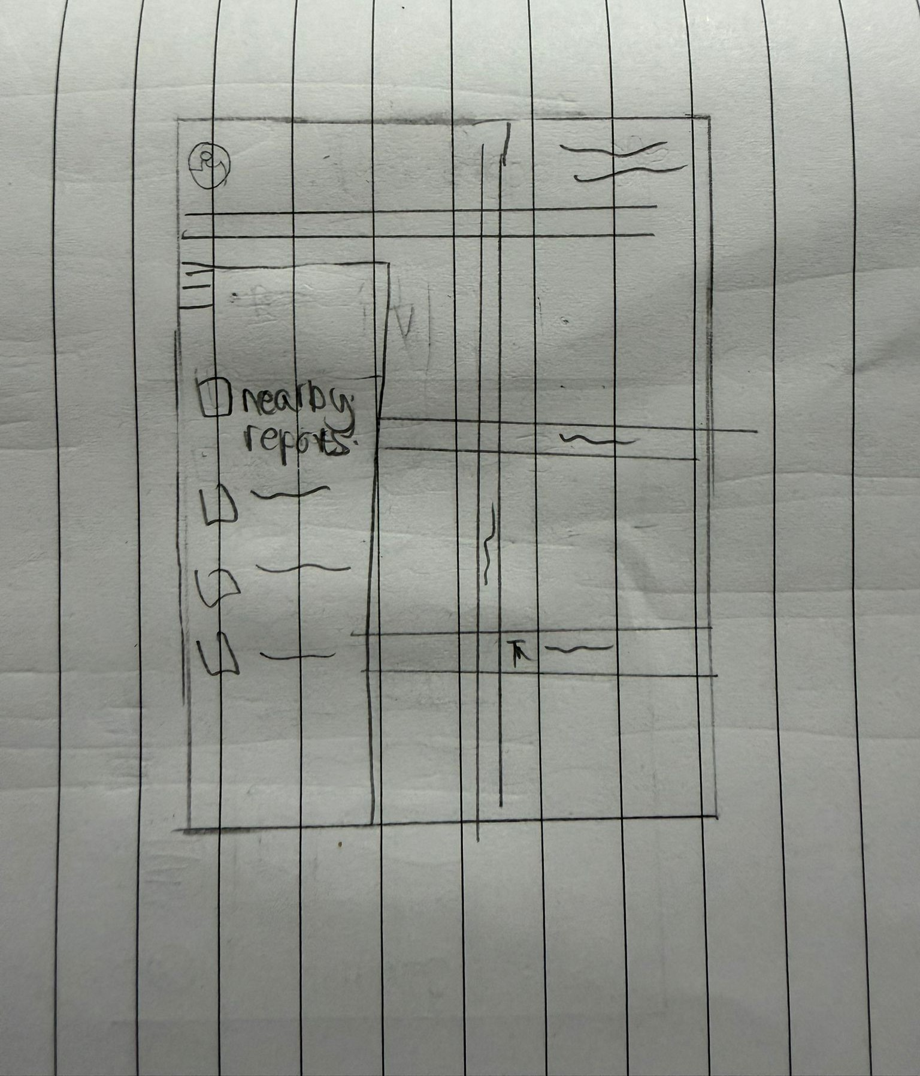

Author: Maan
Users can view nearby reports on the map. (optional to add filters)
User Story 17 – As a police officer, I want to see reports sorted by priority score so that the most urgent incidents appear at the top of my list automatically.  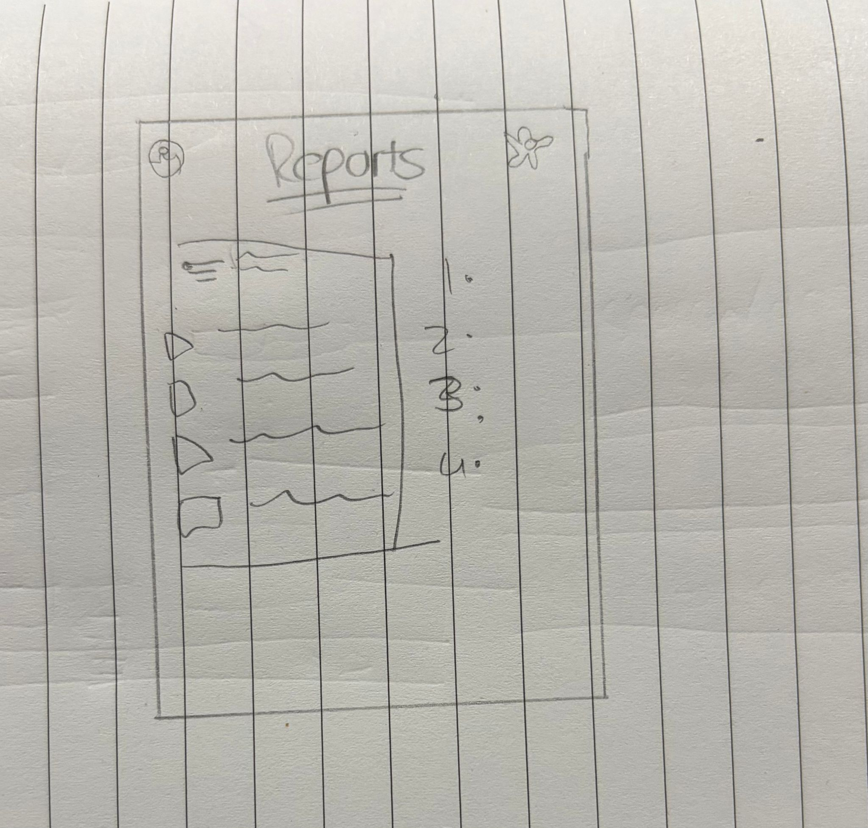  Author: Maan  Officer has a choice to add filters | Lists incidents based on priority score  Police Officers get a star to show they are officers.

