Purpose

Identify short list of schools to target for Code.Org curriculum, focusing on likelihood of being adopted & ordering by highest penetration of under representation.

We will focus on acquiring net new schools rather than increasing existing participation

# Hypothesis

We are more likely to get adoption of curriculum in geographical areas we have had success (social proof bias) & in schools where we have existing engagement with our product

# Method

To identify our short list, we will apply a two-process analytical approach

*Social Proof*

1. Find our highest penetration of current curriculum for high schools by state in 2023
   1. Referred to as **state penetration**
2. Find the highest penetration of key metric (High Needs)
   1. From 1 + 2 what is the short list of states that have the highest combination of current curriculum & high needs penetration
   2. Referred to as **High Needs Penetration**

*Highest Engagement*

1. From our short list of states identify top 10 schools that have at least 1 PD teacher, with the highest number of students who have engaged with Code.Org content

# Results

We find weak correlation between our existing high schools and our key indicators. Our correlation Matrix shows school penetration is positively correlated with High Needs penetration (0.15) & negatively correlated with Rural areas (-0.17) at the state level.

A previous attempt in analysis investigated having a weighted average by total students in each state for our key indicators (high needs/rural/urg) however, due to weak correlation of the individual components, the KPI metric was not pursued further.

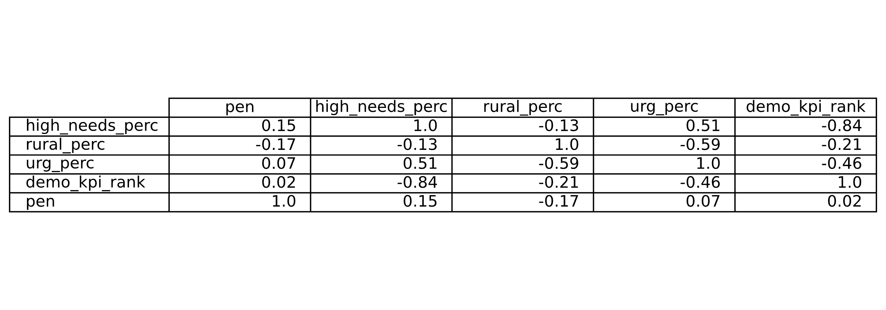

Based on these results we changed our analysis from creating an averaged KPI metric to only High Needs which had the highest positive correlation to state penetration.

Cross referencing our state penetration to high needs penetration we averaged the two rankings to create a composite rank. Plotting the composite rank, we found a wide gap in after the top 5 states (NV, SC, MS, AL, MD). Based on this the target states were the top 5 states.

|  |  |
| --- | --- |
|  |  |

Figure 1,2: All states ranked with smallest value being most desirable (high state & high needs rank)

# Conclusion

Now that the 5 target states have been identified, we are tasked with zeroing in on a specific school list. First, only look at high schools that have at least 1 teacher that has actively engaged with Code.Org in the past year, then we rank by total students who have engaged with our product resulting in the following list:

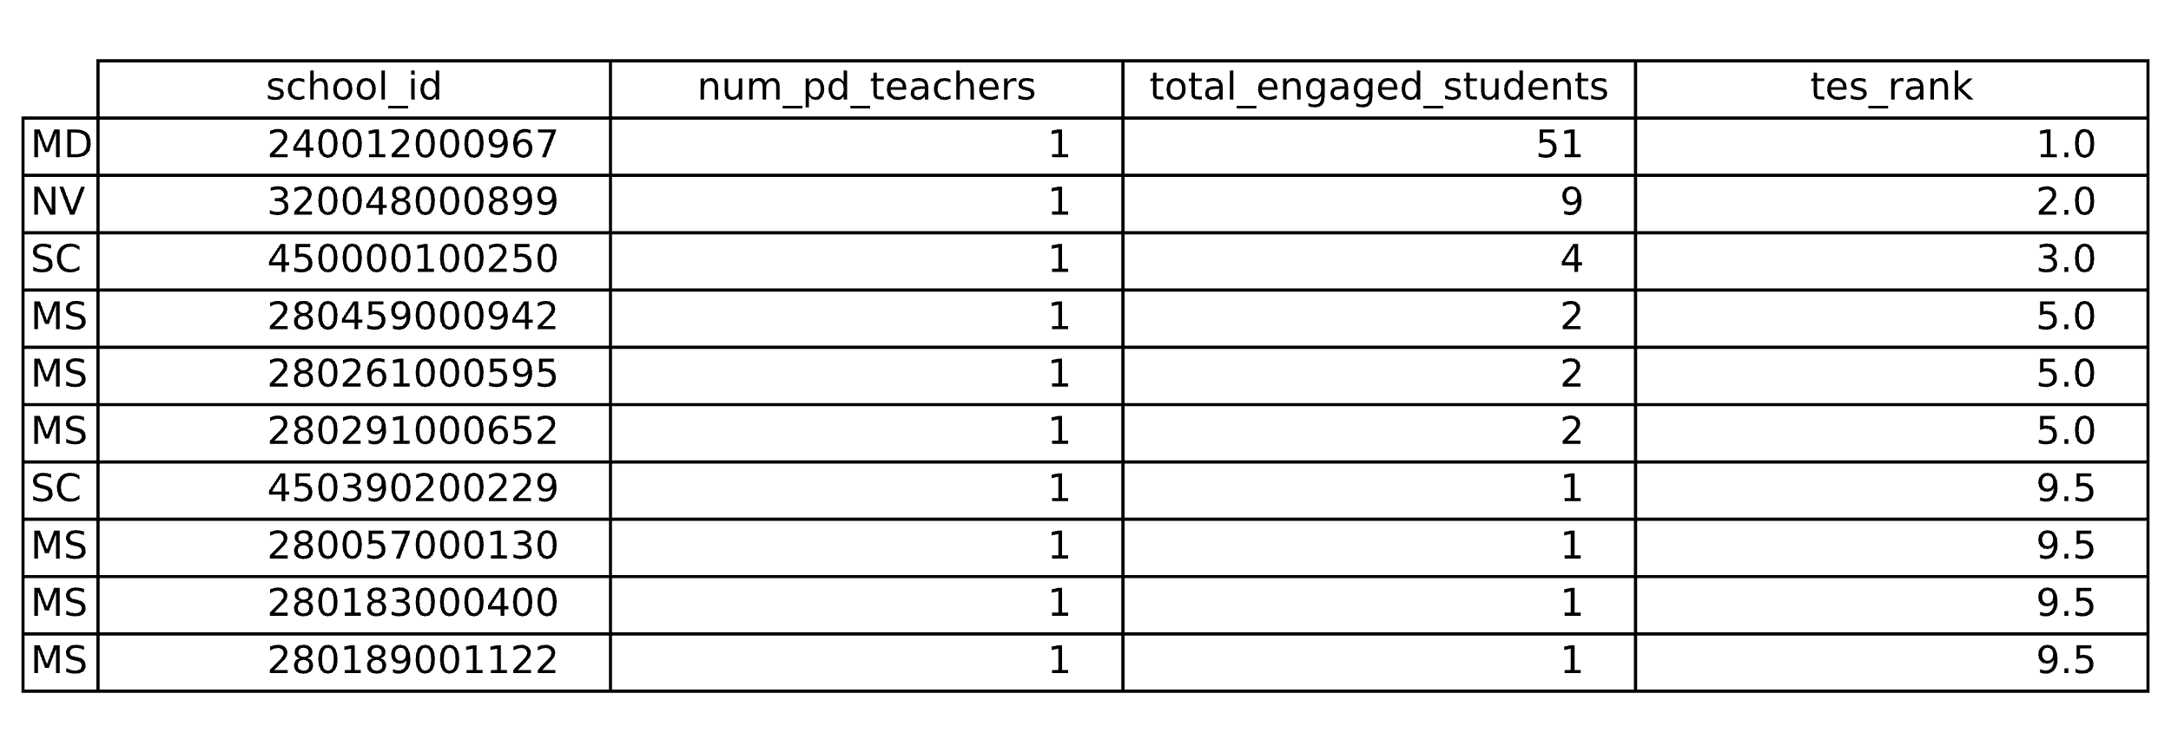

Based on our analysis, these schools should be easier to convert into curriculum users as they have the highest number of engaged students & teachers, are in states that Code.Org has existing relationships with other schools in the same system, and are in one of our key demographics of High Needs.

# Future Analyses

This project investigated net new schools to target. However, it would be easier to increase engagement in existing schools than to onboard net new. Another tactic to increase users would take this approach – finding existing schools with lowest participation and attempt to increase from there.

In addition, layering in school zip code would allow us to rank schools that are in close geographical proximity to existing schools to increase the social proof concept (“school X down the street uses our curriculum and found Y results”)

# Assumptions

* Social Proof Bias is contingent on any school having an active program not only a high school
* We define underrepresented population as weighted average (by total students) of:
  + Is High Needs %
  + Underrepresented Racial Group %
  + Is Rural %
* Our target demographics appear to be repeated for each school year, we assume this is for year 2023