Detecting toxic behaviour in online game chat with natural language processing:
Milestone
- Motivation
Toxic messages in online multiplayer games (insults, harassment, sarcastic put-downs) harm players’ wel-being and drive people away from games communities. Moderation is still manual and game chat is hard to moderate automatically because of slang, game-specific vocabulary and implicit toxicity like sarcasm.
The input of our algorithm is a single chat message from Dota 2 match. We used classifiers to output one of four labels: explicit toxic (E), implicit toxic (I), game action (A) or other (O). We also evaluate a binary version, toxic (E or I) versus non-toxic (A or O).

- Dataset and Method
We used the dataset CONDA, built from Dota 2 chat logs. The files we use contain 43,495 utterances, slightly fewer than the 45K stated in the dataset documentation, so we report the counts of our files. Messages are very shorts (mean 3.8 words, median 3, maximum 57), and classes are imbalanced: in the training file, O is 73.3% of messages, E 13.6%, A 6.6% and I 6.5%.
The test labels are withheld (the authors evaluate through a Codalab leaderboard), so the proposed 60/20/20 split coul not be used. Instead we split train data by match into a training set and a development set used for tuning, and we use the official validation data as our held-out test set. The official train and validation set share over 1,700 matches, so scores on the validation data may be slightly optimistic.
Messages are converted to TF-IDF vectors over word unigrams. A multinomial logistic regression then predicts class probabilities with the softmax function, trained by minimising a class-weighted cross-entropy loss. The binary model is a second logistic regression trained with the same features on the toxic / non-toxic label.

- Prelominary Experiments
We report accuracy and the macro-averaged F1 scor, the unweighted mean of the per-class F1 – 2PR / (P + R), where P is precision and R is recall. Macro F1 is our primary metric because the majority class O makes up 73% of messages and accuracy alone would hide poor performance on E, A and I.
As Result we got Table 1 show the 4-class results and Table 2 the binary results. These are single runs without confidence intervals.
Table 1 : 4-class
Split | Accuracy | Macro F1 | A | E | I | O
Dev(2,864) | 0.882 | 0.787 | 0.693 | 0.811 | 0.714 | 0.930
Valid data(8,706) | 0.869 | 0.769 | 0.677 | 0.806 | 0.673 | 0.921
Table 2: binary toxic vs non-toxic baseline
Split | Accuracy | Macro F1 | Toxic precision | Toxic recall | Toxic F1
Dev(2,864) | 0.924 | 0.880 | 0.784 | 0.832 | 0.807
Valid data(8,706) | 0.917 | 0.874 | 0.784 | 0.817 | 0.800
Explicit toxicity (E) and the majority class are handled well, while action (A) and implicit toxicity (I) are clearly weaker, in line with the dataset authors’ report that implicit toxicity is hardest. For A, E and I recall is higer than precision, an effect of the class weights. Dev and test macro F1 differ by less than 0.02, since dev contains only 187 I and 195 A messages, this difference is within what we would expect from noisem so we cannot conclude whether the shared matches inflate the test scores.
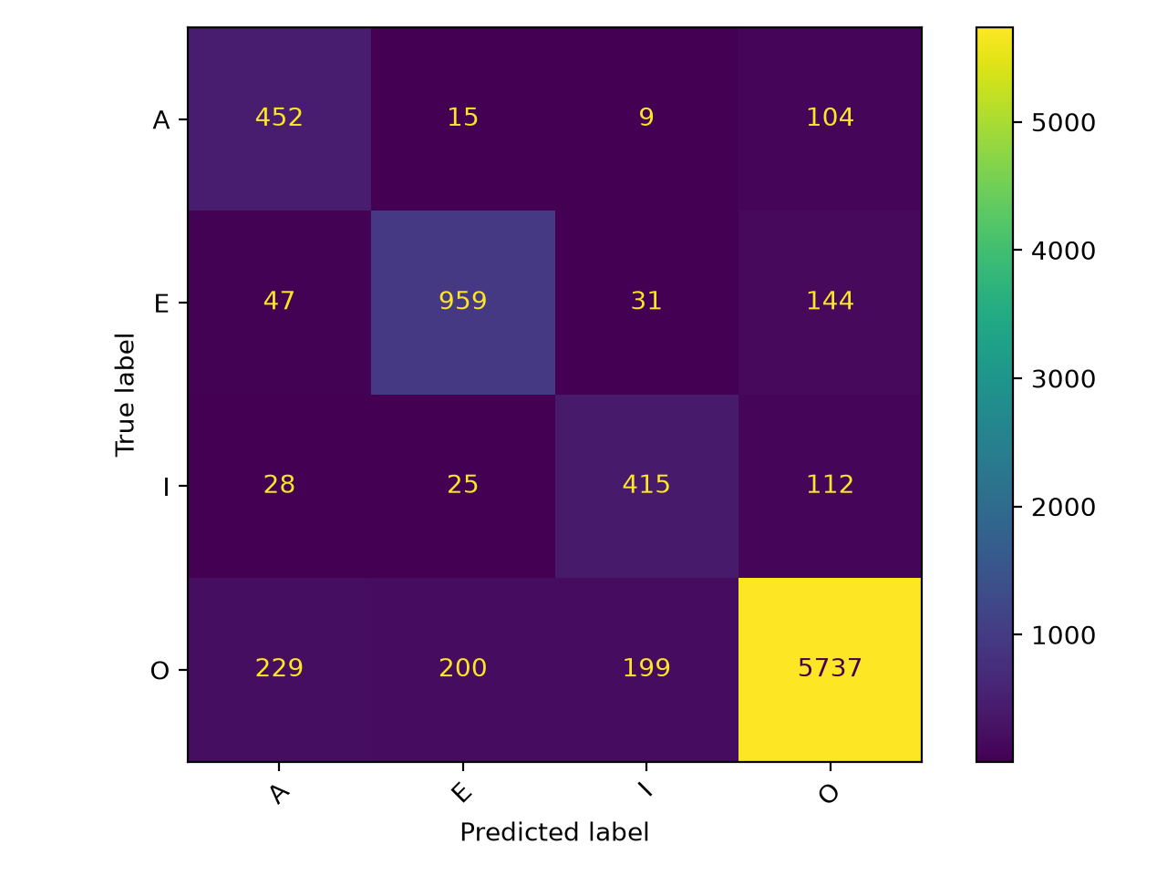
Figure 1: Confusion matrix of the 4-class baseline on the hel-out test set (valid data)
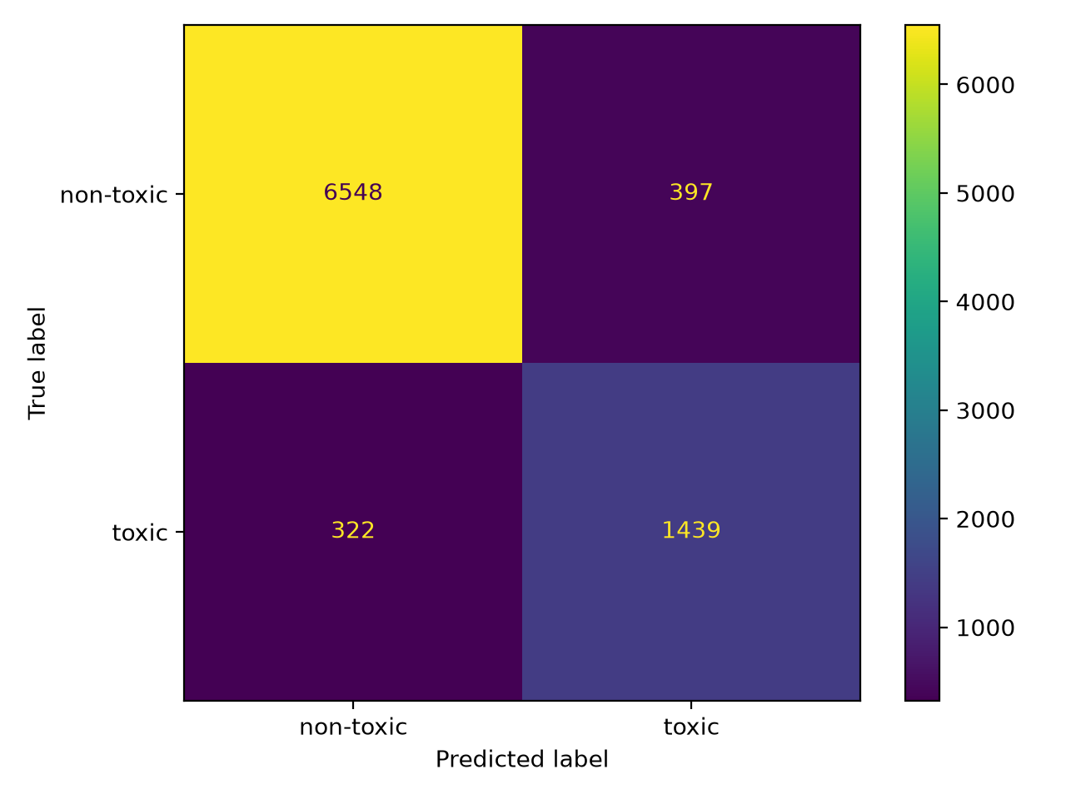
The baseline makes 339 errors on the 2,864 development messages. We read a random sample of 25 errors and 15 misclassified I messages, the following patterns are qualitative observations from this sample, not measured frequencies.
1. Trigger words mislead a bag of words model. Words such as “commend”, “wait plz” and “report” push predictions towards A even when the label is O, and “plz report blue intentional feeding” is labelled I but predicted A.
2. Implicit toxicity depends on the context. Messages such as “0- 4”, “ta is 8-5 magnus is 0-6”, “ayy lmao” and “wtf” are labelled I but predicted O. Their toxicity comes from the game situation or sarcasm, which TF-IDF features of a single message cannot captre. This motivates a context-aware model.

3. Misspellings and obfuscation. “fyuuuhhh” and “Sec lag omg fk u ta” are labelled E but predicted O, because the word forms are rare or unseen.

4. Very short messages. Messages like “easy” and “worth?” Or “g” cannot be resolved from the text alone.

5. Possible label ambiguity. “burn in hell” is labelled I rather than E, and “Shup up plz” is labelled O but predicted E. We have not audited the annotations, so we only note this as a possible limitation.

- Next Steps
- Stronger sparse baselines: add character n-gram features to handle misspellings and compare with a linear SVM, to check that conclusions do not depend on logistic regression.
- Fine-tune transformer: fine-tune DistilBERT on Google Colab with a class-weighted loss, using the same train/ dev /test protocol so the results are directly comparable with the baseline.
- Conversation context: feed the previous messages of the same conversation together with the current message, to test whether context helps implicit toxicity.

