- The Engineering Design Process
en-gi-neer (n) 1. One versed in the design, construction, and use of machines. 2. One who employs the innovative and methodical application of scientific knowledge and technology to produce a device, system, or process, which is intended to satisfy human needs.—American College Dictionary
Take a moment to read and analyze the key elements of the two definitions presented above. If you are an engineering student or practicing engineer, do you think that this definition applies to you? The first definition uses the terms design and construction. People like to think of themselves as designers. Why is that so? The answer may be in the combination of the term construction, and from the second definition, the idea of innovation. Applying innovation and creativity to produce something new is a wonderfully rewarding process. The great thing about being an engineer is that it allows you to be a creative designer. That is generally not the way the profession is viewed. What is the difference between engineering design and other types of design that are associated with creativity such as interior design, fashion design, or webpage design? The answer is supplied in the second definition which states ”…methodical application of scientific knowledge and technology…” As an engineering student, you have studied a great deal of math, science, and fundamental technology, but probably have had limited exposure to creative and innovative design.
The definition also contains the somewhat contradictory terms innovative and methodical. If there is an established and methodical way of employing a scientific principle or process, it does not seem to allow much room for creativity and innovation. The truth is that the two concepts are in competition with each other, but a good engineer realizes this and utilizes both effectively. The definition also indicates that engineers design to satisfy human needs, an important, yet often overlooked point. That means that when designing systems, it is necessary to determine the user’s needs and the ethical application of the technology.
This book aims to help electrical and computer engineers become effective designers, to better understand professional practices, and to provide guidance for executing design projects. This chapter presents the processes by which designs are realized, the characteristics of successful engineers, and an overview of the book.
Learning Objectives
By the end of this chapter, the reader should:
- Understand what is meant by engineering design.
- Understand the phases of the engineering design process.
- Be familiar with the attributes of successful engineers.
- Understand the objectives of this book.

The Engineering Design Process
ABET (formerly known as Accreditation Board of Engineering and Technology) provides the following definition of engineering design [ABE03].
Engineering design is the process of devising a system, component, or process to meet desired needs. It is a decision-making process (often iterative), in which the basic sciences, mathematics, and engineering sciences are applied to convert resources optimally to meet a stated objective. Among the fundamental elements of the design process are the establishment of objectives and criteria, synthesis, analysis, construction, testing, and evaluation.
The definition indicates that, in engineering design, different phases of the process have to be re-visited and the deliverables for each phase updated as necessary. Realistic problems are complex with many potential solutions; the goal is not to find just any solution, but the best one given the constraints and available resources. This requires the application of sound judgment, decision-making skills, and patience in constantly evaluating progress towards a solution. The definition identifies some common elements of the design process, such as establishment of criteria, synthesis, construction, and testing.
Design processes embody the steps required to take an idea from concept to realization of the final system, and are problem-solving methodologies that aim to develop a system that best meets the customer’s need within given constraints. This is not all that different from some everyday processes, such as preparing dinner. Say you are hungry and need to eat dinner before you can go to see a movie that starts in one hour. The constraints are time, money, food, your tastes, and nutritional value if you are health-conscious. You brainstorm and come up with the options of making dinner at home, going to a restaurant, or buying something to eat at the theater. Based on these options, you then select the solution based on your evaluation of the best one. This is similar in philosophy to the stages of design processes where you have a problem to solve, constraints, and a number of potential solutions to select from.
A related term is known as the product realization process. The product realization process is broader in scope, including aspects such as entrepreneurship, market research, financial planning, product pricing, and market strategy. Many technologies have their own particular design processes that have evolved over time and have been found by practitioners in the field to be valuable. For example, different methodologies are applied in the design of integrated circuits (VLSI), embedded systems, and software systems, yet they all have some degree of commonality, such as requirements analysis, technical design, and system test. Design processes continue to evolve. One field in which this is particularly true is in software design due to the constantly changing nature of software and the special challenges that large software projects pose.
Cross [Cro00] identified two types of design processes—prescriptive and descriptive. As the name implies, prescriptive design processes set down an exact process, or systematic recipe, for realizing a system. Prescriptive design processes are often algorithmic in nature and expressed using flow charts with decision logic. An example of a prescriptive process is shown in Figure 1.1, which describes the front end of the design process where the problem and requirements are determined. A decision block is included where the requirements are examined to determine if they satisfy the needs of the problem. Descriptive processes are less formal, describing typical activities involved in realizing designs with less emphasis on exact sequencing. The distinction between descriptive and prescriptive processes is not always clear, however, and some processes may be considered more strongly associated with one property than the other. Cross makes an important point in stating that design processes are sometimes viewed as common sense and thus ignored, resulting in failed products. Cross cites two good reasons to adhere to design processes: 1) they formalize thought processes to ensure good practices are followed, leading to better and more innovative solutions, and 2) they keep all members of the team synchronized in terms of understanding where they are in the design process.
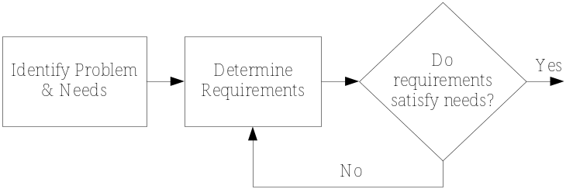

Figure 1.1 A prescriptive design process for problem identification and requirements selection.
A descriptive process that is widely applicable to design problems is shown in Figure 1.2. In a perfect world, the process starts with the identification of the problem, proceeds clockwise to research, followed the requirements phase, and so on until the system or device is delivered and goes into service (maintenance phase). This scenario is unrealistic, ignoring the iterative nature of design where the design team alternates between different phases as necessary. Consequently, links are inserted that allow transitions between all the different phases of the

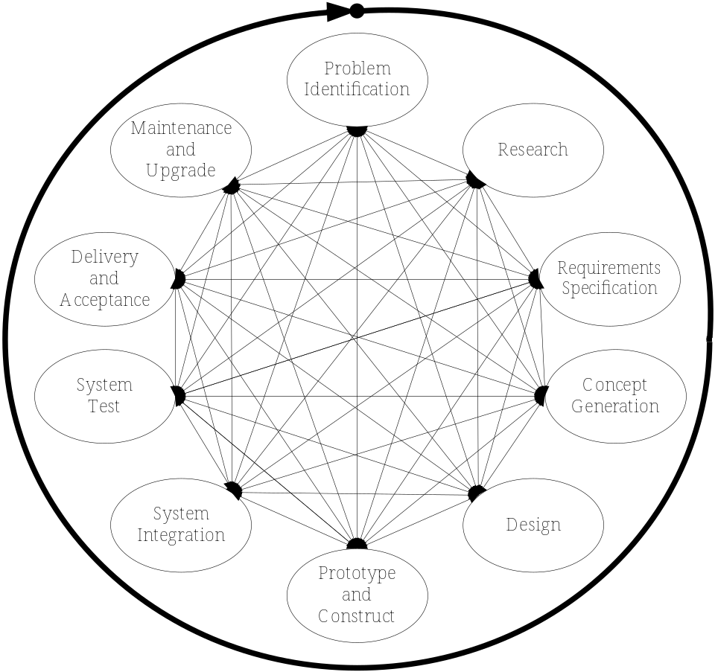
Figure 1.2 A descriptive overview of the design process.

design process. Of course, transitions between certain phases are unreasonable or very costly. It is virtually impossible to move directly from problem identification to system integration without developing a design concept first. It is much more likely for engineers to alternate between nearby phases in the process, such as problem identification, research, requirements specification, and concept generation. This does not mean that you can’t move between phases that are not in close proximity in the model. For instance, the customer’s needs may change while in the design phase, necessitating re-evaluation of the needs, correction of the requirements specification, and system redesign—all at a substantial cost in time and money. Studies have shown that the cost required to correct errors or make changes increases exponentially as the project lifetime increases, as presented in Figure 1.3.

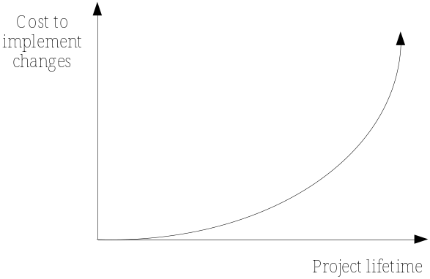
Figure 1.3 The cost to implement design changes increases exponentially with project lifetime.
    - Elements of the Design Process
Nearly all the phases of the design process in Figure 1.2 are covered in this book, with the exception of the maintenance phase. The objective of the first phase, problem identification, is to identify the problem and customer needs. This occurs in a variety of ways, from someone conceiving a new idea to a client coming to you with a problem to solve. In either case, it is important to determine the true needs for the product, device, or system (terms that are used interchangeably throughout the book and often referred to as systems). Failure to correctly identify the needs has negative ramifications for the entire process, typically resulting in costly redesigns, or even worse, abandonment of the project.
In the research phase the design team conducts research on the basic engineering and scientific principles, related technologies, and existing solutions. The objective is to become experts on the problem, save time and money by not re-inventing the wheel, and be positioned to develop new and innovative solutions.
The Requirements Specification articulates what the system must do for it to be successful and to be accepted by the customer. It is important to focus on what the system must do, as opposed to how the solution will be implemented. This is challenging since engineers tend to focus on solutions and propose implementations early in the process. This is not surprising since engineering education focuses on solving problems rather than specifying them. The requirements are the mission statement that guides the entire project, and if properly developed, provide flexibility for creativity and innovation in developing solutions.
In concept generation, many possible solutions to the problem are developed. The hallmark of design is that it is open-ended, meaning that there are multiple solutions to the problem and the objective is to develop the one that best meets the requirements and satisfies the constraints. In this phase, wild creativity is encouraged, but it is ultimately tempered with critical evaluation of the competing alternatives.
In the design phase, the team iteratively develops a technical solution, ultimately producing a detailed system design. Upon its completion, all major systems and subsystems are identified and described using an appropriate model that depends upon the particular technology being employed.
In the prototyping and construction phase, different elements of the system are constructed and tested. In rapid prototyping, the objective is to model some aspect of the system, demonstrating functionality to be employed in the final realization. Many prototypes are discarded or modified as the system evolves—the idea is to experiment, demonstrate proof-of-concept principles, and improve understanding. Prototypes may be used anywhere in the process—you may present the client with prototypes after the concept generation phase, or they may be utilized in the design phase to test a design idea, or as the final system is tested and developed.
During system integration, all of the subsystems are brought together to produce a complete working system. This phase is challenging and time-consuming since many different pieces of the design must be interfaced, and the team must work closely to make it all work. Care taken in the design phase to clearly communicate the functionality and interfaces between subsystems aids in system integration. System integration is closely tied to the test phase, where the overall system is tested to demonstrate that it meets the requirements.
Ultimately the system is delivered to the customer where it is likely that they will test it using a mutually agreed upon process. Development does not necessarily end when the system goes into service, as it will likely enter the maintenance phase where it is maintained, upgraded to add new functionality, or where design problems are corrected. Following and understanding the design process improves the probability of successful system development. The process is flexible, and the designer needs to transition between different phases in order to bring the system to realization. Design is an iterative process—you may not fully understand everything necessary in any given phase and have to revisit different steps as the system evolves. That is not a license for not trying to develop the best design you can on the first attempt—by all means do so—but realize that flexibility and a willingness to change the design are necessary.
    - Technology Specific Design Processes
Different application domains have developed specialized processes for technology-specific design. One such example is VLSI (Very Large Scale Integration) design. A typical VLSI design process is shown in Figure 1.4 [Wol02]. In this model the system specification is used to develop the system architecture. The system architecture is composed of the major functional units that constitute an integrated circuit. Each functional unit is then designed at the gate logic level, which is subsequently designed at the circuit (transistor) level, and finally the circuit elements are laid out on the silicon chip. This is an excellent demonstration of the divide-and-conquer approach to design, where a complex system is broken down into lower levels of abstraction and each of these is further broken down until the design objectives are met.
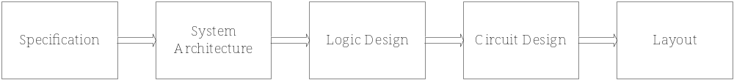
Figure 1.4 A process for integrated circuit (VLSI) design [Wol02].
Next, consider the design process for embedded computer systems shown in Figure 1.5. Embedded systems are combined hardware/software systems embedded into a larger system to perform dedicated application specific operations. Embedded systems are employed in automobiles, DVD players, and digital cameras to name a few applications. Performance issues dominate embedded applications, and the designer needs to partition tasks between software and hardware to achieve optimum performance. This design process is somewhat prescriptive with phases for requirements gathering, specifications, and architectural design. The process reflects the unique nature of embedded systems with separate software and hardware design blocks, married together by the interface design.

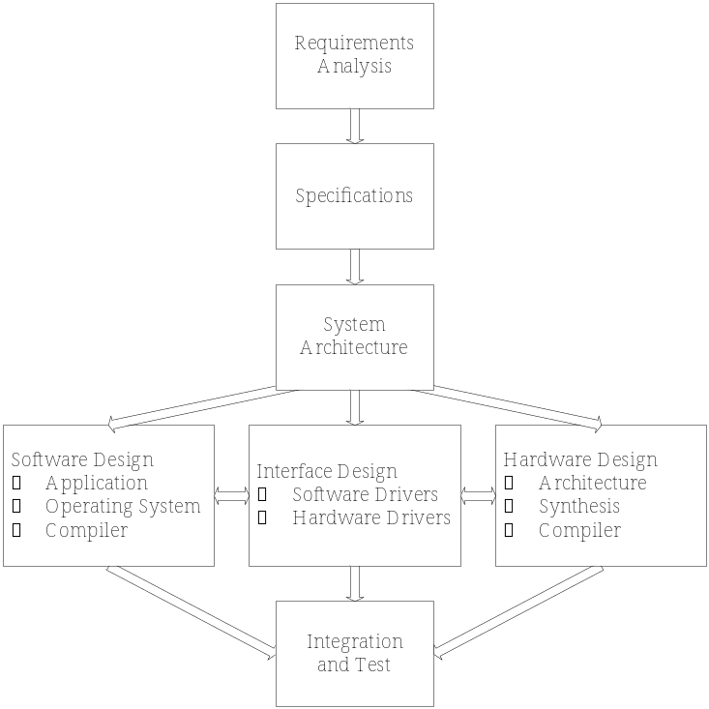
Figure 1.5 An embedded system design process [Ern97].
The field of software engineering is one in which the development of different design process models is still under considerable flux today. This is due to the complex nature of software and the failure of computer scientists and engineers to effectively develop high-quality software systems. There are many reasons why this is so. The sheer size of software programs may easily exceed one million lines of code written by many different software developers. One small mistake in those millions of lines of code can cause the system to fail. Another difficulty is in designing for upgrade and reuse of software. What if the needs change after the millions of lines of code are developed and one of the fundamental structures or objects needs to be upgraded?
The waterfall model shown in Figure 1.6 is one of the first proposed and most well-known software design processes. This is a prescriptive model since the development proceeds linearly from the first step where the user’s needs are analyzed through the phases of specification development, design, test, and maintenance. This works for well-defined and moderately complex software applications, but fails as complexity grows due to the inability to move between phases. A more flexible and descriptive software design process is known as the spiral model, which is a cyclical process where phases are revisited as necessary [Som01]. Extreme Programming is a more recent and controversial software development process, where relatively small teams of software developers rapidly develop software following some strict rules. Both the spiral model and Extreme Programming are examined in more detail in the end of chapter problems.
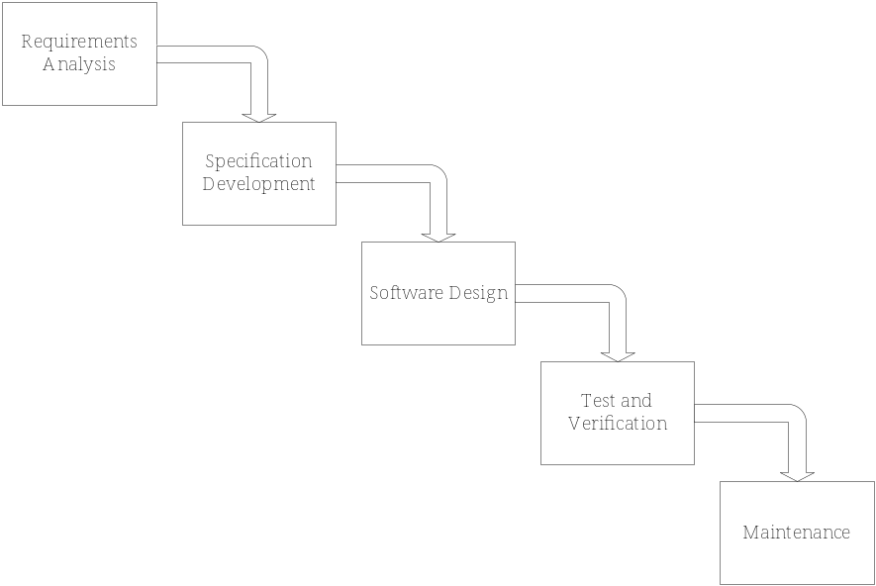
Figure 1.6 Waterfall software development process. In this model, development proceeds linearly from requirements analysis, through each subsequent phase, terminating with maintenance.
  - The World-Class Engineer
The ability to effectively design is important for engineers, requiring strong technical skills and an understanding of the design process. Yet, this ability in itself is not enough to become an effective practicing engineer. The Pennsylvania State University Leonhard Center for the Advancement of Engineering Education, in consultation with a number of industries, developed a description of what is referred to as a “World-Class Engineer” [Leo95]. Shown in Table 1.1, the description identifies the characteristics of successful engineers, and contains six major elements: 1) Aware of the World, 2) Solidly Grounded, 3) Technically Broad, 4) Effective in Group Operations, 5) Versatile, and 6) Customer-Oriented. The description recognizes that engineers must be effective in group operations, since the majority of projects are carried out in teams. Not only that, many projects span multiple technical disciplines and are executed in multifunctional organizations that have diverse groups such as marketing, finance, human resources, technical support, and service. It also recognizes that an engineer must be versatile, innovative, understand ethical principles, and be customer-oriented, important themes that are stressed throughout this book.
  - Book Overview
Consider the digital camera, the cellular phone, and the space shuttle, all complex systems that integrate a variety of technologies. A digital camera is the synthesis of an embedded electronics system, optics, a mechanical lens assembly, and the camera package itself. The embedded electronics contain an imaging sensor, a digital display, digital interface circuitry, flash memory storage, system control software, and the user interface. The challenges of integrating the components of such a system and having it record and transfer huge amounts of image data, within an acceptable timeframe, are immense. Cellular phones are another good example of a complex system that represents a technology that has shrunk in size, but increased tremendously in functionality at the same time. They encompass digital data communications, antenna design, encryption for secure data transmission, a user interface display, and Internet connectivity. At the other end of the spectrum are large-scale space and military systems, such as the space shuttle. Despite the two shuttle accidents, the safety and reliability requirements of the space shuttle are incredibly high. Realizing such a system is accomplished by a tremendous number of people from many disciplines working for different organizations. All three of these technologies were developed by large teams that encompass multiple disciplines. The processes and practices employed in their development represent application of the fundamentals that this book hopes to cover. While you won’t be building complete space shuttles by the end of this design course, you can expect to apply design principles that allow you to design and integrate a relatively complex system, maybe even a part of the space shuttle.
Table 1.1 The World-Class Engineer (Copyright the Leonhard Center for the Advancement of Engineering Education, The Pennsylvania State University. Reprinted by permission.)
I. Aware of the World
- sensitive to cultural differences, environmental concerns, and ethical principles
- alert to market opportunities (both high- and low-tech)
- cognizant of competitive talents, work ethic, and motivation
II. Solidly Grounded
- thoroughly trained in the fundamentals of a selected engineering discipline
- has a historical perspective and remains aware of advances in science that can impact engineering
- realizes that knowledge doubles at breakneck speed and is prepared to continue learning throughout a career
III. Technically Broad
- understands that real-life problems are multidisciplinary
- thinks broadly, seeing an issue in a rich context of various alternatives, probabilities, etc., rather than a narrow quest to find a single answer
- is conversant in several disciplines
- is trained in systems modeling and the identification of critical elements. Understands the need to design experiments to verify or extend analysis, as well as meet specification requirements
- is psychologically prepared to embrace any field necessary to solve the problem at hand
IV. Effective in Group Operations
- cooperative in an organization of individuals working toward a common creative goal that is often multidisciplinary and multifunctional in nature
- effective in written and oral communication
- willing to seek and use expert advice
- cognizant of the value of time and the need to make efficient use of the time in all phases of an endeavor
- understanding and respectful of the many facets of business operation -- general management, marketing, finance, law, human resources, manufacturing, service, and especially quality
V. Versatile
- innovative in the development of products and services
- sees engineering as applicable to problem solving in general
- considers applying engineering beyond the typical employment focus of engineering graduates in the manufacturing industries, to the much broader economy (financial services, health care, transportation, etc.) where engineering skills could make a dramatic improvement in the productivity of those segments of the economy that employ 80 percent of the U.S. population
VI. Customer Oriented
- realizes that finding and satisfying customers is the only guarantee of business success
- understands that products and services must excel in the test of cost-effectiveness in the global marketplace

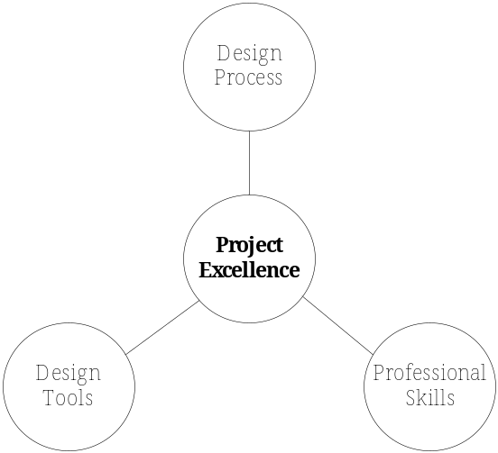
Figure 1.7 The guiding philosophy of this book. In order to achieve success in executing engineering and design projects, it takes an understanding of the design process, strong technical design tools, and professional skills.
The intention is to teach the application of design principles to computer and electrical engineers and to help prepare students for a professional career. The majority of engineering education is devoted to math, science, engineering science, and problem-solving. They are important topics required to enter this highly technical field. However, it is clear that there are other aspects beyond this that are equally important for success, including an understanding of system design, innovation, ethical principles, teamwork, and strong communication skills.
The book is divided into three parts: I–Design Process, II–Design Tools, and III–Professional Skills. This is shown in Figure 1.7 as three separate, but related components that play a key role in achieving Project Excellence—the ability to complete a project, in an ethical manner that meets the customer’s need, satisfies the constraints, and is clearly communicated to all involved. The chapters are decoupled as much as possible so that the reader can move between chapters as necessary. In Part I, the emphasis is on understanding and gaining experience in the different phases of the design process. The reader is guided through the steps of project identification, research, specification development, creative concept generation, and critical evaluation of competing solutions. Part II addresses topics that are often employed in design, including functional decomposition, description of system behavior, reliability, and testing. Part III addresses professional skills, including teamwork principles, project planning, ethics in design and the profession, and oral communication skills.
Here are a few thoughts to conclude the chapter and get started on the path to great designs. You are embarking on what will likely be a fun, challenging, sometimes frustrating, and ultimately rewarding journey. The systems that engineers work with continue to become increasingly complex and multi-disciplinary in nature. The example problems presented in this book come from the fields of analog electronics, digital electronics, electrical systems theory, and software systems. These four areas comprise a significant problem-domain common to the education of most electrical and computer engineers. Finally, consider the quote below by Robert Hayes on the importance of design.
Fifteen years ago, companies competed on price. Today it’s quality. Tomorrow it’s design.—Robert H. Hayes, Harvard Business School, 1991.
What is this saying? Well, it is clear that the world continues to move to a more knowledge-based society, where individuals and companies compete on the strength of their intellectual capital and ability to produce new and innovative products. That is what design is all about. It is not saying that price and quality are unimportant, they certainly are; in fact quality and reliability in design are part of this book. It is that quality and price are a given, and successful products will be distinguished by their design characteristics. The implication is that design will play a larger role in the development and success of products. The future Hayes predicted is now. Design is what distinguishes between products that are seen as commodities and those that are truly unique and profitable.
  - Summary and Further Reading
Engineering design is an iterative process in which the design team employs creativity and technical knowledge to develop a solution that best meets the end-users’ needs within the constraints applied to the problem. There is no single design process that can be applied to all situations and technologies, but there are many common elements shared, regardless of the technology under consideration. In order to successfully bring designs to fruition, it takes a combination of design tools, professional skills, and a clear understanding of the process needed to complete designs. The objective of this book is to develop your proficiency in these areas so that you may become an effective engineer and achieve excellence in design projects.
Engineering Design Methods by Nigel Cross [Cro00] presents the differences between descriptive and prescriptive design processes, and covers a wide array of processes in more detail. It also discusses the cognitive characteristics of effective designers. There are many good books on software engineering process development methods. Software Engineering by Ian Sommerville [Som01] discusses the different software design process models, such as the waterfall and spiral models. This is also true of many modern software engineering texts. The original reference to the waterfall model is by Royce [Roy70]. The Art of Innovation by Michael Kelley [Kel01] describes the activities of well-known design company IDEO and is a highly readable description of their design practices. The ABC Nightline news program also produced an interesting segment on IDEO [ABC01] that can be purchased at the ABC website. The Circle of Innovation by Tom Peters [Pet97] is another popular book that provides his perspective on current trends in business and the importance of design.
  - Problems
  - In your own words, describe the difference between prescriptive and descriptive design processes. Cite examples of each.
  - Describe the relationship between the Problem Identification, Research, and Requirements Specification phases of the design process.
  - Describe the relationship between the Concept Generation and Design phases of the design process.
  - Construct a prescriptive design process for the Problem Identification, Research, Specification, Concept, and Design phases of the design process. The result should be a flow chart that contains decision blocks and iteration as necessary.
  - Describe the main differences between the VLSI and embedded system design processes.
  - Using the library or Internet, conduct research on the spiral software design process.
- Outline the significant elements of the spiral software design process.
- Describe the advantages and disadvantages of this relative to the waterfall model?
Cite all reference used.
  - Using the library or Internet, conduct research on the Extreme Programming design process.
- Outline the significant elements of the Extreme Programming paradigm.
- What are the pro and con arguments for this software development model?
Be sure to cite references.
  - Project Application. In preparation for project and team selection, develop a personal inventory that includes a list of five favorite technologies or engineering subjects that you are interested in pursuing. Also, list the strengths and weaknesses that you bring to a project team.

