Development Board Setup Procedure:

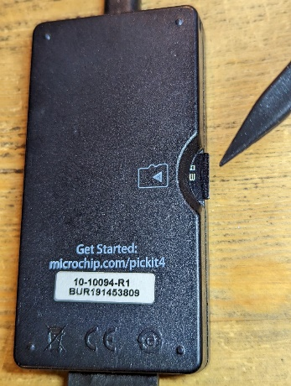
1. Verify that the PIC KIT 4 has a SD card installed. Optionally, verify the contents of the SD card.
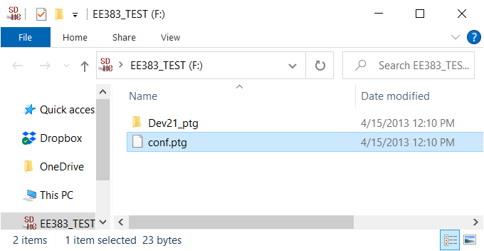
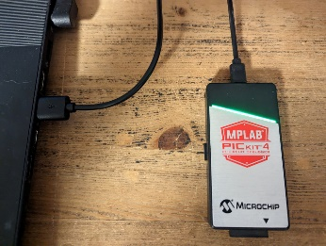
2. Use a micro-USB cable to plug in the PIC Kit 4 to a PC. The green LED-bar should start blinking slowly.

Congrats, you are now ready to start programming the development boards. So let’s start.

Development Board Programming
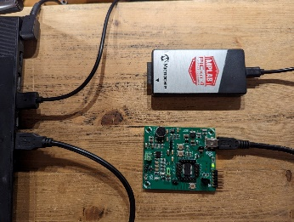
1. Use a USB-mini cable to plug a development board into a PC. The green indicator LED next to the USB mini connector should illuminate.

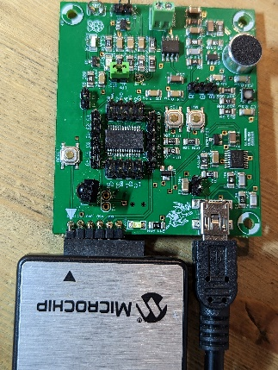
2. Connect the female PIC KIT 4 connector to the make headers on the development board so that the black arrow on the PIC KIT 4 aligns with the white arrow on the development board.

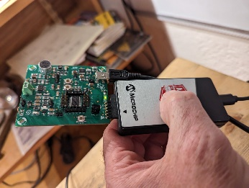
3. To initiate programming, you need to press a hidden button under the red logo on the front of the PIC KIT 4 programmer. I’ve found the best way to do this is to squeeze the programmer between my thumb and fingers.

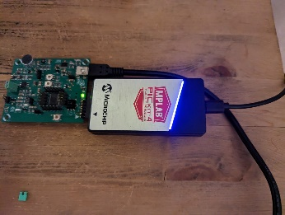
4. When depressed, the PIC KIT 4’s flashing green LED will switch to a flashing purple LED that indicates that the PIC KIT 4 is programming the microcontroller on the development board. The purple flashing will last for a few second. When programming is complete the PIC KIT 4 will resume flashing its green LED. When this happens, you can disconnect the development board from the programmer and then disconnect the UCB-mini cable.
* If at any point in step 4, the PIC KIT 4 LED starts flashing red the development board is faulty. Put this board in the FAILED bin which should then be sent to the Mines hardware repair division.
5. If you have more boards to program goto step 1. Else, it’s time to verify that the boards are functioning correctly. You can start by unplugging the PIC KIT 4 and returning it to plastic box for use next term.

Development Board Testing
1. Use a USB-mini cable to plug a development board into a PC. The green indicator LED next to the USB mini connector should illuminate.
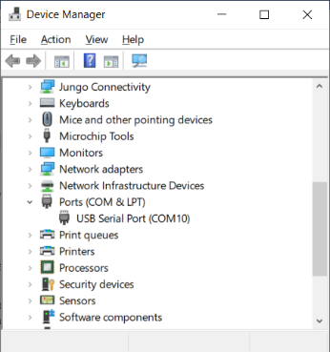
2. Determine the Virtual Com Port number associated with the development board. Each development board plugged into the PC gets a unique virtual com port number. These numbers are issued sequentially by the operating system so there is a good chance that the next board you test will have a virtual com port number one higher than the last. However, when this doesn’t work:
- Press the windows key,
- Type “device” and then click on Device Manager
- In the device manager pop-up expand the Ports (COM & LPT) option and find the number associated with the USB Serial Port. In our case this is COM 10.

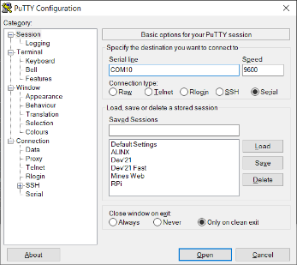
3. Configure Putty to talk to the development board. Make sure the Serial radio button is selected, type in the virtual com port number you found in the last step (no spaces), and leave the speed at 9600, click Open.

You will now perform the tests. If a board fails any one test put it into the FAILED bin which should then be sent to the Mines hardware repair division.
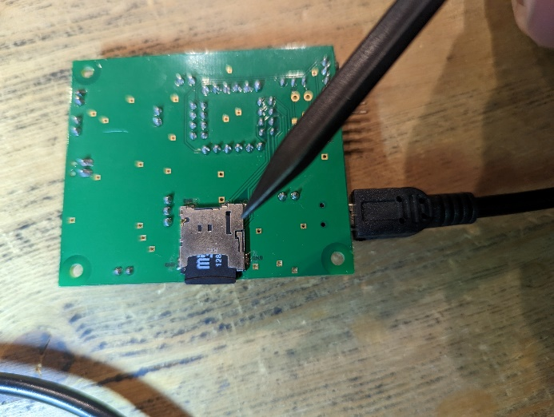
Before you start testing a board, make sure that all 3 jumpers are removed and that a working SD card is inserted. Note that the SD card extends beyond the edge of the PCB. This is important as it allows a user to remove the SD card by pressing the SD card inward, releasing the latch which secures the SD card in place. You can then remove the SD card by pulling it out. Likewise, when inserting an SD card, gently insert it and then press it all the way in until you hear a small click, then release.
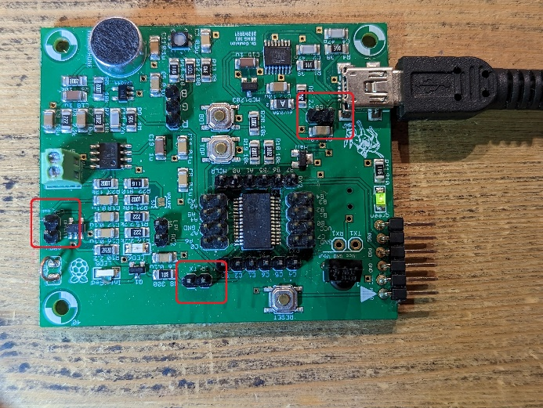
Each test below starts with the letter that you need to type into the PuTTy terminal to elicit the test. This letter is followed by the name of the test and then a description of expected output.
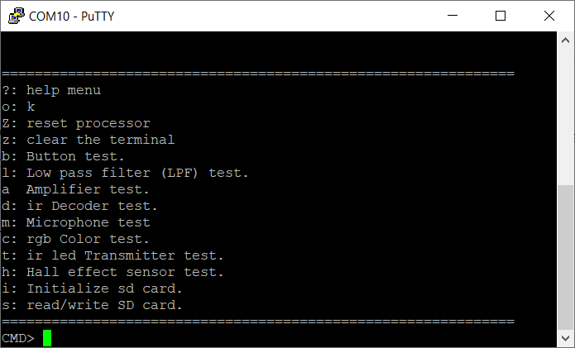
? = Terminal Test: You should be greeted with the main menu of testing options. You will NOT perform all these tests.

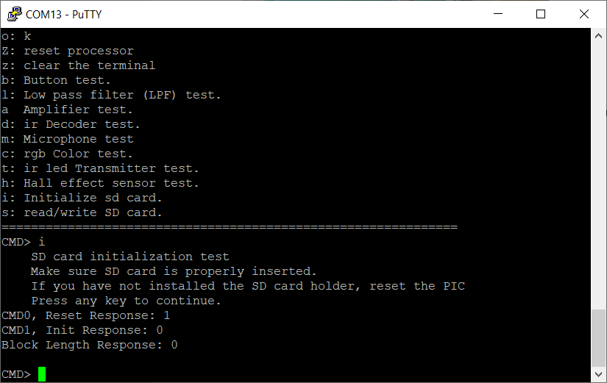
i = SD Card Test: You should be prompted to press any key to continue. When you do, you should be presented with 1, 0, 0 as the responses the three queries. If you do not have a SD card inserted, you will get a 0, 0, 0 response.

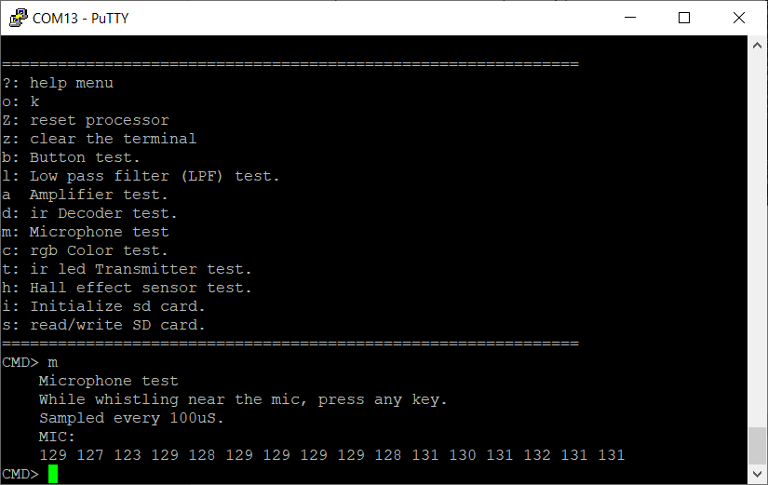
m = Microphone Test: You will be prompted to whistle while pressing any key. Whistling is optional and the response to silence is shown below; samples around 128 are nominal.

Finally, perform a physical inspection of the development board. Look for:
- Missing screws from the green terminal blocks
- Damaged ground loop
- Header pins bent more than 15°
- Damage to the SD card holder
If a board passes all these tests but has mechanical damage, put it into the DAMAGED bin which should be sent to the Mines hardware repair division for repair and return to circulation.
If a board passes all these tests and has no mechanical damage, put it in the PASSED bin.

Thanks for your support and contributing to improving the student experience in our labs.

