Transfer Function | Roots | Canonical Form | Parameters | Performance
G0 = 10/(s + 10) |  |  | σ =  K= | t_{r} =  t_{s} =
G1 = 100/(s + 10)^2 |  |  | ω_{n} =  ζ =  K= | t_{r} =  t_{s} =  %OS =
G2 = 50/(s^2 + s + 100) |  |  | ω_{n} =  ζ =  K= | t_{r} =  t_{s} =  %OS =
G3 = 2/(s^2 + 4) |  |  | ω_{n} =  ζ =  K= | t_{r} =  t_{s} =  %OS =
G4 = 1/(s^2 - s + 100) |  |  | ω_{n} =  ζ =  K= | t_{r} =  t_{s} =  %OS =
G5 = 10/(s - 10) |  |  | σ =  K= | t_{r} =  t_{s} =
G6 = 32/(s^2 + 4*s + 16) |  |  | ω_{n} =  ζ =  K= | t_{r} =  t_{s} =  %OS =

G0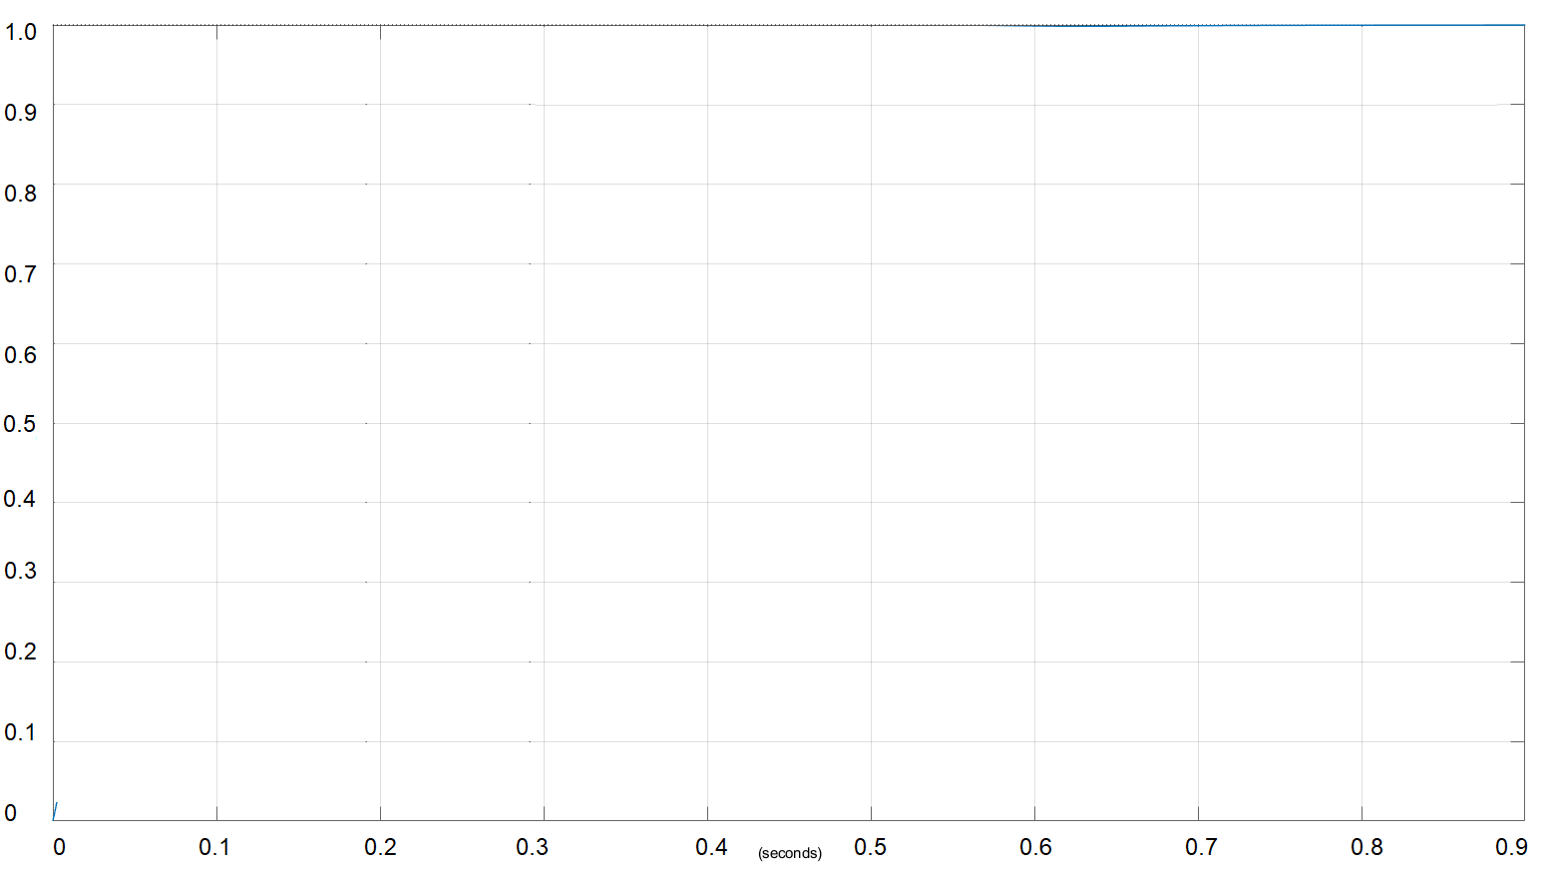 | G1 | G2

G3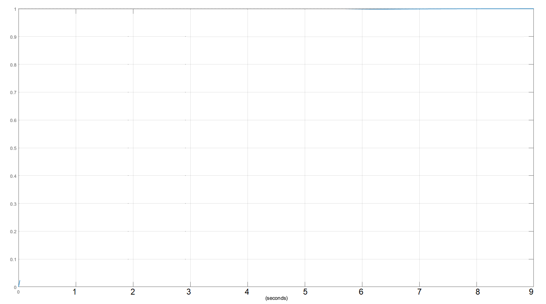 | G4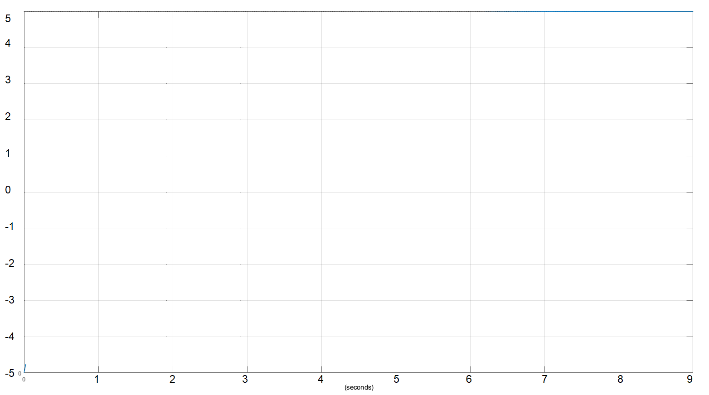 | G5  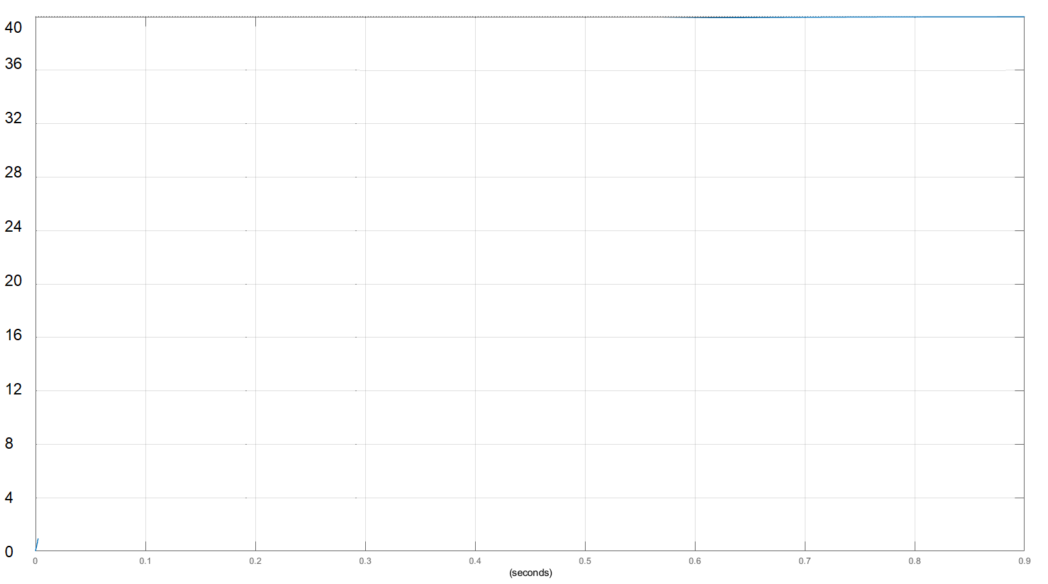
G6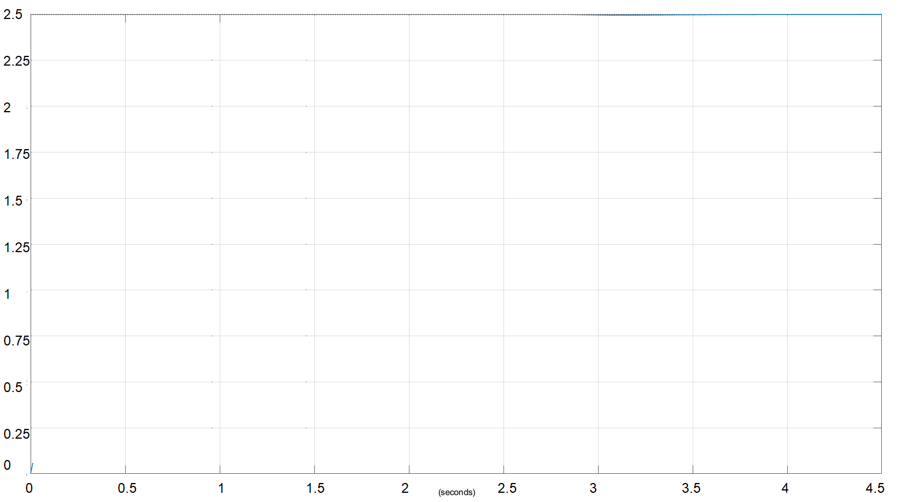 | 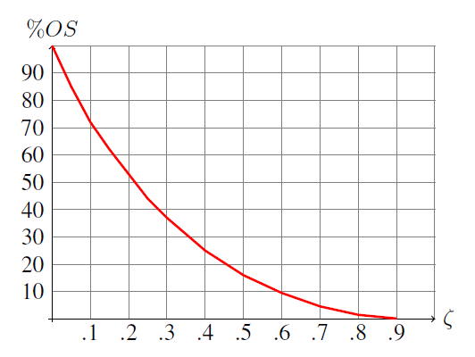 | 