Root Locus Rules & Practice
Step 1: Create pole-zero map by finding and plotting the poles and zeros of L(s) (the loop gain)
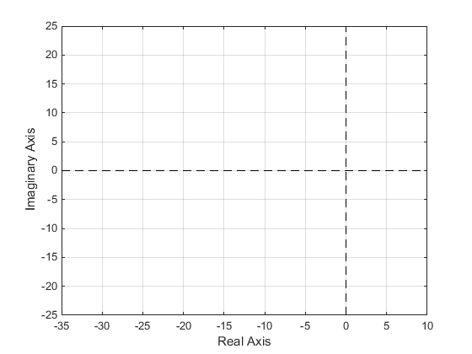
Step 2: Determine the number of loci
Step 3: Determine where the loci begin and end
Step 4: Sketch the loci that lie on the real axis
Step 5: Sketch the asymptotic loci by finding the asymptote centers and asymptote angles
