EENG307: 10/11/16

PID Control Example: Proportional Control of a Water Tank

The design of a proportional controller (K_{p}) to control the height h of water in a tank to a desired reference height r is motivated in Lecture 19 by the following diagram:
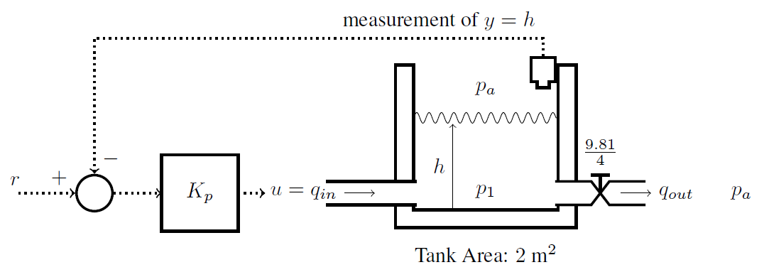
with symbolic representation

To implement this controller, some systems (blocks) and signals (arrows) are physical elements and others occur digitally within a computer. Conversion between the two is done with digital-to-analog (D/A) and analog-to-digital (A/D) converters. Label the systems and symbols in the diagram below:

