Lecture 28: Nyquist Stability Theorem Supplement (In-Class)

Related to general Nyquist concepts and the Example in Section 3

Key Principle of Nyquist
Based on the lecture discussion, fill in the blanks in the sentence below with “open loop” or “closed loop.”
We have previously studied how to use the Routh Hurwitz test to determine the stability of the closed loop system by computing the _________________ transfer function and analyzing its poles. By contrast, the Nyquist Stability theorem allows us to use the frequency response of the _________________ system to predict whether the _________________ system is stable.

What do the following variables represent?
P: ___________________________
N: ___________________________
Z: ___________________________

Sketching a Nyquist Plot
Consider a closed-loop, negative unity feedback system with forward gain
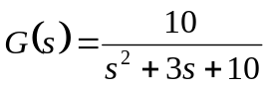,
which has the Bode plot shown in Figure 1.
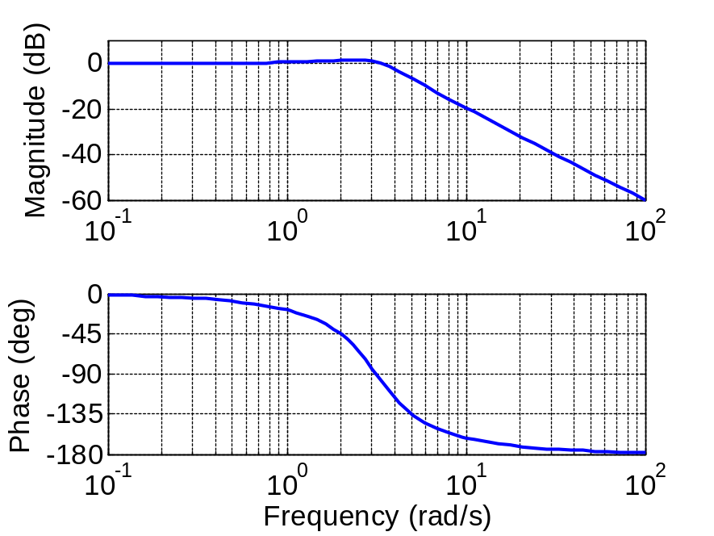
Figure 1: Bode plot for G(s)
- Select at least 8 frequencies on the Bode plot and use them to sketch the Nyquist plot in Figure 2. If you don’t have a calculator, Figure 3 will enable you to convert from magnitude to magnitude in dB and vice versa.

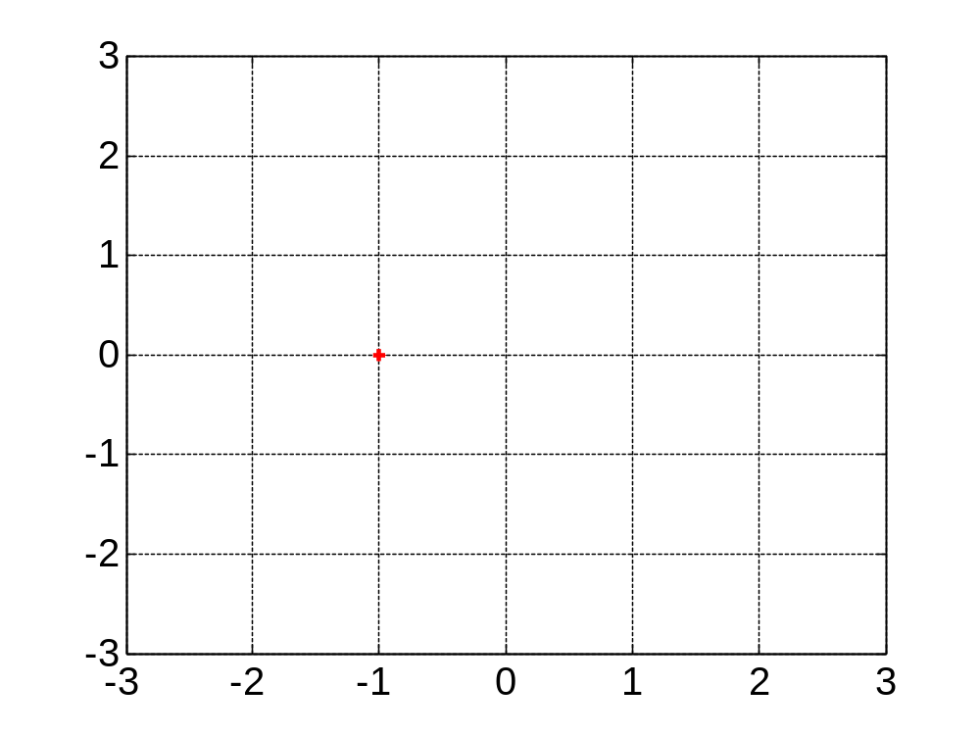
Figure 2: Nyquist plot axes

- Based on your Nyquist plot and values you determine for P, N, and Z, is the closed-loop system stable?

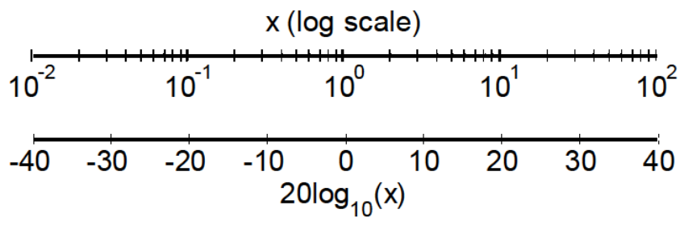
Figure 3: dB conversion plot

