Block Elements | 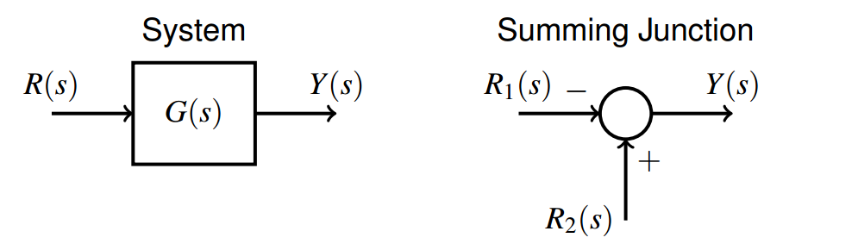
Series | 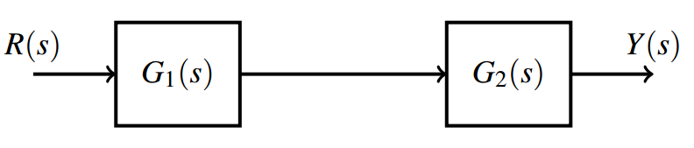
Parallel | 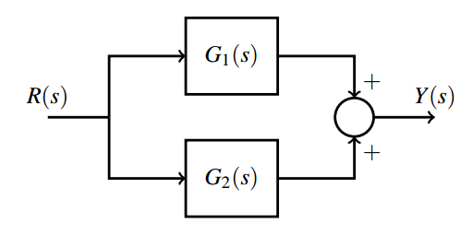
Feedback | 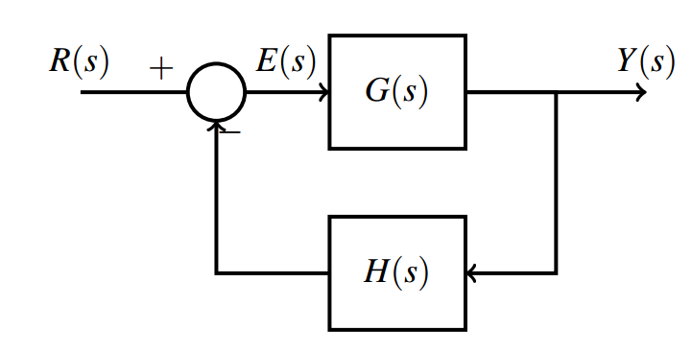
Example #1 | 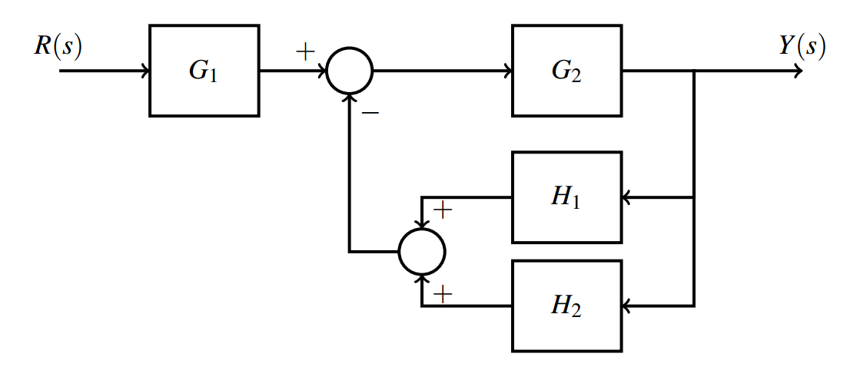
Moving summers | 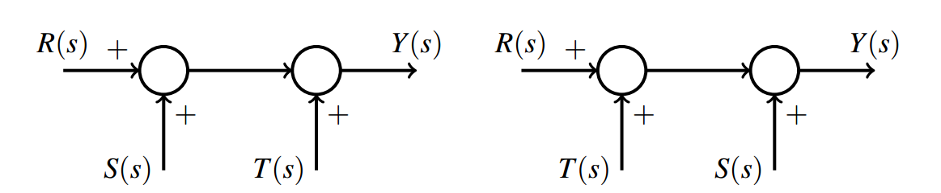
Moving pick-off points | 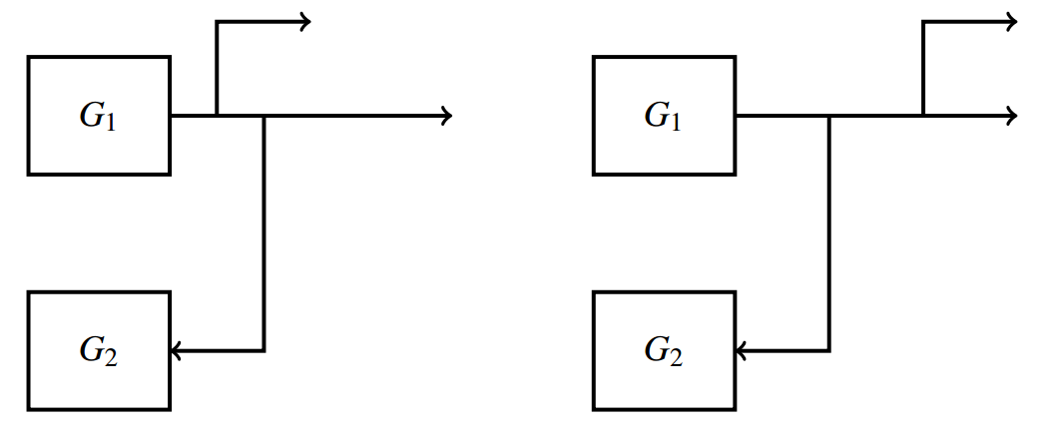
Moving Pick-off points around blocks | 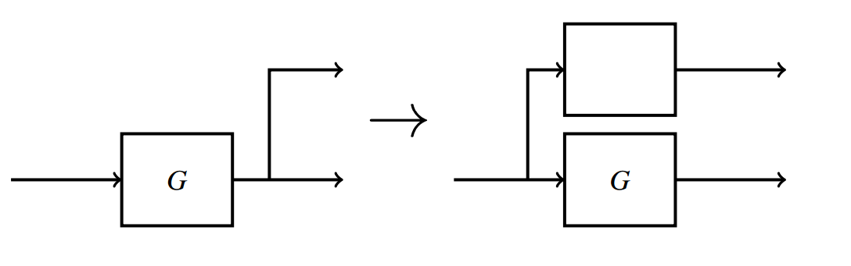
Moving Pick-off points around blocks | 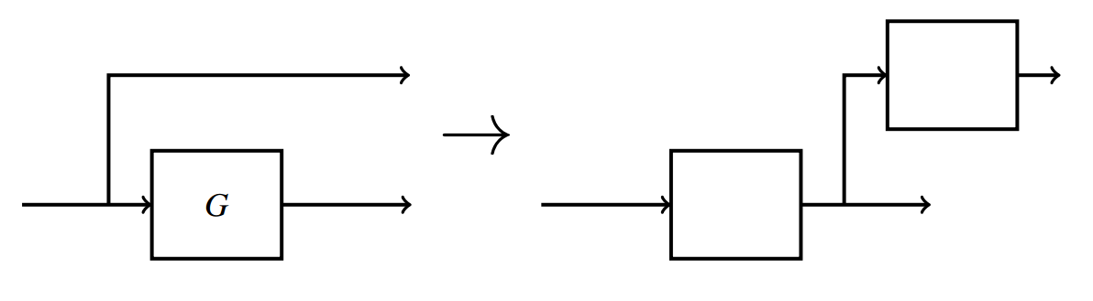
Example #2 | 