Find the Nyquist Plot associated with the following bode plot. The open loop has two poles in the RHP, is the closed loop stable?
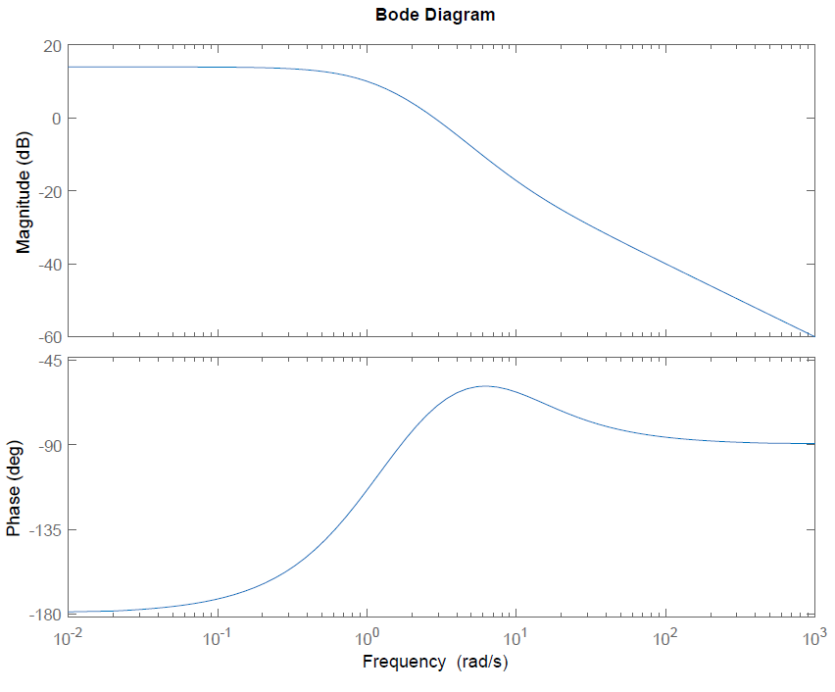
Freq (rad/s) | Mag (dB) | Mag | Phase= θ | X=Mag*cos(θ) | Y= Mag*sin(θ)
0.01
0.1 |  |  | -170
0.5 |  | 5
1
2 | 5
10

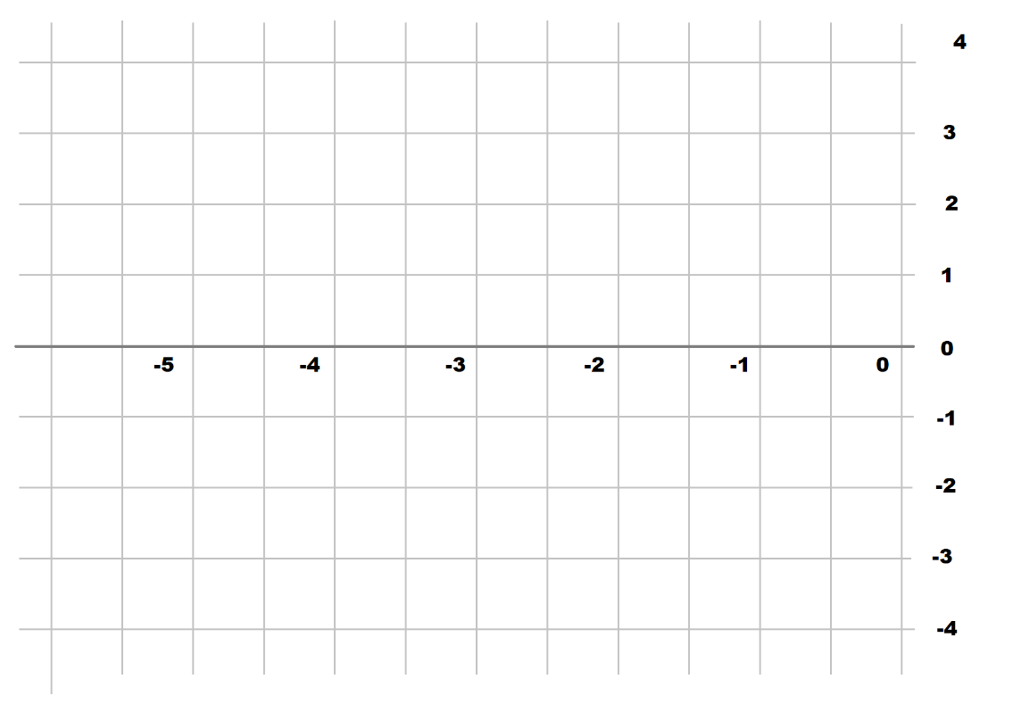
Find the Nyquist Plot associated with the following bode plot. The open loop is stable, is the closed loop stable?
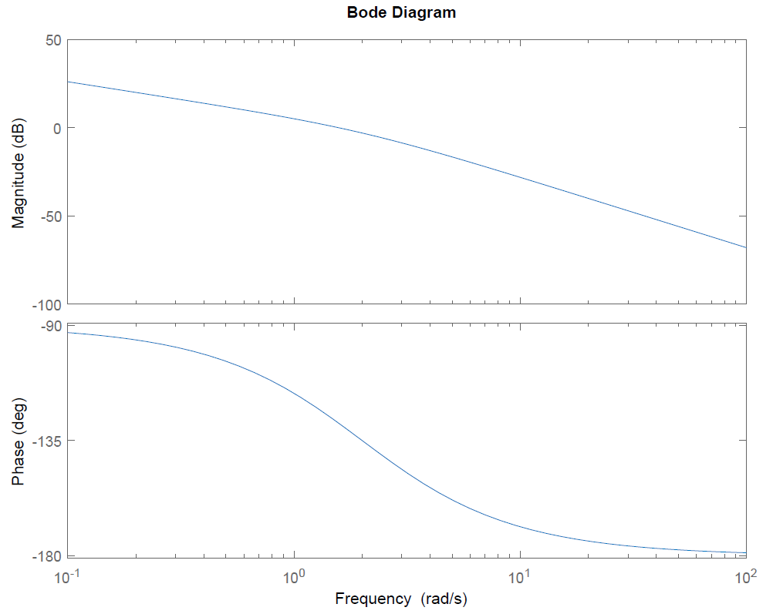
Freq (rad/s) | Mag (dB) | Mag | Phase= θ | X=Mag*cos(θ) | Y= Mag*sin(θ)
0.1
0.5 |  |  | -100
1 |  | 2
2
10 | -30

