Find the Nyquist Plot for the following bode plot. The open loop is has two poles in RHP, is the closed loop stable?
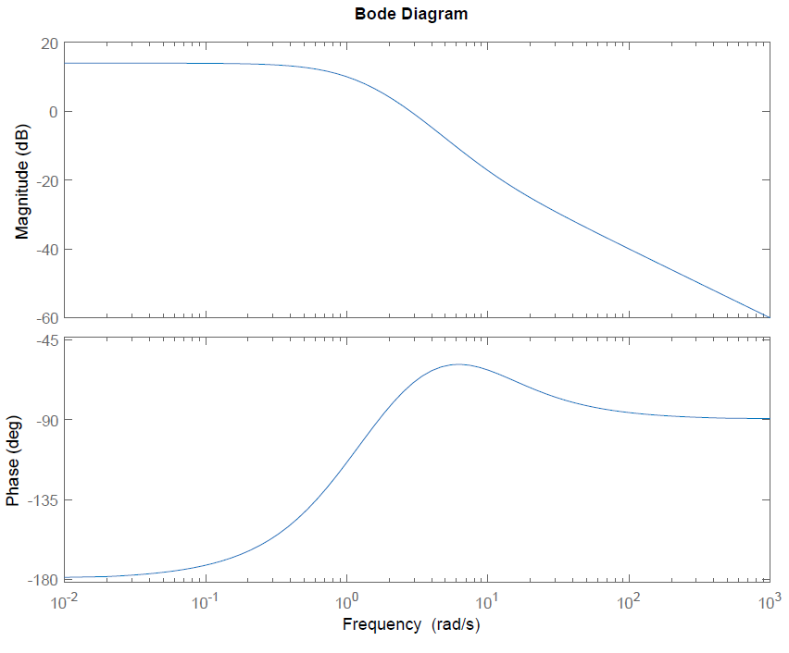
Freq (rad/s) | Mag (dB) | Mag | Phase= θ | X=Mag*cos(θ) | Y= Mag*sin(θ)
0.01 | 15 | 5.6 | -180 | -5.6 | -0
0.1 | 15 | 5.6 | -170 | -5.5 | -1
0.5 | 14 | 5 | -140 | -3.8 | -3.2
1 | 10 | 3.2 | -100 | -0.5 | -3.1
2 | 5 | 1.7 | -80 | 0.3 | -1.8
10 | -20 | 0.1 | -60 | +0 | -0.1

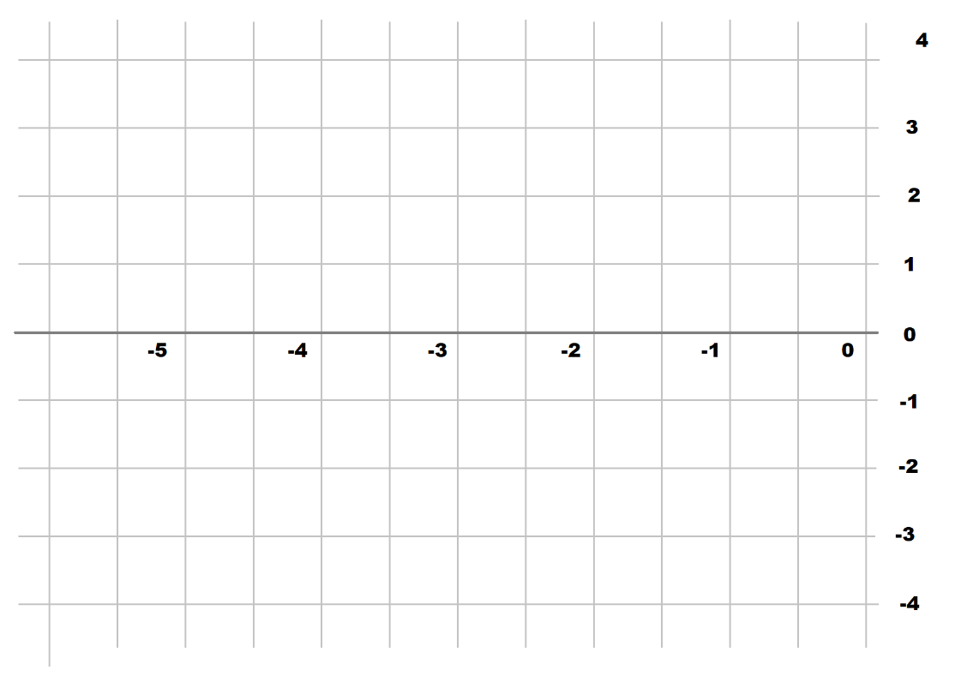
Find the Nyquist Plot for the following bode plot. The open loop is stable, is the closed loop stable?
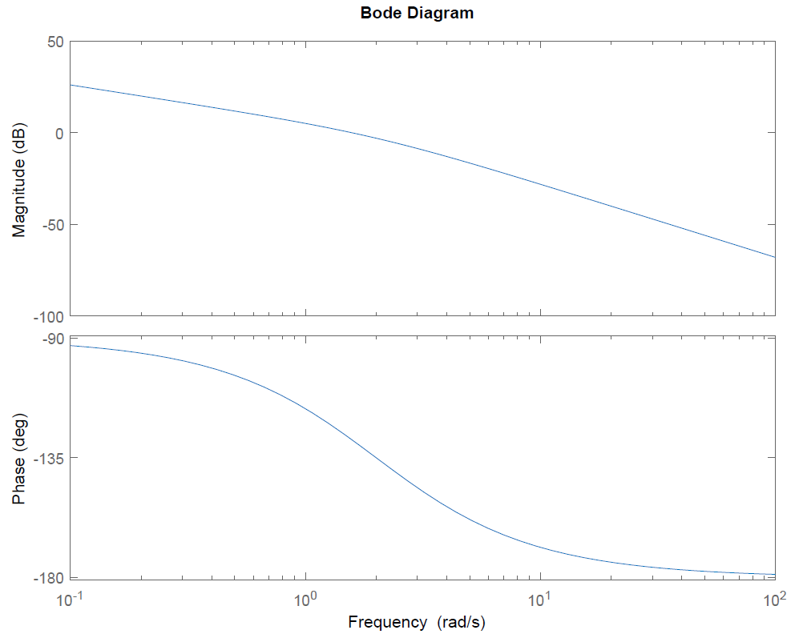
Freq (rad/s) | Mag (dB) | Mag | Phase | X = Re{s} | Y = Im{s}
0.1 | 26 | 20 | -90 | +0 | -20
0.5 | 12 | 4 | -100 | -0.7 | -4
1 | 6 | 2 | -120 | -1 | -1.7
2 | 0 | 1 | -135 | -0.7 | -0.7
10 | -30 | 0.03 | -170 | -0.03 | -0

