Function: $\frac{0.5}{(s+0.5)(s+1)(s+0.1)}$
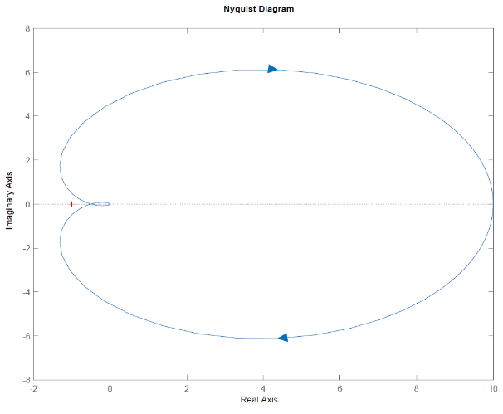
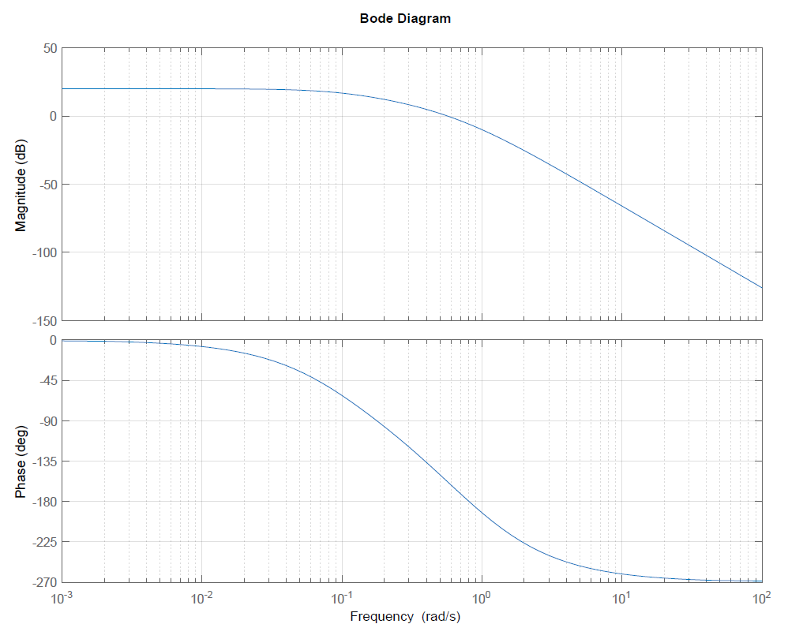
Gain Margin | Phase Margin
At what frequency does phase equal -180°? | At what frequency does magnitude equal 0dB?
At this frequency, what is the magnitude (in dB)? | What is the phase at this frequency?
Compute the gain margin as number of dB below 0dB. | Compute phase margin as number of degrees above -180°
Function: $\frac{0.5e^{\frac{-s}{20}}}{\left(s+0.5\right)(s+1)(s+0.1)}$
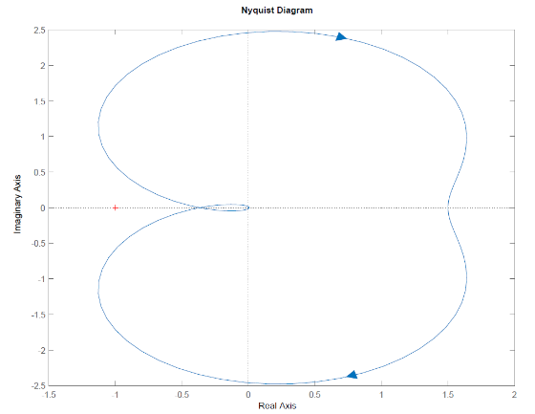
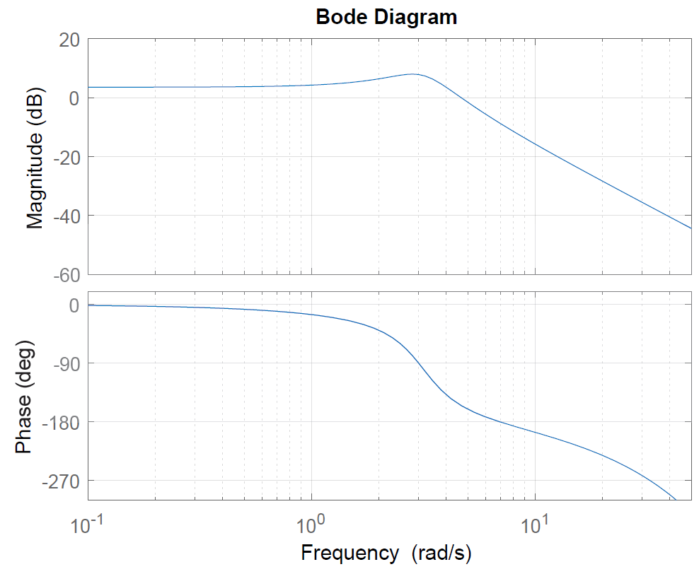
Gain Margin | Phase Margin
At what frequency does phase equal -180°? | At what frequency does magnitude equal 0dB?
At this frequency, what is the magnitude (in dB)? | What is the phase at this frequency?
Compute the gain margin as number of dB below 0dB. | Compute phase margin as number of degrees above -180°

Function: $\frac{20,000s+20,000}{s^{4}+303s^{3}+20,902s^{2}+60,600s+40,000}$
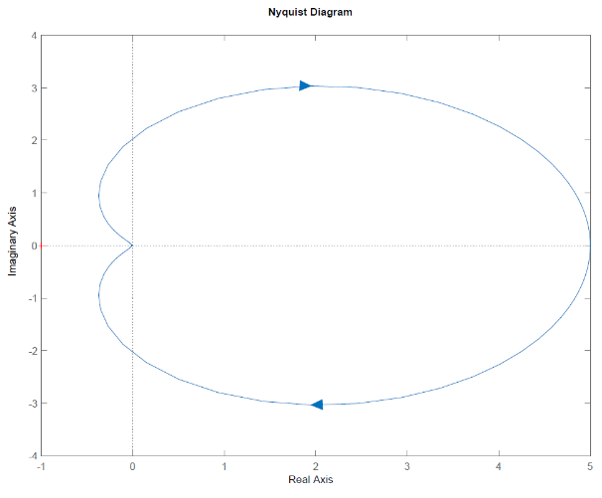
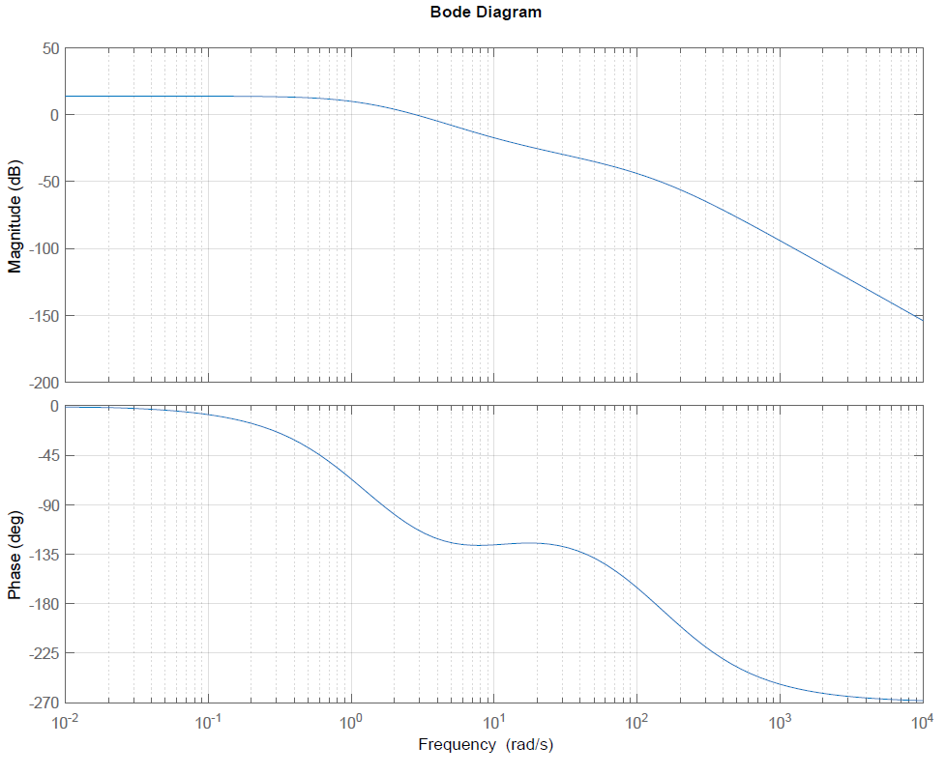
Gain Margin | Phase Margin
At what frequency does phase equal -180°? | At what frequency does magnitude equal 0dB?
At this frequency, what is the magnitude (in dB)? | What is the phase at this frequency?
Compute the gain margin as number of dB below 0dB. | Compute phase margin as number of degrees above -180°
Function: $\frac{1}{s(s+1)}$
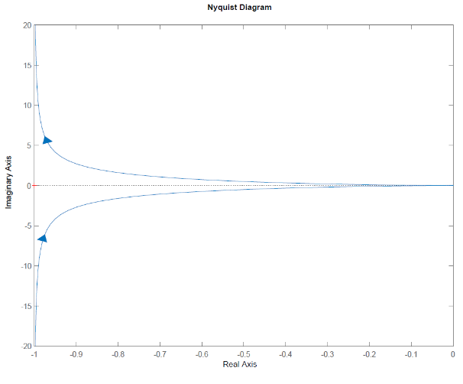
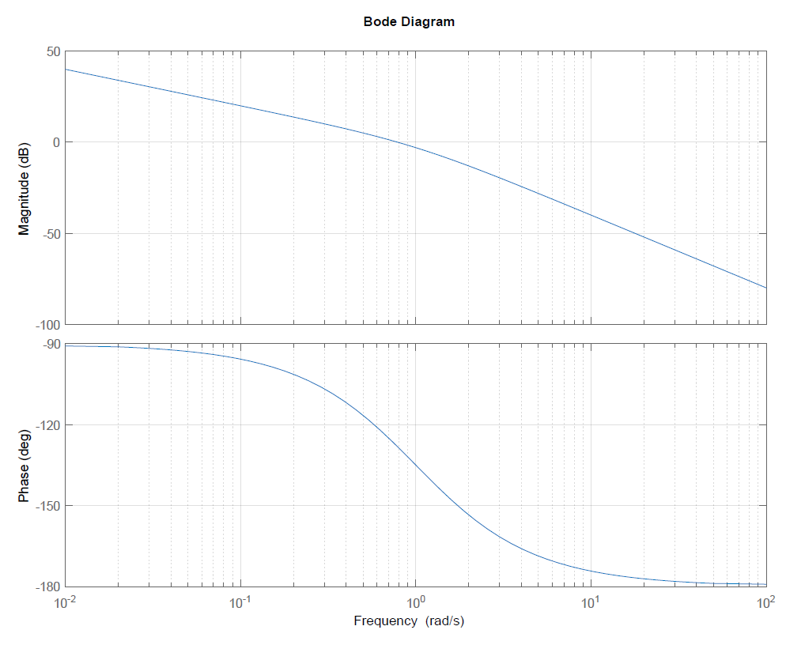
Gain Margin | Phase Margin
At what frequency does phase equal -180°? | At what frequency does magnitude equal 0dB?
At this frequency, what is the magnitude (in dB)? | What is the phase at this frequency?
Compute the gain margin as number of dB below 0dB. | Compute phase margin as number of degrees above -180°

