Function: $\frac{0.5}{(s+0.5)(s+1)(s+0.1)}$
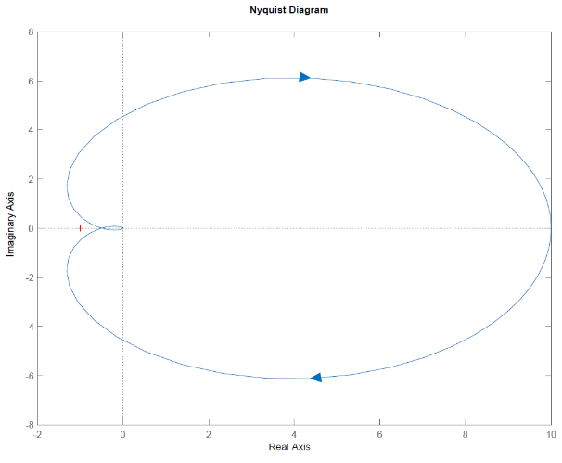
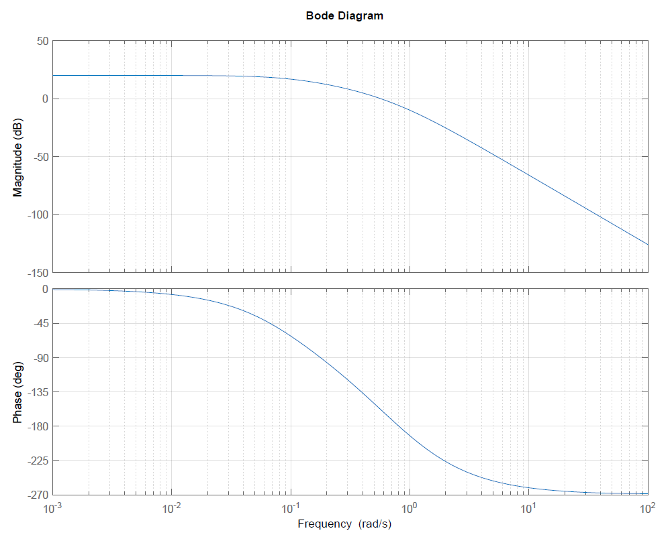
Gain Margin | Phase Margin
At what frequency does phase equal -180°?  0.7 rad/sec | At what frequency does magnitude equal 0dB?  0.6 rad/sec
At this frequency, what is the magnitude (in dB)?  -5dB | What is the phase at this frequency?  -160°
Compute the gain margin as number of dB below 0dB.  5dB = 20log(GM) GM = 1.8 | Compute phase margin as number of degrees above -180°  20°
Function: $\frac{0.5e^{\frac{-s}{20}}}{\left(s+0.5\right)(s+1)(s+0.1)}$
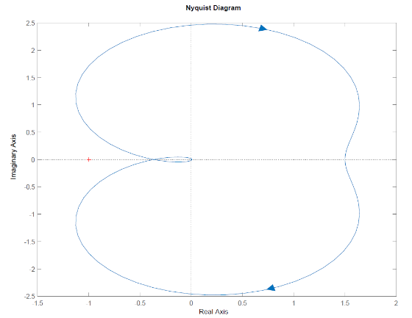
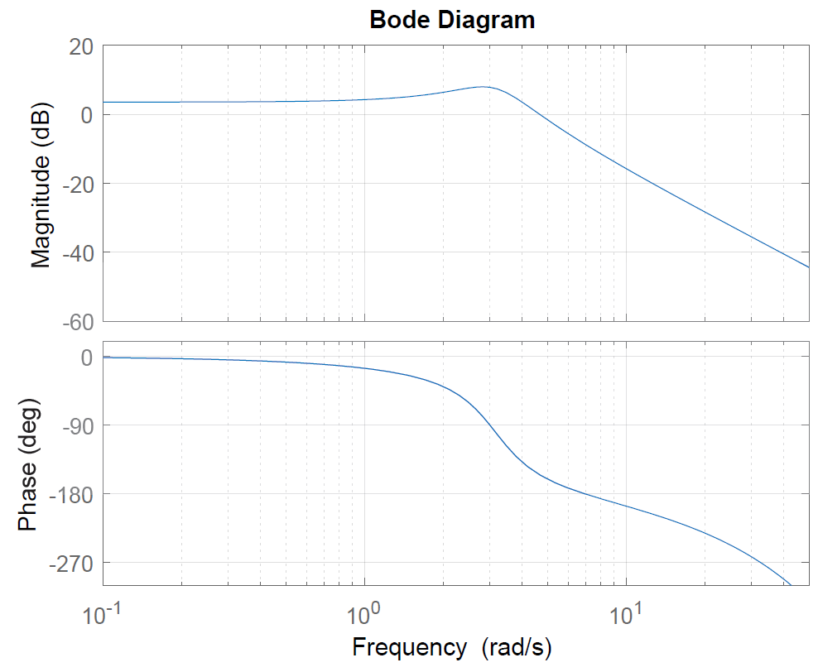
Gain Margin | Phase Margin
At what frequency does phase equal -180°?  7 rad/sec | At what frequency does magnitude equal 0dB?  5 rad/sec
At this frequency, what is the magnitude (in dB)?  -10dB | What is the phase at this frequency?  -160°
Compute the gain margin as number of dB below 0dB.  10dB = 20log(GM) GM = 3.2 | Compute phase margin as number of degrees above -180°  20°
Function: $\frac{20,000s+20,000}{s^{4}+303s^{3}+20,902s^{2}+60,600s+40,000}$
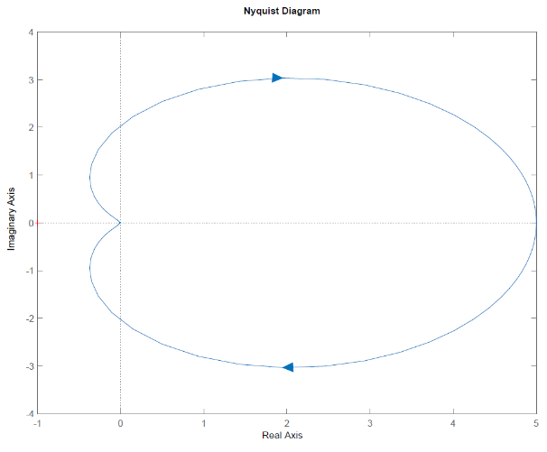
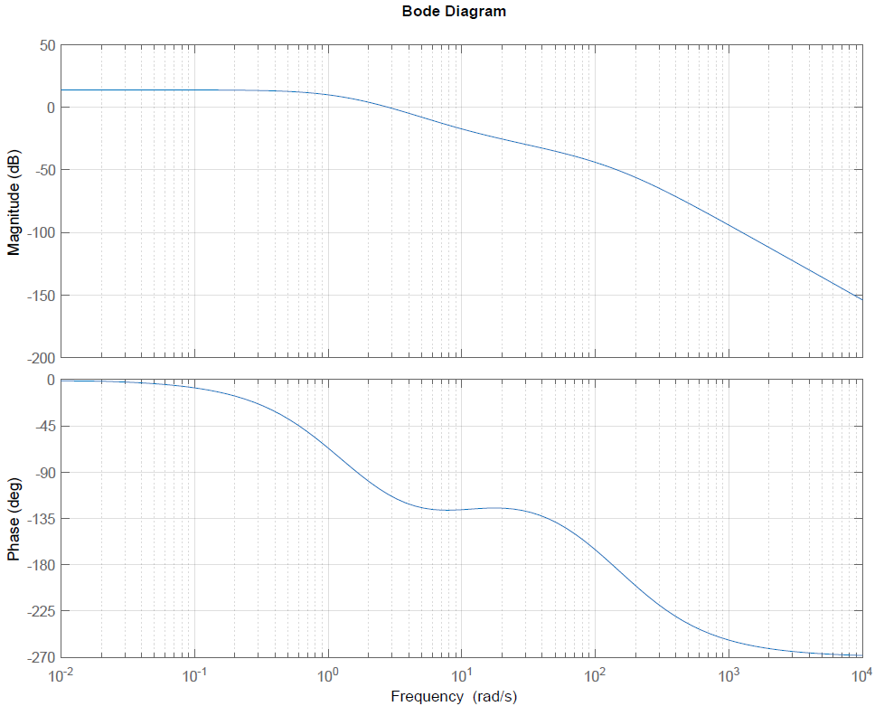
Gain Margin | Phase Margin
At what frequency does phase equal -180°? 130 rad/sec | At what frequency does magnitude equal 0dB? 3 rad/sec
At this frequency, what is the magnitude (in dB)? -50dB | What is the phase at this frequency? 110°
Compute the gain margin as number of dB below 0dB.  50dB = 20log(GM) GM = 316 | Compute phase margin as number of degrees above -180°  70°

Function: $\frac{1}{s(s+1)}$
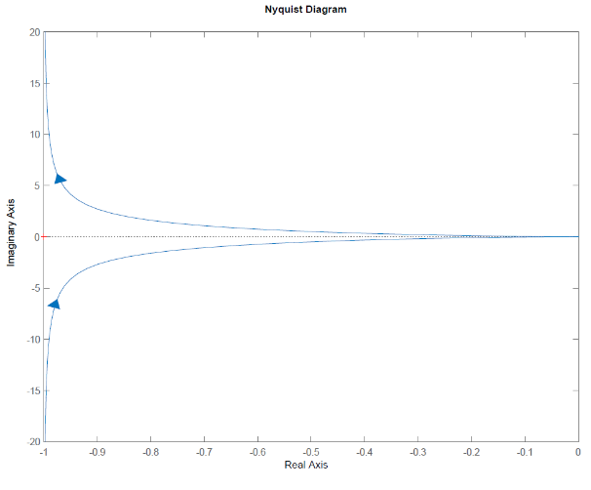
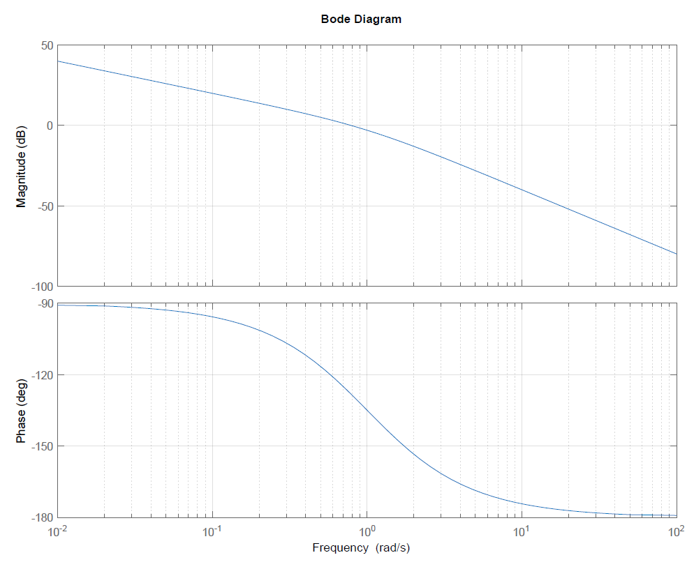
Gain Margin | Phase Margin
At what frequency does phase equal -180°?  $$ω→∞$$ | At what frequency does magnitude equal 0dB?  0.8 rad/sec
At this frequency, what is the magnitude (in dB)?  $$ω→-∞$$ | What is the phase at this frequency?  -130°
Compute the gain margin as number of dB below 0dB.  $$GM→∞$$ | Compute phase margin as number of degrees above -180°  50°

