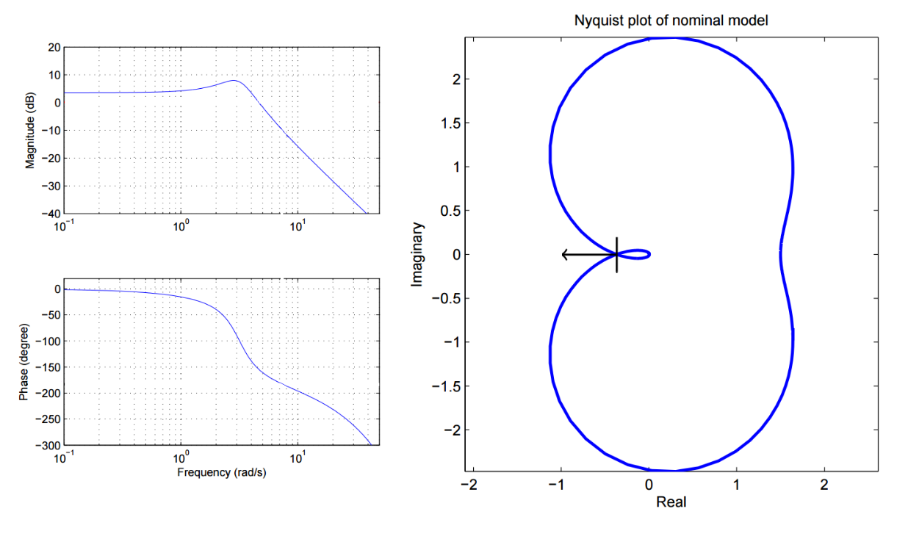

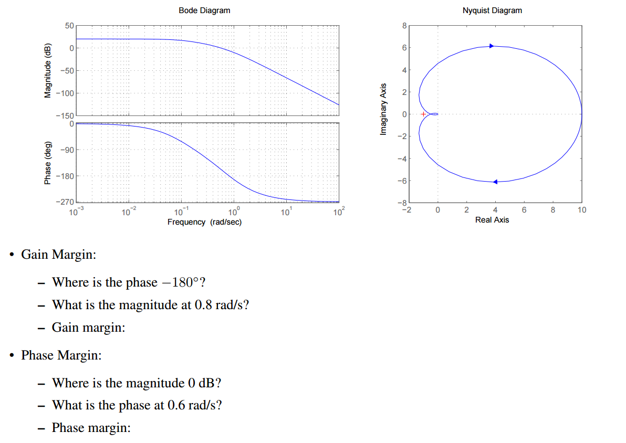

$$G\left(s\right)= \frac{0.5}{(s+0.5)(s+1)(s+0.1)}$$

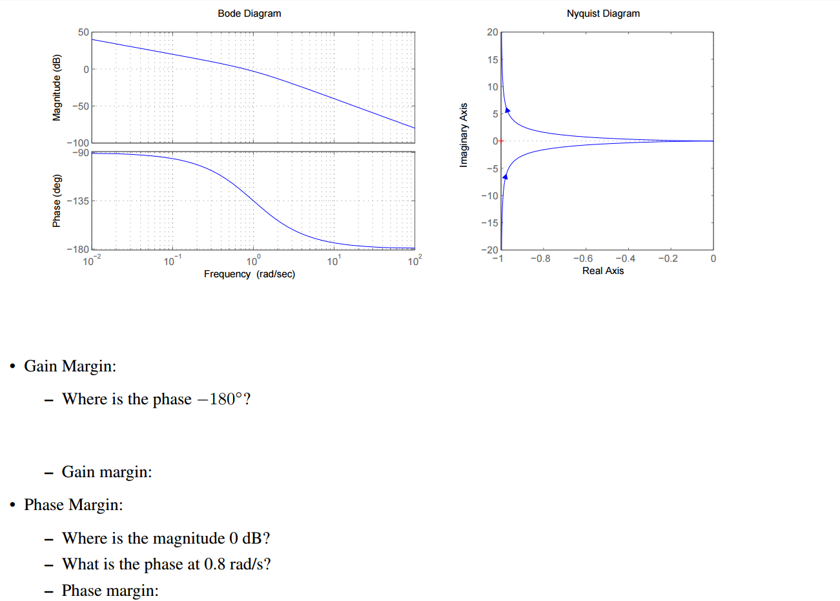

$$G\left(s\right)= \frac{1}{s(s+1)}$$

