Analytic solution using plot function in Matlab

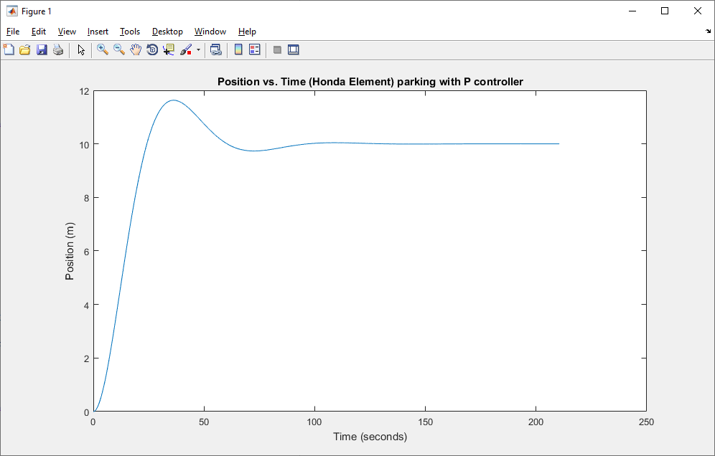

Found with Matlab stepplot function for 3 different values of k

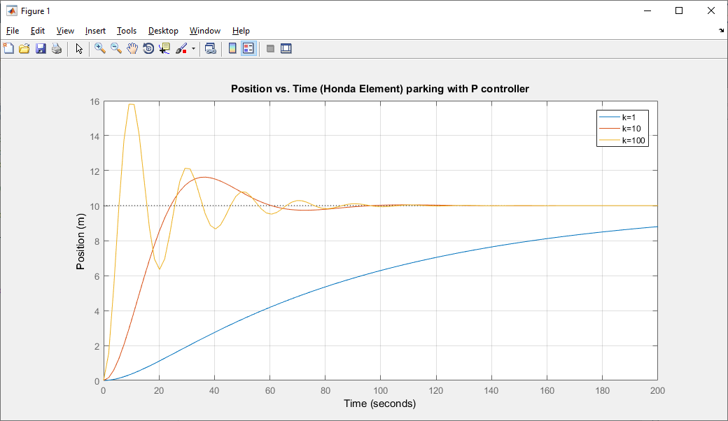
%%%%%%%%%%%%%%%%%%%%%%%%%%%%%%%%%%%%%%%%%%%%%%%%%%%%%%%%%%%%%%%%%
% Chris Coulston Spring 2023 Colorado School of Mines
% EENG 307 Intro to Feedback Control Systems
% A mathematical of a Honda Element in the frequency domain.
% All measurements are in SI units.
%%%%%%%%%%%%%%%%%%%%%%%%%%%%%%%%%%%%%%%%%%%%%%%%%%%%%%%%%%%%%%%%%

% The equation for x follows from 3 pages of math and couple of hours
t = 0:pi/100:67*pi;
x = 10 - 10.*exp(-t/20).*cos(0.0866.*t)- 5.77.*exp(-t/20).*sin(0.0866.*t);
plot(t,x)
xlabel('Time (seconds)');
ylabel('Position (m)');
title('Position vs. Time (Honda Element) parking with P controller');

waitforbuttonpress;

close all;
s = tf('s');

m = 1000; % units of kilograms
b = 100; % drag
kp = 10;

X = 1/(m*s^2+ b*s); % Transfer function of X/F for my Honda Element
X_k1 = feedback(1*X,1); % Transfer function for closed loop
X_k10 = feedback(10*X,1); % Transfer function for closed loop
X_k100 = feedback(100*X,1); % Transfer function for closed loop

stepplot(10*X_k1,10*X_k10, 10*X_k100, 200); % Plot the response for a step input

grid on;
xlabel('Time');
ylabel('Position (m)');
title('Position vs. Time (Honda Element) parking with P controller');
legend('k=1', 'k=10', 'k=100');

waitforbuttonpress;

close all;

