EENG 393 – ICE field session Power Supply Review By:

For:

Complete this worksheet for each schematic and layout reviewed. When you complete this worksheet, save it as “Engineering Review by <your name>” and upload to the reviewees Google drive folder.

**Schematic Review**

Start by reviewing the power supply schematic by opening the schematic in EAGLE CAD. Then make a screen capture of the entire schematic using Shift+PrtSc or the Snipping Tool. Paste the schematic into a image editing tool that you are comfortable with. In the image editing program, annotate the captured image with text pointing out any issues in the list below. Then paste this annotated schematic back into this document when done.

* Run the ERC – note any non-standard errors below
  + Ignore warning “POWER pin XYZ connected to XYZ”
  + Ignore warning “Part XYZ has no value”
  + Ignore warning “Part XYZ has uninvoked date D with unconnected inputs pin XYZ”
  + Ignore warning about unconnected pin on heat sink
* Review component connections – wires should be straight or contains the least number of bends possible,
* Grab and “shake” all components – improperly connected components will “come loose”

Paste annotated schematic below

**Layout Review**

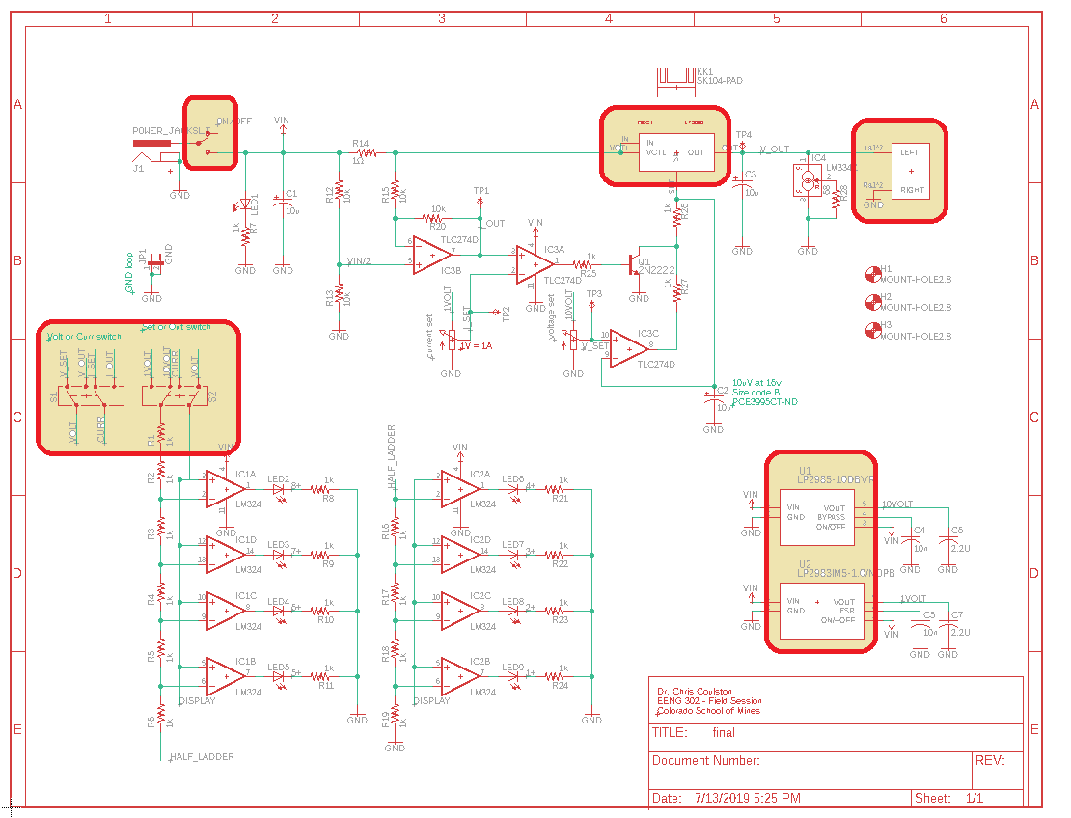

Next review the power supply layout by opening the layout in EAGLE CAD. Then make a screen capture of the entire layout using Shift+PrtSc or the Snipping Tool. Paste the layout into an image editing tool that you are comfortable with. In the image editing program, annotate the captured image with text pointing out any issues in the list below. Then paste the annotated layout back into this document when done.

* Check the footprints of the shaded components in the schematic above,
* Run DRC and report any issues,
* Check configuration of the DPDT switches controlling the VU meter input,
* Check the inverting and non-inverting inputs of all 11 op-amps,
* Grab and “shake” all components – improperly connected components will “come loose”

Paste annotate layout below:

While reviewing the layout, check the following

|  |  |
| --- | --- |
| **Components** | **Pass/Fail + Comments** |
| Place the following components on the edge of the board:   * Heat sink * On/Off switch * Power connector * Spring terminal block |  |
| Have switch near power connector |  |
| Have LED near switch |  |
| Place heat sink away from controls |  |
| Put Iset and Vset pots nearby in a row or column |  |
| Place components on 50 mil grid |  |
| Align adjacent resistors in rows and column |  |
| Put mounting holes near corners |  |
| **Board** |  |
| Board dimensions should be on 0.1" grid |  |
| Make the board outline as small as reasonably possible |  |
| Center mounting holes on 0.1" grid |  |
| Place mounting holes symmetrically |  |
| Route wires on 10 mil grid |  |
| **Wires** |  |
| Avoid routing wires between close pads |  |
| Avoid 90° bends in wires |  |
| Avoid routing on the bottom layer |  |
| Use ground via's when convenient |  |
| **Copper pours** |  |
| Copper pour ground on the bottom plane |  |
| Copper pour power on the top plane |  |
| Exactly align top and bottom pours |  |
| **Silk screen** |  |
| Uniform font and size for part designators |  |
| Uniform location for part designators on similar parts |  |
| Add "on"/"off" text near the switch with correct orientation |  |
| Add "CURR" next to Iset pot and "VOLT" next to Vset pot |  |
| Add polarity, voltage and current details to DC power input |  |
| Add instructions for VU meter switch settings |  |

Note any other suggestions below.