Data Cleaning & Exploration
  - Preparing and Preprocessing the Job Market Dataset
Connor Coulter
Wei Wang
Balqis Bevi Abdul Hannan Kanaga

Import Data
import pandas as pd, numpy as np, os, missingno as msno, matplotlib.pyplot as plt
# load data
CSV_PATHS = ["data/lightcast_job_postings.csv", "lightcast_job_postings.csv"]
csv_path = next((p for p in CSV_PATHS if os.path.exists(p)), None)
if not csv_path:
raise FileNotFoundError("⚠️ lightcast_job_postings.csv not found")
df = pd.read_csv(csv_path, low_memory=False)
print("Loaded dataset:", df.shape)
df.head(5)
df["INDUSTRY_DISPLAY"] = (
df["NAICS_2022_6_NAME"]
if "NAICS_2022_6_NAME" in df.columns
else df.get("INDUSTRY", pd.Series(["Unknown"]*len(df)))
)
salary_candidates = ["SALARY","SALARY_MEDIAN","SALARY_MID","SALARY_ANNUAL","PAY_RATE"]
for c in salary_candidates:
if c in df.columns:
df[c] = pd.to_numeric(df[c], errors="coerce")
df["SALARY_DISPLAY"] = next(
(df[c] for c in salary_candidates if c in df.columns),
pd.Series([np.nan]*len(df))
)
Loaded dataset: (72498, 131)

Data Cleaning & Preprocessing

Drop Unnecessary Columns
print("Derived non-null:", {
"INDUSTRY_DISPLAY": df["INDUSTRY_DISPLAY"].notna().sum(),
"SALARY_DISPLAY": df["SALARY_DISPLAY"].notna().sum()
})
Derived non-null: {'INDUSTRY_DISPLAY': np.int64(72454), 'SALARY_DISPLAY': np.int64(30808)}

Drop Unnecessary Columns
# drops unused cols
columns_to_drop = [
"ID","LAST_UPDATED_TIMESTAMP","DUPLICATES","ACTIVE_URLS","ACTIVE_SOURCES_INFO",
"TITLE_RAW","BODY","COMPANY_RAW",
"NAICS2","NAICS2_NAME","NAICS3","NAICS3_NAME","NAICS4","NAICS4_NAME",
"NAICS5","NAICS5_NAME","NAICS6","NAICS6_NAME",
"NAICS_2022_2","NAICS_2022_2_NAME","NAICS_2022_3","NAICS_2022_3_NAME",
"NAICS_2022_4","NAICS_2022_4_NAME","NAICS_2022_5","NAICS_2022_5_NAME",
"SOC_2","SOC_2_NAME","SOC_3","SOC_3_NAME","SOC_5","SOC_5_NAME",
"CIP2","CIP2_NAME","CIP4","CIP4_NAME","CIP6","CIP6_NAME",
"LOT_CAREER_AREA","LOT_CAREER_AREA_NAME","LOT_OCCUPATION","LOT_OCCUPATION_NAME",
"LOT_SPECIALIZED_OCCUPATION","LOT_SPECIALIZED_OCCUPATION_NAME",
"LOT_OCCUPATION_GROUP","LOT_OCCUPATION_GROUP_NAME",
"LOT_V6_SPECIALIZED_OCCUPATION","LOT_V6_SPECIALIZED_OCCUPATION_NAME",
"LOT_V6_OCCUPATION","LOT_V6_OCCUPATION_NAME","LOT_V6_OCCUPATION_GROUP",
"LOT_V6_OCCUPATION_GROUP_NAME","LOT_V6_CAREER_AREA","LOT_V6_CAREER_AREA_NAME",
"ONET","ONET_NAME","ONET_2019","ONET_2019_NAME"
]
drop_existing = [c for c in columns_to_drop if c in df.columns]
df.drop(columns=drop_existing, inplace=True)
print("Remaining columns (first 30):", list(df.columns)[:30])
Remaining columns (first 30): ['LAST_UPDATED_DATE', 'POSTED', 'EXPIRED', 'DURATION', 'SOURCE_TYPES', 'SOURCES', 'URL', 'MODELED_EXPIRED', 'MODELED_DURATION', 'COMPANY', 'COMPANY_NAME', 'COMPANY_IS_STAFFING', 'EDUCATION_LEVELS', 'EDUCATION_LEVELS_NAME', 'MIN_EDULEVELS', 'MIN_EDULEVELS_NAME', 'MAX_EDULEVELS', 'MAX_EDULEVELS_NAME', 'EMPLOYMENT_TYPE', 'EMPLOYMENT_TYPE_NAME', 'MIN_YEARS_EXPERIENCE', 'MAX_YEARS_EXPERIENCE', 'IS_INTERNSHIP', 'SALARY', 'REMOTE_TYPE', 'REMOTE_TYPE_NAME', 'ORIGINAL_PAY_PERIOD', 'SALARY_TO', 'SALARY_FROM', 'LOCATION']

Handle Missing Values
import missingno as msno, matplotlib.pyplot as plt
msno.heatmap(df)
plt.title("Missing Values Heatmap")
plt.show()
df.dropna(thresh=len(df) * 0.5, axis=1, inplace=True)
if "SALARY_DISPLAY" in df.columns:
df["SALARY_DISPLAY"].fillna(df["SALARY_DISPLAY"].median(), inplace=True)
for col in df.select_dtypes(include="object").columns:
df[col].fillna("Unknown", inplace=True)
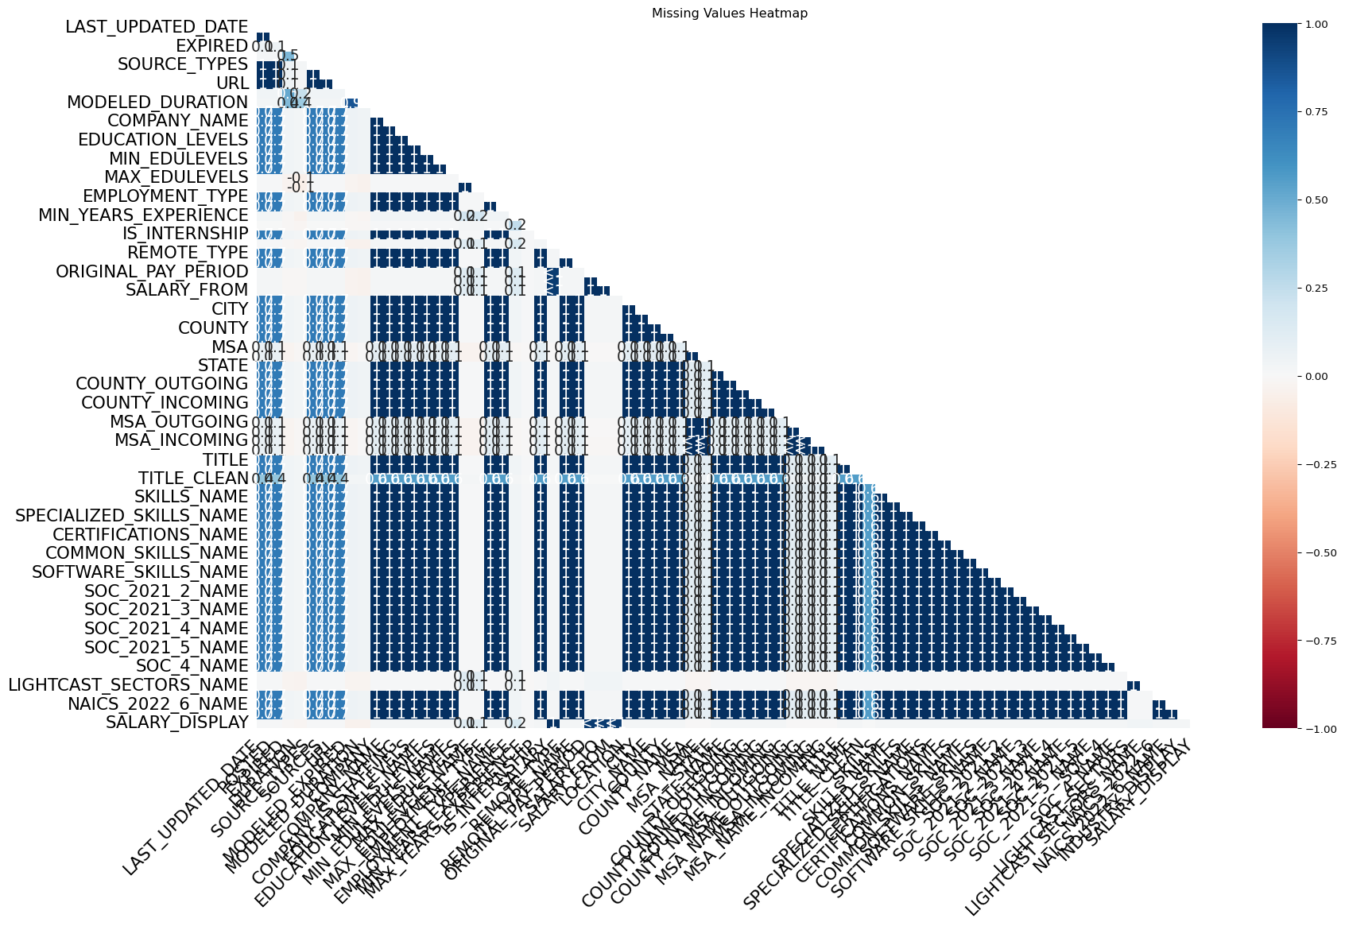
/tmp/ipykernel_3176/2447604449.py:13: FutureWarning:
A value is trying to be set on a copy of a DataFrame or Series through chained assignment using an inplace method.
The behavior will change in pandas 3.0. This inplace method will never work because the intermediate object on which we are setting values always behaves as a copy.
For example, when doing 'df[col].method(value, inplace=True)', try using 'df.method({col: value}, inplace=True)' or df[col] = df[col].method(value) instead, to perform the operation inplace on the original object.

Remove Duplicates
subset_cols = [c for c in ["TITLE","COMPANY_NAME","LOCATION","POSTED"] if c in df.columns]
if subset_cols:
before = len(df)
df.drop_duplicates(subset=subset_cols, keep="first", inplace=True)
print(f"Removed {before - len(df)} duplicates using {subset_cols}")
Removed 3300 duplicates using ['TITLE', 'COMPANY_NAME', 'LOCATION', 'POSTED']

