Assignment 02

Spark SQL and DataFrames

Connor Coulter

## Query 1 — Tech Industry Median Salaries (NAICS 518210)

Median salary by specialized occupation computed via percentile_approx on numeric salary values.

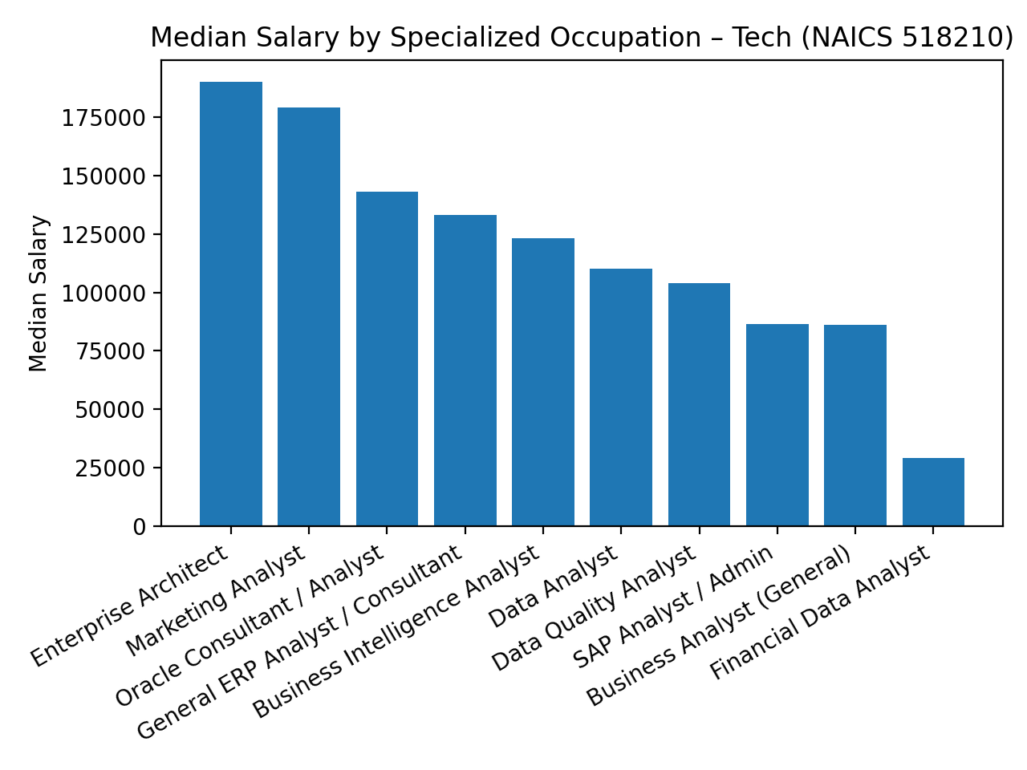

## Query 2 — Top 5 Companies with Remote Jobs in California

Count of remote postings by company (California only), descending.

## Query 3 — Monthly Job Posting Trends in California

Monthly counts grouped by year to visualize seasonality and trend.

## Query 4 — Salary Comparisons Across Major US Metros

Average salary for selected MSAs (rounded) with posting counts.

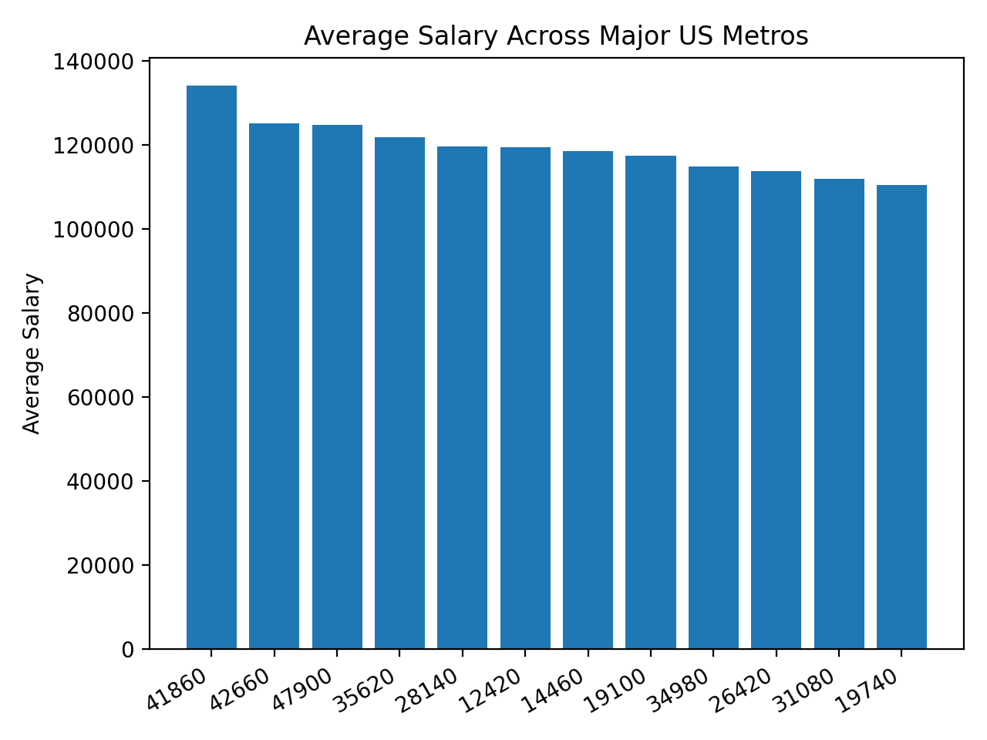

Repository: https://github.com/coulterc-code/coulterc-code-ad688-a2.git