Labib Fawaz

Lf2494

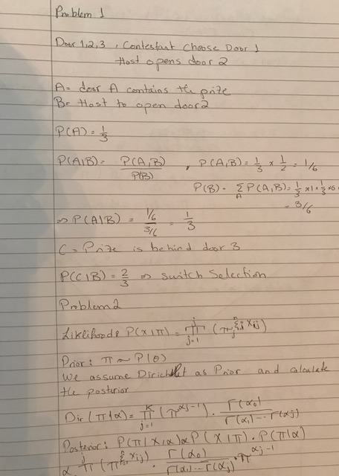

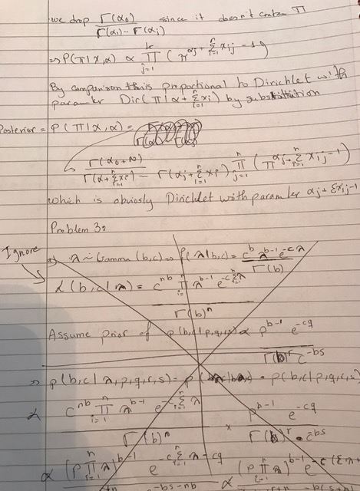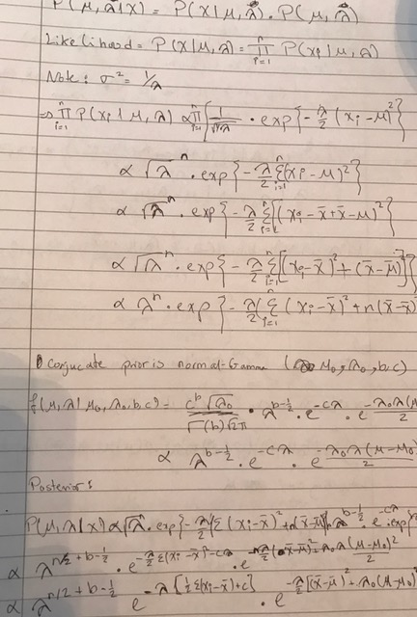

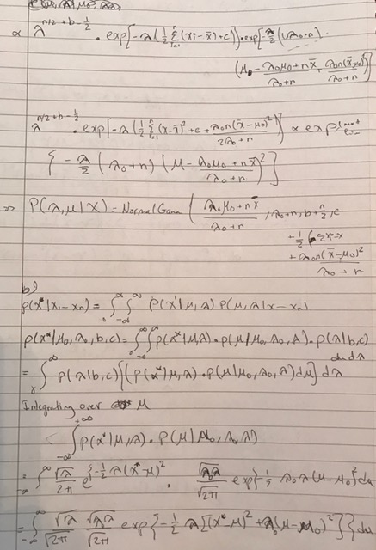

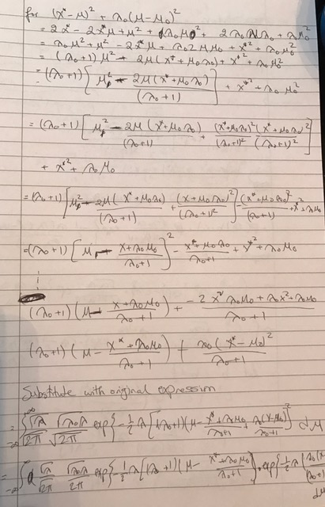

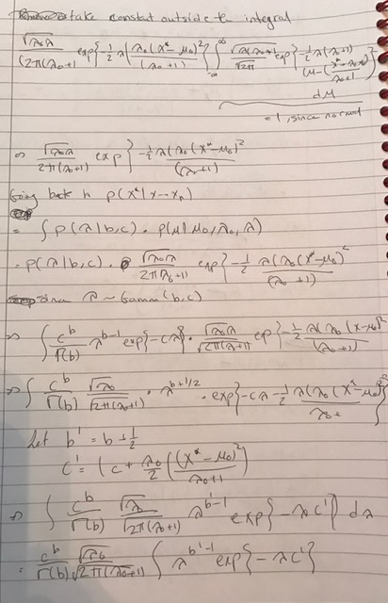



Problem 4:

Part a

* Code submitted

Part b

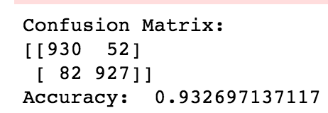

Part c – Misclassified Images

|  |  |
| --- | --- |
| 0 0.264645  1 0.735355 |  |
| 0 0.480633  1 0.519367 |  |
| 0 0.273412  1 0.726588 |  |

d- Ambiguous Images

|  |  |
| --- | --- |
| 0 0.500275  1 0.499725  diff 0.000550 |  |
| 0 0.497692  1 0.502308  diff 0.004616 |  |
| 0 0.503592  1 0.496408  diff 0.007185 |  |