**Beginning new project**

# Option 1: Node.js, Git, and Github setup for new blank project

1. Navigate to project folder and open in VSCode, then open the terminal
2. Run ***npm init*** and accept defaults
3. Install node packages:
   1. ***npm install lite-server@2.5.4 –save-dev***
   2. ***npm install jquery@3.5.1 popper.js@1.16.1*** [***bootstrap@4.5.2***](mailto:bootstrap@4.5.2)
4. In your package.json, add two scripts (make sure all scripts but the last have a comma:
   1. ***“lite”: “lite-server”,***
   2. ***“start”: “npm run lite”***
5. Run ***git init***
6. Create a new file called .gitignore (make sure to include the period) and add node_modules to the first line
7. Create index.html (and optionally setup the head and body of a bootstrap html page)
8. Run ***git add .***
9. Run ***git commit -m “Descriptive but short message describing the changes made”***
10. Go to github and create a new repository whose name matches your project name
11. Follow the instructions that look like these on your new github repo:

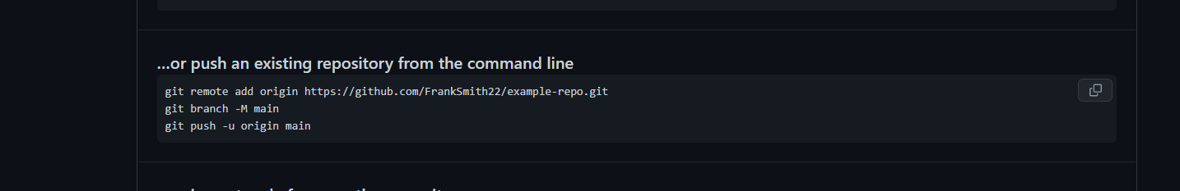

# Option 2: Cloning and setting up Node.js project from Github repo

1. Copy github repository url from desired repository from green code button:

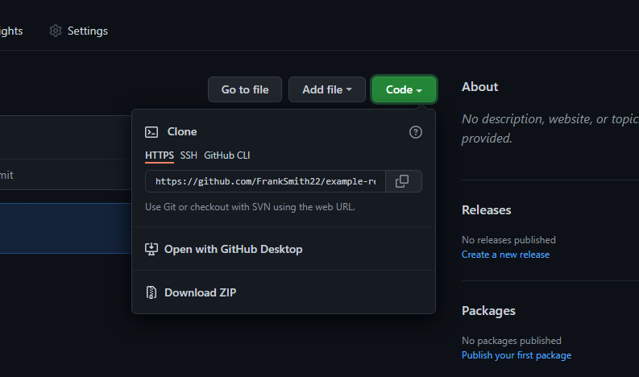

1. In VSCode, open the parent folder of where you’d like the project folder to go
2. Run ***git clone https://github.com/FrankSmith22/example-repo.git*** replacing my url with yours
3. Now open the newly cloned project folder in VSCode
4. Run ***npm install*** to get the dependencies specified in the package.json
5. If you are developing with a team that are all pushing to same repo (and branch) to share code ALWAYS make sure to run ***git pull*** before developing to obtain latest changes.

# Committing and saving future changes

Regardless which option you went with, these are the commands you need in order to commit and push your future changes, both to your local git repository and your remote repository.

In this order:

1. Run ***git add .***
2. Run ***git commit -m “some short but descriptive message”***
3. Run ***git push***