Optimisation for Games Devices CI6510

Shaders for Unity Report

Student K-Number: K1541500

Student Name: Vladislav Li

Introduction

Shaders in Unity can be made in 2 ways. The first of which is to write a shader in Cg that is the most used and native approach in doing shaders in Unity. The vast majority of tutorials in internet are written based on Cg. The other approach is to use new Shader Graph introduced in Unity 2018 Lightweight Pipeline. It has limited capabilities in comparison with Cg-written shader. However, Shader Graph can show result during runtime instantly because of visual programming based on nodes as opposed to classical Cg shader programming where we have to write, compile and check a result.

In this report, all shaders were made using Shader Graph because it is convenient and easy to use tool.

The shaders made are Fresnel Effect, Dissolve, Hologram, Water, Triplanar and its variation.

Main Part

Fresnel Effect

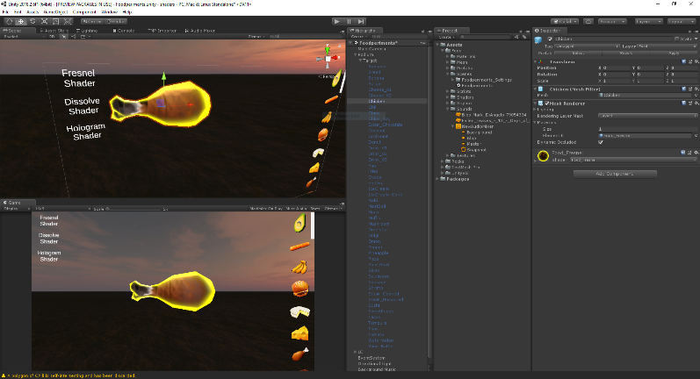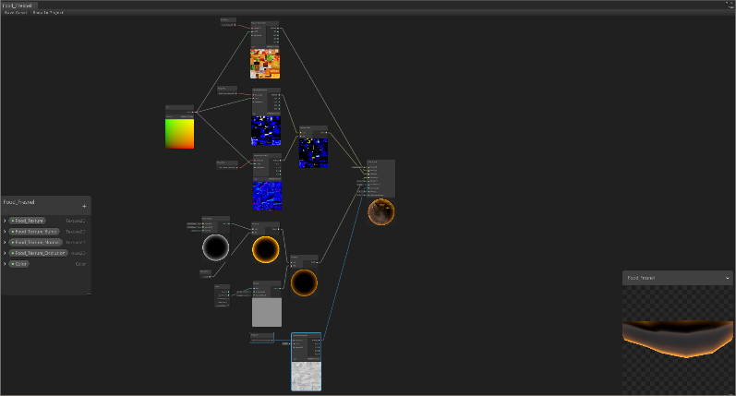

Based on built-in node “Fresnel Effect” with added HDR colour and bumped up intensity. Also, connect with time to achieve glowing effect by remapping sin of time to 0.25 to 1 to avoid complete disappearance of glow effect. After, main texture and occlusion texture were added using usual samples, and blended normal textures of bump and classic normal.

Dissolve Effect

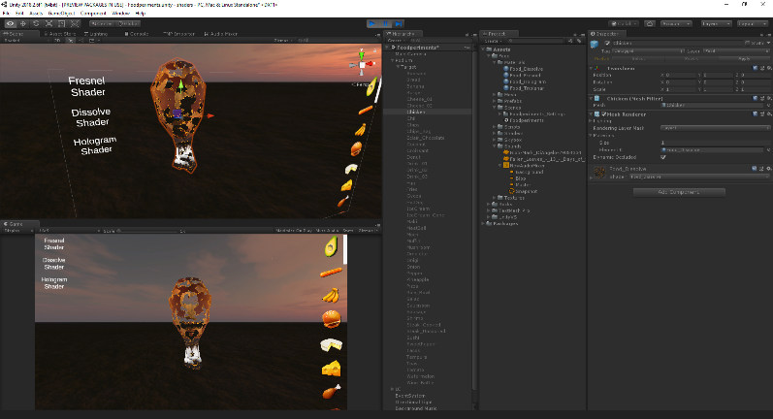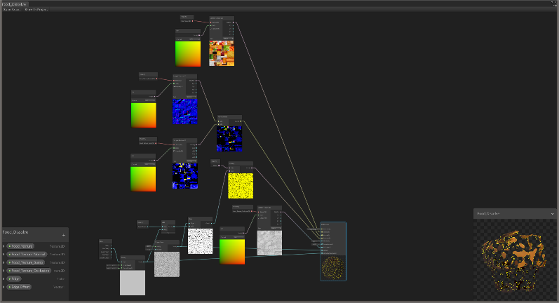

Dissolve Effect was achieved by using Simple Noise node and Sin of Time together. It was filtered using Step node and added colour using Color node. Also, added main texture, normal and bump map like in Fresnel Shader.

Hologram Effect

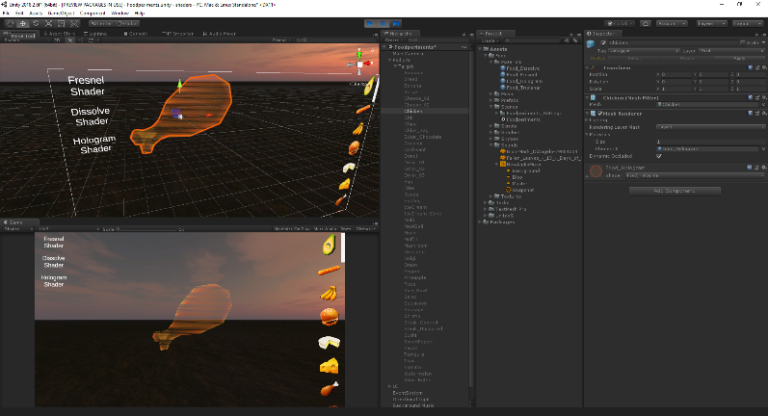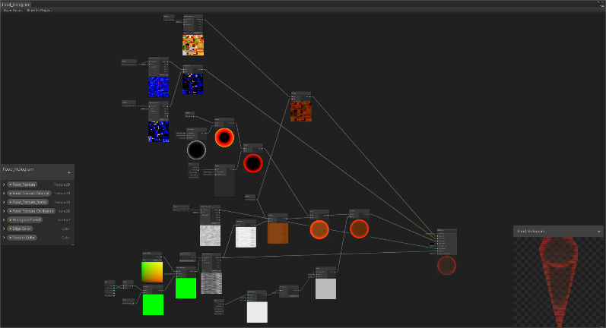

Hologram Effect is based on Time node and Tiling and Offset. Combined Time and Sin of Time to make hologram texture to go from right to left and vice versa while scrolling down of time. Change tiling to change proportion of the tiling to have it stretched along one of the axis. To enhance an effect I used Fresnel Effect with its glowing. Also, used main texture and combined normal.

Water Effect

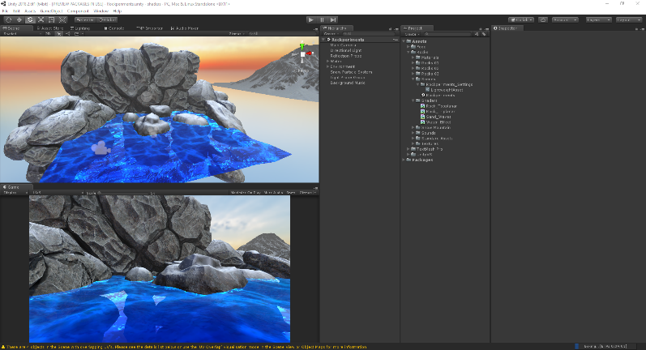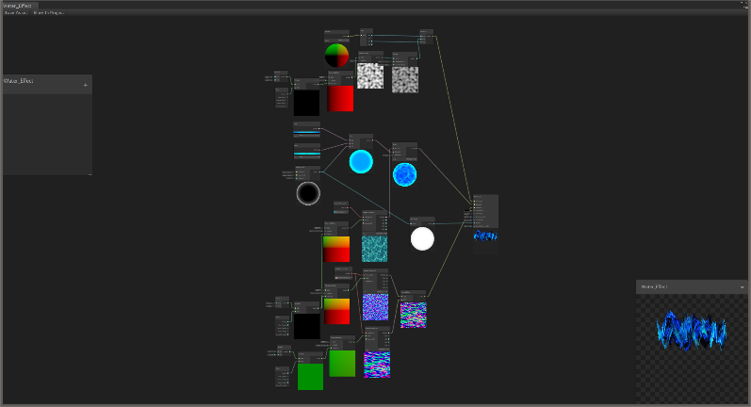

Water Effect is based on Normal nodes and Time node to make an effect of waves. 2 normal textures were used with different tiling scales and looped over in different directions using time of Time node. To give a reflection feeling an inverse of Fresnel Effect was used. At top down view water texture would be darker and lighter when looking at sharper angles. To enhance an effect of water waves I used Gradient Noise node and looped over UVs with Time and Tiling and Offset nodes. Also, added main texture as albedo of master node.

Triplanar Effect

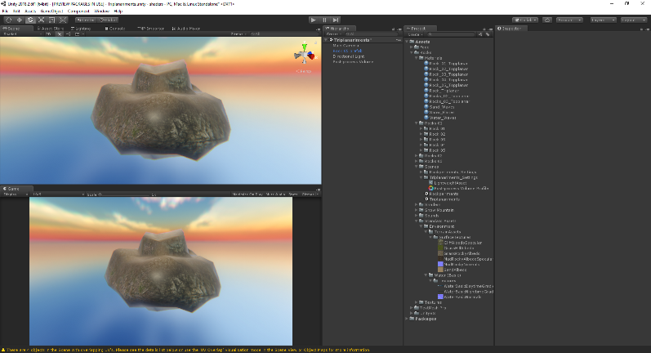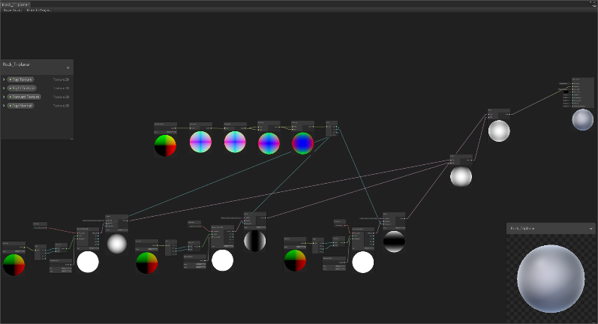

Triplanar Effect was achieved by using Position node combined with Texture Sample. It would project texture according to how we extract x, y and z from Position node. For example, using x and y we would project along z axis. But to avoid texture stretching on other side, I used Normal Vector node and by multiplying it by itself a couple of times to create more noticeable difference between axis I then used Blend node set to Screen mode to filter out other sides and make them look black. After, Add node just added processed textures and output them to Albedo of the master node.

Topplanar (Triplanar variation)

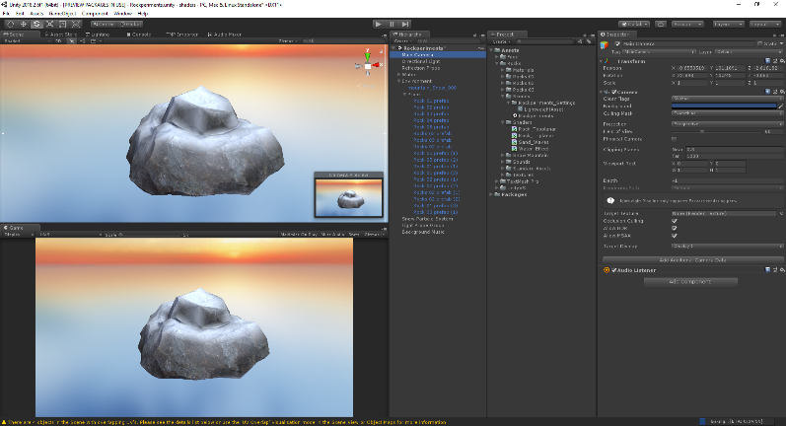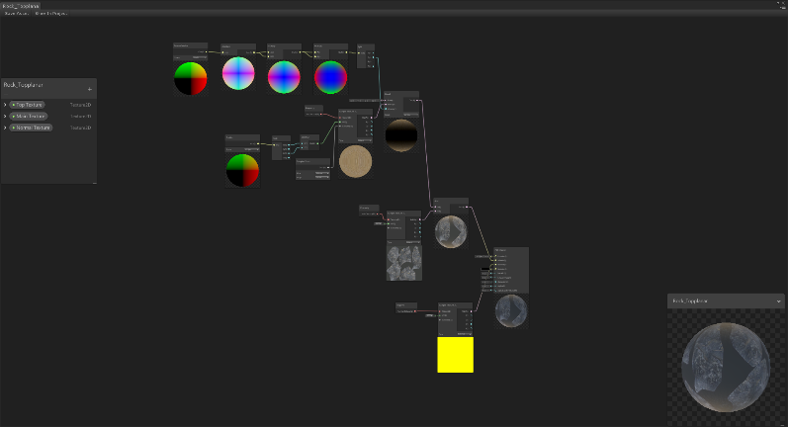

Topplanar Effect is a variation of Triplanar shader because in the project all the models given had UVed textures and to add an effect of snow or sand landing on top of them a projection along y-axis was used. Combined with classical sampled texture using model’s UV.

Conclusion

Shader Graph is much more user-friendly than its code counter-part and it is getting more and more versatile day by day. However, now, Cg’s capabilities are wider, although less friendly to people like Artists. For example, during my research, I found out that at the version of Shader Graph we have now, we can’t mimic Cel Shading, except outlining. Although, I am sure it will be fixed in future updates.

[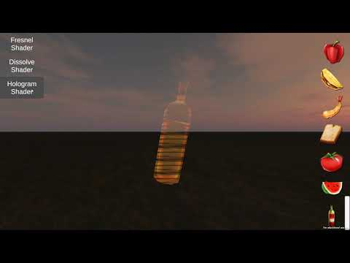](https://www.youtube.com/watch?v=eC3zoAqlGvo)

Unity 2018.2.6f1 Lightweight Pipeline Shader Graph Demo

Made by Vladislav Li, K1541500

References:

triplanar mapping - https://catlikecoding.com/unity/tutorials/advanced-rendering/triplanar-mapping/

water shader - https://www.youtube.com/watch?v=uuzB93F39P8

water texture - https://forum.blockland.us/index.php?topic=185623.0

snow texture - https://www.the3rdage.net/item-831?addview

snow texture - https://assetstore.unity.com/packages/3d/environments/landscapes/free-snow-mountain-63002

ocean waves sound - http://soundbible.com/1935-Ocean-Waves.html

snow particle - https://api.unrealengine.com/udk/Two/EmittersExamples.html

snow particle system - https://www.youtube.com/watch?v=b8oVAS9IdZM

snow music - https://www.adamvitovsky.com/magical-winter

beach background - http://freemusicarchive.org/member/jason/Take_Me_to_the_Beach

blop sound - http://soundbible.com/2067-Blop.html

http://www.gamasutra.com/blogs/DavidLeon/20150702/247602/NextGen_Cel_Shading_in_Unity_5.php