# 商家页面元素内容的模板

## 标题H1

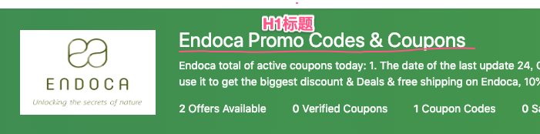

{{store_name}} 是商家名  
随机选择下面一句，生成H1标题

{{store_name}} Coupon & promo codes  
{{store_name}} coupons & promo code  
{{store_name}} Coupon codes & promos  
{{store_name}} coupons & promo  
{{store_name}} Pormos & coupon code  
{{store_name}} promos & coupon  
{{store_name}} Promo & coupon codes  
{{store_name}} promo codes & coupons  
{{store_name}} promo & promo codes  
{{store_name}} coupons & coupon codes  
{{store_name}} Coupon code & deals  
{{store_name}} promo code & deals  
{{store_name}} Promo & discount codes  
{{store_name}} coupons & voucher code  
{{store_name}} promo & voucher codes  
{{store_name}} Coupons & disount code

## 商家介绍

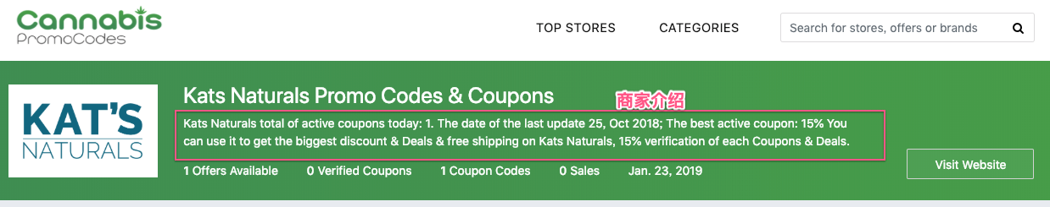

{{coupon_count}}是有效优惠券总数量  
{{last_update_date}} 商家的优惠券最后更新时间  
{{best_coupon_name}} 商家优惠值最大的有效优惠券标题，如 Get Up To 26% Off Sitewide  
随机选择下面选一段，生成商家介绍

* The last update time of {{coupon_count}} coupons is {{last_update_date}}, and there are {{coupon_count}} discounts in all. The best offers are: {{best_coupon_name}}. COUPONPA.com is one of the important partners of {{store_name}}. All the coupon codes of {{store_name}}are verified officially. You can find the best promotions at COUPONPA.com for sure, and save you more money.
* The last update time of {{store_name}} promo codes is {{last_update_date}}, and there are {{coupon_count}} coupons in all. The best offers are: {{best_coupon_name}}. All the discount codes of {{store_name}} are verified officially. COUPONPA.com is a professional web site you can count on, which is updated most timely. At COUPONPA, you can find the best coupons & discounts of {{store_name}}, which is what you want.
* The last update time of {{store_name}} promos is {{last_update_date}}, and there are {{store_name}} discounts in all. The best offers are: {{best_coupon_name}}. All the discount codes of {{store_name}} are verified officially. COUPONPA.com and {{store_name}} have a long-term cooperation, so the coupon code of {{store_name}} is real-time updated, and you can find the coupon you want at COUPONPA.com anytime.
* The last update time of {{store_name}} coupons is {{last_update_date}}, and there are {{coupon_count}} discounts in all. The best offers are : {{best_coupon_name}}. All the promo codes of {{store_name}} are verified officially, so they are safe to use. You can trust COUPONPA.com. It will give you the best discounts and save more money for you by choosing us and using {{store_name}} coupon code.
* The last update time of {{store_name}} discounts is {{last_update_date}}, and there are {{coupon_count}} coupons in all. The best offers are: {{best_coupon_name}}. All the promo codes of {{store_name}} are verified officially. COUPONPA.com and {{store_name}} have a long-term cooperation. Find the coupon code you need at COUPONPA.com, save more money, do not let you wallet cry anymore.
* The last update time of {{store_name}} promos is {{last_update_date}}, and there are {{coupon_count}} discounts in all. The best offers are {{best_coupon_name}}. All the discount codes of {{store_name}} are verified officially. COUPONPA.com is one of the important partners of {{store_name}}. Find the promo code of the best discount at COUPONPA.com and use it, so you can save more money, and let your wallet grow thicker.

* The last update time of {{store_name}} coupons is {{last_update_date}}, and there are {{coupon_count}} promos in all. The best offers are {{best_coupon_name}}. All the discount codes of {{store_name}} are verified officially. The coupon code of {{store_name}} is real-time updated. You can find the coupon you want most at COUPONPA.com and save more money. Do not let your wallet cry anymore, so COUPONPA.com is your best choice.

* The last update time of {{store_name}} coupons is {{last_update_date}}, and there are {{store_name}} discounts in all. The best offers are {{best_coupon_name}}. All the promo codes of {{store_name}} are verified officially. {{store_name}} is one of the important partners of COUPONPA.com, and we have maintained a good long-term cooperation. The coupon code of {{store_name}} is real-time updated, and we ensure the authenticity. You can find the promo code you most want fastest, and let you save more money.
* The last update time of {{store_name}} promos is {{last_update_date}}, and there are {{coupon_count}} coupons in all. The best offers are {{best_coupon_name}}. All the discount codes of {{store_name}} are verified officially. {{store_name}} is one of the important partners of COUPONPA.com. Find the promo code of the best discount at COUPONPA.com and use it, so you can save more money, and let your wallet grow thicker.

## Title元素

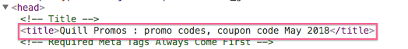  
{{best_off}}是商家的有效优惠券中最大优惠折扣值，如30%, $50  
{{store_name}} 商家名  
{{month}} 年月，如January 2019

{{best_off}} Off {{store_name}} Coupons : promo codes,coupon code {{month}}   
{{store_name}} Coupons: {{best_off}} OFF coupon codes, promo code, {{month}}  
{{best_off}} Off {{store_name}} Promos : promo codes, coupon code {{month}}  
{{store_name}} Promos: {{best_off}} OFF coupon codes, promo code, {{month}}  
{{store_name}} Coupons {{month}} : {{best_off}} OFF promo code & discounts  
{{store_name}} Promos {{month}} :{{best_off}} OFF coupon code, discounts  
{{best_off}} Off {{store_name}} Coupons : coupon & promo codes {{month}}  
{{best_off}} Off {{store_name}} Coupons : promo, coupon codes {{month}}  
 {{best_off}} Off {{store_name}} Promos : coupon & promo codes {{month}}  
{{best_off}} Off {{store_name}} Promos : promo, coupon codes {{month}}  
{{store_name}} Coupons: {{best_off}} OFF coupon & promo codes {{month}}  
{{store_name}} Coupons: {{best_off}} OFF promo ,coupon Codes {{month}}  
{{store_name}} Promos: {{best_off}} OFF coupon & Promo Codes {{month}}  
{{store_name}} Promos: {{best_off}} OFF promo ,coupon Codes {{month}}  
{{store_name}} Coupons {{month}} : {{best_off}}OFF Promo Code, Discounts  
{{store_name}} Promos {{month}} : {{best_off}} OFF coupon Code & Discounts  
{{best_off}} Off {{store_name}} Coupons : coupon code, promos {{month}}  
{{best_off}} Off {{store_name}} Coupons : promo code & coupon {{month}}  
{{best_off}} Off {{store_name}} Promos : promo code, coupons {{month}}   
{{best_off}} Off {{store_name}} Promos : coupon code & promo {{month}}  
{{store_name}} Coupons: {{best_off}} OFF coupon code, promos {{month}}   
{{store_name}} Coupons: {{best_off}} OFF promo code & coupon {{month}}  
{{store_name}} Promos: {{best_off}} OFF promo code, coupons {{month}}  
{{store_name}} Promos: {{best_off}} OFF coupon code & promo {{month}}  
{{store_name}} Coupons {{month}} :{{best_off}}OFF promo code & discounts  
{{store_name}} Promos {{month}} : {{best_off}} OFF coupon code & discounts  
{{store_name}} Coupons: Save {{best_off}} OFF W/ {{month}} promo code, discounts  
{{store_name}} Promos: Save {{best_off}} OFF W/ {{month}} coupon code, discounts

## Meta keyword 元素

image.png

{{store_site}}是商家官网

{{store_name}}, {{store_site}}, {{store_name}} promos, coupon, promo codes, deals  
{{store_name}}, {{store_site}}, {{store_name}} promos, promo, coupon codes, deals  
{{store_name}}, {{store_site}}, {{store_name}} coupons, coupon, promo codes, deals  
{{store_name}}, {{store_site}}, {{store_name}} coupons, promo, coupon Codes, deals  
{{store_name}}, {{store_site}}, {{store_name}} promos, coupon, promo codes, deals  
{{store_name}}, {{store_site}}, {{store_name}} promos, promo ,coupon codes, deals  
{{store_name}}, {{store_site}}, {{store_name}} coupons, promo code, discounts, deals  
{{store_name}}, {{store_site}}, {{store_name}} promos, coupon code, discounts, deals  
{{store_name}}, {{store_site}}, {{store_name}} coupons, coupon code, promos, deals  
{{store_name}}, {{store_site}}, {{store_name}} coupons, promo code, coupon, deals  
{{store_name}}, {{store_site}}, {{store_name}} promos, promo code, coupons, deals  
{{store_name}}, {{store_site}}, {{store_name}} promos, coupon code, promo, deals  
{{store_name}}, {{store_site}}, {{store_name}} coupons, coupon code, promos, deals  
{{store_name}}, {{store_site}}, {{store_name}} coupons, promo code, coupon, deals  
{{store_name}}, {{store_site}}, {{store_name}} promos, promo code, coupons, deals  
{{store_name}}, {{store_site}}, {{store_name}} promos, coupon code, promo, deals  
{{store_name}}, {{store_site}}, {{store_name}} coupons, promo code, discounts, deals  
{{store_name}}, {{store_site}}, {{store_name}} promos, coupon code, discounts, deals  
{{store_name}}, {{store_site}}, {{store_name}} coupons, promo code, discounts, deals  
{{store_name}}, {{store_site}}, {{store_name}} promos, coupon code, discounts, deals

## Meta description 元素

{{coupon_count}} 是有效优惠券总数量  
{{best_coupon_name}}商家优惠值最大的有效优惠券标题，如 Get Up To 26% Off Sitewide

* {{store_name}} coupons, promo code & free shipping W/ {{month}}, Have {{coupon_count}} active discount codes, Hot Discount code:{{best_coupon_name}}
* {{store_name}} promos, coupon code & free shipping W/ {{month}}, Have {{coupon_count}} active discount codes, Hot Discount code：{{best_coupon_name}}
* {{coupon_count}} active {{store_name}} coupons, promo codes & free shipping W/ {{month}}. Hot Discount code：{{best_coupon_name}}
* GET {{store_name}} {{coupon_count}} active Coupons, deals & free shipping W/ {{month}}. Hot Promo codes：{{best_coupon_name}}
* GET {{store_name}} {{coupon_count}} active Promos, deals & free shipping W/ {{month}}. hot Coupon codes：{{best_coupon_name}}