TEMPLATE 2: PRODUCT REQUIREMENTS DOCUMENT

Company Name: Courageous Land Ltda
PART 1:
- Describe the primary use cases (real-world applications) of your solution. Include both actual and potential use cases. Please share any data or results from pilot implementations. For each actual and potential use case, explain why your technology is well-suited for that application.

 | Use case 1  (Real-world application) | Use case 2 | Use case 3
Brief Description  (200 characters limit) | Drone RGB imagery of a smallholder agroforestry plot is turned into a georeferenced census: every food-producing tree detected, identified by species, counted and measured. | Detected species are mapped to FAO food groups and converted to estimated edible yield, producing a public, per-territory indicator of food availability, refreshed at every flight. | Before any count is reported, the tool measures the model's precision and recall on the user's own orthophoto, from a small sample the user confirms. It works on third-party models too.
Actual or Potential | Actual | Potential | Potential
Has the tech component of your solution been prototyped and tested? If yes, please summarise the components prototyped and test results:  (200 characters limit) | Yes. Six species, three sites. Against hand-drawn labels: recall 0.91-0.98, precision 0.59-0.89, centroid error 3-18 cm. 1,893 trees inventoried over 36 ha; 9,818 coffee plants on one orthophoto. | Partially. The crown-to-biometry chain is validated for timber: crown area to DBH to height to volume, field-calibrated on 134 trees, R2cv 0.70, with Monte Carlo 95% CI under +/-10% per stand. | Partially. The measurement engine exists and runs: it produced every figure here, including the finding that one model scored mAP 0.826 yet found 2 of 198 plants outside its training strip.
Why is the technology suitable for this use case:  (200 characters limit) | A single 20-minute flight measures every individual on hectares of mixed canopy. Ground counting of intercropped agroforestry is so slow that in practice the number simply does not exist. | Same machinery, different target: edible biomass instead of timber volume. Remote sensing already measures the upstream environmental cause of child undernutrition - what food exists nearby. | Models do not transfer between sites - we measured it on our own data. A detector that cannot say how wrong it is on your imagery reports a confident number that nobody can check.

PART 2:

Please choose the most relevant technology category (ies) for your solution and complete questions on either

A) Software
B) Content

*Make sure all relevant components are covered. You can provide answers in one or two categories.
*Note that the questions for start-ups using data and/or blockchain in section (A) Software should only be answered if relevant to your solution.

SECTION A: SOFTWARE

- Prototyping: Describe the work you have done on proofs of concept, mockups, and user testing. List the last three versions of your solution’s design. For each version, please provide 2 sentences that describe the reasons for the changes (including data) and outline the main changes made.

Version | Main characteristics and features | Main changes from the previous version | Reasons for changes made  (Including data collected/ feedback received/ refined understanding of user needs):
Version 1 | Acai counter - cloud service, single species. A detector trained on 344 hand-drawn polygons (133 tiles of 1024 px) over a smallholder agroforestry plot in Rorainopolis, Roraima. FastAPI + Pub/Sub + Cloud Run + object storage; orthophoto upload up to 10 GB; tiled inference; pixel to UTM to WGS84 conversion; spatial de-duplication under 2 m; GeoJSON output on an interactive map. Validation mAP@0.5 = 0.849. | First version. | -
Version 2 | Crown segmentation plus field-calibrated biometry. A segmentation model that outlines the crown instead of boxing it, over 1,936 aerial images across 10 stands (36 ha). Allometry calibrated against 134 field-measured trees converts crown area to DBH, height, basal area and volume, with uncertainty propagated by Monte Carlo (n=500) to 95% confidence intervals. Per-tree competition indices (Hegyi, BAL). Crown segmentation mAP@0.5 = 0.68. | Box detection became instance segmentation; a single count became a full forest inventory; field calibration and uncertainty quantification were added. | A count alone supports no decision. Crown AREA is the variable that predicts DBH (cross-validated R2 = 0.70, RMSE 4.78 cm), so boxes had to become masks. The architecture was also settled by measurement rather than preference: on the same data and the same splits, our choice beat the best of 13 competing runs plus a 28-trial hyper-parameter search, mAP50-95 0.400 against 0.365.
Version 3 | Multi-species, portable, self-measuring inference. The user brings an orthophoto and a model - ours or a third party's - and gets a georeferenced count plus the model's precision and recall measured on that very imagery. Four food species trained (coffee, avocado, pitaya, banana). Inference runs on CPU at 100 ms per tile. Portable Python ingestion (GeoTIFF to COG) and on-demand tile serving replaced Windows-only GDAL scripts and a 608 MB static tile pyramid. | The managed cloud of version 1 was dropped for a package anyone clones and runs on their own machine; one model per site and species replaced the idea of one universal model; and a calibration step was added so the tool reports its own error. | Two measurements forced this. First, a model trained on a contiguous 95 m strip scored mAP@0.5 0.826 on its own validation set but found only 2 of 198 plants in held-out windows elsewhere on the same orthophoto - recall 0.01, while precision stayed at 1.00, so it failed silently. Spatial spread of samples matters more than sample count. Second, open pre-trained models fail in this domain, so the product cannot be a model; it must be the machine that produces the local model.

- Before you developed your own technology or selected an existing one, what other similar technologies did you consider using, improving or iterating to solve the problem you want to solve? (Outline what other technologies were considered to address the problem you identified and why were they rejected as unsuitable).

 | Technology description (200 characters limit) | Unsuitable because: (500 characters limit)
1 | DeepForest - open pre-trained tree-crown detector, trained on NEON airborne imagery of North American forests. | Benchmarked zero-shot on our reference stand against 208 manually delineated crowns: F1@0.5 = 0.002, returning 5,771 predictions for 208 real crowns. On tropical mixed canopy it segments texture rather than crowns. Retraining it would mean rebuilding the training pipeline we already have, with no advantage.
2 | Detectree2 - open Mask R-CNN crown delineation, with weights trained on tropical forest (Paracou). | The best of the open baselines and still far short: F1@0.5 = 0.220 and crown-area error 44.8%, against 0.532 and 14.9% for our own model on the same stand. Tropical natural forest and tropical agroforestry are different problems: planted rows, mixed ages and bare inter-rows break the assumptions the model was trained on.
3 | Airborne LiDAR - the reference method for forest structure and carbon stock. | Cost and access. A LiDAR flight over smallholder plots in Roraima costs more than those plots produce in a season, requires contracted aircraft, and cannot be repeated often enough to track a growing agroforestry system. RGB drone imagery plus field-calibrated allometry reaches 95% confidence intervals under +/-10% per stand at a small fraction of the cost, and can be repeated by the landholder.
4 | Ultralytics YOLO (v8, v11, v26) - the default open detector for this task, and what our own first version used. | Not rejected on principle but on measurement, after a fair contest: 13 training runs across YOLOv8, v11 and v26 variants plus a 28-trial hyper-parameter search, all on the same data and splits. The best YOLO reached mAP50-95 0.365; RF-DETR reached 0.400. YOLO also could not produce crown masks of the quality the allometry needs, and its AGPL-3.0 licence constrains downstream reuse more than Apache-2.0.

- Please choose the type of license that applies to your solution:
- Copyleft (e.g., GNU General Public License) [X] SELECTED - GPL-3.0
- Permissive (e.g., MIT License, Apache License)
- Uncertain of Category, but an OSI-Approved License
- Not Open Source yet
- Other (please specify)

- If currently not an Open Source license solution, are you willing to release your tech solution under an Open Source license (https://opensource.org/licenses/) (please refer to the Funding Agreement to consider the obligations for Open Source licensing and investment by the Venture Fund):
☐ Yes
☐ No

- Please insert at the end of this template (Annex 1) a diagram of your current tech stack including all components and subsystems, showing their linkages and interactions. A tech stack is a combination of software products and programming languages used. For this diagram, include both client-side and server-side documentation, if relevant, tools used for front-end and back-end systems (including databases), and any meta-layers. If you are using machine learning, please describe your pipeline.

Please find here two examples of tech stacks that you can use as templates:

- 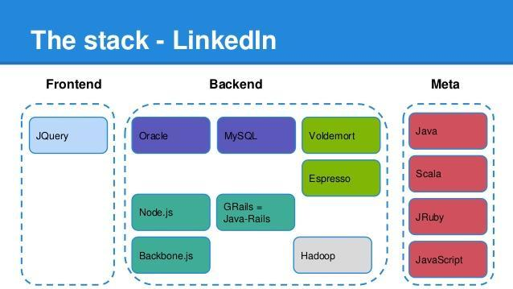

- 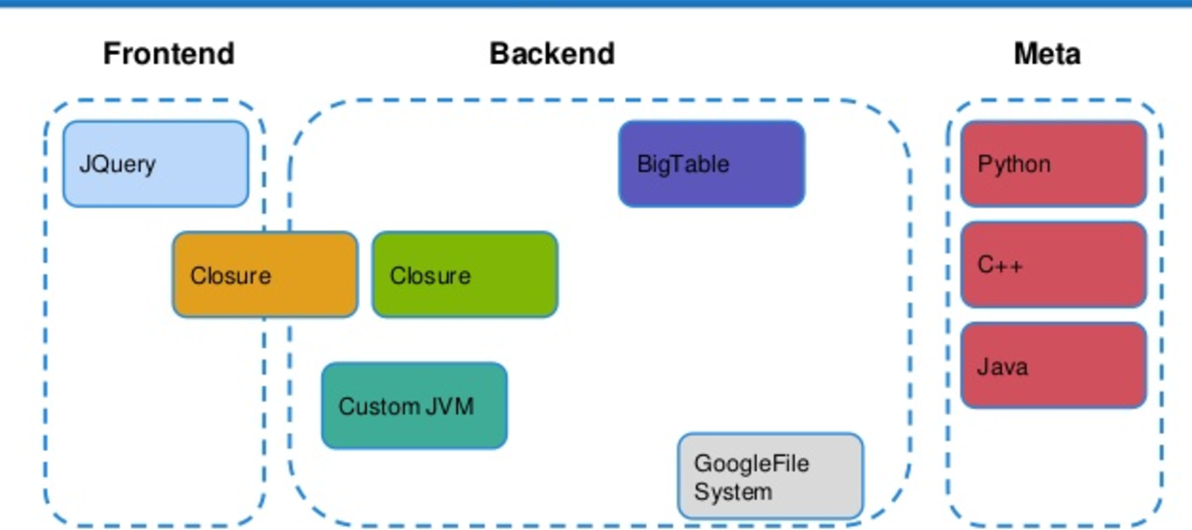

Additionally, please provide written documentation explaining the diagram provided, outlining each element included in the diagram, its role and its status of development (complete, under development, expected date of completion, etc). Please clarify if these components are currently Open Source or proprietary, and in the case of the latter if you intend to release it as Open Source solution. Include links or documents outlining process documentation, system documentation, user documentation, and any instructions on API usage, if relevant. (5,000 characters limit)
Answer: The whole stack runs offline on the user's own machine. There is no server to sign up for, no API key and no cloud account: the user clones the repository, installs the dependencies, downloads the models and runs one command.
ENTRY POINT (inventario.py) - chains the three stages below and opens the browser at the end. Complete. `python inventario.py minha_ortofoto.tif --especie cafe`.
INGESTION (ingerir.py) - converts any GeoTIFF orthophoto to a Cloud Optimized GeoTIFF, with the depth of the internal pyramid computed from the image dimensions rather than fixed, so it keeps working when the orthophoto reaches 4 GB. Complete; pure Python over rasterio, with no external binary required on the PATH, so it behaves the same on Windows, Linux and Mac.
DETECTION (inferir.py) - walks the orthophoto in overlapping tiles, converts each predicted box to geographic coordinates through the raster's affine transform, and de-duplicates the plants that appear in more than one tile. Outputs GeoJSON and CSV in EPSG:4326. Complete; runs without a GPU at 100 ms per tile - about 4 minutes for a 1.9 GB orthophoto, 9 minutes for a 4 GB one - against 17 ms with a GPU.
MAP SERVICE (servidor.py + tiles.py) - serves the page and cuts every map tile from the COG on demand, which removes the need to pre-generate an image pyramid that would cost over 600 MB per orthophoto. Measured at 23-67 ms per new tile and 2 ms cached, and verified pixel-by-pixel against a conventionally generated pyramid: zero positional offset, 99.92% agreement of the transparency mask. Complete.
VIEWER (web/) - map with the orthophoto, the detections, a confidence filter, the count and export. The map library is vendored in the repository, so the page works with no internet at all. Complete.
MODEL DISTRIBUTION (modelos.json + baixar_modelos.py) - the weights are 121 MB each and are published as release assets rather than committed. Each is verified by sha256 on download, because a truncated file loads and infers silently. The manifest carries, for every model, where it was trained, its measured precision and recall, and a plain statement of where it fails. Complete.
TRAINING - fine-tuning per species; complete, requires a GPU. It is how we produce the published models, not something the end user is asked to run.
EVALUATION (aferir.py, consolidar_metricas.py) - regenerates every accuracy figure we publish from the source files. Complete.
BIOMETRY AND ALLOMETRY - crown area to DBH to height to volume with Monte Carlo confidence intervals. Complete for timber; the edible-yield equivalent is to be built.
CALIBRATION STEP - measures precision and recall of any model on the user's own imagery before reporting a count. To be built; a core deliverable of the investment.
PUBLIC INDICATOR API - to be built; territory-level aggregates under CC-BY 4.0.
Third-party components: RF-DETR (Apache-2.0), PyTorch, rasterio/GDAL, rio-tiler, MapLibre GL, WebODM for photogrammetry, and Ultralytics YOLO (AGPL-3.0) in version 1 only. All components we author are open source; none is proprietary.

- Which repository hosting service/git forge do you use for your solution:
  - GitHub [X] SELECTED
  - GitLab
  - Gitea
  - Other (please specify):

- Share here all GitHub / Bitbucket (or other) repositories for all components of your solution: (1,000 characters limit)
Answer: [[TO BE COMPLETED BEFORE SUBMISSION]] The three components (multi-species detection and calibration pipeline; crown segmentation and allometry; cloud inference service) are being published as public repositories under GPL-3.0 before submission. Access for @unicefinnovation will be granted.

If your repositories are private, and on Github, GitLab or Bitbucket; please make sure to give access to our user before you send this form back to us: @unicefinnovation or venturefund@unicef.org (we assure you that the information in your repositories will only be used to evaluate funding your solution and will not be shared).

- Please share the GitHub, GitLab or bitbucket (or other) handles of the code developers within your team:
Answer: [[TO BE COMPLETED BEFORE SUBMISSION]]

- How many external contributors have there been to your code?
Answer: 0 to date. The code has been developed in-house. Opening it under GPL-3.0 and publishing the model zoo is intended precisely to change this, and interoperability with NetFlora (Embrapa Acre, GPL-3.0) is the first planned collaboration.

- What processes and tools do you leverage for quality assurance and testing? (1,000 characters limit)
Answer: Verification is empirical and geospatial, not unit-test-driven: the failure modes are misalignment and inaccuracy, not program logic.
Imagery: every pipeline change is checked against a known-good reference. Replacing the static tile pyramid with on-demand tiling was accepted only after pixel-by-pixel comparison over 40 tiles and four zoom levels confirmed zero positional offset and 99.92% mask agreement.
Models: evaluated only on held-out windows never used in training, the split stored on disk and reused, chosen by spatial stratification so it spans the area.
Metrics: produced by scripts in the repository (aferir.py, consolidar_metricas.py), so every published figure is regenerated from source files rather than transcribed.
Interface: exercised through the Chrome DevTools Protocol with real input events.
Declared gap: no automated test suite and no continuous integration; both scheduled for Q1.

- If you are not using git version control system, what are you using? Please specify (200 characters limit)

- Sustainability: What is the ongoing plan for maintenance, updates, and support of your software? Describe what the needs will be for the next two years and how these will be met. (1,000 characters limit)
Answer: Maintenance is funded by the consulting layer that already exists: per-stand inventory reports generated automatically by the same pipeline are saleable to consultancies, certifiers and cooperatives, and Courageous Land's agroforestry platform is the distribution channel. Community, school and smallholder use stays free and open - that segment cannot pay, and it is the reason for the copyleft licence.
Needs over two years: a maintainer for the pipeline and the public model zoo; periodic retraining as species and sites are added, affordable because our internal annotation rather than compute is the bottleneck; hosting for the zoo and the indicator, modest because published data is aggregate and heavy computation runs on the user's machine; and governance so contributed models carry honest accuracy cards.
The architecture is deliberately cheap to keep alive: no mandatory server, no GPU for inference, no external API.

- If your start-up is using data as a central part of the solution:

  - Describe the scope of the data that you are processing. Specifically:

- What data elements are you processing (i.e., collecting, using, retaining, sharing, etc.) to provide your product/service? Describe: (1,000 characters limit)
Answer: Aerial RGB orthophotos of vegetation, produced from drone flights (DJI Mavic 3 Multispectral with RTK, around 3 cm ground sampling distance), together with their geospatial metadata: coordinate reference system, affine transform, footprint and flight date.
Derived from these: polygon and point geometries of individual plants, each carrying a species class, a detection confidence, a provenance flag (drawn by a human, or produced by a model and then confirmed), crown area, and the biometry computed from it.
Separately, field measurements of a sample of trees - stem circumference, height and two crown diameters - used only to fit the allometric coefficients.
No imagery of people is collected. Flights are planned over vegetation; any incidental person in the imagery is not a subject of interest and is never detected, indexed or retained as such.

- Do you collect any personally identifiable data, and/or children’s data? If so, how are you collecting, processing and storing this information? Please provide any details on data management policies, agreements, or practices being followed or planned. (1,000 characters limit)
Answer: We process no personally identifiable data and no children's data. The solution measures plants, not people. There is no user account system, no biometric data, no health record and no individual-level information anywhere in the pipeline. Nothing we hold could identify a person.
There is, however, one genuinely sensitive element and we treat it as such: the precise location of smallholder and family farms. In Roraima, plot-level coordinates carry real land-tenure and invasion risk. Our practice is that public outputs are aggregated to territory level and never published per plot; plot-level geometry stays with the landholder and is shared only with explicit consent. Collection over a family's land proceeds only by free and informed consent, and the family receives the resulting inventory of its own land.
This will be formalised as a written data policy published in the repository in Q1.

- How much data will you be collecting and using? How often will you be collecting data (is it a one-time collection or on an ongoing basis)? Describe your processes: (1,000 characters limit)
Answer: Per flight campaign: on the order of 2,000 aerial images, which photogrammetry reduces to a single orthophoto of 1 to 4 GB covering tens of hectares. From that orthophoto the pipeline derives 2,000 to 5,000 inference tiles and a few thousand individual plant records. Storage grows by roughly 5 GB per flight per site.
Collection is periodic, not continuous: one flight per monitoring cycle. Two campaigns have already been flown over the same stands (January and March 2026) specifically to establish repeatability, which is also what makes drift detection possible.
During the pilot the intended cadence is one flight per phenological cycle of the species tracked, which for the Amazonian food species in scope means two to four flights per year per site. Processing is triggered by the operator: nothing is collected automatically or in the background.

  - Describe how you already collect or plan to collect data. Please provide a data flow diagram (1,000 characters limit).
Answer: Drone flight over vegetation; photogrammetry with WebODM (third-party, open source); ingestion to a Cloud Optimized GeoTIFF on the operator's own machine. From there the orthophoto goes to tiled inference with a chosen model, producing detections. Detections are spatially de-duplicated into per-plant records carrying species, geometry, confidence and provenance, then pass through the calibration step, where a human confirms a sample and the tool reports precision and recall measured on that operator's own imagery. Only then are they aggregated to territory level and published.
Two boundaries are deliberate. Raw imagery, plot-level geometry and per-plant records stay on the operator's machine and are never transmitted: the pipeline runs offline and the interface uses a vendored map library with no API key. Only the territory aggregate becomes public. See the data flow diagram in the annex.

- If your start-up is using classical machine learning (i.e. not Generative AI) in the proposed solution (ML):
  - Describe your intended models and the rationale for selecting them. Explain how you balance model sophistication with constraints (e.g., data availability, computational resources, and interpretability needs, etc.) (1,000 characters limit).
Answer: We use a modern object detector in two sizes, small and medium, and settled on it by measurement rather than novelty: on the same data and the same splits it won a head-to-head contest against the most widely used alternative, mAP50-95 0.400 against 0.365 — the latter being the best of 13 competing runs plus a 28-trial hyper-parameter search. For biometry we use a segmentation variant, because what the allometry consumes is crown AREA, not a box.
Sophistication is bounded by two constraints. Labelled data is scarce - a few hundred hand-drawn polygons per species - so we use nano and medium backbones; at our sample sizes a bigger model buys overfitting, not accuracy. And inference must run without a GPU for the organisations we build for: 100 ms per tile on CPU against 17 ms on an RTX 4070, worth about 4 minutes for a whole orthophoto. Training does need a GPU, which is why the model zoo exists.
Interpretability comes free: every prediction is a polygon a person can judge.
  - Describe your model evaluation metrics (e.g., accuracy, F1, recall, AUC) and explain why they're appropriate for your solution. How will you monitor performance and detect performance decline? What is your roadmap for improvement, retraining, and handling data drift or changing requirements? (1,000 characters limit)
Answer: We report precision, recall and F1 at IoU 0.5 on held-out windows never seen in training; mAP is diagnostic only. Precision and recall are operative: users ask how many plants were missed and how many reported are real, and mAP hides that trade-off. We also report median centroid error, 3-18 cm. Across four food species: recall 0.91-0.98, precision 0.59-0.89; crown segmentation mAP 0.68.
A caution we apply to ourselves: higher validation mAP can mean a worse model. Our first coffee model scored 0.826 because its validation came from the same strip as its training data; against 198 labels in held-out windows elsewhere it found 2 - recall 0.01 - while precision stayed 1.00. It went blind rather than hallucinating. Its replacement scores 0.423 and reaches recall 0.91, precision 0.72 on those same labels.
Drift: we compare crown-area distributions and counts between flights over the same stands. Improvement comes from the human-in-the-loop cycle: one round cut avocado false positives 39%.

  - Describe the limitations of your methodology: Where does your approach fail? (e.g. your predictions are biased because you do not have enough data for a certain class) (1,000 characters limit)
Answer: Measured, not hypothetical.
1. Models do not transfer, not even across one orthophoto. A coffee model with mAP@0.5 0.826 on its own validation set found 2 of 198 plants in held-out windows a few hundred metres away - recall 0.01. It failed silently: precision stayed 1.00, so nothing signalled that 99% of the crop was missing. This is the most important limitation, and why the product is a training and calibration loop, not a model.
2. Performance is not uniform across species: field precision ranges 0.59-0.89. We claim no cause - the obvious hypothesis, crown size, is contradicted by our own data, and with four species and four confounded variables it would be guesswork.
3. Overlapping crowns and closed canopy degrade separation.
4. Species outside the training set are missed silently: there is no unknown class.
5. Height is inferred from allometry, not measured; calibration is population-level.
6. Resolution is not the bottleneck we assumed: the limit is internal model rescaling.

  - Describe your approach to ensuring training data diversity and fairness. How do you ensure that your model's training data is (i) diverse and representative of your target population, (ii) how do you measure fairness in your model, including performance testing disaggregated by relevant demographic or population groups (iii) what method do you use to identify performance disparities, measure that your model promotes fairness and avoids discriminatory outcomes? (1,000 characters limit).
Answer: The relevant population is species, site, canopy size and date, not demographic groups: the model never sees a person and we hold no personal data. The question is whether performance is equal across those strata, and whether it fails silently for under-represented ones (limitation 1).
(i) Representativeness: validation windows are chosen by k-means spatial stratification so the held-out set spans the whole area, and the split is stored and reused. That came from measured harm: our first model, validated on a contiguous strip, was meaningless outside it.
(ii) Measurement: performance is reported disaggregated by species, crown size, label volume and site, by scripts, so every figure is reproducible.
(iii) Disparities: field precision ranges 0.59-0.89 across four species. We assert no cause; isolating it is an activity of the investment period.
(iv) Mitigation: no aggregate figure is published without its disaggregation, and calibration measures the disparity on the user's own imagery.

- If your startup is using Artificial Intelligence (AI), Generative AI or Agentic AI:

  - Are you implementing or planning to implement LLMs? If so, please explain why the chosen model is appropriate for your solution and context? Whether you will conduct any additional training, fine-tuning, or distillation, and how this will be done. Whether any of the models are open-weight models or not. (1,000 characters limit).
Answer: Not applicable. The solution uses no large language models and no generative components.

  - Do you plan to evaluate your models or methods? Please describe your evaluation metrics and approach. Consider factors such as accuracy metrics (e.g. BLEU/ROUGE/METEOR, perplexity, faithfulness), task-specific performance (e.g. RAGAS metrics; tool-use accuracy), safety and alignment (e.g. toxicity, refusal rates, bias benchmarks), and performance efficiency (e.g. latency, cost per query). If you consider other factors, explain the metrics and approach (1,000 characters limit).
Answer: Not applicable - no generative AI is used. Evaluation of the classical ML models is described in the section above.
  - Do you have a plan for model iteration, cost management, and resource optimization? Please address: 1) whether and how you will update or swap models as technology and costs evolve, 2) how you will monitor token usage and inference costs, and 3) whether your solution can function in low-resource or low-bandwidth settings or on device.
Answer: Not applicable - no generative AI is used. Note nonetheless that the solution is designed for low-resource settings: inference runs on CPU, the pipeline works offline, and there is no per-query cost and no external API dependency.
  - Describe the limitations of your methodology and approach. Where does your solution underperform or fail? Address your understanding of the different forms of bias that may be exhibited by your application (e.g., data bias from underrepresented classes, model bias, demographic bias, etc.) and how you plan to identify and mitigate them. Additionally, are there any ethical considerations that affect your approach?
Answer: Not applicable - no generative AI is used. The limitations of the classical ML approach are described in the section above.
  - Describe how you evaluate your application for algorithmic bias and fairness. 1) Do you have a monitoring and evaluation process? What does it assess? 2) How do you test for group fairness (i.e., performance equality, demographic parity across groups)? 3) What methods do you use to identify and mitigate discriminatory outcomes? (1,000 characters limit).
Answer: Not applicable - no generative AI is used. Our approach to disaggregated performance testing is described in the classical ML section above.
  - If you plan to use an existing Generative AI model, please describe the novel component and differentiated approach you will implement. Examples can include but are not limited to model distillation for resource-constrained settings, fine-tuning on domain-specific data, multilingual data collection, or custom evaluation frameworks. (1,000 characters limit).
Answer: Not applicable - no generative AI model is used.

- If your start-up is using blockchain:

  - What blockchain platform(s) are you using? (i.e. Bitcoin, Ethereum, Hyperledger, etc). Please explain your choice and clarify whether it is a private or public chain (1,000 characters limit).
Answer: Not applicable - the solution does not use blockchain.

  - Is your product deployed? If so, where? Describe (i.e. private node, mainnet, test net) (1,000 characters limit).
Answer: Not applicable - the solution does not use blockchain.

  - What language are you using to create your smart contracts? (i.e. Solidity, Lvy, Viper) (1,000 characters limit).
Answer: Not applicable - the solution does not use blockchain.

  - How do you test your smart contracts? (1,000 characters limit).
Answer: Not applicable - the solution does not use blockchain.

  - Is personal/biometric data being stored in the blockchain? If yes, how are you ensuring the privacy of that data? (1,000 characters limit).
Answer: Not applicable - the solution does not use blockchain, and no personal or biometric data is processed anywhere in the solution.

  - Are elements of your solution subject to regulatory scrutiny or compliance requirements (e.g. VASP license, money transmitter license, KYC/AML etc.)? (1,000 characters limit).
Answer: Not applicable to blockchain. The only regulatory requirement affecting the solution is civil drone operation, governed in Brazil by ANAC and DECEA (SARPAS authorisation); flights are conducted in compliance with it.

  - If you are subject to regulatory scrutiny, do you possess the required licenses and permissions to deploy your solution? (500 characters limit).

    - Please provide proof of possession of the above licenses/permissions

    - Please provide links to official government sources which point to the latest on this subject from your country

  - If you are subject to compliance requirements, please provide proof of compliance or a plan to become compliant (1000 characters limit).

  - Please explain how a user can connect and interact with the blockchain of your solution (e.g. through non-custodial wallets, through an email based privy integration, through a web2 user interface with username and password but with wallet abstracted by the back end etc.) (1000 character limit)

SECTION B: CONTENT (leave blank, if no content-related components to your project)

- Please provide an overview of the new content you have created or are planning to create. Provide a description that includes but is not limited to: subject, audience, language, format, medium. (1,000 characters limit).

- Who else is developing similar or identical content? How is your new content different from the existing one? What is the gap you are attempting to address? (1,000 characters limit)

- List the learning objectives you are planning to meet through the content (1,000 characters limit).

- Please insert on the last page of this template (Annex 3), a content/curriculum map diagram (max 1 page), including the general organization of the content, rough relational hierarchy. Please clarify if any these components are currently open source or proprietary, and in the case of the latter if you intend to release them as open content. Be sure to give details at the lowest level of granularity of your content.

- Please provide a sample of the content you have created (at the end of this template Annex 4) and/or plan to create (copy/paste at the end of this form in the appropriate place). The sample should cover one piece, i.e. one video, one pdf, one set of exercises etc.

- Provide a short explanation that shows how this sample relates to the overall content. Describe the context of the example content within your larger set of content (1,000 characters limit).

- Please describe how the content will be delivered to the user (face-to-face facilitation, self-paced, etc). (1,000 characters limit)

- Please explain where the content will be hosted and how the user will access the content (LMS, CMS, etc.) (1,000 characters limit)

- Provide the number of content objects (including the breakdown of media types) …
a) ...currently offer:
-audio (e.g. mp3)
-video (e.g. mp4)
-rich text (pdf, html, other markup language)
-pure HTML5 frontend apps (embeddable in iframe)

b) propose to create:
-audio (e.g. mp3)
-video (e.g. mp4)
-rich text (pdf, html, other markup language)
-pure HTML5 frontend apps (embeddable in iframe)

- Please select the license type that your content is registered under.
☐ CC-BY
☐ CC-BY-SA
☐ CC-BY-NC
☐ CC-BY-ND
☐ CC-BY-NC-SA
☐ CC-BY-NC-ND
☐ Other equivalent (please specify):
☐ Not currently on an open source license

- If currently not on an open content, are you willing to release your content under a CC-BY or CC-BY-SA or equivalent open content license (please refer to the Funding Agreement to consider the obligations for open source licensing and investment by the Innovation Fund):
☐ Yes
☐ No
- Sustainability: How will content be updated based on user needs, feedback and data collected? (1,000 characters limit)

ANNEX 1: SECTION A. QUESTION 5
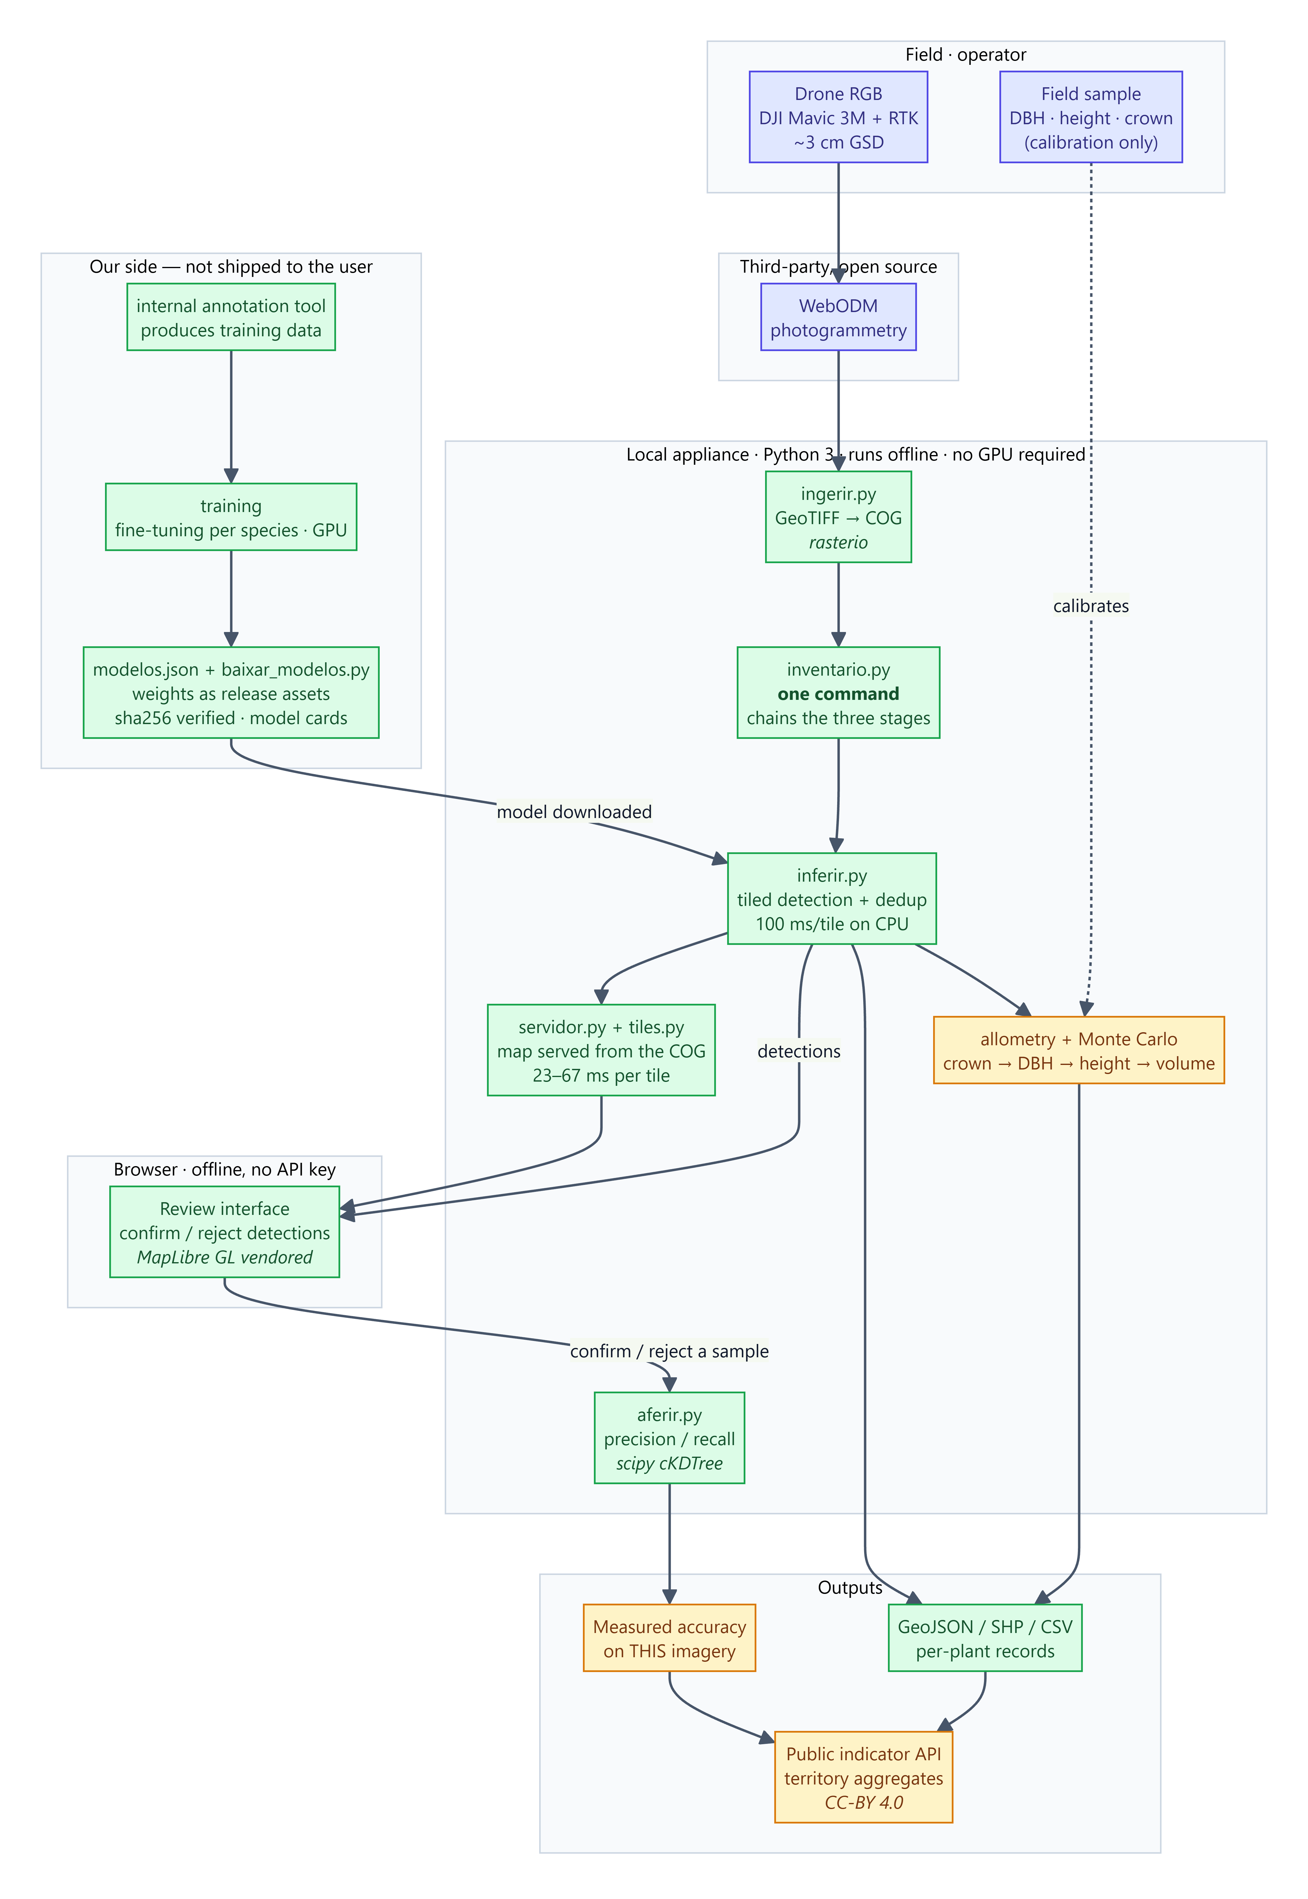
Annex 1 - Technology stack. Green: complete and verified. Amber: to be built during the investment period. Blue: third-party component or field step. Everything inside 'Local appliance' runs offline on the user's own machine, without a GPU.

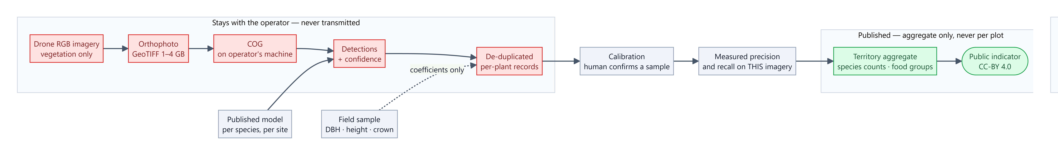
Data flow. Red: stays on the operator's machine and is never transmitted, including the plot-level geometry. Green: the only thing published, aggregated to territory level. No personal data and no children's data enters at any point.

PLEASE INSERT HERE: Annex 1: a diagram of your current tech stack including all components and subsystems, showing their linkages and interactions. A tech stack is a combination of software products and programming languages used. For this diagram, include: both client-side and server side documentation if relevant, tools used for front-end and back-end systems (including databases), and any meta-layers.

ANNEX 3: SECTION C. QUESTION 4
PLEASE INSERT HERE: Annex 3: a content/curriculum map diagram (max 1 page), including the general organization of the content, rough relational hierarchy. Be sure to give details at the lowest level of granularity of your content.

ANNEX 4: SECTION C. QUESTION 5
PLEASE INSERT HERE: Annex 4: a sample of the content you have created (at the end of this template Annex 4) and/or plan to create (copy/paste at the end of this form in the appropriate place). The sample should cover one piece, i.e. one video, one pdf, one set of exercises etc.

