https://blog.csdn.net/xmdxcsj/article/details/51763886
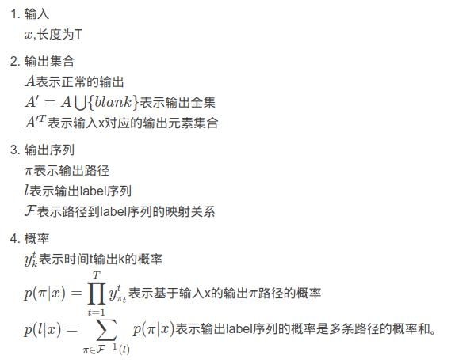
https://blog.csdn.net/luodongri/article/details/77005948?utm_medium=distribute.pc_relevant.none-task-blog-BlogCommendFromMachineLearnPai2-6.control&depth_1-utm_source=distribute.pc_relevant.none-task-blog-BlogCommendFromMachineLearnPai2-6.control

