Course Evaluation Results

Allan Omondi

2023-10-04

Table of Contents

| Key | Value |
| --- | --- |
| **Course** | Business Intelligence II |
| **Course Code** | BBT4206 |
| **Class** | BBIT 4.2 |
| **Semester Duration** | 21st August 2023 to 28th November 2023 |
| **Date of Evaluation** | 25th September 2023 to 4th October 2023 Week 6 & 7 of 14 |
| **Total number of students who submitted the course evaluation** | 102 |
| **Total number of students registered in the AMS at the time of the course evaluation** | 115 |
| **Response rate** | 88.69% |
| **e-Learning URL** | <https://elearning.strathmore.edu/course/view.php?id=6599> |
| **Data collection tool URL for access to the raw data** | <https://elearning.strathmore.edu/mod/questionnaire/view.php?id=221958> |
| **Lecturer** | Dr Allan Omondi <aomondistrathmore.edu> |

# Course Evaluation Score

Mean Course Evaluation Score = 4.3770 / 5

Percentage Score = 87.54%

## Course Evaluation Scores per Group

The **“Average Course Evaluation Rating”** variable in the plot below indicates the score **per group** with a baseline of 4/5.

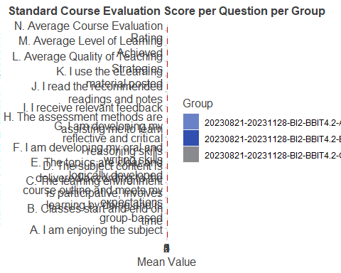

The **“Average Course Evaluation Rating”** variable in the plot below indicates the score **per gender** with a baseline of 4/5.

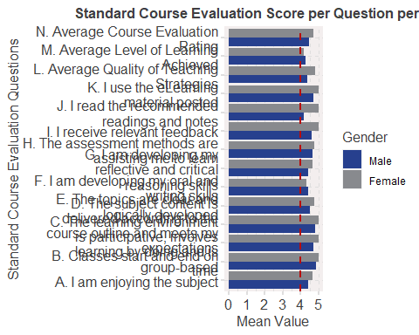

The plot below presents a drill-down of the class group into **regular and exempt** students:

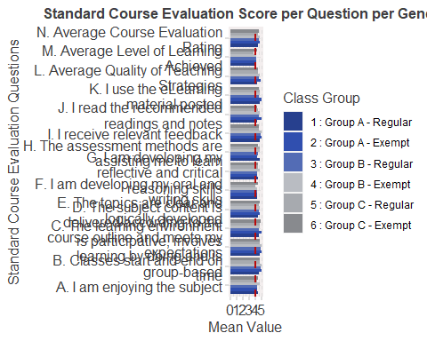

# Correlations

The following variables have been renamed to fit the correlation plots:

* `A. Enjoying Subject` = `Q02_General Questions->A - 1. I am enjoying the subject`,
* `B. Classes Start-End` = `Q02_General Questions->A - 2. Classes start and end on time`,
* `C. Learning Environment` = `Q02_General Questions->A - 3. The learning environment is participative, involves learning by doing and is group-based`,
* `D. Content Delivery` = `Q02_General Questions->A - 4. The subject content is delivered according to the course outline and meets my expectations`,
* `E. Clear Topics` = `Q02_General Questions->A - 5. The topics are clear and logically developed`,
* `F. Oral and Writing` = `Q02_General Questions->A - 6. I am developing my oral and writing skills`,
* `G. Critical Thinking` = `Q02_General Questions->A - 7. I am developing my reflective and critical reasoning skills`,
* `H. Assessment Methods` = `Q02_General Questions->A - 8. The assessment methods are assisting me to learn`,
* `I. Relevant Feedback` = `Q02_General Questions->A - 9. I receive relevant feedback`,
* `J. Read Recommendations` = `Q02_General Questions->A - 10. I read the recommended readings and notes`,
* `L. eLearning Material` = `Q02_General Questions->A - 11. I use the eLearning material posted`,
* `Understood Concept 1` = `Q03_Level of Learning Achieved->B - 1. Concept 1 of 4 - Ensemble Methods for Predictive Analytics`,
* `Understood Concept 2` = `Q03_Level of Learning Achieved->B - 2. Concept 2 of 4 - Predictive Modelling Using R`,
* `Teaching - Labs` = `Q04_Quality of Teaching Strategies->C - 1. Labs with comments that describe each step to be followed`,
* `Labs with Submission` = `Q04_Quality of Teaching Strategies->C - 2. Labs that require you to put in effort to make a submission related to the content of the lab`,
* `Git in Teams` =`Q04_Quality of Teaching Strategies->C - 3. Labs that require you to use Git to work in a team`,
* `Solo Labs` = `Q04_Quality of Teaching Strategies->C - 4. Labs that require you to work alone`,
* `Quality of Lectures` = `Q04_Quality of Teaching Strategies->C - 5. The quality of the lectures given (quality measured by the breadth (the full span of knowledge of a subject) and depth (the extent to which specific topics are focused upon, amplified, and explored) of learning - NOT quality measured by how fun/comical/lively the lectures are)`,
* `Recordings of Classes` = `Q04_Quality of Teaching Strategies->C - 6. The recordings of online classes`,
* `Online Classes` = `Q04_Quality of Teaching Strategies->C - 7. Online classes in general`,
* `Physical Classes` = `Q04_Quality of Teaching Strategies->C - 8. Face-to-Face classes in general`

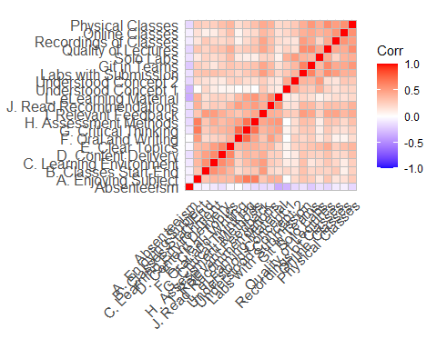

The specifc correlation values are presented below:

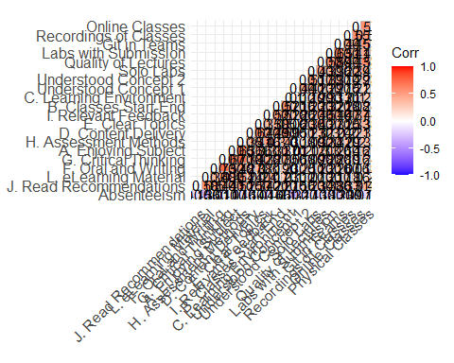

## Interesting Correlations

The following are hypothetical statements given that “correlation does not imply causation”.

* **.73 correlation** between “I am developing my oral and writing skills” and “I am developing my reflective and critical reasoning skills”: *Consider writing as formalized thinking.*
* **.71 correlation** between “The assessment methods are assisting me to learn” and “I am developing my reflective and critical reasoning skills”: *The more effort students put into the assessment, the more they develop their reflective and critical reasoning skills.*
* **.67 correlation** between “I am enjoying the subject” and “I am developing my reflective and critical reasoning skills”: *The more a student enjoys the subject, the more they consider their reflective and critical reasoning skills as developing.*
* **.65 correlation** between “The assessment methods are assisting me to learn” and “I am enjoying the subject”: *The more interesting/challenging the assessment methods, the more students enjoy the course.*
* **.63 correlation** between “Labs that require you to use Git to work in a team” and “Labs that require you to put in effort to make a submission related to the content of the lab”: *The more students appreciate the use of Git for working in teams, the more they appreciate labs that require a submission to be made.*
* **.62 correlation** between “The subject content is delivered according to the course outline and meets my expectations” and “The topics are clear and logically developed”: *The more the course outline is followed, the clearer and more logically developed the topics are.*
* **-.32 correlation** between “Concept 1 of 4 - Ensemble Methods for Predictive Analytics” and “Absenteeism”: *Students who started the semester late (high absenteeism), had a harder time understanding concept 1 which was covered at the beginning of the semester.*
* **-.36 correlation** between “I use the e-learning material posted” and “absenteeism”: *The higher the number of classes missed, the lower the student’s engagement with content posted on e-learning*

Below are the two most extreme (positive and negative) correlations:

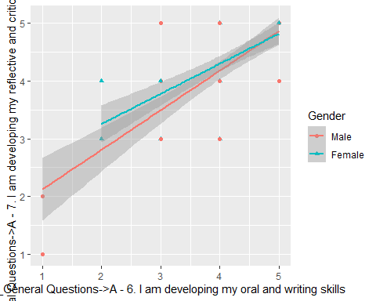

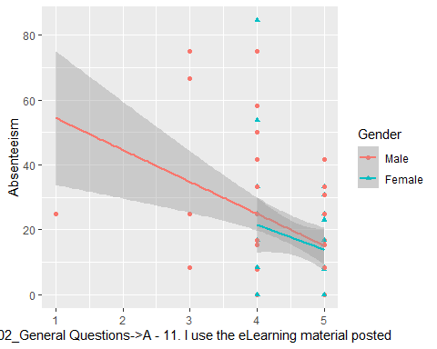

## Absenteeism Percentage

The lower the absenteeism, the more a student makes use of the e-learning materials posted. And the more a student makes use of the e-learning materials posted, the higher their overall grade in the course.

With this in mind, a further investigation of the **absenteeism percentage** is presented below.

Absenteeism by general class group:

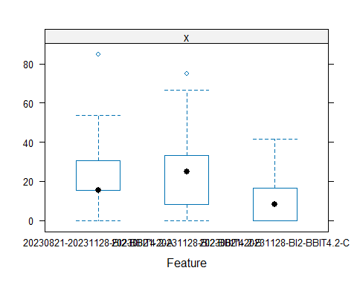

Absenteeism by specific class group:

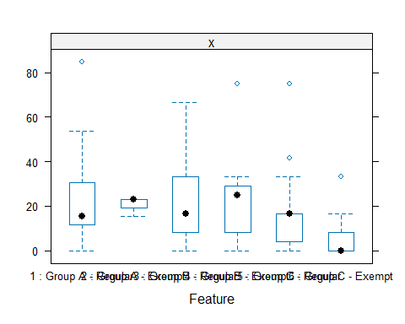

Absenteeism by gender:

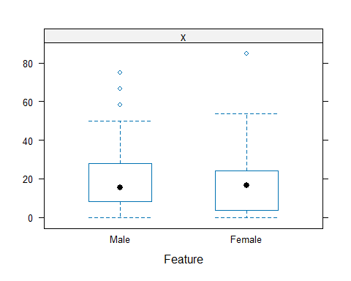

# Qualitative Data (Likes and Wishes)

## Term Frequency - Inverse Document Frequency (TF-IDF) Score

The plot below presents the quantitative measure of “significance” using the Term Frequency - Inverse Document Frequency (TF-IDF) score:

TF-IDF Score (likes) per gender:

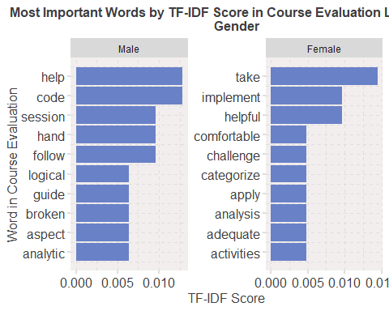

TF-IDF Score (likes) per specific class group:

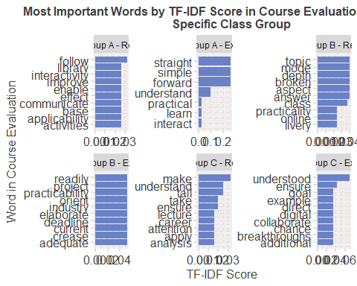

TF-IDF Score (wishes) per gender:

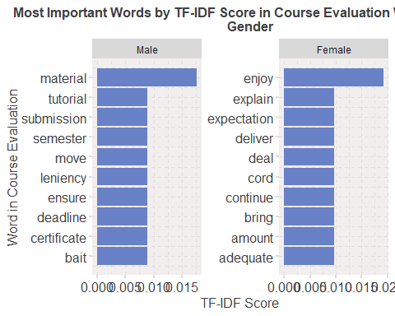

TF-IDF score (wishes) per specific class group:

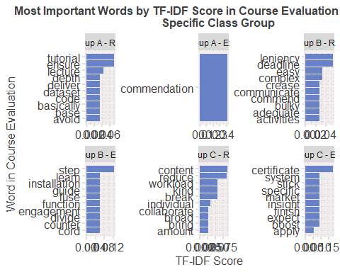

## Lexicon-Based Sentiment Analysis

The overall sentiment for the likes is:

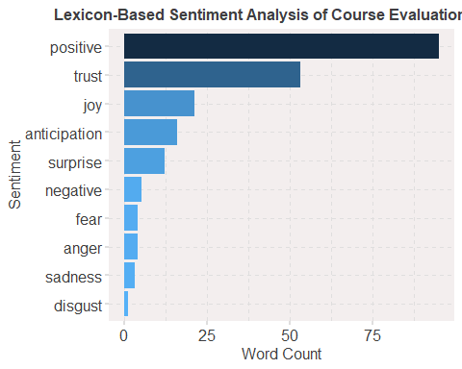

The overall sentiment for the wishes is:

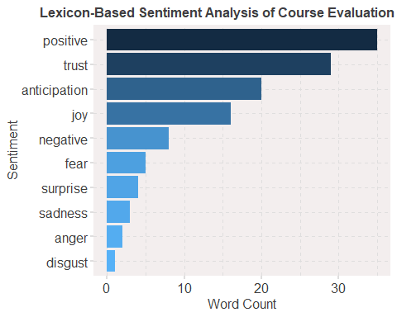

Chord Diagram of Likes per Class Group:

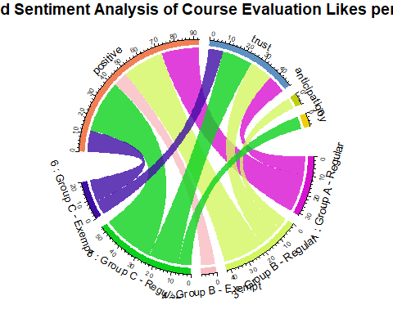

Chord Diagram of Likes per Class Gender:

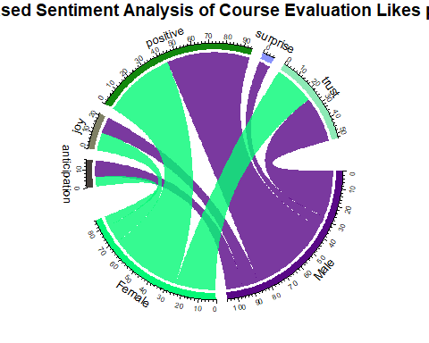

Chord Diagram of Wishes per Class Group:

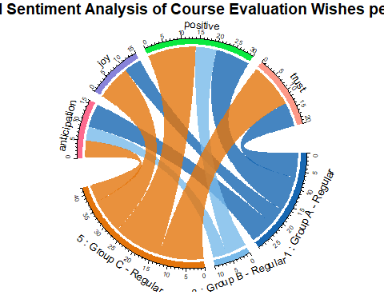

Chord Diagram of Wishes per Gender:

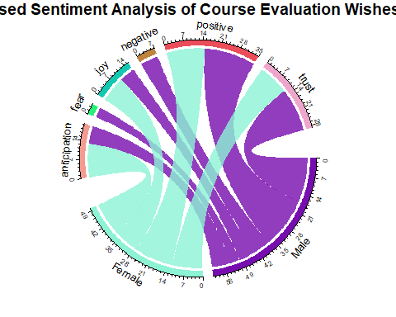

## Raw Data

### Likes

The raw data of the likes is as follows:

Write two things you like about the teaching and learning in this unit so far

x

It is interesting and helps improve coding skills

it is very detailed hence of great helpIt is interactive both in the unit and in regards to other units such as IS project II

 Ensemble Methods for Predictive Analytics  Predictive Modelling Using R

Interactive

The concepts are well explained Communication is effective

It is a bit more practical due to the use of python and r The instructor is well organized and the teaching methods are useful

It is practical and based on modern concepts The labs are interesting and thought provoking

I like that the labs are practical I like being given enough time to do the labs

Everything is good

It is interesting and interactive since we get to use different tools in our sessions.

So far its been a hard unit and fortunately the teaching style for the lecture is helping as he guides us along

Lecturer is efficient classes start and end on time

Increase submission deadline

The practical labs are engaging hence skill development  the teaching method and lectures

1. It is comprehensive 2. It is interesting.

* It is step by step
  + The content is really engaging and intense and shows that learning is there. - Also additional hands on skills like using GitHub and collaborations which plays a huge role in the personal development goals in the digital space.
  + N/A
  + Interactivity and applicability of the unit
  + The online classes The Labs that require submissions help me to dig deeper.
  + The practical examples and labs
  + The unit is very practical which helps me in the long run. The lecturer does not leave anyone behind, ensures everyone has understood the concept
  + Work is clearly and easily broken down The lecturer is very available for consultation
  + The teaching for this unit has been very comprehensive so far and engaging with the lecturer. The learning implements group works.
  + Learning to use GIT Being taught practically and through walk-throughs
  + The step by step explanation of the concepts is very helpful The time to complete the labs is sufficient
  + The lec takes his time to teach the concept
  + Detailed Explanations. Quick feedback by lecturer.
  + The labs are guided and help to learn The lecturer is willing to repeat explaining areas of less understanding
  + The lecturer is readily available to help when one is stuck The unit is well structured and organized
  + Very in depth Very practical
  + Its practical and has interactive learning
  + It is interactive  It is engaging
  + The lecturer does everything in his power to ensure we are comfortable with content being taught and make sure we are following along together. The e-learning site is also very well organized and categorized for this unit
  + Answers the questions asked Explains well
  + Patience and flow
  + mode of delivery Information
  + The mode of delivery  The assistance of reference links put on elearning for easy reference
  + The lecturer ensures everyone understandsThe labs are fun
  + The lecturer ensures everyone has understood. It is practical.
  + The explanations to the various concepts are well explained
  + the labs sessions are nice
  + i like the group labs i like the topics
  + I find it current industry oriented
  + The lecturer provides adequate feedback on the questions asked. The lab work clearly elaborates on the work taught.
  + The lecturer explains the content really well.
  + Takes time to organize his work, I appreciate the effort
  + So far so good The lecturer is very clear
  + It is comprehensive It is easy to follow
  + Labs that describe each step to be followed are engaging and learning enables me to follow through the lab properly It is very engaging and interactive.
  + The lecturer asks questions The lectures are clear
  + Interactive Interesting
  + The content is very well delivered.
  + The assistance by the lecturer, the practicality
  + Lab work Class sessions
  + It is very participative and lecturer gives room for questions
  + feedback is quickLecturer is willing to help
  + Working as a team
  + the fact that we get to do the lab work in groups  the interactive online and on campus classes
  + I like how the Lecturer explains the concepts and takes us through the labs
  + The concept are explained very well A chance to learn R I have wanting to interact with R and data
  + very interactive and hands on
  + on hand Practice Good delivery
  + It’s interactive and very logical.
  + The technical aspect of the unit. The attentiveness to detail when it comes to the labs and concepts are clearly explained.
  + i like the templates that come with the labs  i like the fact that we draw references from real world scenarios
  + Wide scope of content Practicability
  + Once you follow the steps for the lab you will be okay. The lecturer helps in one on one for the labs if one has an issue
  + The attention to detail when explaining the code. It makes it easier to understand Having practical labs
  + I like the way the topics are broken down very logical and easy to understand. I like that we are constantly able to ask questions and be answered regardless of the nature of the question.
  + The lectures
  + Its Good
  + the lecturer the lectures
  + Lecturer, Teaching method
  + I like this ui=nit because it prompts me to think actually think and connect the dots
  + Well explained content
  + Gaining R skills
  + Use of realistic  code group work
  + practicality Engagement
  + Group Labs
  + its straight forward and simple to understand
  + I like the practicality of R and learning github in depth through the group work
  + Group workPractical Exercises
  + The learning of this unit is good in terms of the detailed and step by step practicals shown by the lecturer for each lab.The recordings.
  + The teaching is very thorough and labs have well explained instructions.
  + I like that it challenges me to apply everything practically.
  + None
  + The practical aspect. The group work is good.
  + Labs activities, Quizzes help a lot on learning during the semester
  + clear and direct to the point  step by step teaching works for me
  + The lecturer explains everything in detail and caters for both ides that is vscode and rstudio
  + N/A
  + Systematic Modular
  + N/A
  + How to use and implement R as a language for data analysis
  + I am learning to use new language, R language, and how to use it together with the available libraries for predictive analytics.
  + Its practical
  + none
  + It is very practical and a good example of a prospective career path for many.
    1. The lecturer makes the content easy to understand
    - the teaching method the recording being online is also helpful
    - The practicals

### Wishes

The raw data of the wishes is as follows:

Write at least one recommendation to improve the teaching and learning in this unit (for the remaining weeks in the semester)

x

none

i would like if the concepts were divided where we learn the functions first online then do the practicals of it in person

N/A

Flexibility

I don’t have any

Leniency with regards to lab work submission and future project work

More tutorials based on the labs

Use of less complex datasets

i have no recommendations

A guide to help us counter different problems like installation of packages during labs.

I would like lab exercises to be done more in class so as to easily understand

Lecturer might be a bit fast at times

Step by step materials/videos on how to do the lab works

student involvement

1. Nothing

* Go easy on us abit, it is te last semester
  + To give us insights or recommendations about certifications that we can as well do, related to this unit which will boost our C.Vs for the interested students.
  + N/A
  + A bit more tutorials on technical errors such as ones on knitting and rendering the markdown files
  + If the concept requires many practicals, the classes should be more online.
  + N/A
  + For the physical class to be moved to a lab
  + Being more lenient with lab work
  + Everything is okay so far.
  + Sticking to a specific application to be used
  + No recommendation at the moment
  + None
  + The content is too broad and covers a lot i.e new softwares which make the unit overwhelming.
  + More teamwork collaboration in labs.
  + It would be better if the physical classes were being recorded because at times one might be behind or missed an important lab step
  + No recommendations
  + N/A
  + Make the course work less bulky and complex
  + no comment
  + n/a
  + Too much content to deal with
  + time liniency
  + That the labs should be given more time to them
  + Breaks in between classes
  + Nothing. I am enjoying and understanding the course.
  + None
  + increase more labs
  + the labs are quite hefty so it really makes the work easier to do in a group
  + More engagement
  + More time to be allocated in the lab work assignments.
  + Nothing
  + I am content
  + Reduce content Reduce labwork
  + .
  + Proper detailed explanation of the labs, rather than rushing through them quickly  More time is needed for lab completion and progressive follow-up so the lecturer knows where you are stuck.
  + More time for labs
  + So far none
    - Reduce the workload, its honestly too much
    - More reference material Breaks during classes at least 5 mins
    - None….The unit met my expectation and was delivered perfectly
    - Avoid online classes
    - Deadlines to be extended abit
    - N/A
    - i am enjoying the unit as it is
    - Since we are about to finish our 8.4.4 system. To give us more recommendation on certificates and what the job market expects from us
    - better communication of activities btwn the students and the lec
    - .
    - Ensure that the code work can work with any dataset and not fixated on provided dataset
    - I would like there be more simpler labs with easier datasets to understands the concepts first then move on to more complex data handling and manipulation.
    - i wish that that the lab assignments could be allocated more time, that they are marked towards the end of the semester
    - None so far
    - Kindly share more reading materials and past papers.
    - Having more practical labs
    - I recommend that the deadlines on the labs be more flexible as there are many subject and projects running concurrently.
    - The labs are long, they are individually basically the same size as an entire same project
    - No recomendation
    - so far so good
    - Greater in depth exploration into labs to ensure we’re actually understanding what is going on.
    - The content is so hard to understand and the lec solving other people’s issues only bring more confusion to some of us, I wish he would go through the content first then afterwards focus on individual problems
    - He is doing a good job
    - Personally I use linux and its kinda hard for me  You can add some YouTube materials
    - Lab submissions still very confusing
    - More online sessions
    - None
    - so far so good
    - Adequate time for completing the labs
    - More group work, less individual work
    - No recommendations there is good delivery.
    - Generally just slow down the amount of work we have to submit considering the IS project we need to work on
    - One recommendation may be to explain how these concepts can relate to and apply to our IS Project 2.
    - None
    - It is okay.
      * Slide are very long (too much content) lecture can improve on that-
      * nothing really
      * There are many labs
      * N/A
      * Further work on ease of following the lab work
      * N/A
      * No comment, everything is fine
      * None
      * nothing all is well
      * reduce the workloads on the labs kindly
      * n/a.
      * N/A
      * so far I have been struggling a little with the Lab a bit but i’m hoping it will get better as we continue with the other labs
      * N/A