SUMMER COURSE WEEK 4

|  |  |
| --- | --- |
|  | due to 1/8/2025 @ 10:00 am Good luck! :) |

# משימה 1

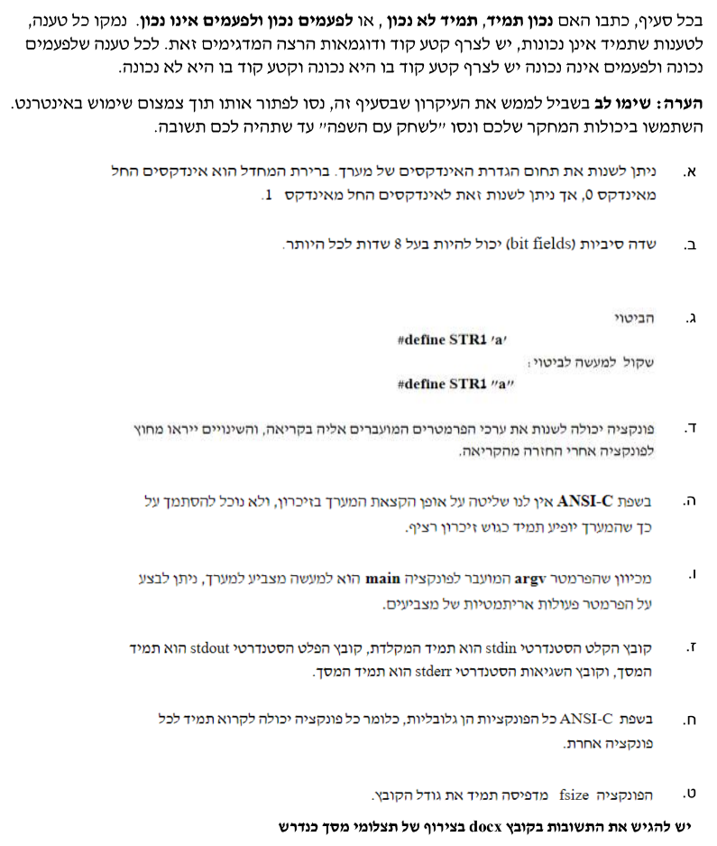

# משימה 2



 