**Physics**

# Physical Quantities and Measurement

## Class – 01

Comparing an unknown quantity with a standard quantity (unit) is called measurement.  
MEASURMENT = NUMBER X UNIT  
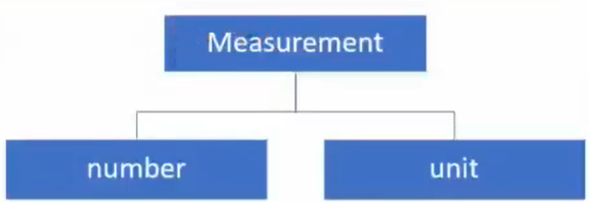  
Unit is the standard quantity of constant magnitude which is used to measure the magnitude of other quantities of the same nature.

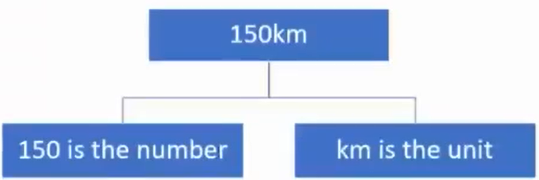

**The three types of units are Fundamental Units, Derived Units and Supplementary Units**  
A FUNDAMENTAL UNIT (OR BASIC) UNIT is that which is independent of any other unit or which can neither be changed nor can be related to any other fundamental unit.  
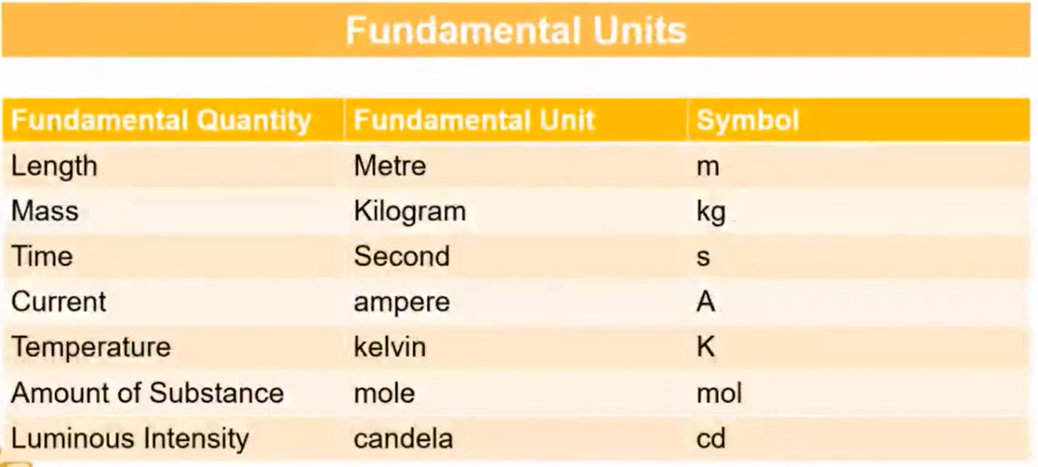

All the Fundamental units become SI Units.

DERIVED UNITS are those which depend on the fundamental units or which can be expressed in terms of fundamental units.  
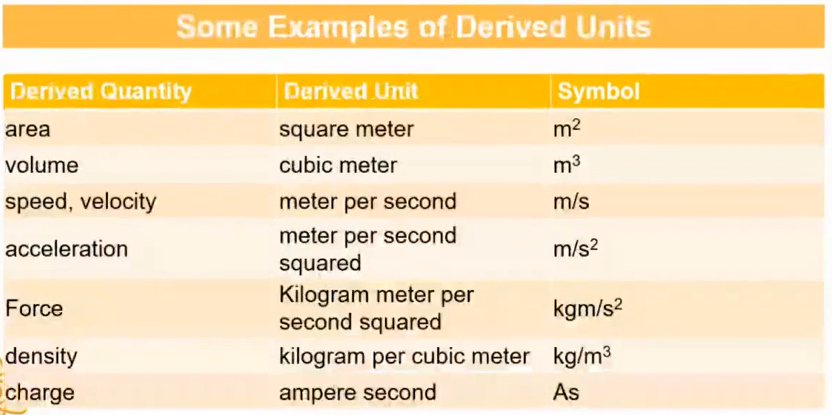  
There are many derived units.

The Angles drawn by the protractor are considered as SUPPLEMENTARY UNITS.

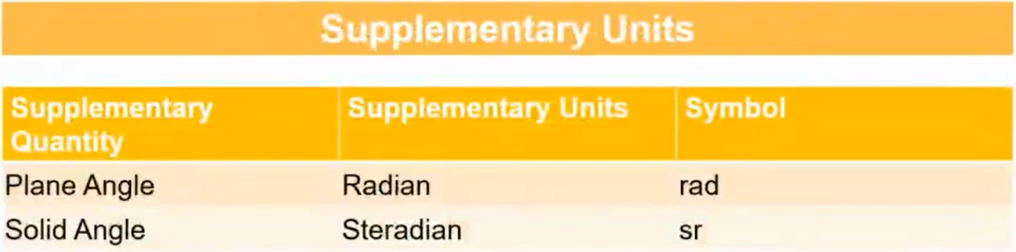

The scientists could not classify the angles into fundamental or derived units so they branched them under supplementary units.

**Choice of Unit (Which Unit to Use?)**

* **The units should be convenient to use**
* **It should be possible to define the unit without ambiguity (confusion)**
* **The unit should be reproducible**
* **The value of the unit should not change with space and time**

**System of Units**

**There is the C.G.S system, F.P.S system, M.K.S system and the S.I system.**

**C 🡪 Centimeter (cm)**

C.G.S System

**G 🡪 Grams (g)**

**S 🡪 Seconds (s)**

**F 🡪 Foot**

F.P.S System

**P 🡪 Pound (lbs.)**

**S 🡪 Second (s)**

**M 🡪 Meter (m)**

M.K.S System

**K 🡪 Kilometer (km)**

**S 🡪 Second (s)**

**S.I system is the International Standard accepted all over the world.**

**Prefixes and Suffixes for Bigger and Smaller Unit**

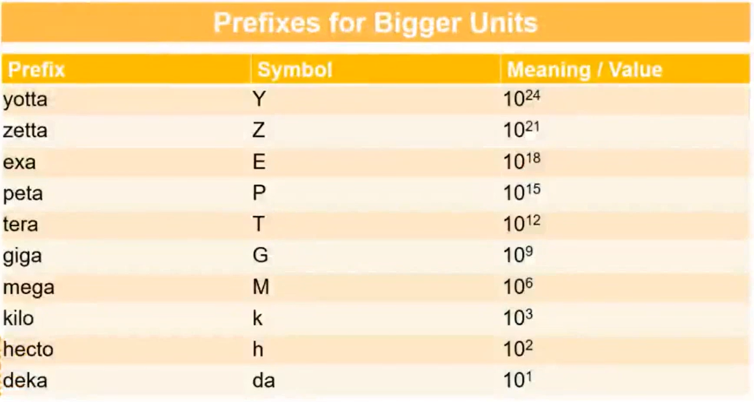

**I light year is the distance travelled by light in vacuum in 1 year.**

**Light Year = Speed of light x Time (1 year)**

**1*ly* = 3 x 108 x 1 year**

**1*ly* = 3 x 108 x 360 x 24 x 60 x 60 m**

**1*ly* = 9.46 x 1015 m / 9.46 x 1012km**

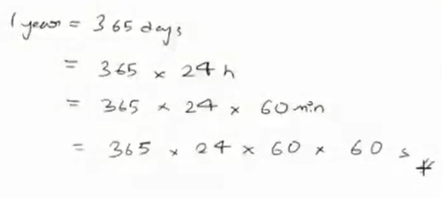

**Astronomical Unit (A.U) = 1A.U = 1.496 x 1011m**

**Parsec = 1Parsec = 3.26*ly***

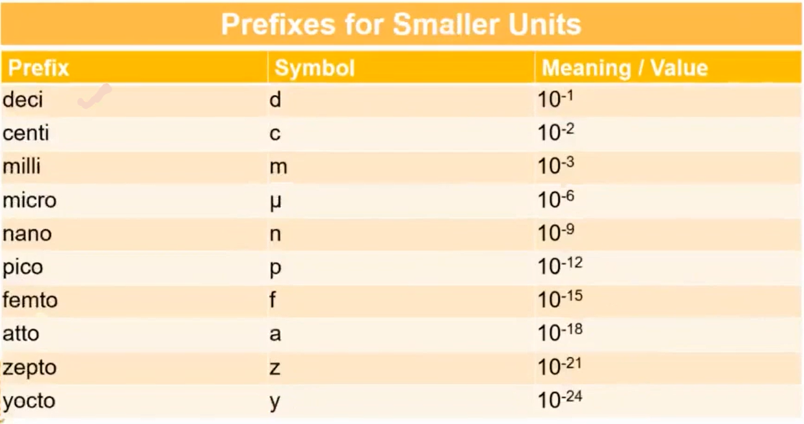

**Angstrom 🡪 Å 🡪 1Å = 10-10m = 1/1010m**

**1 fermi = 1 femtometer = 10-15m = 1/1015m**

## **Class - 02**

**Mass**

**The SI unit of mass is Kilogram.  
The mass of 1*l* water at 4℃ is 1kg.  
