AN

INDIAN

BOY’S

LIFE

BY VYOM MAHAJAN

As we know India is a big and the seventh largest country in the world with a population of 132.42 crores. People will be found all over India from the richest people to the beggars on the streets. India is surrounded by a few countries, they are Pakistan ,China ,Myanmar and Bangladesh.

SPORTS

India is also good at sports especially cricket ,wrestling and badminton.

I am not saying that we are bad at other sports but we are better at the other sports. We have started to improve at football and table tennis.

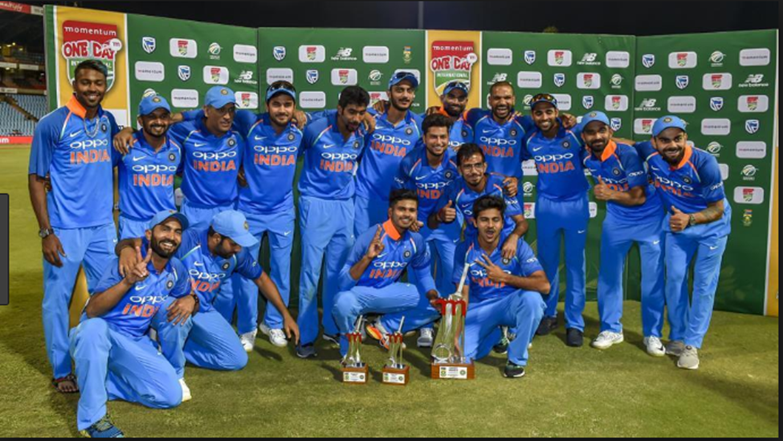

Now as an Indian boy I think India is a truly good country. I don’t know why people want to go to US and Europe, why can’t they just live in India. Our prime minister Narendra Modi has helped in developing India. Now almost every farmer has a tractor and is able plough faster with the tractor than using bulls or cows. But still there is a disadvantage that the tractors pollute the environment and the air. If this happens then the crops won’t be able to grow.